Misc.
WordPress is an open-source, free platform for building and developing websites. WordPress is the most user-friendly and efficient blogging and website builder on the market right now.
WordPress is utilized by 43.2% of all websites live on the internet in the current year, 2022. This is an increase from 39.5 in 2021.
WordPress.com, primarily, is a managed host, while WordPress.org is not a host. In essence, WordPress.org allows you to host your website. In contrast, WordPress.com handles everything for you.
Anonymous comments can cause serious damage to your website’s reputation. To prevent individuals from submitting anonymous comments, choose the option “Comment author must fill out name and e-mail.”
WWW or no WWW – whether your website is brand-new or has been hosted for a few months already will depend entirely on its stage. If it brand-new, you must definitely choose whether to use www or non-www in the URL of your site.
Folks learning to code has increased by 60 to 70 % year-on-year.
Tor browser – once the user places the request for information in the browser, then a new node or Tor server is created at random by the browser.
It is a computer graphics program to create intricate layouts, patterns and drawings. Capabilities – freehand drawings, colour palettes, fillings shapes, geometric objects, digital artwork, promotional or branded content, icons, website images.
One of the top platforms now on the market is Adobe Illustrator.
According to the Stack Overflow Survey 2022, there has been a 60 to 70% year on year increase in the number of students who want to learn coding online.
JavaScript was originally called Live Script, Netscape changed its name to JavaScript, and it is believed that this was because of the hype of Java within the industry.
Fastify provides a faster alternative for Express.js.
Python is an interpreted, general-purpose high-level programming language that is mainly used for automation, website development and data analytics. Python is managed by the Python Software Foundation.
When compared to compiled languages like C and C++, the python code is generally short, however, it executes programs slower.
Low-code no-code (LCNC)
HTML was invented by Tim Berners-Lee in 1993. Modern HTML codebases are now shorter than what they used to be. A huge number of interactive and design elements that programmers rely on to code manually can now be handled with the help of CSS or JS.
HTML can interact with our OS and not just the browser, features like easy to drag files onto a webpage so that we can upload them or made a video display on full-screen.
CSS was established in October 1994 by Hakon Wium Lie, who was a Norwegian web pioneer. Lie was sick of the lack of styling options that were available to developers.
By using Spring, JSF, Hibernate, Struts and Apache Hadoop, we can develop web-based programmes in Java. It is also a official programming language for Android development.
SQL – Structured Query Language.
NoSQL was created to function as a support system for SQL, not as its replacement. The language is based on a model that is considered to be fairly less stringent.
The term # in C# is derived from the musical sharp key. This symbol is used to denote a one semitone increase in pitch. C# is known for improving and updating many C and C++ feature.
Rust is often labelled as an alternative to traditional C++. Rust prevents memory leaks, which means there would be fewer errors in the work. As Rust is also considered a rather low-level language, it really comes in handy when developers need to get more gains more out of the minimal resources they have.
In contrast to this logic, high-level dynamically typed languages (form instance, Python and JavaScript) are considered to be better for tasks related to quick prototypes.
Perl (Practice extraction and report language) – one of the most common uses when it comes to Perl is executing text file information as well as generating a report or other output format. This is an interpretive language as opposed to a compile language. Now most uncompiled programs need a lot more CPU run time. This language was initially created only for text handling and system management. Currently, this language is known for its capabilities regarding handling Regex.
Go – developed very much in the same way as Algol or C. The defining feature of Go is concurrency means many different processes can easily be executed simultaneously. The main goal of this experiment was to address some of common criticisms pertaining to other programming language while also making sure that the still retain their most useful features.
Many different languages have similar structures and patterns. We need to get out of the mindset of believing that certain coding languages are better than others.
A great way to understand more about the world of coding is by looking at the work done by developers before you.
Some of the top websites that often open source projects include – gihub explore, code triage, open source Friday, source sort, first timers only, first contributions, up for grabs, 24 pull requests.
We should not create any features of functionality when we are carrying out the refactoring process.
Browse daily and get new information – code chef, code wars, coding game, geektastic, hacker rank, leet code, project euler, spoj, top coder, exercism.io, codebyte.
If we find a person with a rare intellect, we should ask him about the books he reads. Without good reading and comprehension skills, a person takes more time to understand the problems before solving it. Books that every programmer must read once – the mythical man month by Frederick brooks, the pragmatic programmer: your journey to mastery, code complete 2 by steve mcconnell, the art of computer programming, programming pearls, code: Charles petzold, introduction to algorithms, refactoring: improving the design of existing code, design patterns: elements of reusable object-oriented software.
How product companies handle production downtime - They use website like ManageEngine.com.
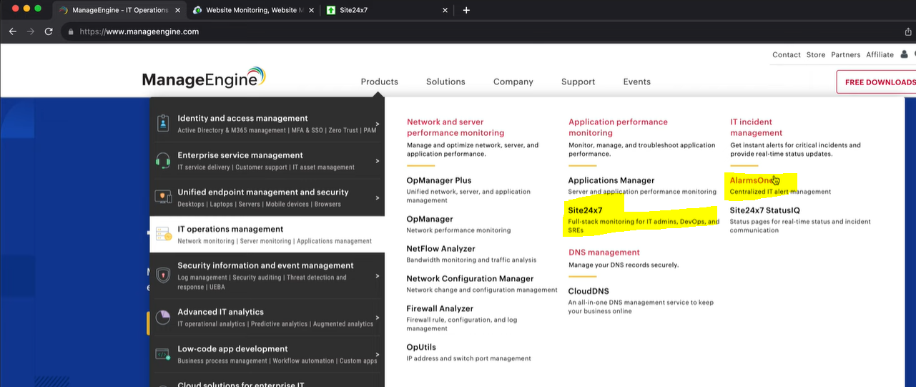
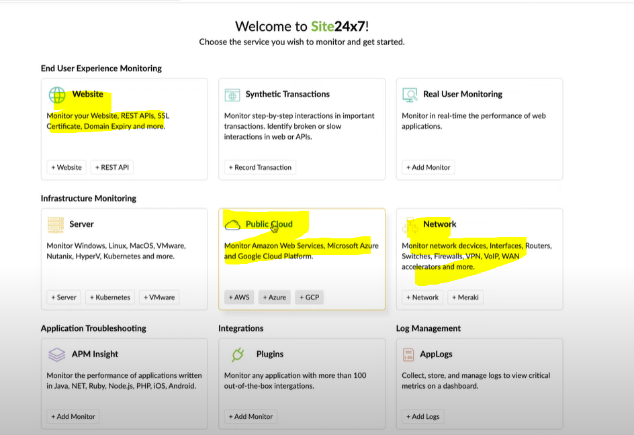
Android App Development - An app that seamlessly transitions between folded and unfolded states is essential for user satisfaction. Smartphone design moving away from traditional, rigid form factor to a more flexible and adaptable one. Two types – book-style and claimshell-style.
These devices, which can switch between a phone and table-like format, are a promising frontier for developers and designers alike. Users expect between different screen sizes and orientations.
Challenges include handling multiple screen ratios, dealing with screen continuity, and ensuring a seamless transition between folded and unfolded states.
Programming Pearls
- The programs use a terse coding style: short variable names, few blank lines, and little or no error checking.
- A merge sort program reads the file once from the input, sorts it with the aid of work files that are read and written many times, and then writes it once.
- Careful analysis of a small problem can sometimes yield tremendous practice benefits.
- A designer knows he has arrived at perfection not when there is no longer anything to add, but when there is no longer anything to take away. Simple programs are usually more reliable, secure, robust and efficient than their complex cousins, and easier to build and to maintain.
- Good programmers are a little bit lazy: they sit back and wait for an insight rather than rushing forward with their first idea.
- Coding skill is just one small part of writing correct programs. The majority of the task is the subject of the tree previous columns: problem definition, algorithm design, and data structure selection. If we perform those tasks well, writing correct code is usually easy.
- The first binary search was published in 1946, the first published binary search without bugs did not appear until 1962.
- If run time doesn’t matter, linear search is much simpler than binary search; many programmers can get it right on the first try. Because run time is important enough for us to introduce the additional complexity of binary search, we should conduct experiments to ensure that is performance is what we expect.
- Rick Lemons said that the best lessor he ever had in debugging was watching a magic show. The magician did a half-dozen impossible tricks, and Lemons found himself tempted to believe them.
- Inefficient programs sadden their users with longs waits and missed opportunities.
- Everything should be made as simple as possible, but no simpler.
- Premature optimization is the root of much programming evil, it can compromise the correctness, functionality and maintainability of programs.
- Insertion sort is the method most car players use to sort their cards. Insertion sort is simple to code and may be fast enough for small sorting jobs. For large numbers, run time of Quicksort is crucial.
- One part of a programmer’s job is solving today’s problem. Another, and perhaps more important, part of the job is to prepare for solving tomorrow’s problems.
- Heapsort never takes more than O(n log n) time to sort and n-element array, and uses just a few words of extra space. The fasters Heapsort is usually slower than the simple Quicksort.
- Make it work first before you make it work fast.
- Sorting works well for finding the mode, but hashing can be faster.
HTTP crash course - URL, URI and URN are almost same to get the location address.
Types of headers – X-prefix for headers has been deprecated.
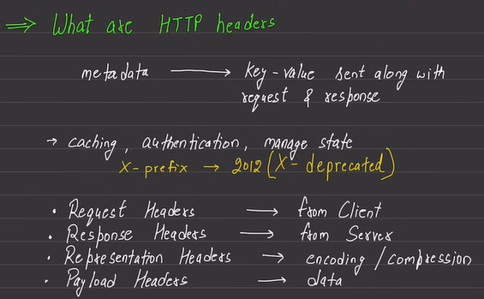
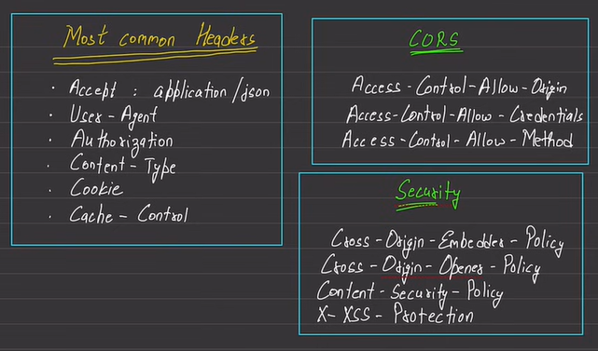
We also have methods like HEAD, TRACE. TRACE is useful to have debugging in case of multiple proxies in-between the communication.
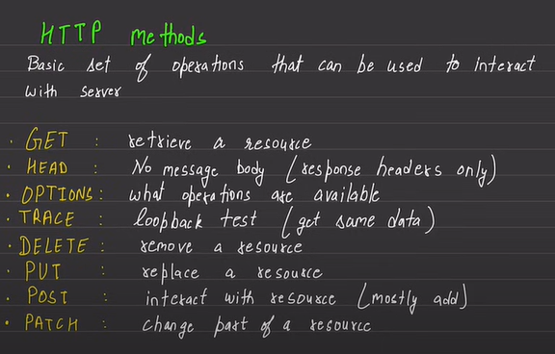
Useful status code –
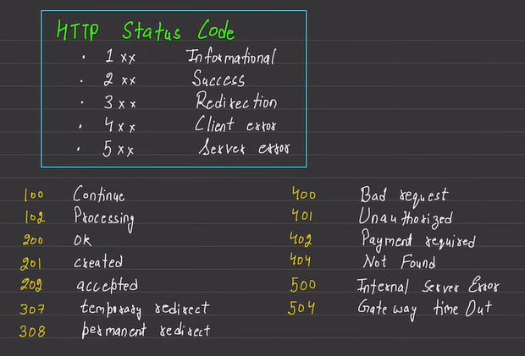
Reverse Proxy – Nginx and caddy are example of reverse proxy servers.
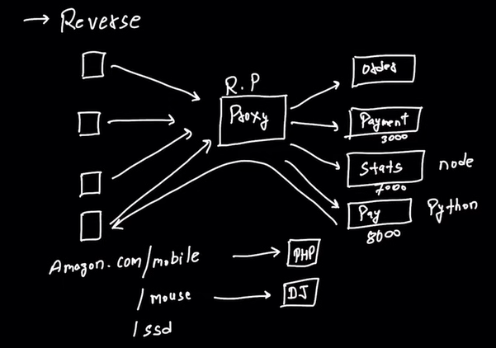
Assistive technology refers to any device, software or system that is designed to support individuals with disabilities and improve their functional capabilities. Examples – wheelchairs, speech recognition software, and adapted keyboards.
Adaptive technology, on the other hand, refers to technology that has been modified of an individual with a disability. For example, adaptive mouse might be modified to accommodate the needs of an individual with limited dexterity.

Misc. Angular React
Problem With Media Queries - Four breakpoints. Four different font sizes. Works, but you just added 12 lines of CSS for one heading. Now imagine doing this for every heading, every paragraph, every button, every container. You end up with hundreds of lines of media queries. What happens at 800px? Or 1200px? You get awkward jumps where text suddenly changes size. Users on 767px see 24px text. Users on 768px see 32px text. That’s not smooth scaling — it’s jarring steps.
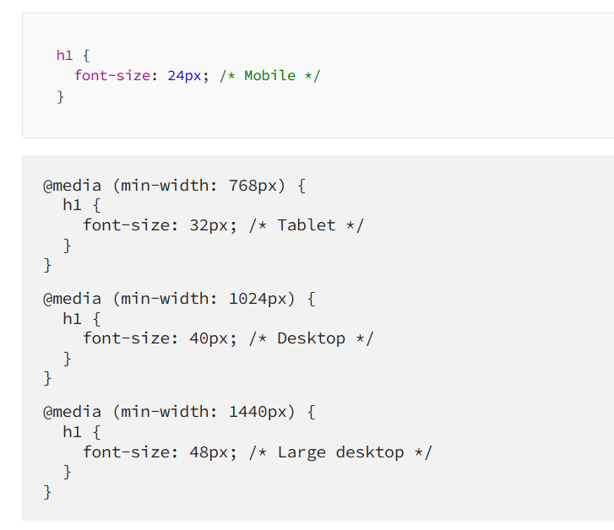
What clamp() Actually Does - clamp() takes three values: minimum, preferred, and maximum. The browser picks the middle value (preferred) unless it’s too small (then it uses minimum) or too large (then it uses maximum).
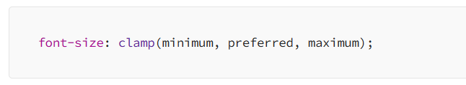
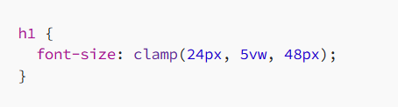
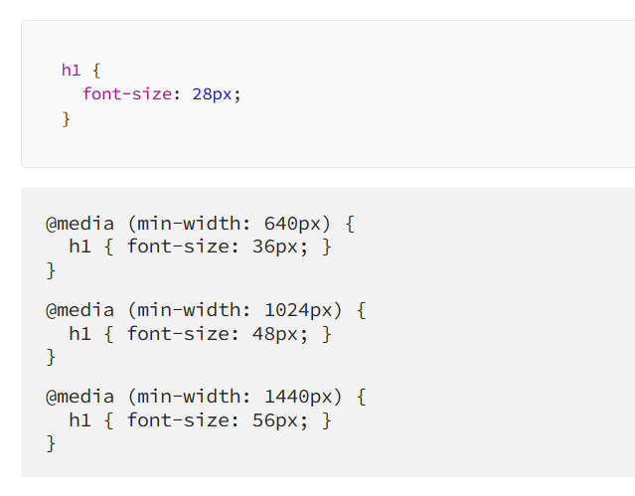
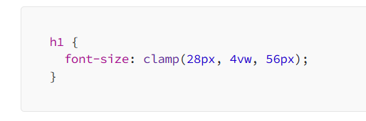
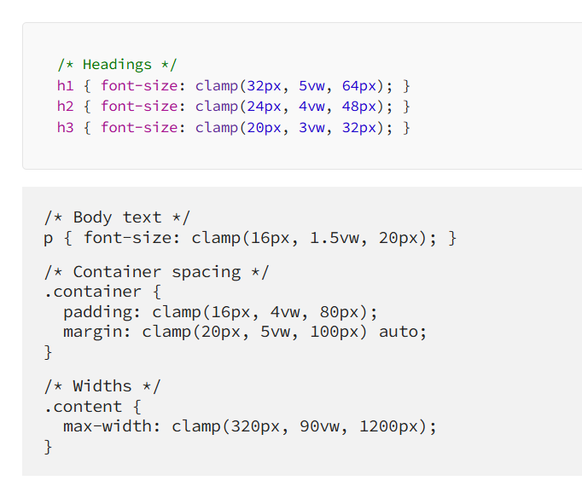
Key UX design laws –
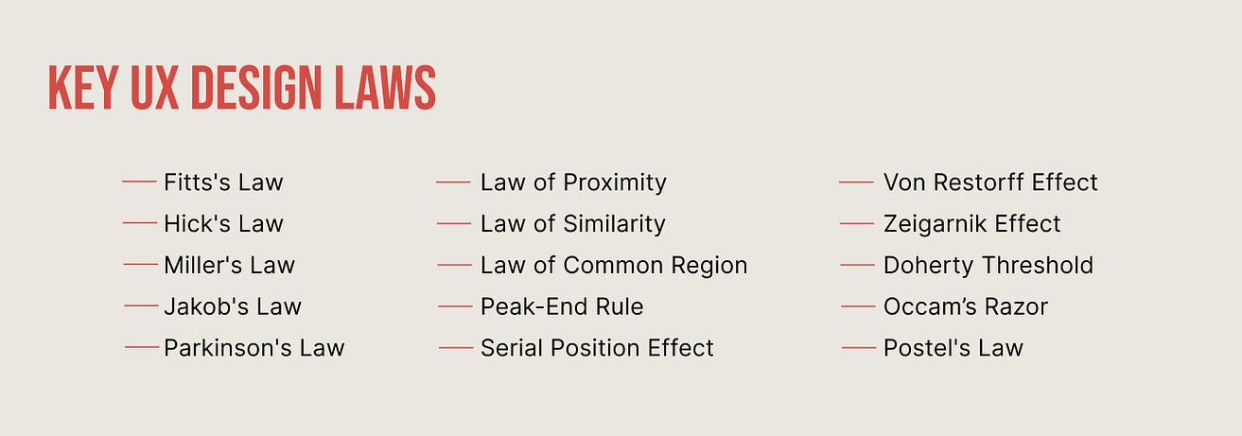
Unnatural color contrast vs. natural depth contrast –
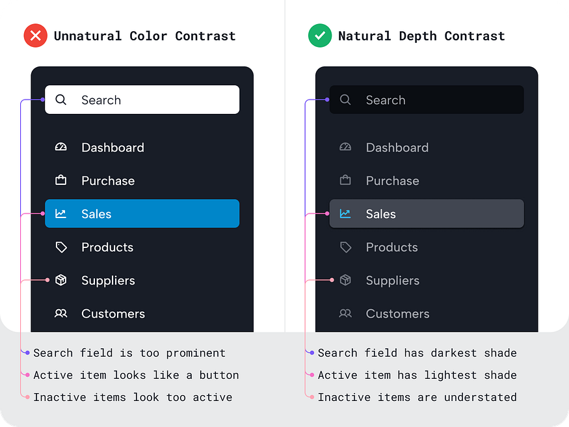

Best Practices
[Practice 1] Cognitive load: Don’t make users think harder than they need to
- One main action per screen is usually enough.
- Don’t overload users with 12 menu options when 4 will do.
- Hide complexity until it’s needed (advanced settings can stay advanced).
[Practice 2] Hick’s Law: Too many choices = decision paralysis
- Use progressive disclosure (show options gradually).
- Highlight the most common or recommended choices.
- Pre-fill defaults (most users won’t change them anyway).
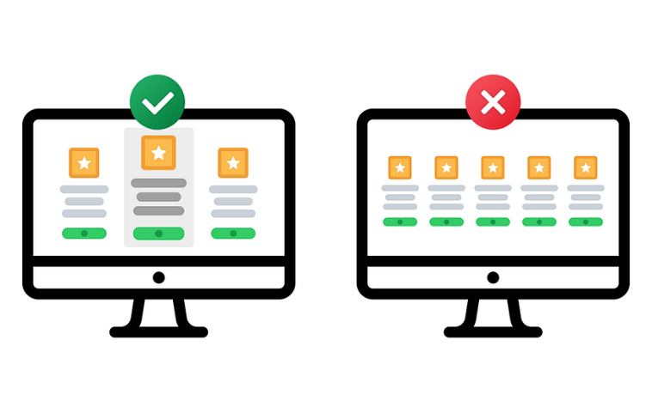
[Practice 3] Fitts’ Law: Make targets easy to hit
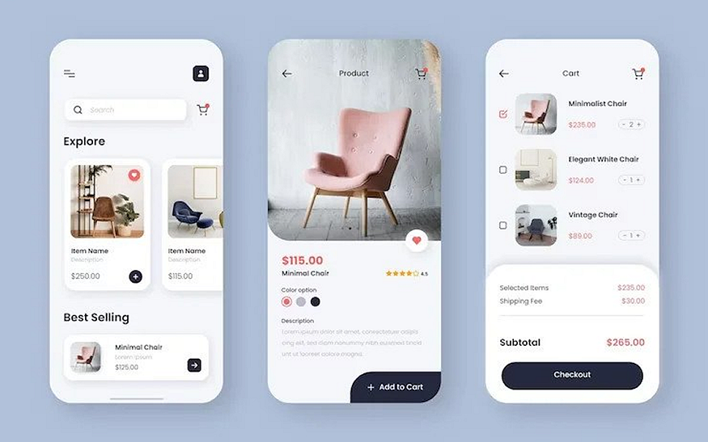
- Touch targets on mobile should be at least 44px (unless you enjoy lawsuits from people with normal-sized thumbs).
- Put primary actions in easy-to-reach “thumb zones.”
- Don’t put destructive actions (“Delete account”) right next to safe ones (“Save changes”).
[Practice 4] Familiarity > originality
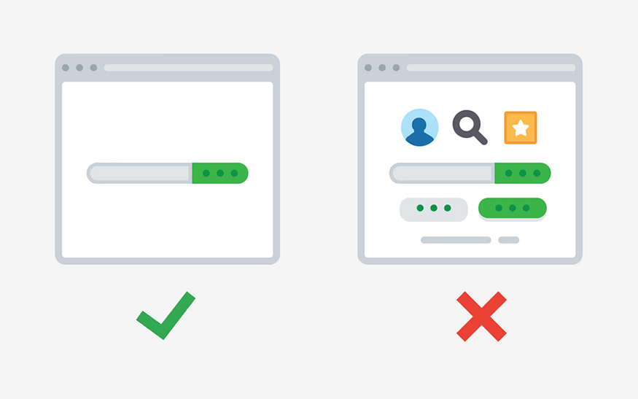
Familiar patterns feel safe. Login forms, navigation bars, checkout flows, they all follow conventions for a reason. Break them, and your users will break up with you.
- Keep common flows standard (sign-up, login, navigation).
- Save your creativity for visuals, animations, and micro interactions.
- Remember: weird = suspicious, familiar = trustworthy.
There’s a reason nobody messes with the order of “email” then “password.” Keep the basics boring and make the extras delightful.
[Practice 5] Don’t disable text selection / copying
The inability to copy text interrupts user workflow and forces hacks (screenshots + OCR) just to read or use content. It “turns text into media,” which is less interactive or manipulable.

UX Best Practice
Don’t block the flow - Keep the main action button (e.g., submit or continue) enabled to allow users to proceed. If there are issues, display clear error messages after submission.
Disabling the button preemptively creates confusion - users won’t know which validation criteria are missing, which increases frustration and cognitive load.
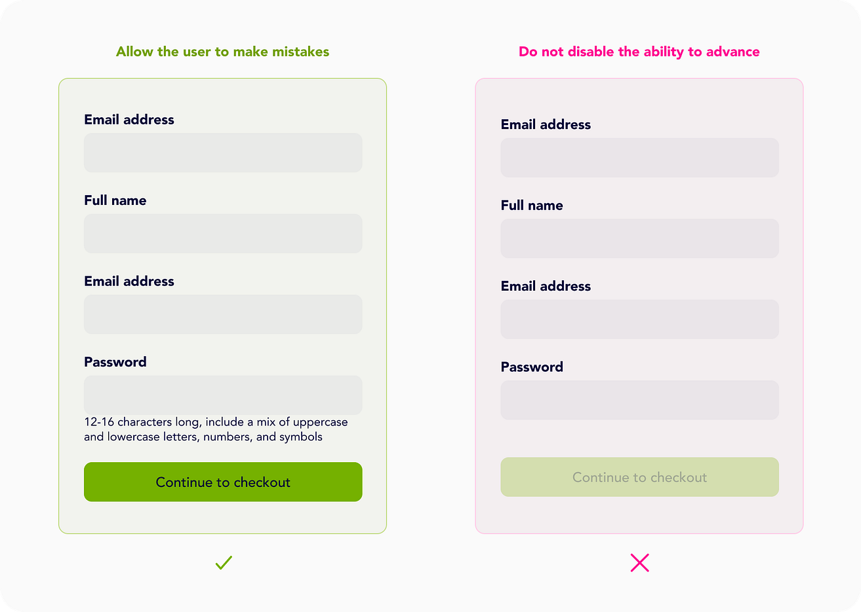

While building, focus on: Component structure and proper separation of concerns, State management (local state, lifting state up, maybe context), Data fetching / asynchronous flows if needed, UI-logic separation and good patterns of design, Handling edge cases and building something you would feel okay showing to others
The Angular CLI now includes an experimental Model Context Protocol (MCP) server. MCP is a standard interface that lets AI tools (in your IDE) interact with local development tools (like CLI) in a structured way. In this case: the CLI exposes project context, scaffolding, documentation, etc, so your AI assistant (or tooling) can “understand” your Angular workspace, instead of just generic code.
D less “churning code” and more thinking, designing, mentoring, system-level decisions. That work requires energy and clarity — which overwork undermines.
AI can code, but it can't build software. Coding is easy, software engineering is hard. Building a production-ready app is not coding, it’s software engineering.
The next wave of front-end innovation lies: beyond “responsive design” or “single-page apps” — into interfaces that understand context and adapt themselves.
The “generative UI” idea could influence your low-code UI framework: imagine letting an AI generate new screen configurations (JSON) based on user intent or prompt.
Integrate with your JSON-config form renderer so it can automatically pre-populate or revise fields.
Outcome:
Demo screen where typing “Apply for a 25-year mortgage of £350k in London” auto-fills loan type, tenure, and city fields.
1. “AI-Driven Form Completion”
Concept from article: Structured completions — AI fills form fields intelligently instead of users typing every detail.
Experiment:

In Angular, create a directive like aiSuggest="loanApplication" that connects a text prompt or uploaded document to your backend.
Spring Boot backend exposes a /suggest-fields API that takes user prompt + context and returns JSON field values.
Integrate with your JSON-config form renderer so it can automatically pre-populate or revise fields.
Outcome:
→ Demo screen where typing “Apply for a 25-year mortgage of £350k in London” auto-fills loan type, tenure, and city fields.
2. “Generative UI from Prompts”
Concept from article: Generative UI — the AI knows your component library and assembles screens dynamically.
Experiment:
Define metadata for all available UI components (textField, dropdown, chart, etc.).
Add an Angular service UiGeneratorService that accepts a natural-language prompt and produces a JSON UI config (e.g. via OpenAI API or Bedrock).
Render that config using your low-code engine.
Outcome:
→ User types “Create a dashboard showing total loans by month and average approval time”, and your app builds it live.
🧪 5. “Explain This Screen” Mode
Concept from article: Transparency & comprehension — users understand what’s on screen.
Experiment:
Add a “?” icon on each Angular page; clicking it calls /ai/explain with the current screen’s JSON config.
Spring Boot backend uses an LLM to summarise purpose, data sources, and key actions.
Outcome:
→ Users (or onboarding testers) can get natural-language explanations like “This page shows active mortgage cases and lets you upload supporting documents.”

UX – Misc.
Users View Details Better with Slide overs
The conventional approach to displaying details is no longer the best option. When users click to view details, you typically display them in a full-page layout. But did you know this full-page layout can slow users down and make information hard to find?
Most designers aren’t aware of this because they’ve followed the same practice forever. However, if you want to help users find information faster, you should opt for a more compact layout to display details.
Viewing details in a compact layout reduces scanning time because of smaller saccades. Users don’t need to move their eyes across the page in broad movements to gather information. A more compact layout brings the data closer together, so the eyes don’t have to do as much work.
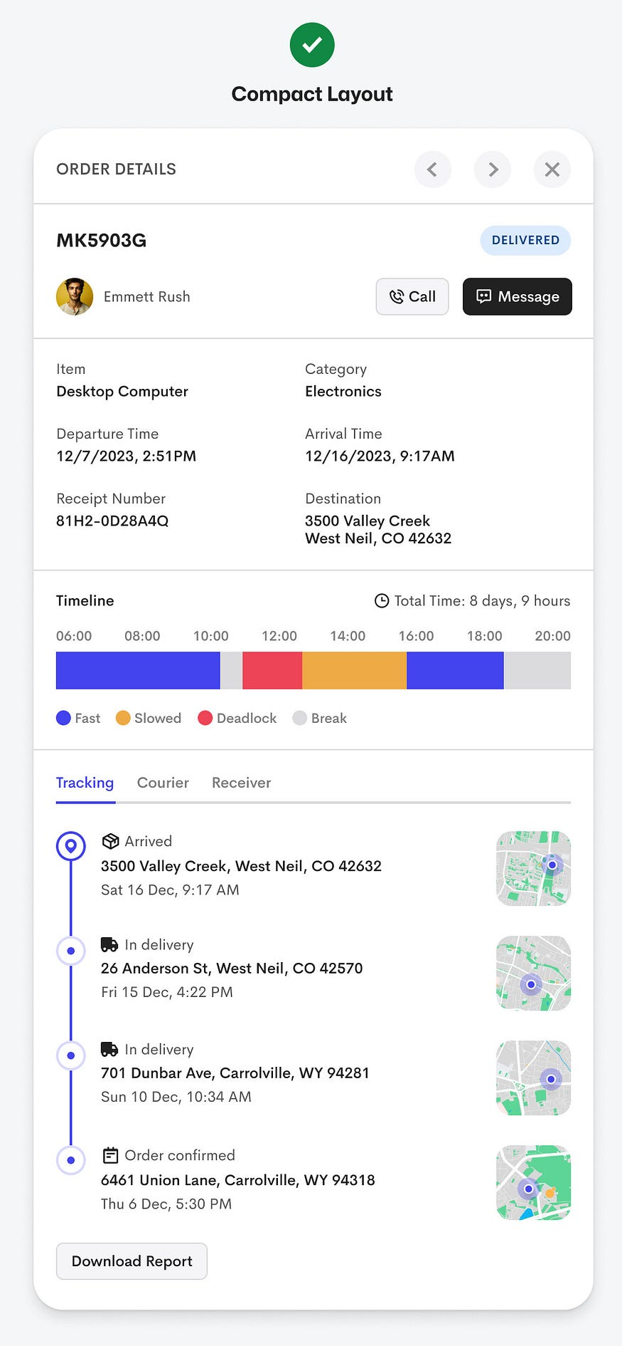
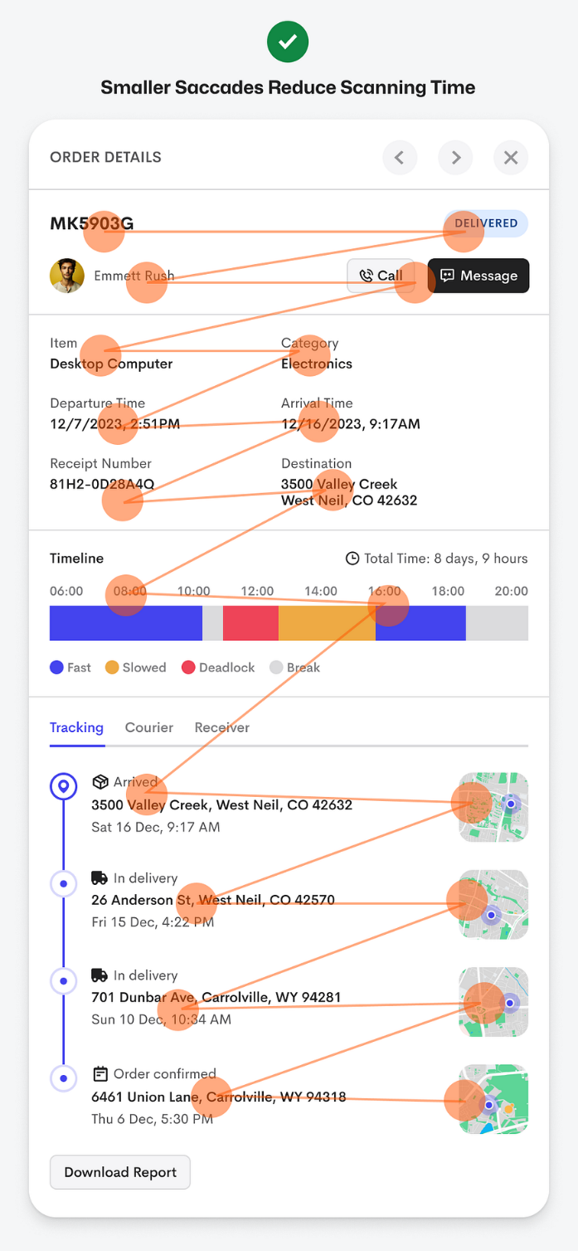
When to Use This Pattern
- When users need to glance quickly at details without losing their place in a list or summary.
- When you want to provide more details but not fully disrupt the flow of browsing.
- In contexts where maintaining the user’s orientation is important (e.g., inside a data-table, list of cases, etc.).
- But be mindful: A slideover might not work if the details are extremely complex or require a full view; sometimes a full page is still valid.
Considerations / When Not to Use
- If the detail content is very long or dense, a slideover might constrain readability.
- If the user needs full screen real estate (e.g., large charts, many fields) then full-page might be better.
- Need to ensure good performance, accessibility, and clear affordances (closing the slideover, navigation back) so the pattern doesn't confuse users.

Best practices - Understand cards vs panels and use semantic HTML. Cards for actions, panels for structure, and always pick the right HTML elements to improve accessibility and maintainability.
Users Complete Forms Faster with Floating Labels – With top-aligned labels, every field requires two fixations: one to the label, one to the input. This doubles the work the user’s eyes must do for each field. With floating labels, the eye uses a single fixation for both the label and the input, reducing friction and enabling a smoother scan.
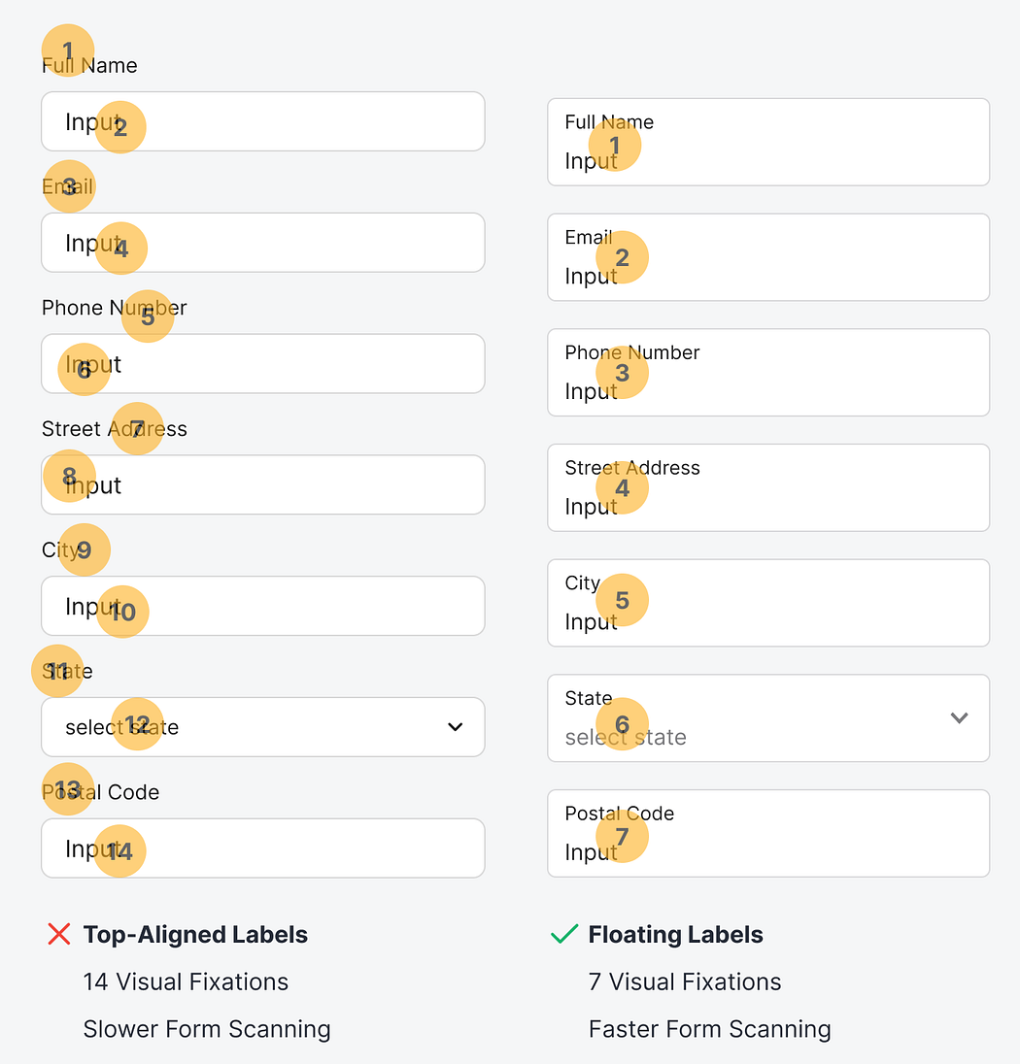
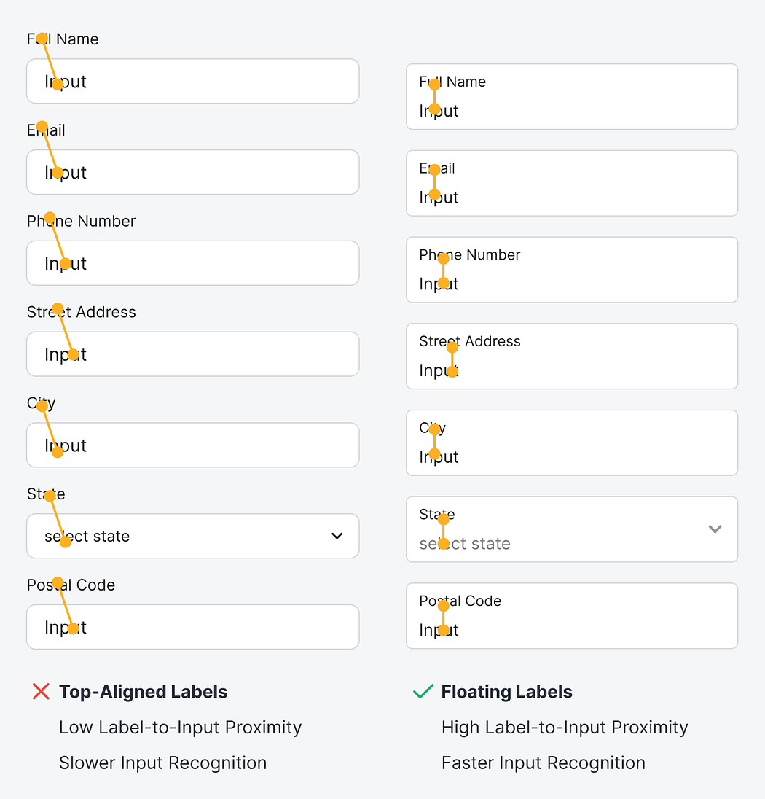
Best practices - The <output> element is intended to represent the result of a calculation or user action. Importantly, when the content (value) of an <output> changes, many screen readers automatically announce the update—without needing extra ARIA tweaks or manual announcements. Using <output> avoids moving focus, avoids interrupting the user’s flow, and reduces the need for extra JavaScript or ARIA workarounds. When you have UI that dynamically updates (e.g. calculators, live results, value changes), consider wrapping the result in an <output> element instead of a generic <div> or <span>. This small change can dramatically improve accessibility for screen reader users, with fewer hacks or extra scripting.

