Microsoft Copilot Foundations
LLMs key features – trained on diverse internet text, books, articles and more. Grasps contexts and nuances in the text inputs, generates text, code, answers, stories and more.
LLMs applications – content generation, language translation, coding assistance, customer support, research aid.
Microsoft copilot ecosystem – the copilot brand includes all of MS’s pre-built AI solutions for both consumers and enterprises.
Microsoft 365 copilot – for productivity, available for MS 365 apps, have access to data like emails, files and documents, meetings, chats, calendars and contacts. It has access to everything we do and data but keep it private. It is also directly available in the MS 365 products itself like outlook, excel, word, PowerPoint, teams, SharePoint etc.
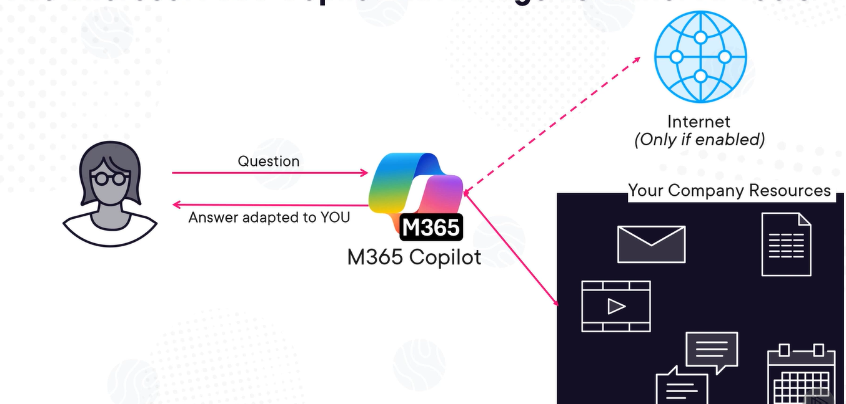
Azure Copilot – we can even ask to optimize our resources for maximum efficiency –
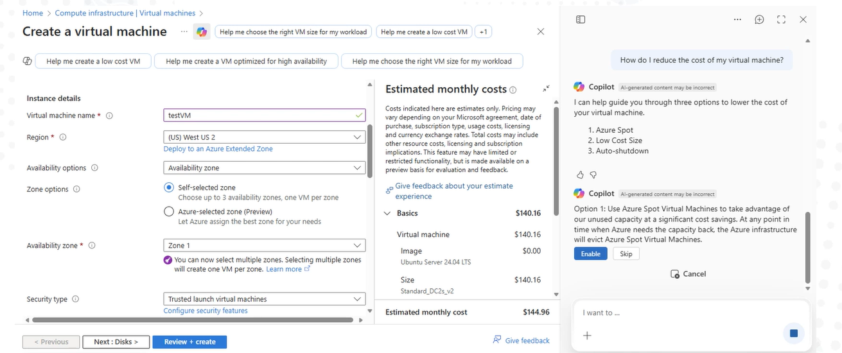
GitHub Copilot – first copilot launched by Microsoft in 2021. It is available on IDE, GitHub Mobile, Windows Terminal Canary, GitHub CLI, and GitHub website.

