User Experience – Best Practices
[Practice 1] Cognitive load: Don’t make users think harder than they need to
- One main action per screen is usually enough.
- Don’t overload users with 12 menu options when 4 will do.
- Hide complexity until it’s needed (advanced settings can stay advanced).
[Practice 2] Hick’s Law: Too many choices = decision paralysis
- Use progressive disclosure (show options gradually).
- Highlight the most common or recommended choices.
- Pre-fill defaults (most users won’t change them anyway).
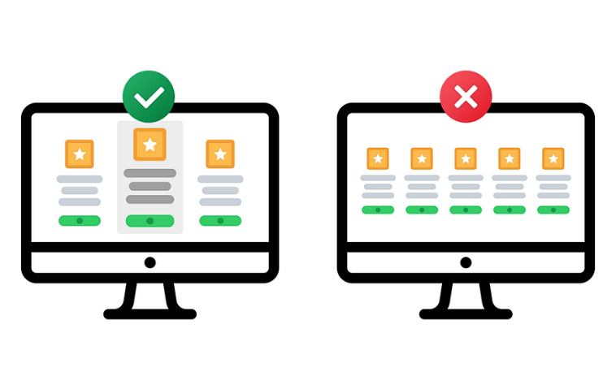
[Practice 3] Fitts’ Law: Make targets easy to hit
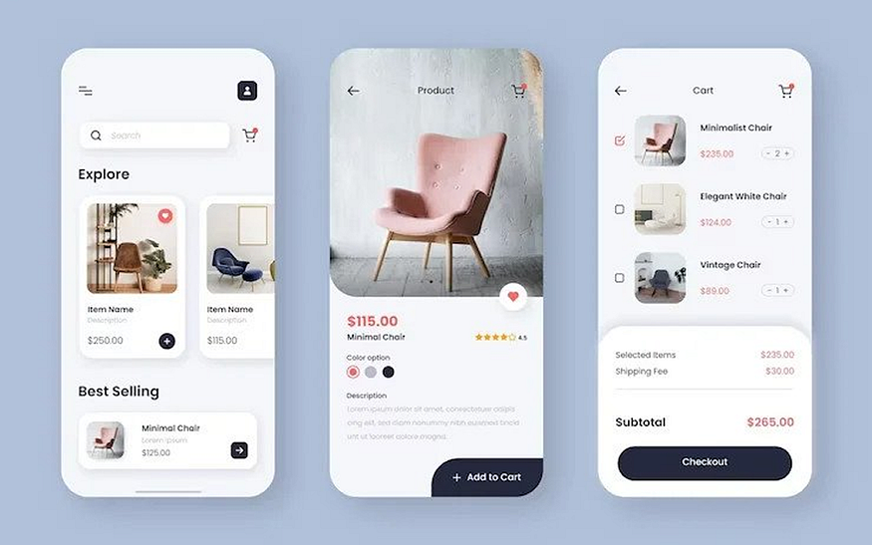
- Touch targets on mobile should be at least 44px (unless you enjoy lawsuits from people with normal-sized thumbs).
- Put primary actions in easy-to-reach “thumb zones.”
- Don’t put destructive actions (“Delete account”) right next to safe ones (“Save changes”).
[Practice 4] Familiarity > originality
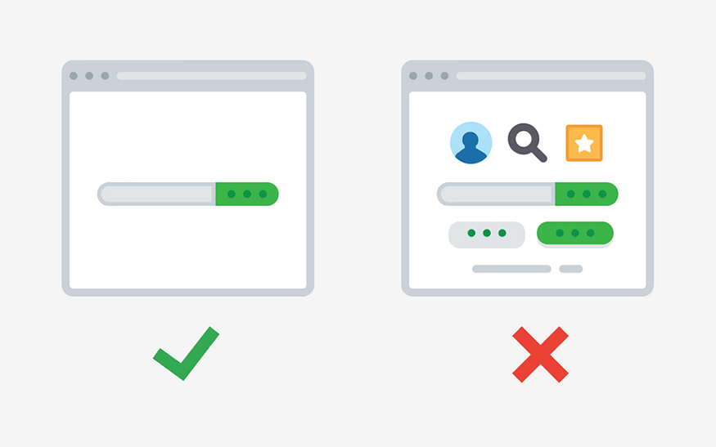
Familiar patterns feel safe. Login forms, navigation bars, checkout flows, they all follow conventions for a reason. Break them, and your users will break up with you.
- Keep common flows standard (sign-up, login, navigation).
- Save your creativity for visuals, animations, and micro interactions.
- Remember: weird = suspicious, familiar = trustworthy.
There’s a reason nobody messes with the order of “email” then “password.” Keep the basics boring and make the extras delightful.
[Practice 5] Don’t disable text selection / copying
The inability to copy text interrupts user workflow and forces hacks (screenshots + OCR) just to read or use content. It “turns text into media,” which is less interactive or manipulable.

UX Best Practice
Don’t block the flow - Keep the main action button (e.g., submit or continue) enabled to allow users to proceed. If there are issues, display clear error messages after submission.
Disabling the button preemptively creates confusion - users won’t know which validation criteria are missing, which increases frustration and cognitive load.
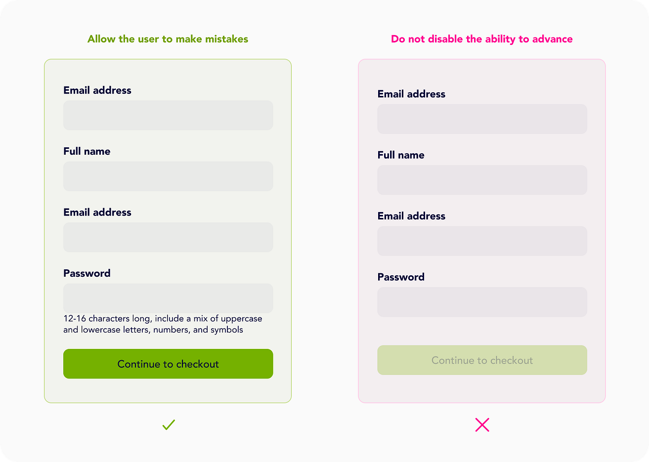

While building, focus on: Component structure and proper separation of concerns, State management (local state, lifting state up, maybe context), Data fetching / asynchronous flows if needed, UI-logic separation and good patterns of design, Handling edge cases and building something you would feel okay showing to others
The Angular CLI now includes an experimental Model Context Protocol (MCP) server. MCP is a standard interface that lets AI tools (in your IDE) interact with local development tools (like CLI) in a structured way. In this case: the CLI exposes project context, scaffolding, documentation, etc, so your AI assistant (or tooling) can “understand” your Angular workspace, instead of just generic code.
D less “churning code” and more thinking, designing, mentoring, system-level decisions. That work requires energy and clarity — which overwork undermines.
AI can code, but it can't build software. Coding is easy, software engineering is hard. Building a production-ready app is not coding, it’s software engineering.
The next wave of front-end innovation lies: beyond “responsive design” or “single-page apps” — into interfaces that understand context and adapt themselves.
The “generative UI” idea could influence your low-code UI framework: imagine letting an AI generate new screen configurations (JSON) based on user intent or prompt.
Integrate with your JSON-config form renderer so it can automatically pre-populate or revise fields.
Outcome:
Demo screen where typing “Apply for a 25-year mortgage of £350k in London” auto-fills loan type, tenure, and city fields.
1. “AI-Driven Form Completion”
Concept from article: Structured completions — AI fills form fields intelligently instead of users typing every detail.
Experiment:

In Angular, create a directive like aiSuggest="loanApplication" that connects a text prompt or uploaded document to your backend.
Spring Boot backend exposes a /suggest-fields API that takes user prompt + context and returns JSON field values.
Integrate with your JSON-config form renderer so it can automatically pre-populate or revise fields.
Outcome:
→ Demo screen where typing “Apply for a 25-year mortgage of £350k in London” auto-fills loan type, tenure, and city fields.
2. “Generative UI from Prompts”
Concept from article: Generative UI — the AI knows your component library and assembles screens dynamically.
Experiment:
Define metadata for all available UI components (textField, dropdown, chart, etc.).
Add an Angular service UiGeneratorService that accepts a natural-language prompt and produces a JSON UI config (e.g. via OpenAI API or Bedrock).
Render that config using your low-code engine.
Outcome:
→ User types “Create a dashboard showing total loans by month and average approval time”, and your app builds it live.
🧪 5. “Explain This Screen” Mode
Concept from article: Transparency & comprehension — users understand what’s on screen.
Experiment:
Add a “?” icon on each Angular page; clicking it calls /ai/explain with the current screen’s JSON config.
Spring Boot backend uses an LLM to summarise purpose, data sources, and key actions.
Outcome:
→ Users (or onboarding testers) can get natural-language explanations like “This page shows active mortgage cases and lets you upload supporting documents.”

UX – Misc.
Users View Details Better with Slide overs
The conventional approach to displaying details is no longer the best option. When users click to view details, you typically display them in a full-page layout. But did you know this full-page layout can slow users down and make information hard to find?
Most designers aren’t aware of this because they’ve followed the same practice forever. However, if you want to help users find information faster, you should opt for a more compact layout to display details.
Viewing details in a compact layout reduces scanning time because of smaller saccades. Users don’t need to move their eyes across the page in broad movements to gather information. A more compact layout brings the data closer together, so the eyes don’t have to do as much work.
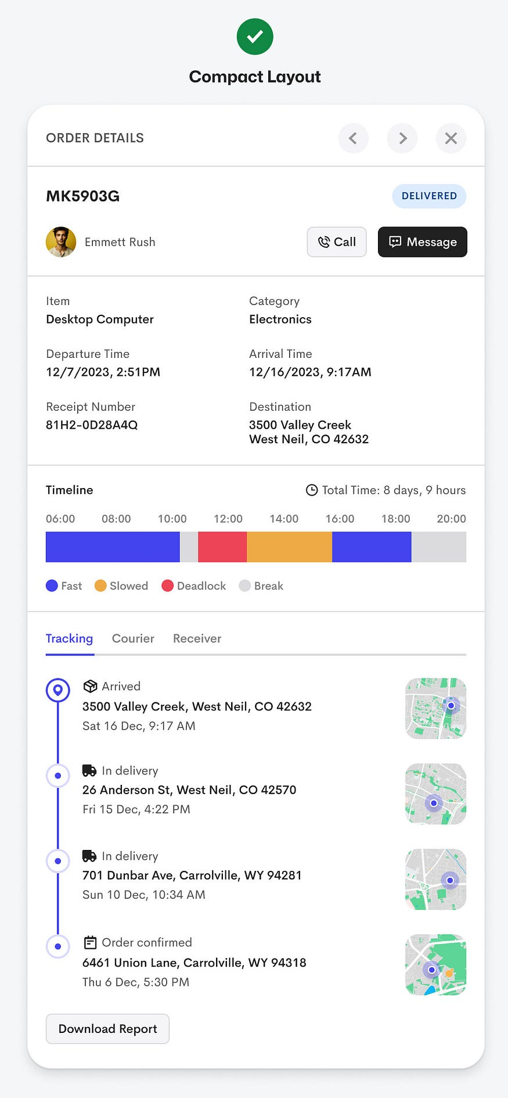
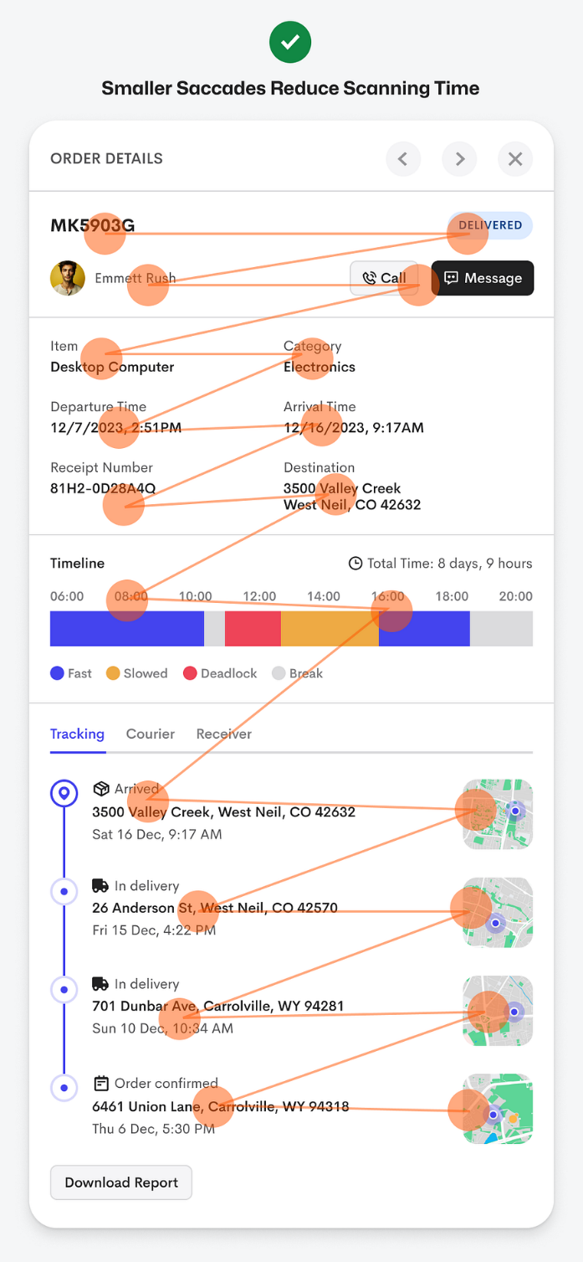
When to Use This Pattern
- When users need to glance quickly at details without losing their place in a list or summary.
- When you want to provide more details but not fully disrupt the flow of browsing.
- In contexts where maintaining the user’s orientation is important (e.g., inside a data-table, list of cases, etc.).
- But be mindful: A slideover might not work if the details are extremely complex or require a full view; sometimes a full page is still valid.
Considerations / When Not to Use
- If the detail content is very long or dense, a slideover might constrain readability.
- If the user needs full screen real estate (e.g., large charts, many fields) then full-page might be better.
- Need to ensure good performance, accessibility, and clear affordances (closing the slideover, navigation back) so the pattern doesn't confuse users.

Best practices - Understand cards vs panels and use semantic HTML. Cards for actions, panels for structure, and always pick the right HTML elements to improve accessibility and maintainability.
Users Complete Forms Faster with Floating Labels – With top-aligned labels, every field requires two fixations: one to the label, one to the input. This doubles the work the user’s eyes must do for each field. With floating labels, the eye uses a single fixation for both the label and the input, reducing friction and enabling a smoother scan.
