System Design
As projects grow, it gets harder to keep everything looking consistent, a design system solves this by giving use one source for reusable components.

Designing YouTube
Direct upload to blob storage –
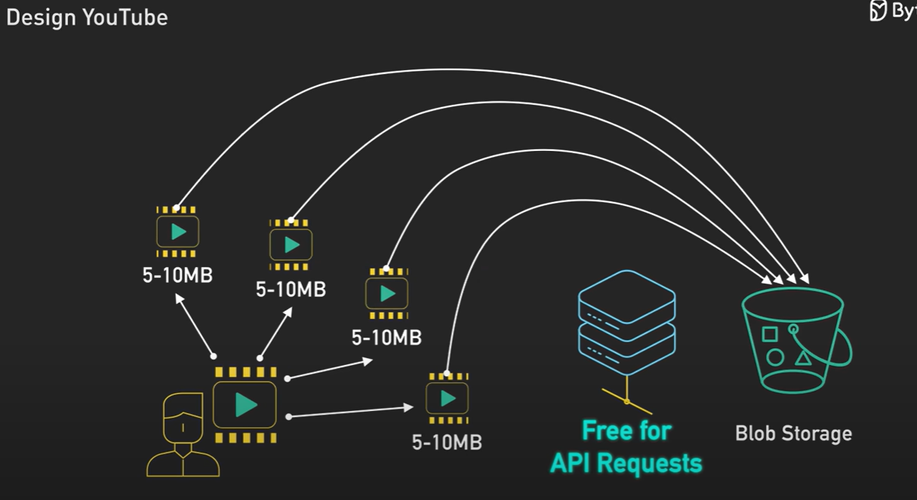
Using Parallel workflow instead of sequential –
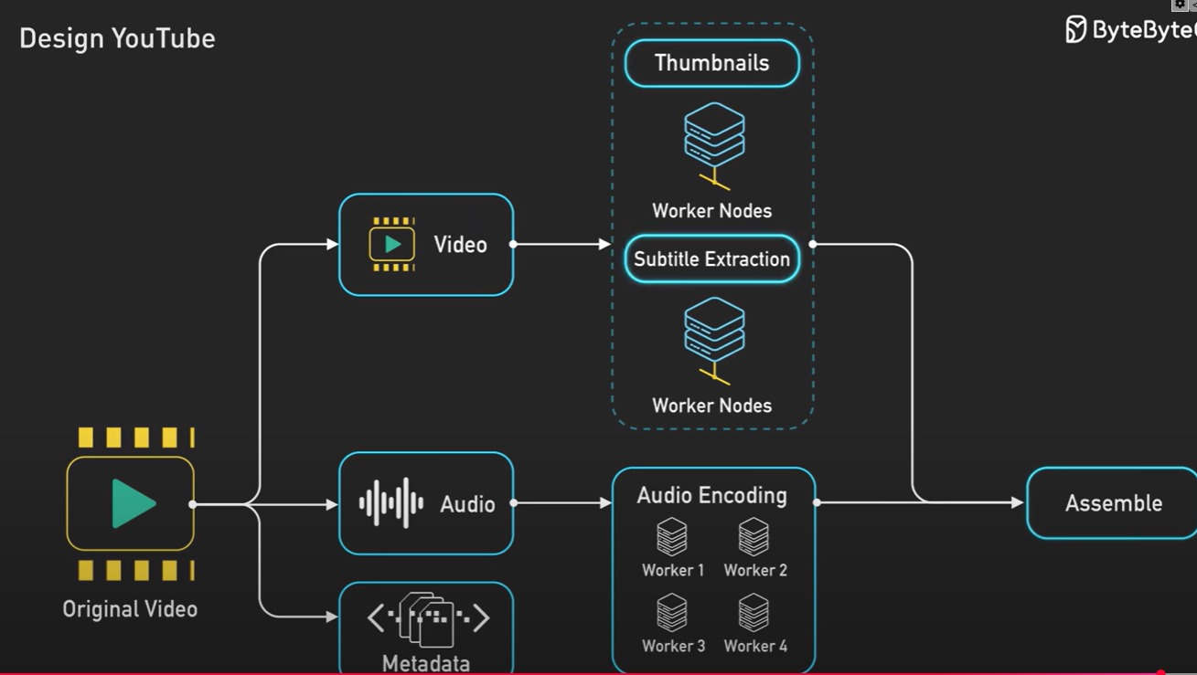
Adaptive streaming for smooth playback –
