Misc.
WordPress is an open-source, free platform for building and developing websites. WordPress is the most user-friendly and efficient blogging and website builder on the market right now.
WordPress is utilized by 43.2% of all websites live on the internet in the current year, 2022. This is an increase from 39.5 in 2021.
WordPress.com, primarily, is a managed host, while WordPress.org is not a host. In essence, WordPress.org allows you to host your website. In contrast, WordPress.com handles everything for you.
Anonymous comments can cause serious damage to your website’s reputation. To prevent individuals from submitting anonymous comments, choose the option “Comment author must fill out name and e-mail.”
WWW or no WWW – whether your website is brand-new or has been hosted for a few months already will depend entirely on its stage. If it brand-new, you must definitely choose whether to use www or non-www in the URL of your site.
Folks learning to code has increased by 60 to 70 % year-on-year.
Tor browser – once the user places the request for information in the browser, then a new node or Tor server is created at random by the browser.
It is a computer graphics program to create intricate layouts, patterns and drawings. Capabilities – freehand drawings, colour palettes, fillings shapes, geometric objects, digital artwork, promotional or branded content, icons, website images.
One of the top platforms now on the market is Adobe Illustrator.
According to the Stack Overflow Survey 2022, there has been a 60 to 70% year on year increase in the number of students who want to learn coding online.
JavaScript was originally called Live Script, Netscape changed its name to JavaScript, and it is believed that this was because of the hype of Java within the industry.
Fastify provides a faster alternative for Express.js.
Python is an interpreted, general-purpose high-level programming language that is mainly used for automation, website development and data analytics. Python is managed by the Python Software Foundation.
When compared to compiled languages like C and C++, the python code is generally short, however, it executes programs slower.
Low-code no-code (LCNC)
HTML was invented by Tim Berners-Lee in 1993. Modern HTML codebases are now shorter than what they used to be. A huge number of interactive and design elements that programmers rely on to code manually can now be handled with the help of CSS or JS.
HTML can interact with our OS and not just the browser, features like easy to drag files onto a webpage so that we can upload them or made a video display on full-screen.
CSS was established in October 1994 by Hakon Wium Lie, who was a Norwegian web pioneer. Lie was sick of the lack of styling options that were available to developers.
By using Spring, JSF, Hibernate, Struts and Apache Hadoop, we can develop web-based programmes in Java. It is also a official programming language for Android development.
SQL – Structured Query Language.
NoSQL was created to function as a support system for SQL, not as its replacement. The language is based on a model that is considered to be fairly less stringent.
The term # in C# is derived from the musical sharp key. This symbol is used to denote a one semitone increase in pitch. C# is known for improving and updating many C and C++ feature.
Rust is often labelled as an alternative to traditional C++. Rust prevents memory leaks, which means there would be fewer errors in the work. As Rust is also considered a rather low-level language, it really comes in handy when developers need to get more gains more out of the minimal resources they have.
In contrast to this logic, high-level dynamically typed languages (form instance, Python and JavaScript) are considered to be better for tasks related to quick prototypes.
Perl (Practice extraction and report language) – one of the most common uses when it comes to Perl is executing text file information as well as generating a report or other output format. This is an interpretive language as opposed to a compile language. Now most uncompiled programs need a lot more CPU run time. This language was initially created only for text handling and system management. Currently, this language is known for its capabilities regarding handling Regex.
Go – developed very much in the same way as Algol or C. The defining feature of Go is concurrency means many different processes can easily be executed simultaneously. The main goal of this experiment was to address some of common criticisms pertaining to other programming language while also making sure that the still retain their most useful features.
Many different languages have similar structures and patterns. We need to get out of the mindset of believing that certain coding languages are better than others.
A great way to understand more about the world of coding is by looking at the work done by developers before you.
Some of the top websites that often open source projects include – gihub explore, code triage, open source Friday, source sort, first timers only, first contributions, up for grabs, 24 pull requests.
We should not create any features of functionality when we are carrying out the refactoring process.
Browse daily and get new information – code chef, code wars, coding game, geektastic, hacker rank, leet code, project euler, spoj, top coder, exercism.io, codebyte.
If we find a person with a rare intellect, we should ask him about the books he reads. Without good reading and comprehension skills, a person takes more time to understand the problems before solving it. Books that every programmer must read once – the mythical man month by Frederick brooks, the pragmatic programmer: your journey to mastery, code complete 2 by steve mcconnell, the art of computer programming, programming pearls, code: Charles petzold, introduction to algorithms, refactoring: improving the design of existing code, design patterns: elements of reusable object-oriented software.
How product companies handle production downtime - They use website like ManageEngine.com.
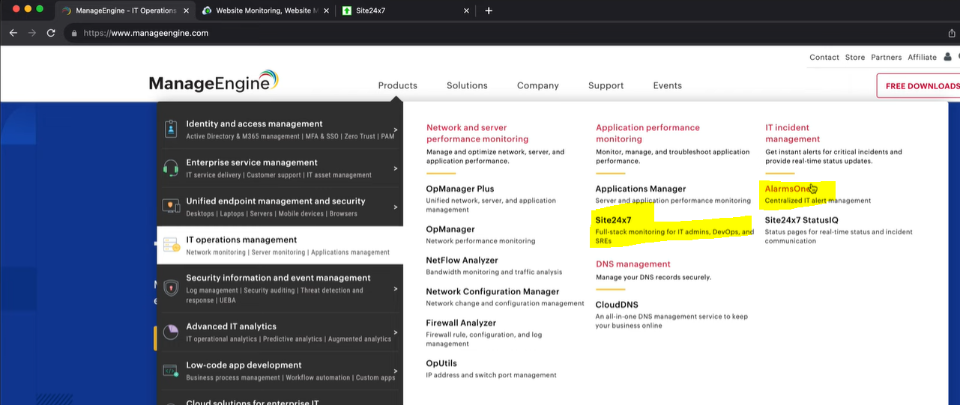
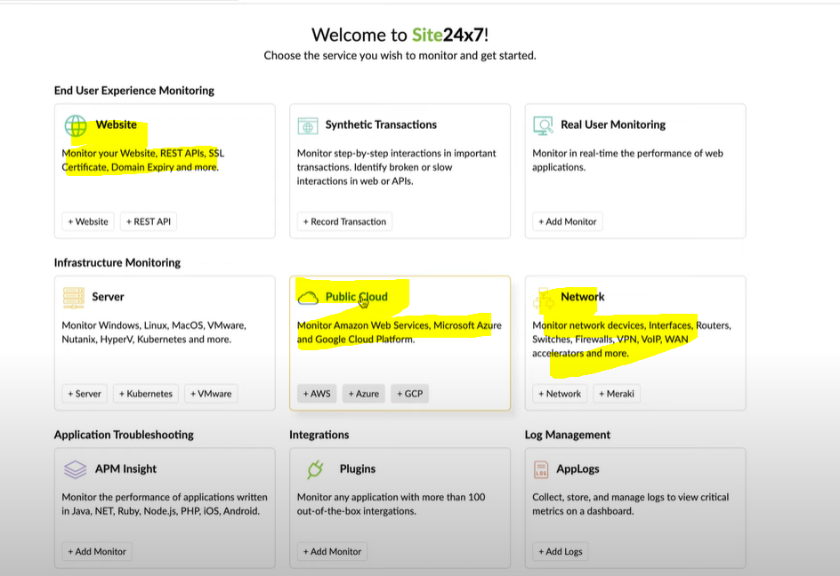
Android App Development - An app that seamlessly transitions between folded and unfolded states is essential for user satisfaction. Smartphone design moving away from traditional, rigid form factor to a more flexible and adaptable one. Two types – book-style and claimshell-style.
These devices, which can switch between a phone and table-like format, are a promising frontier for developers and designers alike. Users expect between different screen sizes and orientations.
Challenges include handling multiple screen ratios, dealing with screen continuity, and ensuring a seamless transition between folded and unfolded states.
Programming Pearls
- The programs use a terse coding style: short variable names, few blank lines, and little or no error checking.
- A merge sort program reads the file once from the input, sorts it with the aid of work files that are read and written many times, and then writes it once.
- Careful analysis of a small problem can sometimes yield tremendous practice benefits.
- A designer knows he has arrived at perfection not when there is no longer anything to add, but when there is no longer anything to take away. Simple programs are usually more reliable, secure, robust and efficient than their complex cousins, and easier to build and to maintain.
- Good programmers are a little bit lazy: they sit back and wait for an insight rather than rushing forward with their first idea.
- Coding skill is just one small part of writing correct programs. The majority of the task is the subject of the tree previous columns: problem definition, algorithm design, and data structure selection. If we perform those tasks well, writing correct code is usually easy.
- The first binary search was published in 1946, the first published binary search without bugs did not appear until 1962.
- If run time doesn’t matter, linear search is much simpler than binary search; many programmers can get it right on the first try. Because run time is important enough for us to introduce the additional complexity of binary search, we should conduct experiments to ensure that is performance is what we expect.
- Rick Lemons said that the best lessor he ever had in debugging was watching a magic show. The magician did a half-dozen impossible tricks, and Lemons found himself tempted to believe them.
- Inefficient programs sadden their users with longs waits and missed opportunities.
- Everything should be made as simple as possible, but no simpler.
- Premature optimization is the root of much programming evil, it can compromise the correctness, functionality and maintainability of programs.
- Insertion sort is the method most car players use to sort their cards. Insertion sort is simple to code and may be fast enough for small sorting jobs. For large numbers, run time of Quicksort is crucial.
- One part of a programmer’s job is solving today’s problem. Another, and perhaps more important, part of the job is to prepare for solving tomorrow’s problems.
- Heapsort never takes more than O(n log n) time to sort and n-element array, and uses just a few words of extra space. The fasters Heapsort is usually slower than the simple Quicksort.
- Make it work first before you make it work fast.
- Sorting works well for finding the mode, but hashing can be faster.
HTTP crash course - URL, URI and URN are almost same to get the location address.
Types of headers – X-prefix for headers has been deprecated.
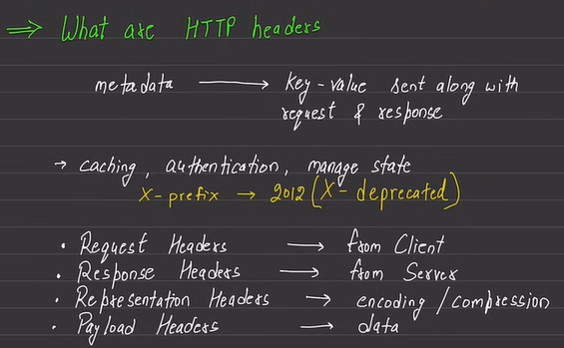
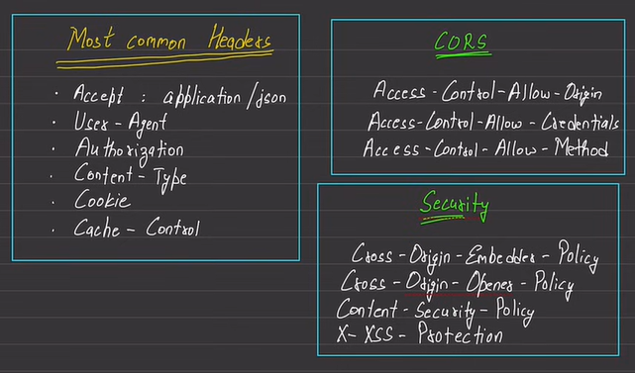
We also have methods like HEAD, TRACE. TRACE is useful to have debugging in case of multiple proxies in-between the communication.
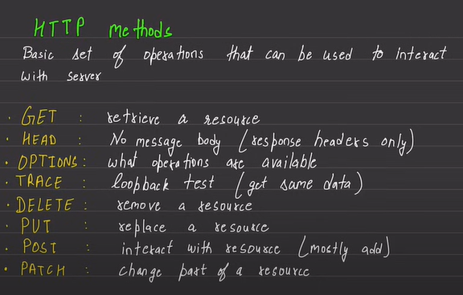
Useful status code –
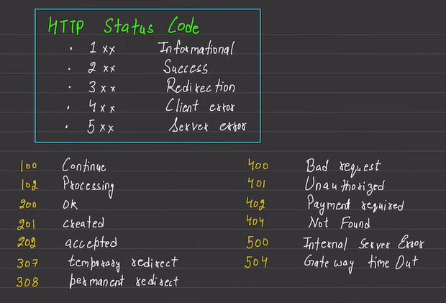
Reverse Proxy – Nginx and caddy are example of reverse proxy servers.
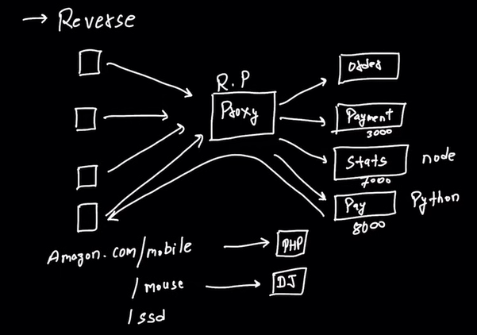
Assistive technology refers to any device, software or system that is designed to support individuals with disabilities and improve their functional capabilities. Examples – wheelchairs, speech recognition software, and adapted keyboards.
Adaptive technology, on the other hand, refers to technology that has been modified of an individual with a disability. For example, adaptive mouse might be modified to accommodate the needs of an individual with limited dexterity.

