Example of “inclusion” property for steering files –
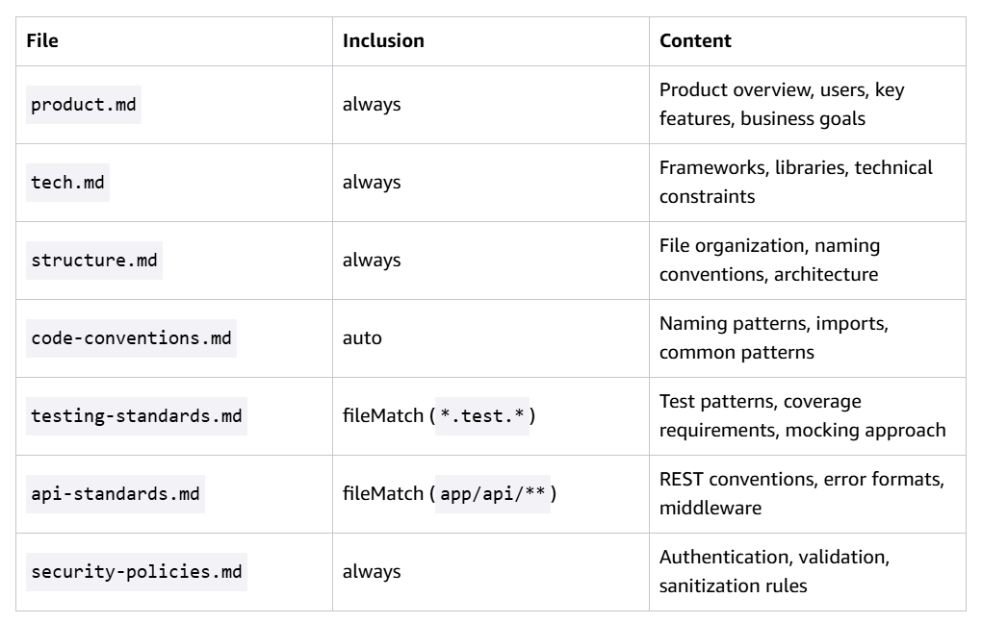
Candidates for Global steering files –
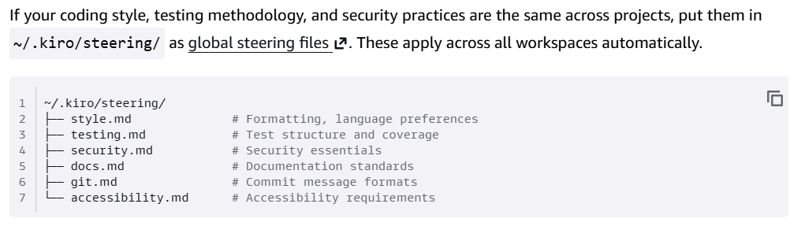
Optimization checklist –
