System Design
Building high-availability systems –
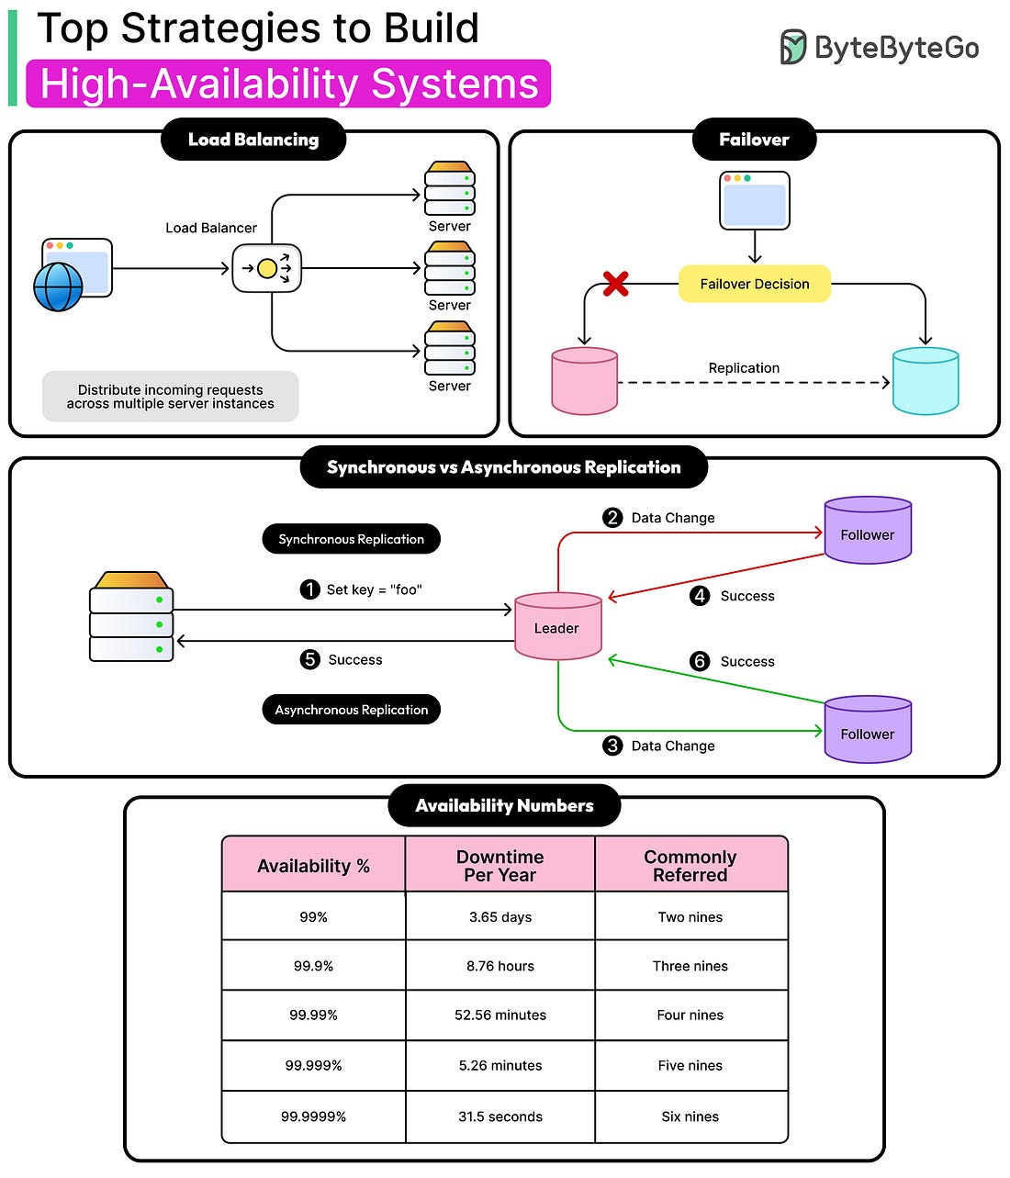
Service Mesh Architecture –
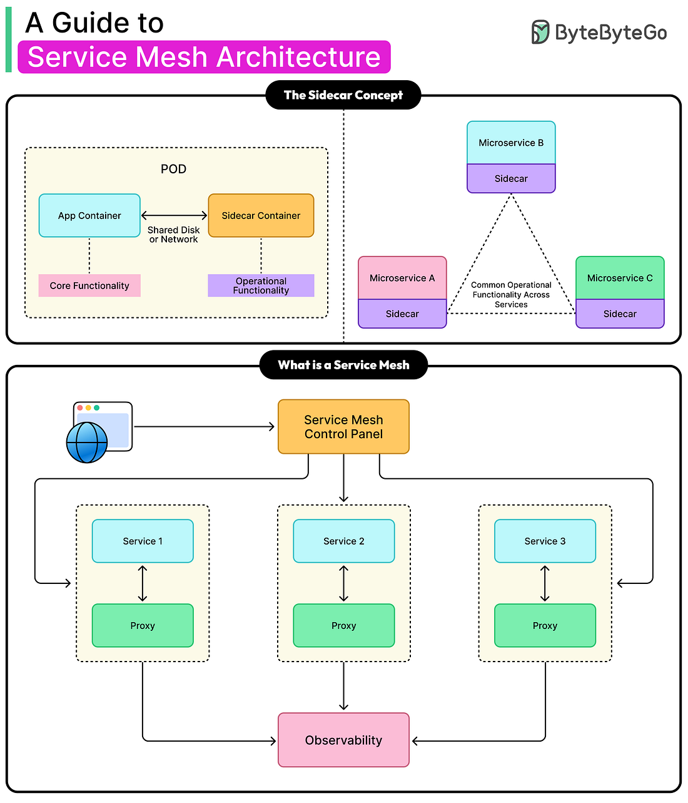
Write ahead log - Write-Ahead Log is a simple but powerful idea. It is a system that keeps a record of every change made to data before those changes are applied to the actual database. You can think of it like keeping a journal of all the actions you plan to take. Even if something goes wrong during the process, you still have that journal to remind you exactly what you were doing, so you can pick up right where you left off.
In practical terms, when an application wants to update or delete information in a database, it first writes that intention to the WAL. Only after the entry has been safely recorded does the database proceed with the operation. This means that if a server crashes or a network connection drops, Netflix can replay the operations from the WAL and restore everything to the correct state. Nothing is lost, and the data remains consistent across systems.
The WAL provides several key benefits that make Netflix’s data platform more resilient:
- Durability: Every change is logged first, so even if a database goes offline, no data is permanently lost.
- Retry and Delay Support: If a message fails to process due to an outage or network issue, the WAL can automatically retry it later, with custom delays.
- Cross-Region Replication: Data can be copied across regions, ensuring the same information exists in multiple data centers for disaster recovery.
- Multi-Partition Consistency: For complex updates involving multiple tables or partitions, WAL ensures that all changes are coordinated and eventually consistent.
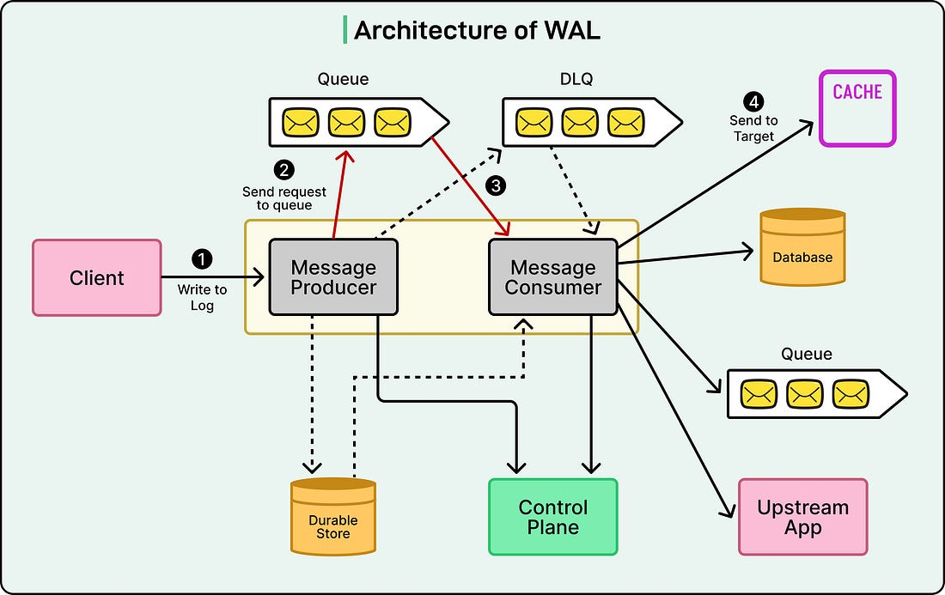

UX
7 Anti-Overthinking Design Rules
• The 5-Second Test (Clarity is King) — If someone can’t tell what the screen/page is about in the first 5 seconds, the design is failing. There should be one clear, primary action or purpose (e.g. “Sign Up”, “Order Now”, “Read Article”) and it should be obvious. Medium
• The Thumb Test (Mobile-First Movement) — On mobile devices, important buttons or interactive elements should be placed where thumbs naturally reach (bottom-middle area), so users can tap easily. Secondary or rare actions can be in harder-to-reach areas. Medium
• Consistency Over Creativity — Once you pick a style (buttons, colors, icons, typography), stick with it across the design. Changing styles arbitrarily adds confusion and erodes usability. Medium
• Group Related Items (Visual Clutter Buster) — Related items (form fields, info, controls) should be visually grouped so that the structure is logical and clear. Use proximity and whitespace to separate distinct groups. Medium
• Prioritize the Scan (No One Reads Anymore) — Most users skim content instead of reading everything. Use headings, bold text, bullets, short paragraphs — make the important info easy to grasp at a glance. Medium
• The “Undo” Safety Net (Permission to Mess Up) — Don’t make user actions feel final/permanent without a way back. Provide undo buttons or confirmations for destructive actions to reduce fear and friction. Medium
• “Steal Like an Artist” (Leverage Familiarity) — Rather than inventing new UI patterns, use established conventions (e.g. a magnifying glass for search, a heart or star for “favorite/like”, a hamburger icon for menu) so users instantly know how to interact.

HTML
The “Essential 7” Meta/HTML Tags
According to Gunter, these are the only tags you really need to include: Medium
- <title> tag — sets the page title, which appears as the clickable headline in search results and in browser tabs. Crucial for giving your page a clear identity. Medium+2Search Engine Journal+2
- <meta name="description"> — provides a short summary of the page. Search engines may display this as the snippet under your title in results, influencing click-throughs (though not directly ranking). Medium+2Search Engine Journal+2
- Character encoding (e.g. <meta charset="utf-8">) / Content-Type meta tag — ensures correct text encoding so the content displays properly, which is also important for indexing and accessibility. Google for Developers+2Wikipedia+2
- Viewport meta tag — helps control how the page renders on mobile devices, making the site responsive and mobile-friendly — a key factor now that many users browse on mobile. Google for Developers+1
- Robots / crawl-control meta tag (e.g. <meta name="robots" content="noindex, nofollow">) — lets you instruct search engines whether to index the page or follow links. Useful when you want to hide certain pages from search or prevent crawl of irrelevant/duplicate content. Google for Developers+1
- Tags for accessibility or SEO-relevant metadata (depending on context) — though the article doesn’t list all 7 explicitly in the opening section, the point is that proper metadata and minimal but correct tags already cover most SEO + accessibility needs. Medium+1
- Avoid unnecessary / outdated tags — rather than adding lots of meta tags (some of which are ignored by search engines), it's better to stick to the essentials. Gunter’s thesis is that more isn’t always better: correctness and clarity matter more.

