Python is becoming famous because for simplicity and readability.
Timeline of major python version releases –
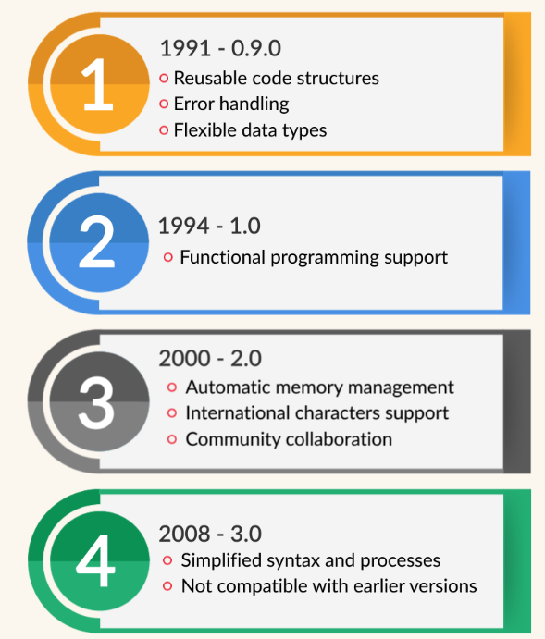
Google Colab (short for Colaboratory) is a free, cloud-based platform that allows you to write and execute Python code directly in your browser. It is essentially a hosted Jupyter Notebook environment provided by Google Research that requires no setup on your local machine.
Python use interpreter named as CPython.

