Visual Communication: Creating Engaging and Effective Technical Diagrams
Common tools used to create diagrams – Miro, Figma, diagrams.net, Microsoft Visio, lucid chart, smart draw, OmniGraffle, Microsoft PowerPoint.
Three common diagram types – structural, behavioral, interaction –
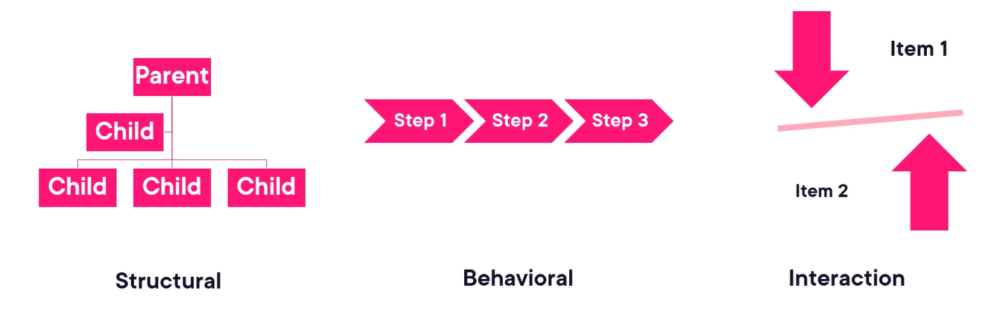
Common nodes in diagram –
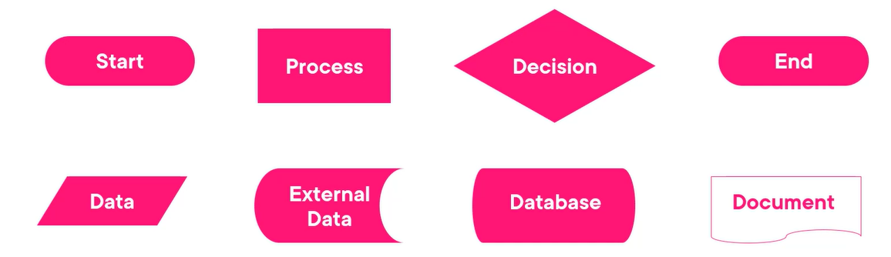
Common connectors in diagram –
