TanStack Router Foundations
It is a set of tools created by Tanner Linsley. TanStack Router is one of those tools, it is distributed individually instead of as one complete framework.
Query string problem – ambiguous states –
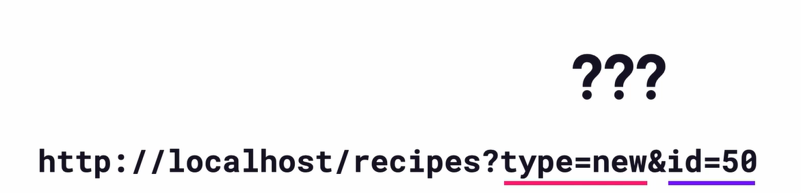
It is better to organize with URL-based rules –
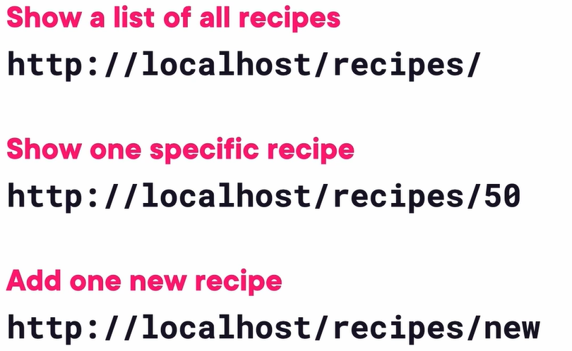
Router does a simple thing – Read a URL + Parse the path + Decide what to display.
In TanStack, CreateRouter creates the actual router object, RouterProvider is a component that connects that router to React. The CreateRootRoute is the top-level route and layout for the single page application.
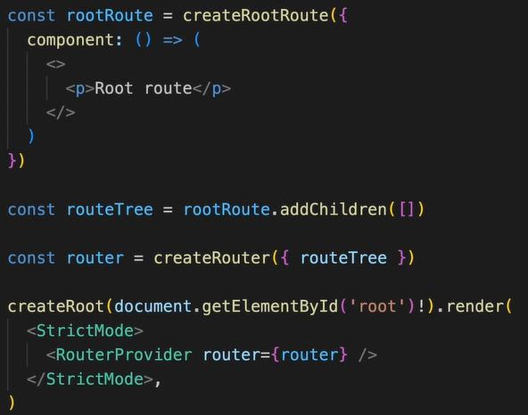
It supports code-based and file-based routing.
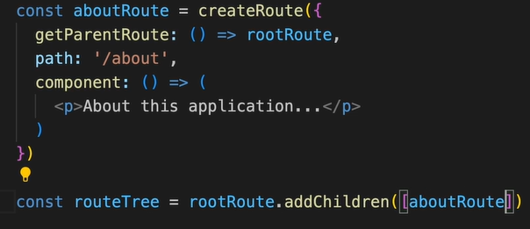
This children root will get render in the place Outlet below –
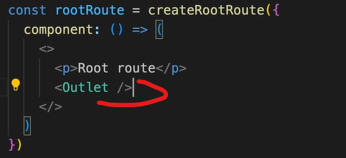
Loaders – to an async function before a route renders like to load the data the components need to access and display.
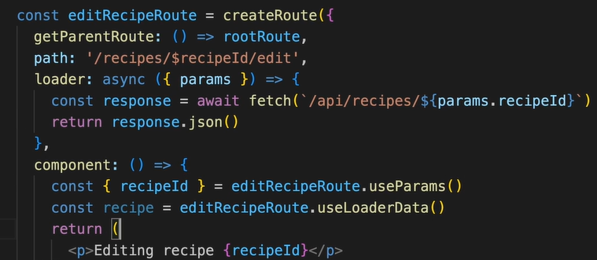
Loaders rerun when their route becomes active or when relevant params or search values change and TanStack router caches loader results based on the route state.
It also provides two lifecycle hooks – pendingComponent and errorComponent.
When to use path vs. search params – path params determine which components load, search params determine how data looks in an already loaded component.
When we add nested child route to another child route, we should use below approach. With this approach if data or state changes in the nested child route then only that route data will change, not its parent or siblings.
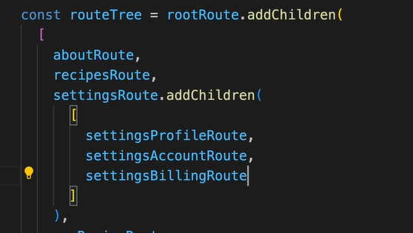
When to use child vs. sibling routes –
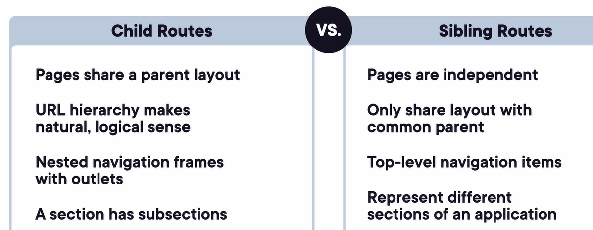
File-based Routing – it is recommended to use this type of routing as it avoids configuring so many manual wirings of routes in codes. By this approach the Route tree is generated at build time from a Vite plugin and imported a run time. We also might need to use the concept of pathless routes in it.
There is another library tanstack query which helps with data fetching and server-state management, tanstack table to show grid-based data.

