CAP776: PROGRAMMING IN PYTHON
MINOR PROJECT #1 REPORT
MY DATA, MY STORY
Personal Activity Intelligence Report

Student Details | Info
Student Name | Himanshu Gupta
Registration / Roll No. | 12602516
Program / Section | MCA / D1P2635
Activity Recording Period | 17 August 2026 to 21 September 2026
Date of Report Generation | 27 September 2026

1. Activity Data Summary
Particular | Value
Expected number of days | 36
Valid days recorded | 34 (19 August to 21 September)
Missing days | 2 (17 and 18 August)
Invalid / excluded records | 0 invalid
Average Sleep/day | 394.12 min/day
Average Fitness/day | 45.29 min/day
Average Study/day | 148.24 min/day
Average Coding/day | 109.41 min/day
Average Class/day | 170.59 min/day
Average Other Activities/day | 110.00 min/day
Average Free / Unaccounted Time/day | 462.35 min/day

2. Index Values
These values use 34 valid days from 17 August to 21 September 2026, using the start date specified by the teacher. PAI follows the weights in this report template, including 0.05 for DCI. Calculations retain full precision until the final values are displayed.
Index Name | Acronym | Formula | Value to Enter
Personal Activity Index | PAI | PAI = 0.15(TPI) + 0.20(AAI) + 0.15(PhAI) + 0.20(SRI) + 0.15(TUI) + 0.10(EI) + 0.05(DCI) | 317.48
Tech Productivity | TPI | TPI = Average(Coding Time per valid recorded day) | 109.41 min/day
Academic Activity | AAI | AAI = Average(Study Time + Class Time per valid recorded day) | 318.82 min/day
Physical Activity | PhAI | PhAI = Average(Fitness Time per valid recorded day) | 45.29 min/day
Sleep & Recovery | SRI | SRI = Average(Sleep Time per valid recorded day) | 394.12 min/day
Activity Balance | ABI | ABI = Average(Free / Unaccounted Time per valid recorded day) | 462.35 min/day
Time Utilization | TUI | TUI = Average(Total Tracked Time per valid recorded day) | 977.65 min/day
Experience Index | EI | EI = Average of daily (Feeling Score + Satisfaction Score + Energy Score) / 3 | 3.20 / 5
Data Continuity Index | DCI | DCI = (Valid Recorded Days / Expected Days) × 100 | 94.44 %
Feeling and satisfaction use the prescribed 5/4/3/2/1 scores; energy uses 3/2/1. EI is their mean, without rescaling energy. The template labels EI out of 5, although its maximum with these scores is 4.33. DCI = 34/36 x 100 = 94.44%. PAI is a weighted index, not a percentage.

3. Key Findings from My Data
No. | Correlation/Observation | Evidence from my data
1 | Sleep ↔ Energy | Positive r = 0.473. Sleep averaged 430 min on 8 high-energy days and 348 min on 5 low-energy days.
2 | Study ↔ Satisfaction | Positive r = 0.513. Study averaged 226.67 min on 6 very satisfied days and 139.17 min on 12 neutral days.
3 | Coding ↔ Energy | Positive r = 0.518. Coding averaged 165 min on 8 high-energy days and 74 min on 5 low-energy days.
4 | Fitness consistency | 12 of 34 days recorded 0 fitness minutes, despite an overall average of 45.29 min/day.
5 | Recording and free time | 34 of 36 expected days were recorded (94.44%). Free or unaccounted time averaged 462.35 min/day; this is not necessarily wasted time.
Pearson r uses all 34 days and the prescribed scores. These associations do not prove causation.

4. Findings About Myself (100–200 words)
My recorded days show that studies and classes took 318.82 minutes per day, while coding took 109.41 minutes. I spent more time coding on high-energy days, but these records cannot show which came first. My average sleep was 394.12 minutes, about 6 hours 34 minutes. On 19 of the 34 days, I slept less than seven hours. Fitness averaged 45.29 minutes, although 12 days had no recorded fitness activity. This makes my routine less consistent than the average alone suggests. I also left 462.35 minutes per day free or unaccounted for; the log does not tell me how all of that time was spent. On 21 September, I noted an SSD problem and reported feeling stressed. My experience therefore depended on circumstances as well as activity time.

5. Areas and Ways to Improve My Lifestyle (100–200 words)
I would first work on a more regular sleep routine because my recorded sleep averaged about 6 hours 34 minutes. I plan to finish evening work earlier and keep a consistent bedtime. Since 12 days had no fitness entry, a short walk on busy days would make my routine more regular. For study and coding, I would use short daily sessions instead of relying on a few long project days. I would also describe meals, travel and breaks more clearly so that unaccounted time becomes easier to understand. A reminder before bed would help me record each day. Keeping a local backup of my work would reduce disruption from another laptop problem. I would review the next two weeks of entries to see whether these changes helped.

6. Student Declaration
I confirm that the values entered in this report have been generated from my submitted activity data using my Python program and that the report represents my own analysis.
Student Name | Signature | Date
Himanshu Gupta | 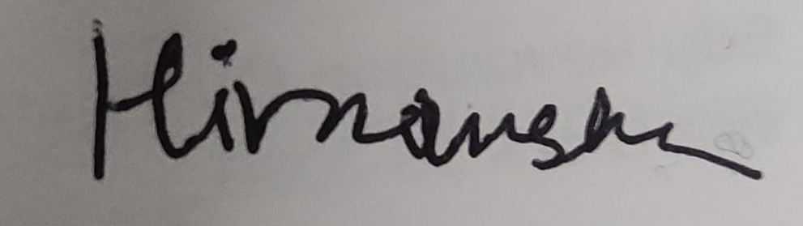 | 28-09-2026

