

**AI/ML Programming**

**MCA-475**

**CIA – 01**

***BY***

**Himanshu Heda (24225013)**

**SUBMITTED TO**

**Dr. Manjula Shannhog**

**SCHOOL OF SCIENCES**

**2024-25**

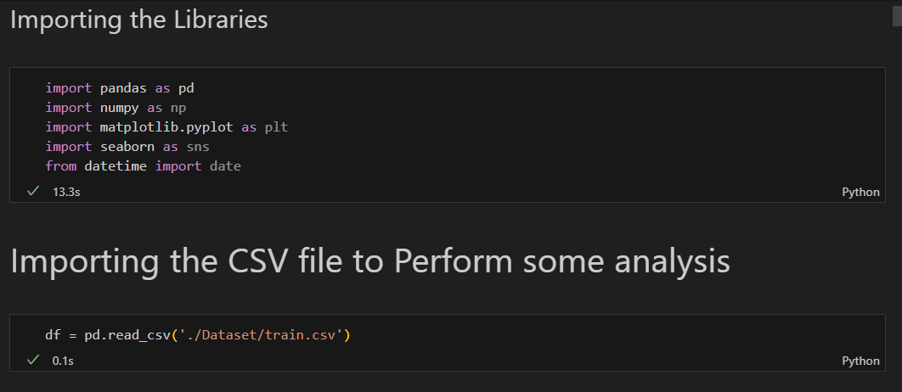

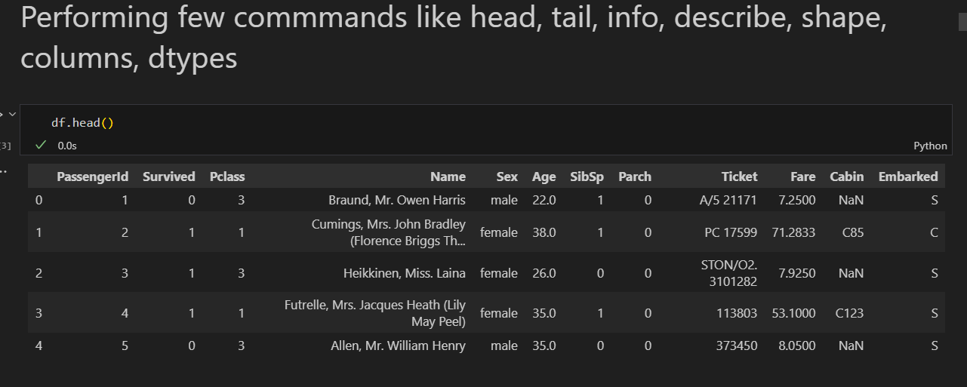

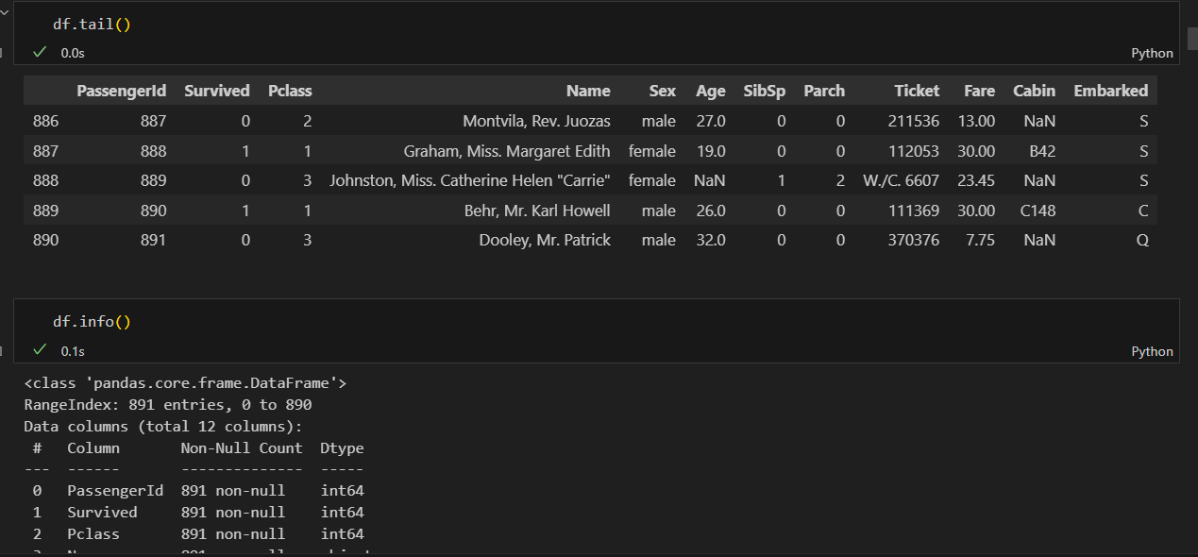

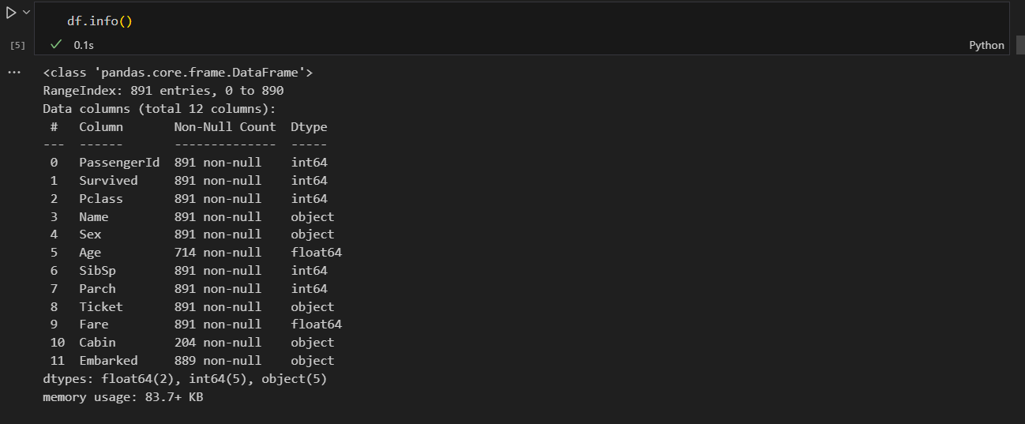

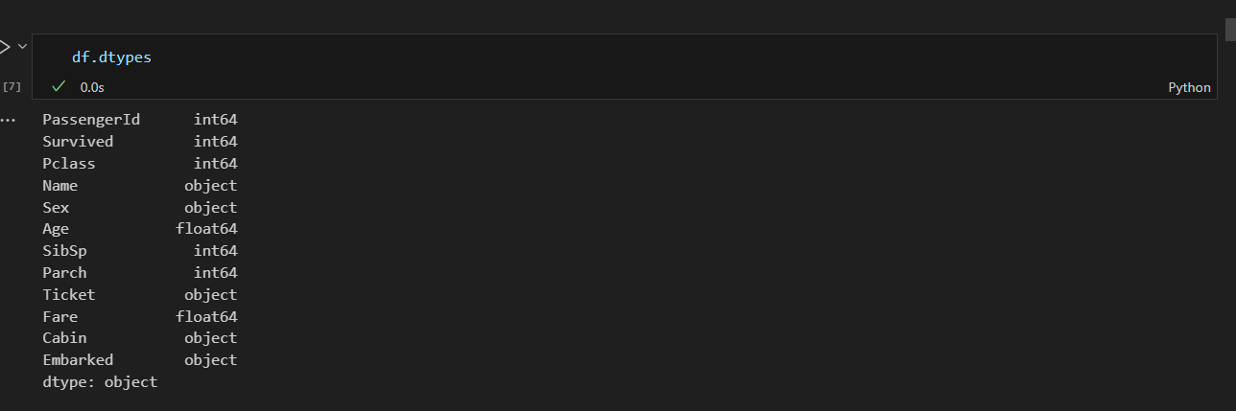

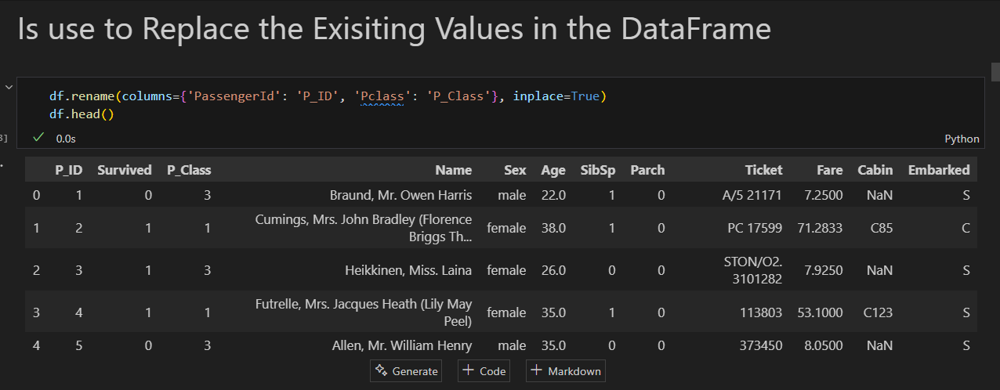

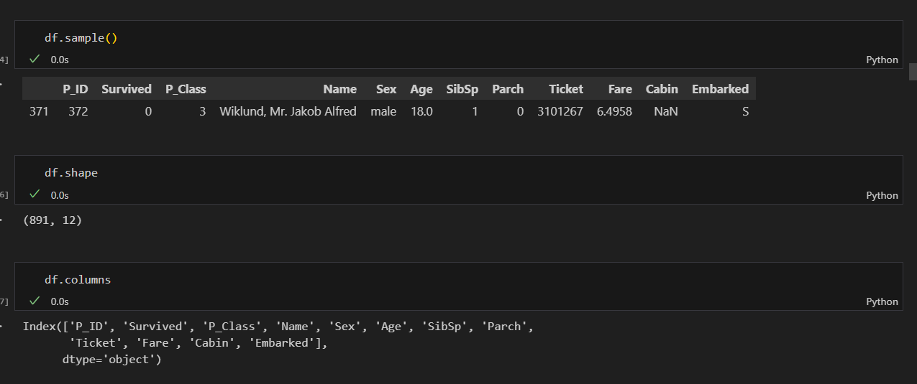

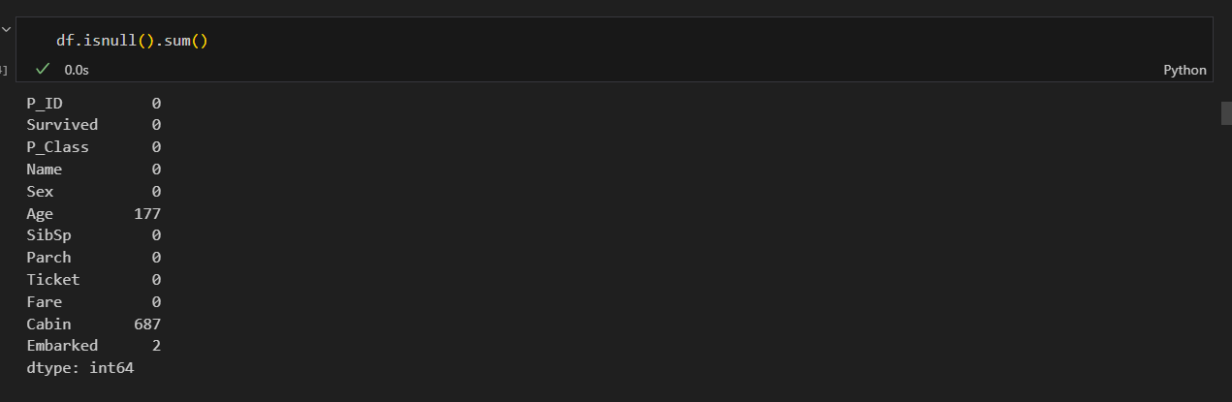

df['P_Class'].value_counts().plot(kind='pie', autopct='%1.1f%%')

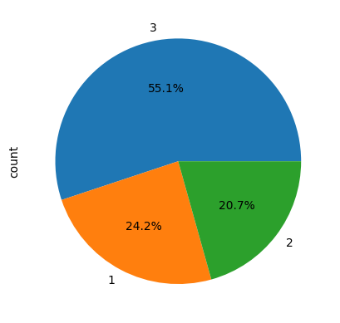

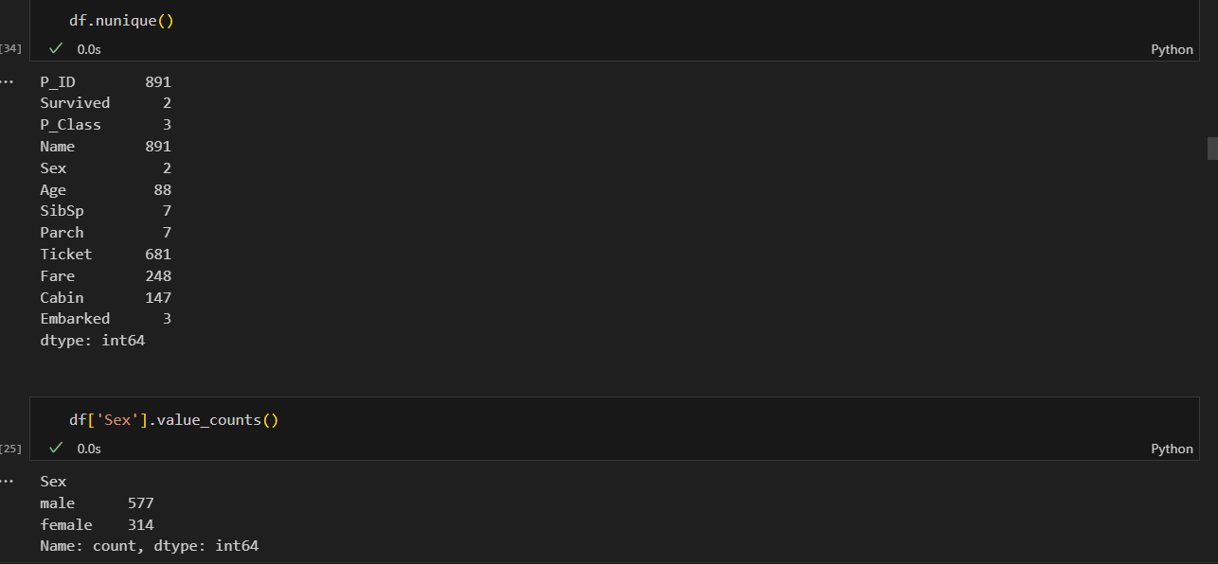

df['Sex'].value_counts().plot(kind='pie', autopct='%1.1f%%')

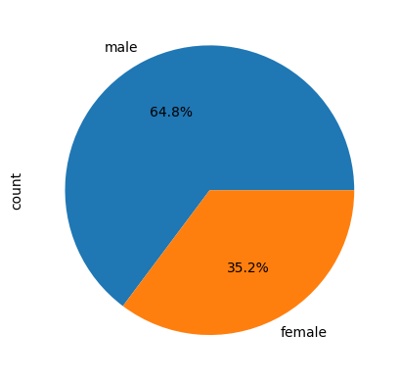

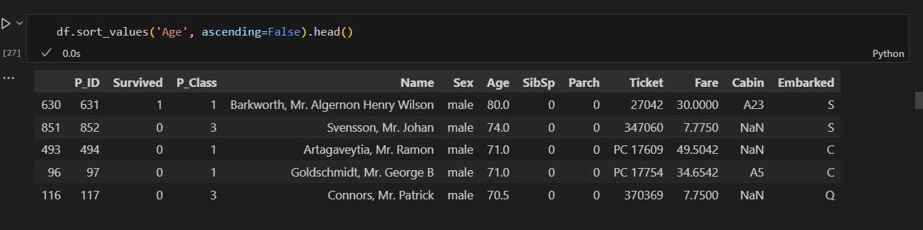

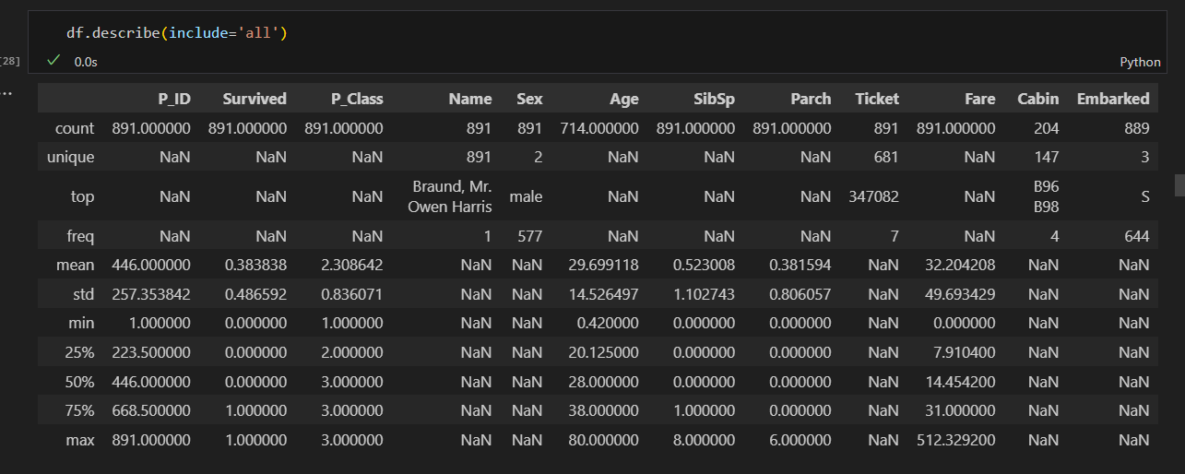

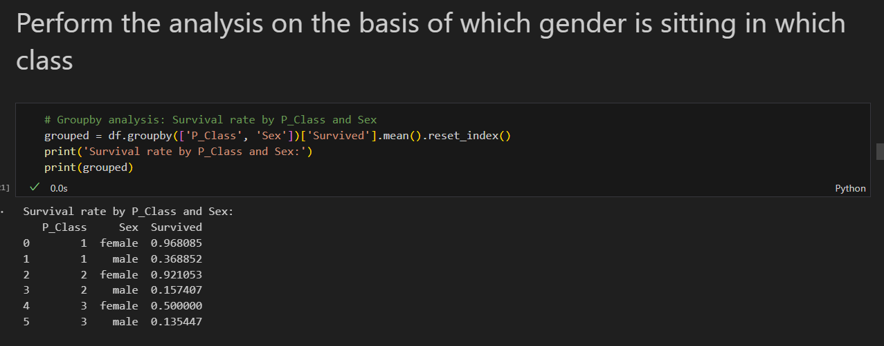

# Plotting the survival rate by P_Class and Sex

plt.figure(figsize=(8,6))

sns.barplot(data=grouped, x='P_Class', y='Survived', hue='Sex', palette='Set2')

plt.title('Survival Rate by Passenger Class and Sex')

plt.xlabel('Passenger Class')

plt.ylabel('Survival Rate')

plt.legend(title='Sex')

plt.show()

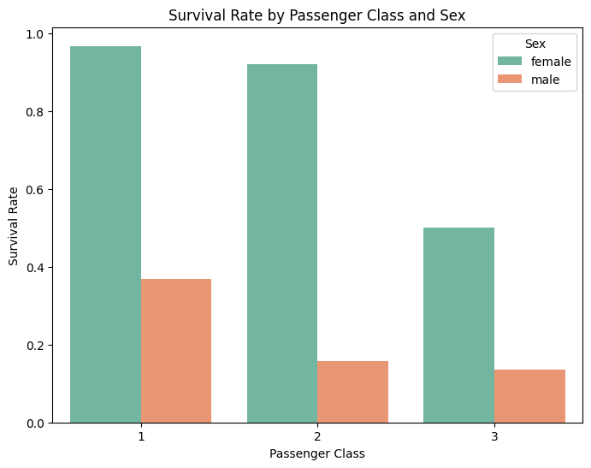

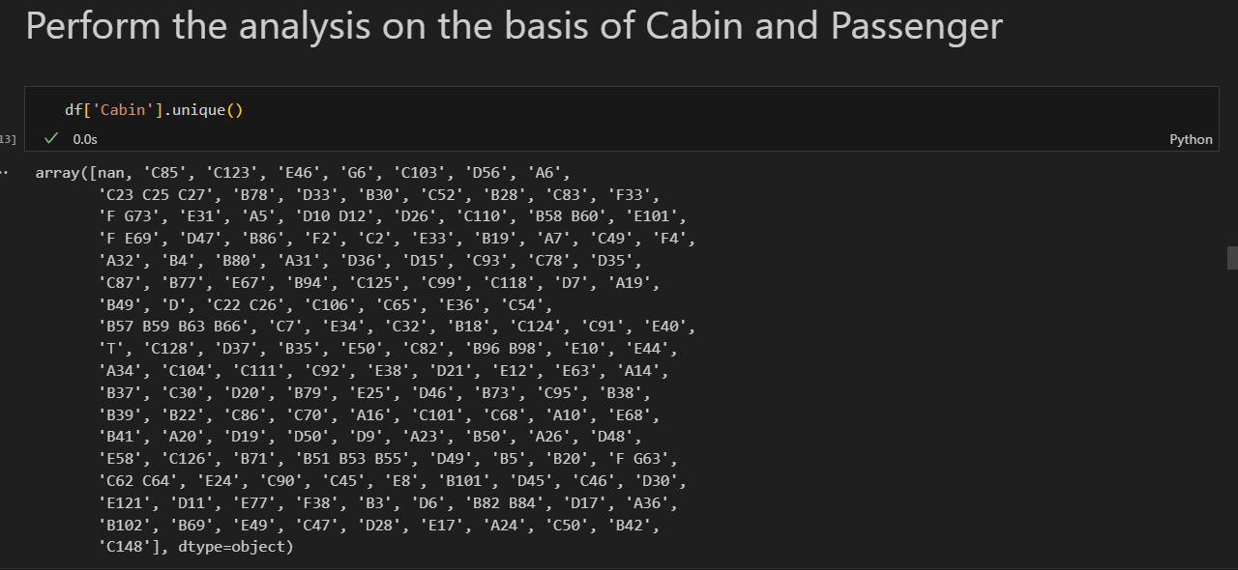

# Graphical presentation of Cabin data

plt.figure(figsize=(10,5))

cabin_missing = df['Cabin'].isnull().sum()

cabin_present = df['Cabin'].notnull().sum()

sns.barplot(x=['Missing', 'Present'], y=[cabin_missing, cabin_present], palette=['#d7263d', '#1b998b'])

plt.title('Cabin Data Availability')

plt.ylabel('Number of Passengers')

plt.show()

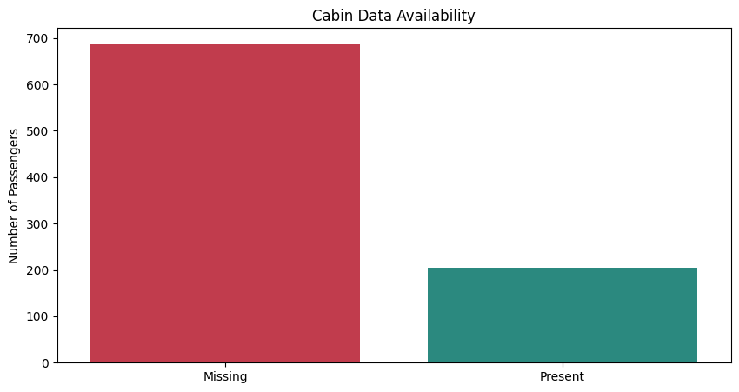

# Most common cabins (excluding missing)

cabin_counts = df['Cabin'].value_counts().head(10)

plt.figure(figsize=(12,6))

sns.barplot(x=cabin_counts.index, y=cabin_counts.values, palette='viridis')

plt.title('Top 10 Most Common Cabins')

plt.xlabel('Cabin')

plt.ylabel('Count')

plt.xticks(rotation=45)

plt.tight_layout()

plt.show()

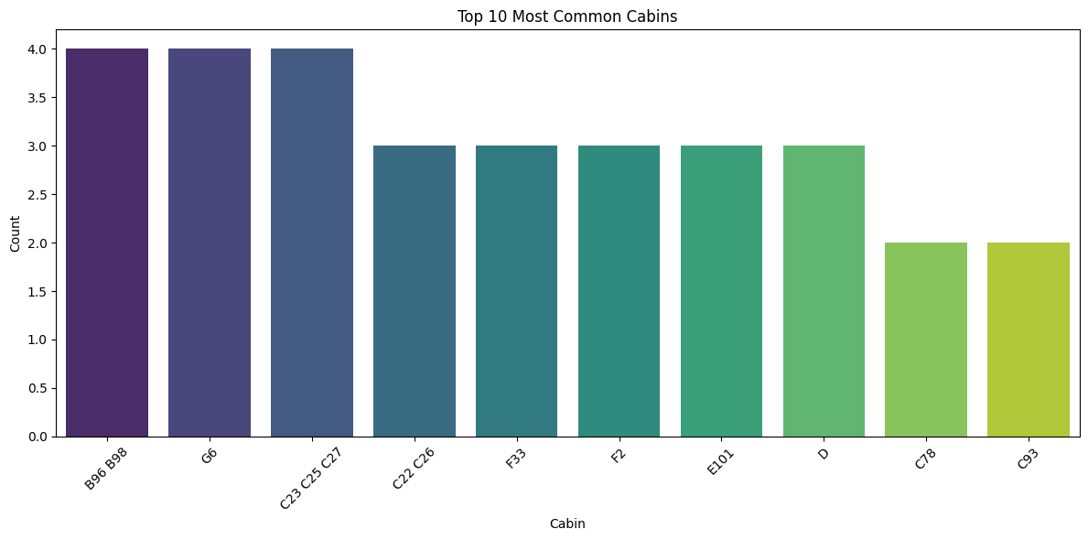



# Age distribution by Sex: Boxplot and Violinplot

plt.figure(figsize=(10,6))

sns.boxplot(data=df, x='Sex', y='Age', palette='Set2')

plt.title('Age Distribution by Sex (Boxplot)')

plt.xlabel('Sex')

plt.ylabel('Age')

plt.show()

plt.figure(figsize=(10,6))

sns.violinplot(data=df, x='Sex', y='Age', palette='Set2')

plt.title('Age Distribution by Sex (Violinplot)')

plt.xlabel('Sex')

plt.ylabel('Age')

plt.show()

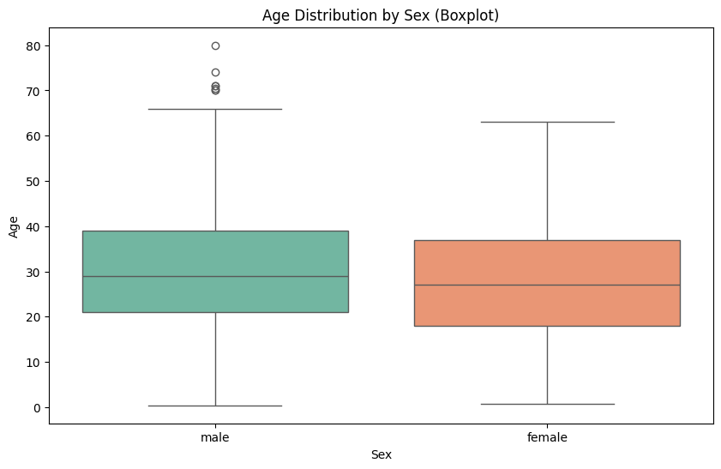

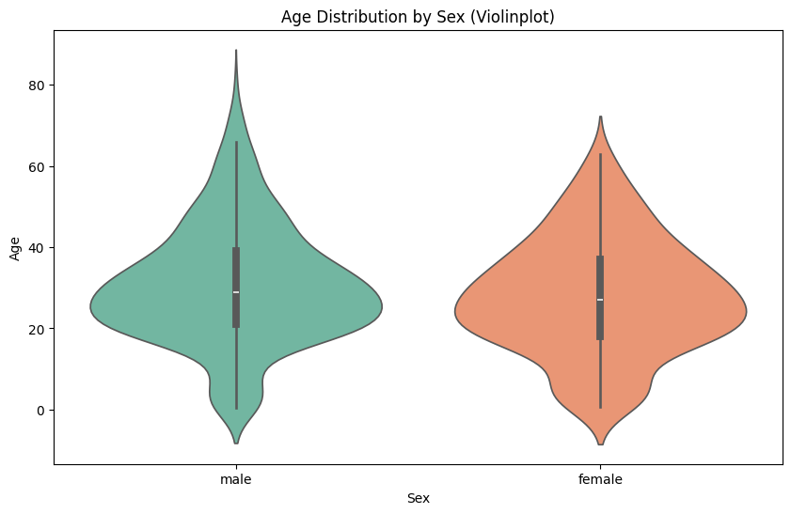



# Survival rate by Embarked port

embarked_survival = df.groupby('Embarked')['Survived'].mean().reset_index()

print('Survival rate by Embarked port:')

print(embarked_survival)

plt.figure(figsize=(6,4))

sns.barplot(data=embarked_survival, x='Embarked', y='Survived', palette='Set2')

plt.title('Survival Rate by Embarked Port')

plt.ylabel('Survival Rate')

plt.xlabel('Embarked Port')

plt.show()

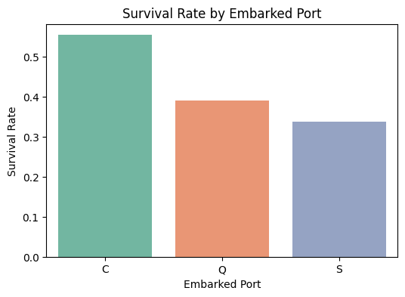



# Pairplot for selected features

sns.pairplot(df, vars=['Age', 'Fare', 'Survived'], hue='Sex', palette='Set2')

plt.suptitle('Pairplot of Age, Fare, Survived by Sex', y=1.02)

plt.show()

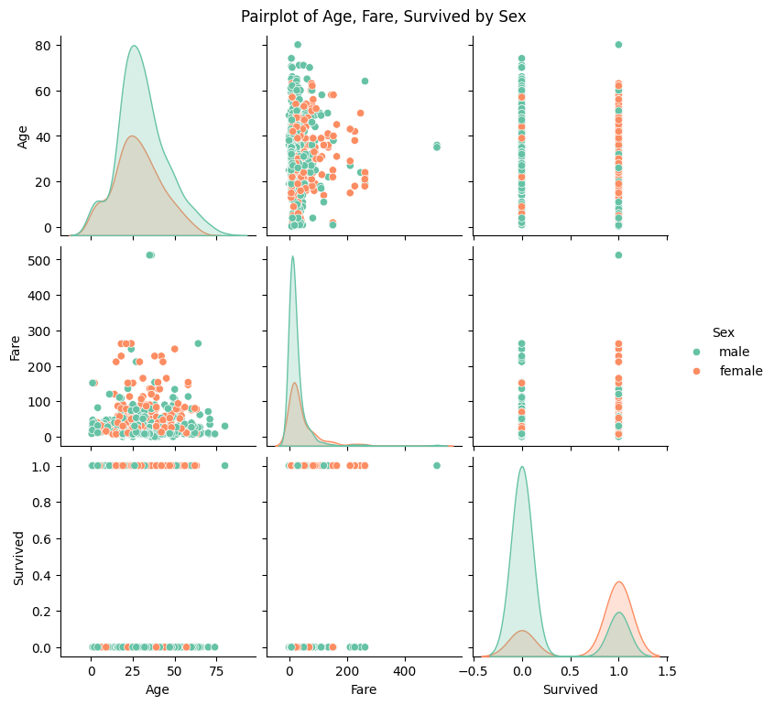



# Distribution of Fare by Passenger Class

plt.figure(figsize=(8,6))

sns.boxplot(data=df, x='P_Class', y='Fare', palette='Set2')

plt.title('Fare Distribution by Passenger Class')

plt.xlabel('Passenger Class')

plt.ylabel('Fare')

plt.show()

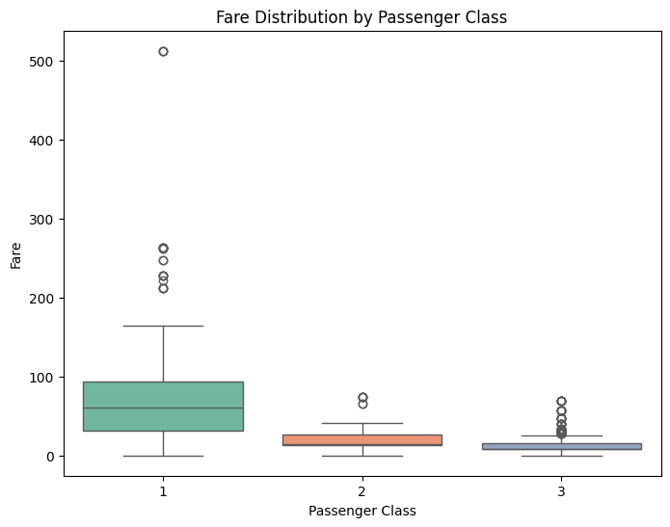



# Countplot for number of siblings/spouses aboard (SibSp)

plt.figure(figsize=(7,5))

sns.countplot(data=df, x='SibSp', palette='Set2')

plt.title('Number of Siblings/Spouses Aboard (SibSp)')

plt.xlabel('SibSp')

plt.ylabel('Count')

plt.show()

