

**AI/ML Programming**

**MCA-475**

**Assignment – 01**

***BY***

**HIMANSHU HEDA (24225013)**

**SUBMITTED TO**

**Dr. Manjula Shannhog**

**SCHOOL OF SCIENCES**

**2024-25**

**Importing Libraries**

import pandas as pd

import numpy as np

import matplotlib.pyplot as plt

import seaborn as sns

from datetime import date

df = pd.read_csv('./Dataset/used_car_dataset.csv')

df.head()

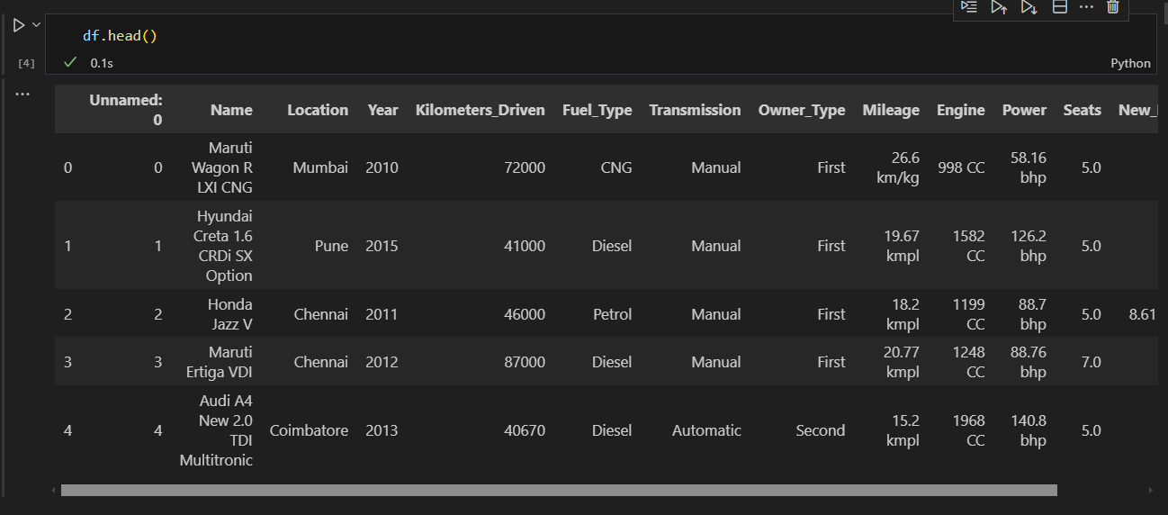

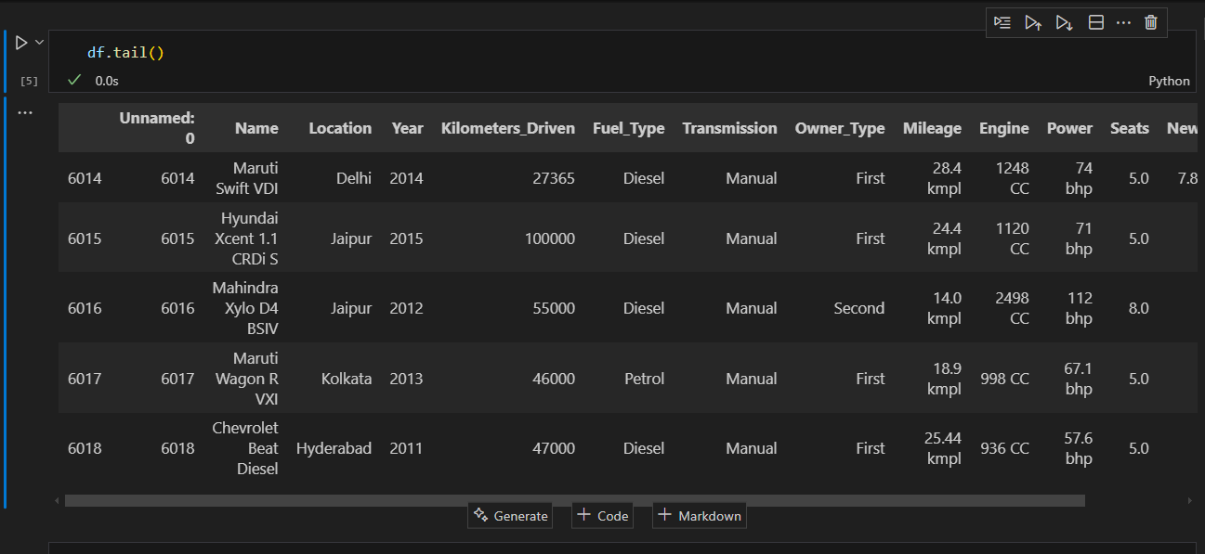

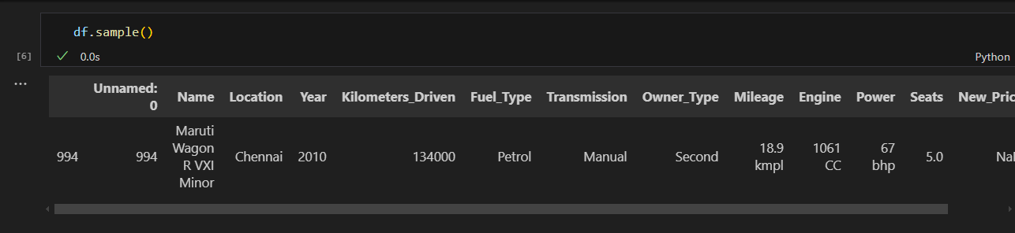

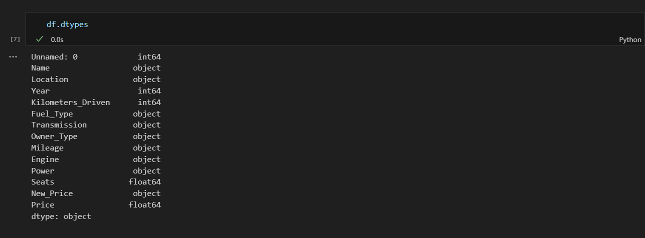

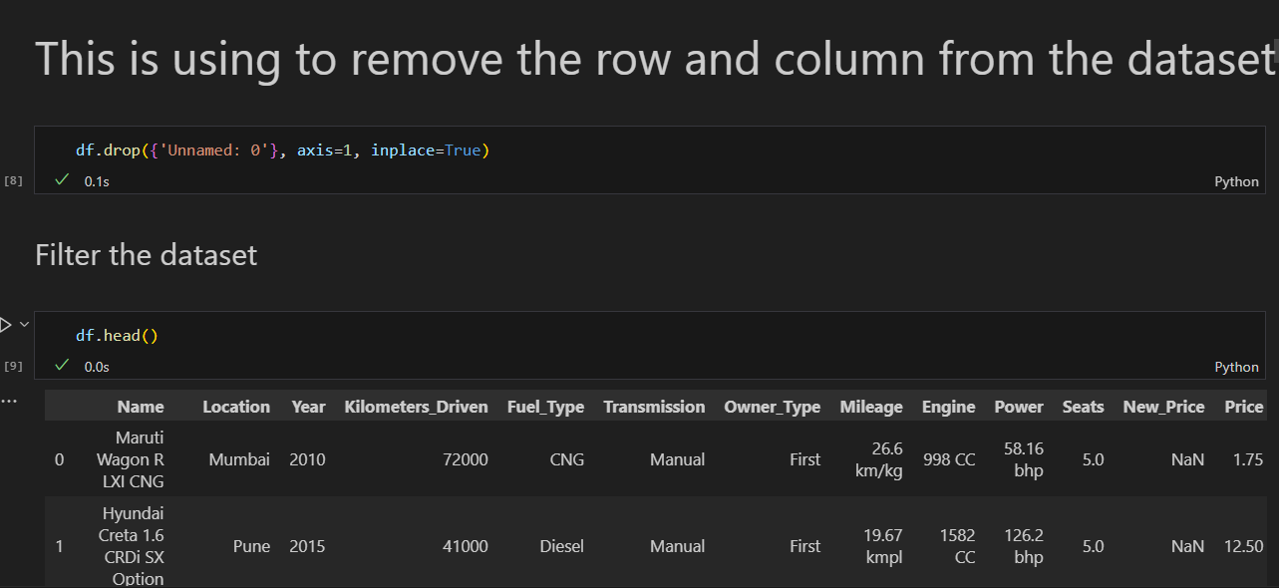

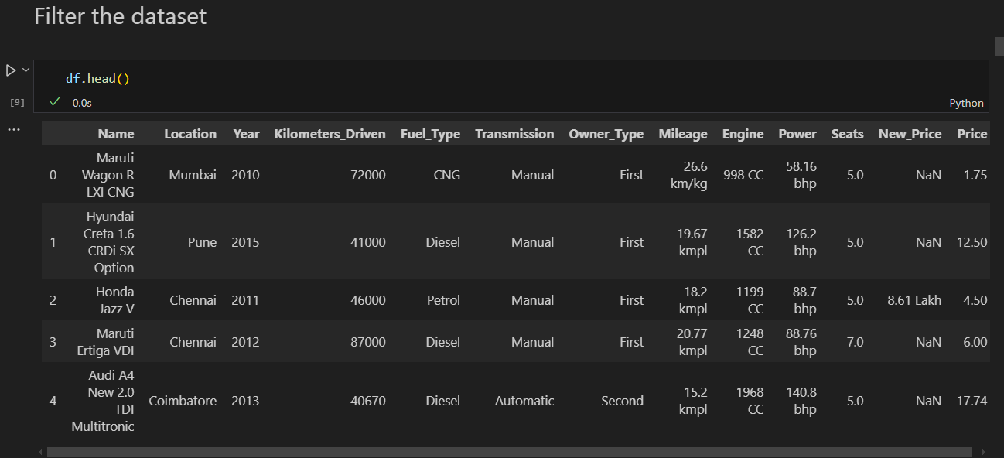

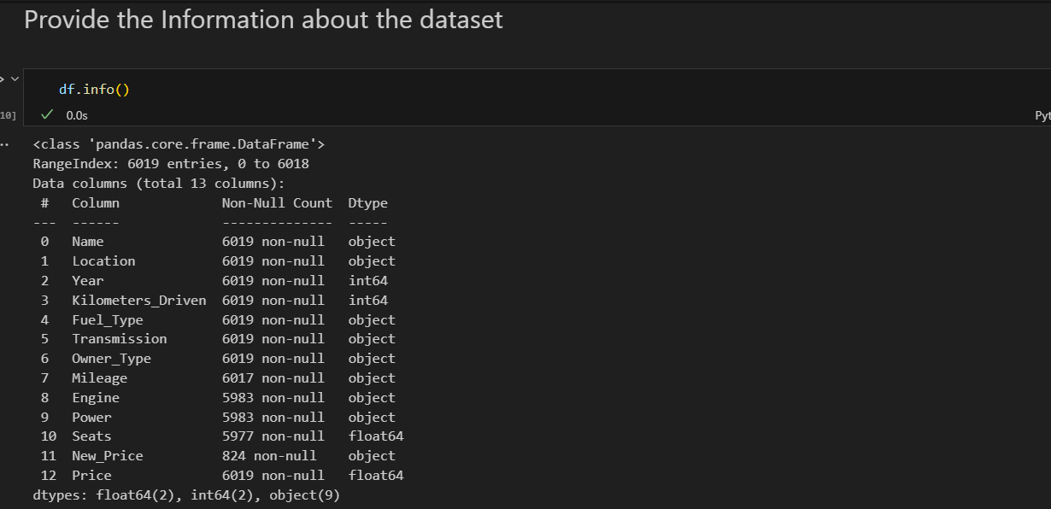

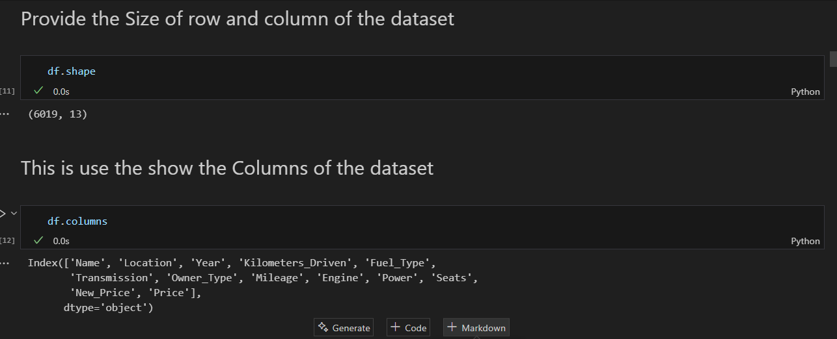

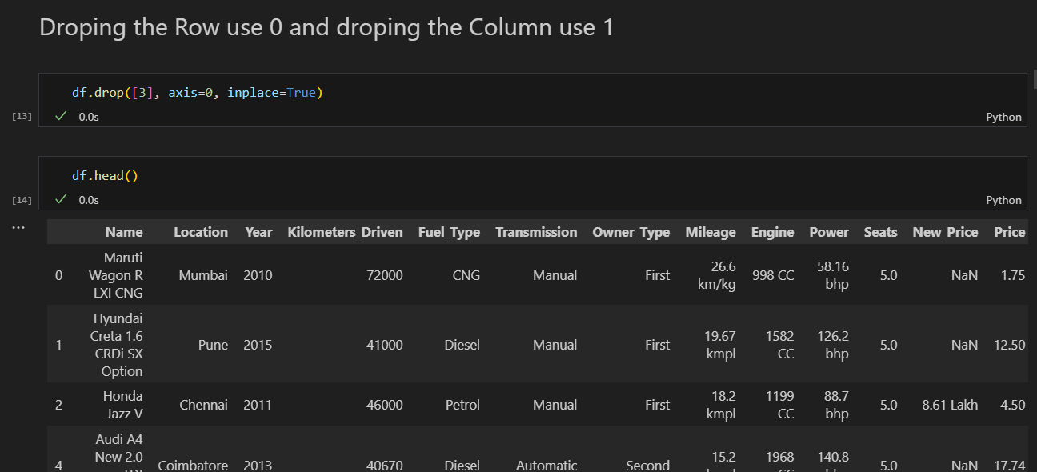

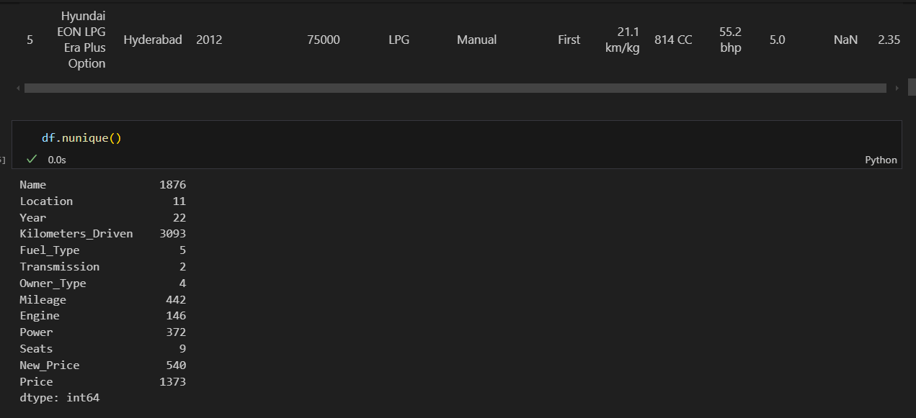

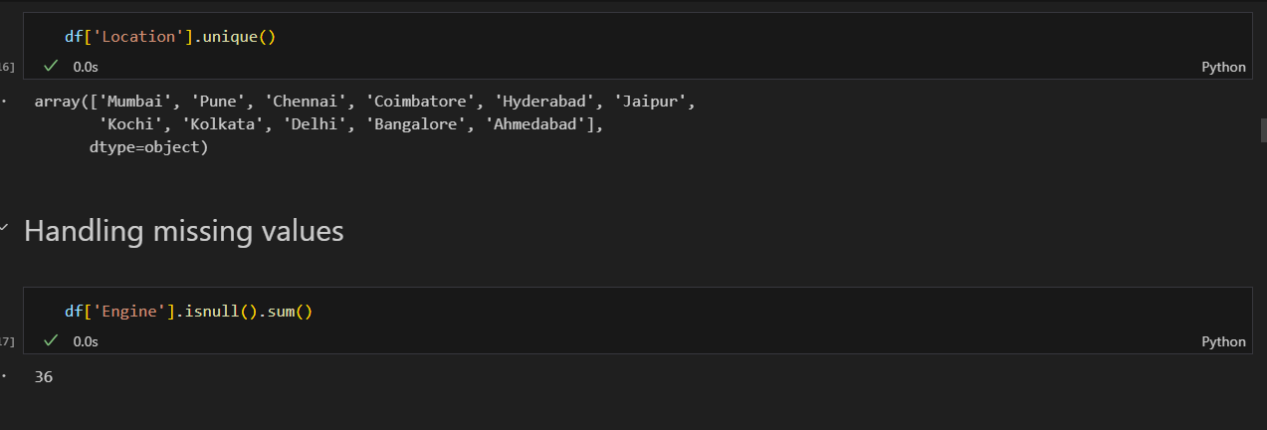

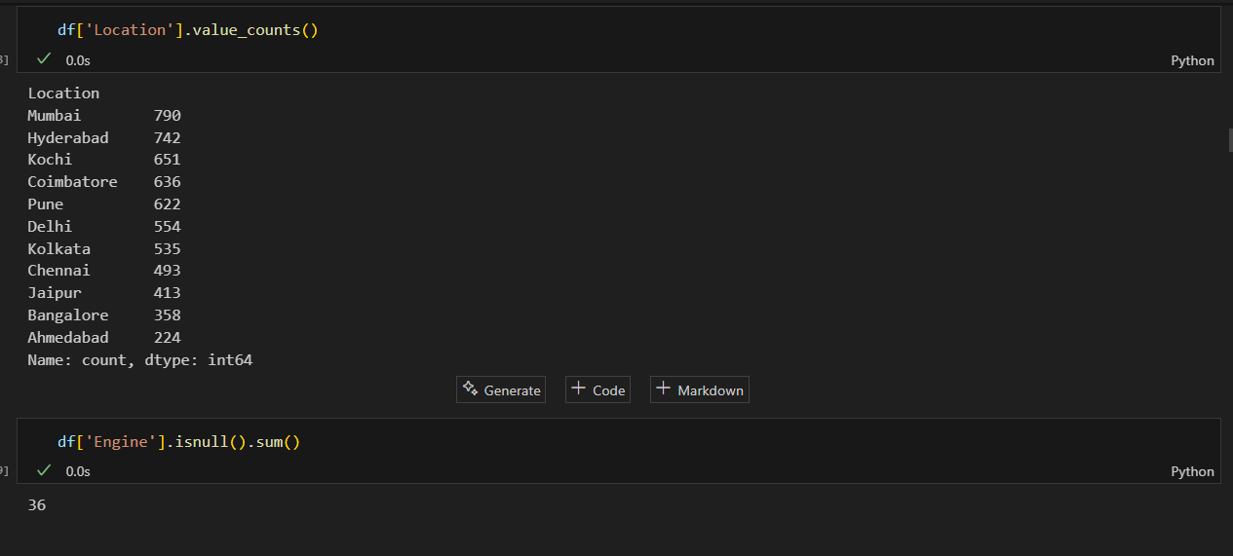

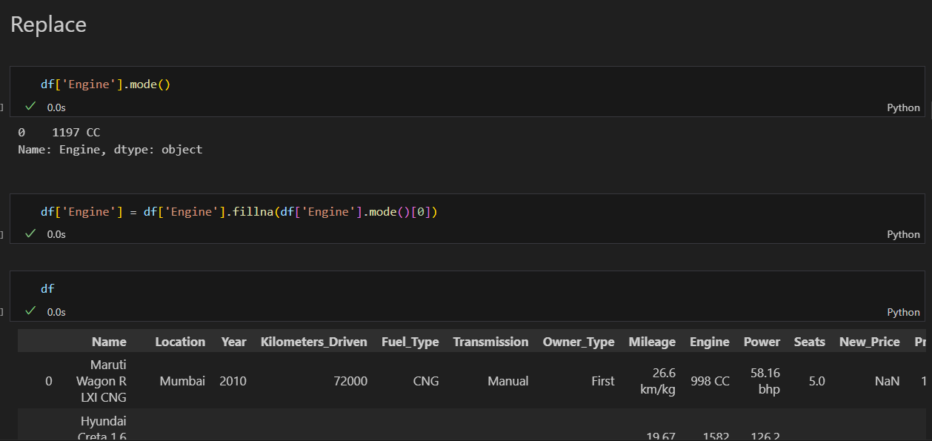

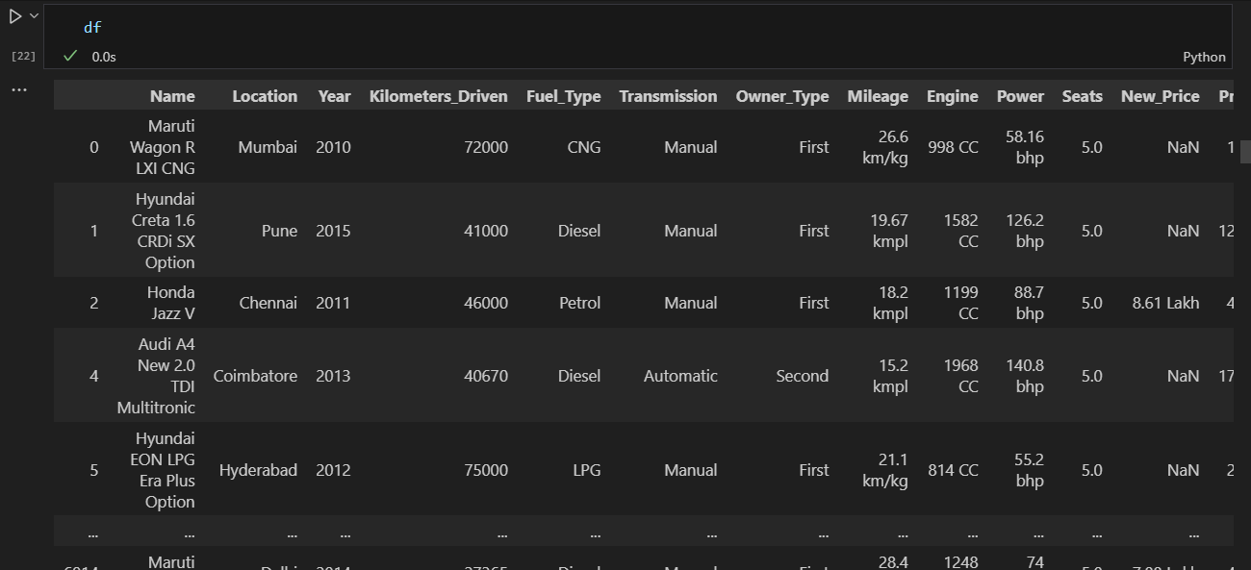

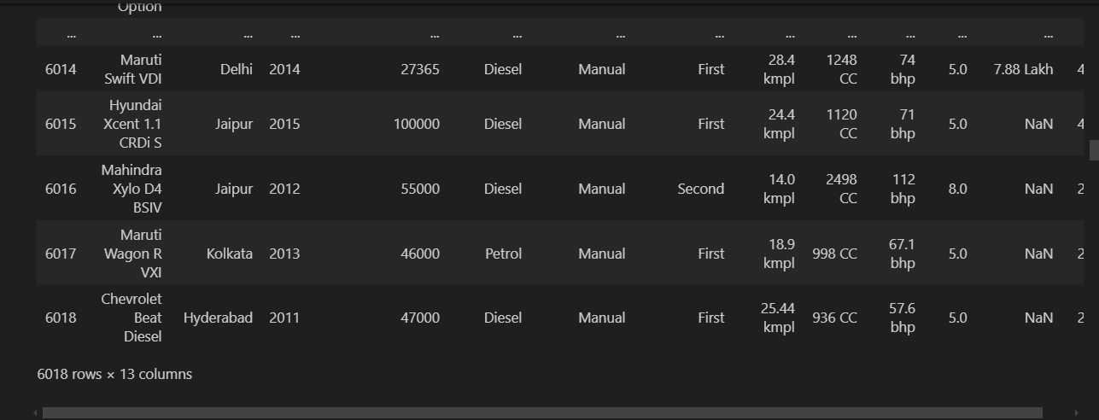

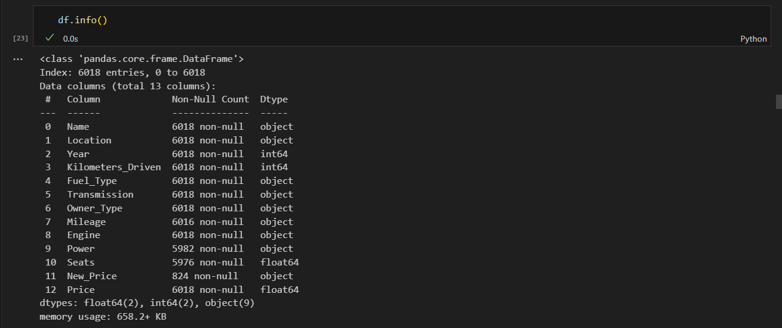

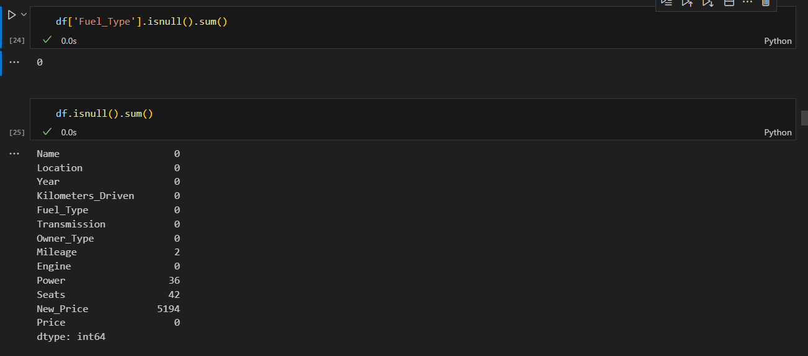

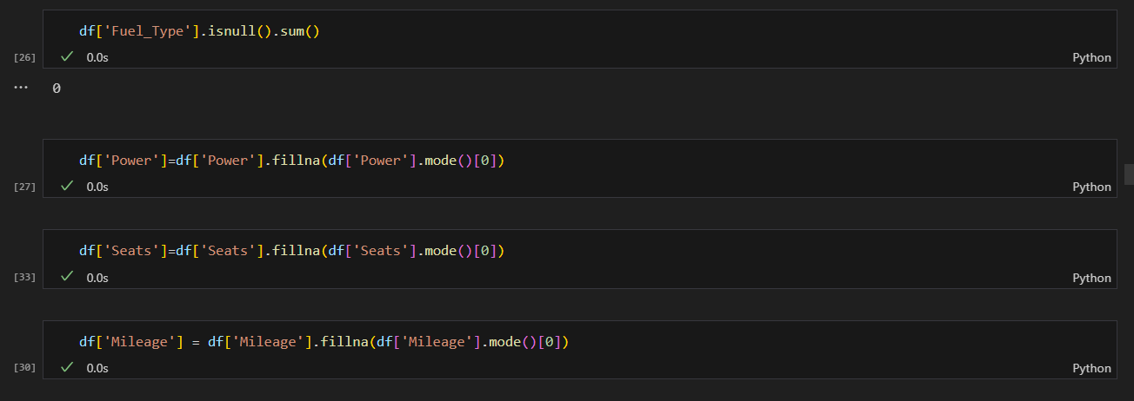

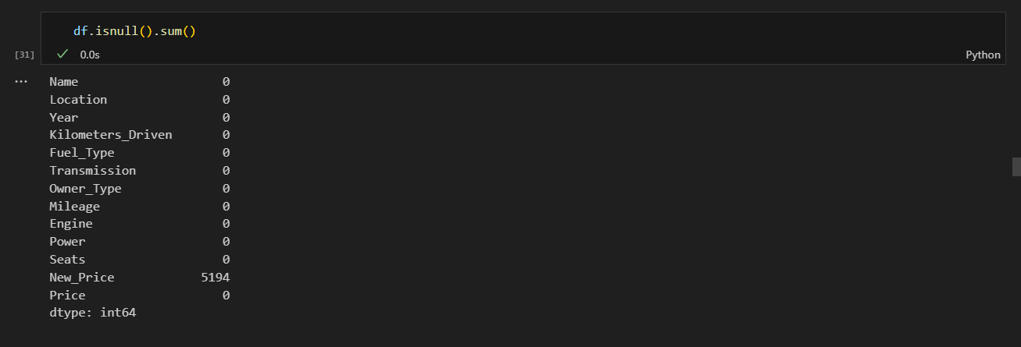



plt.figure(figsize=(16, 8))

sns.countplot(data=df, y='Location')

plt.title('Count of Cars by Location')

plt.xlabel('Count')

plt.ylabel('Location')

plt.show()

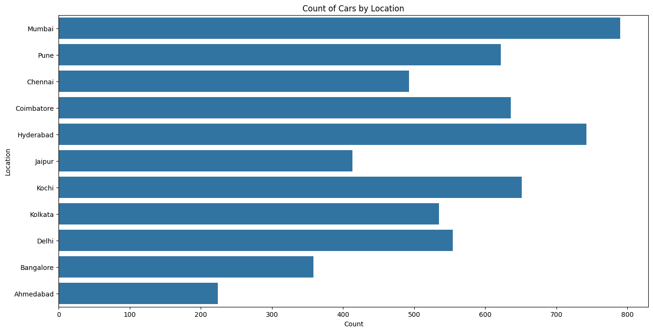

sns.countplot(data=df, x='Location')

plt.figure(figsize=(16, 8))

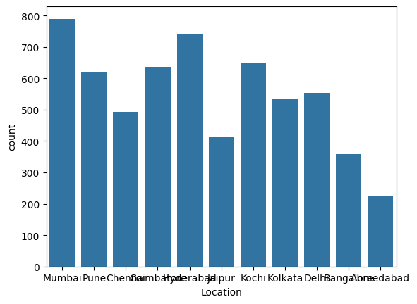

sns.countplot(data=df, x='Location', hue='Fuel_Type')

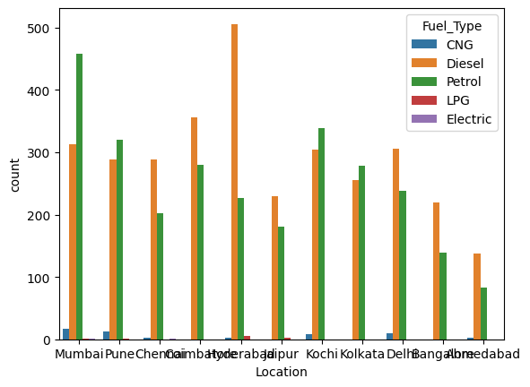

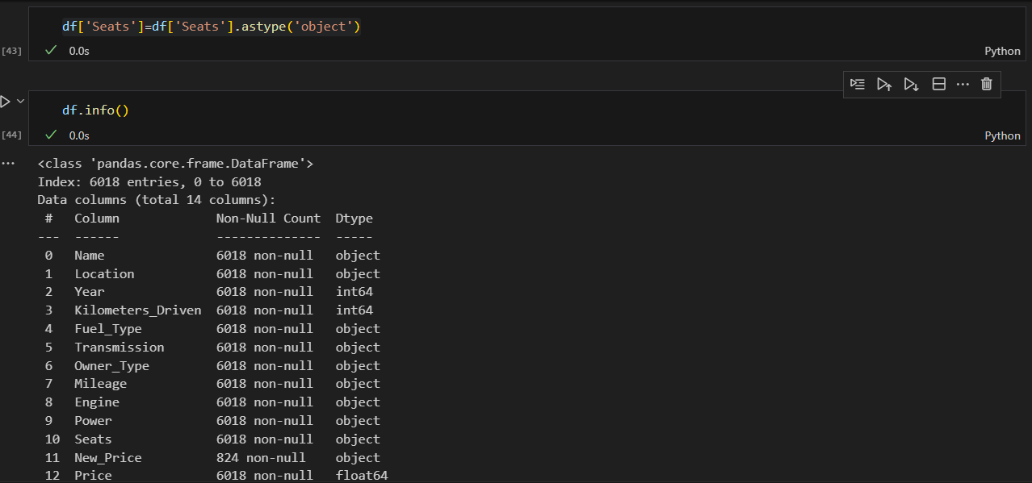

sns.countplot(data=df, y='Location', hue='Owner_Type')

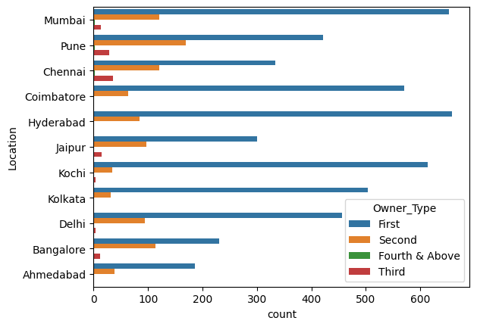

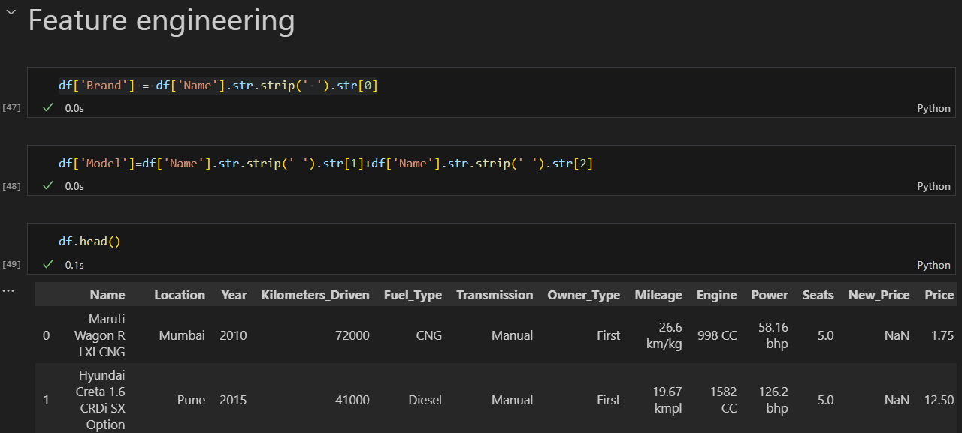

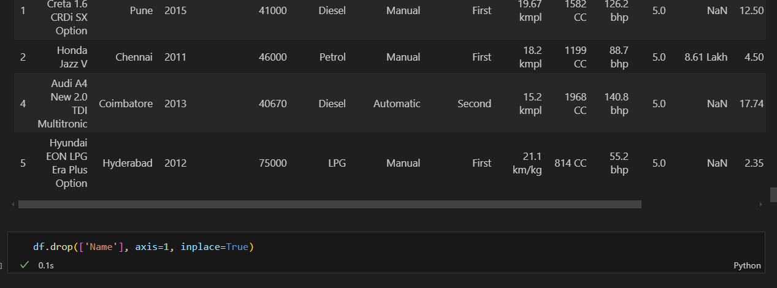

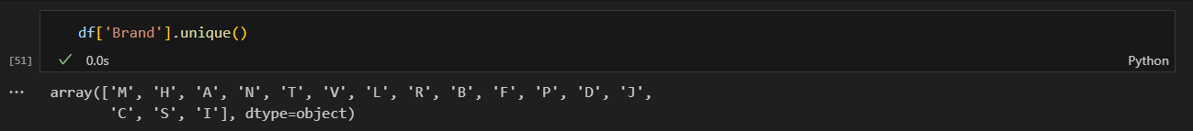

sns.scatterplot(data=df, y='Brand' ,x='Price')

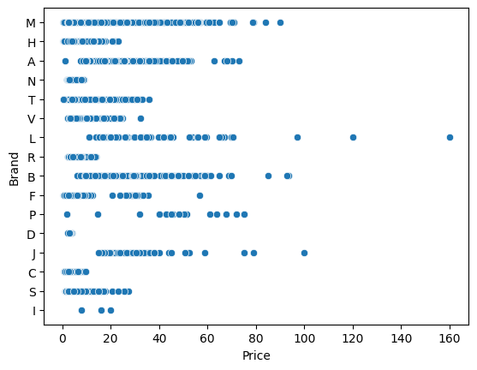

sns.pairplot(df, hue='Brand', diag_kind='kde')

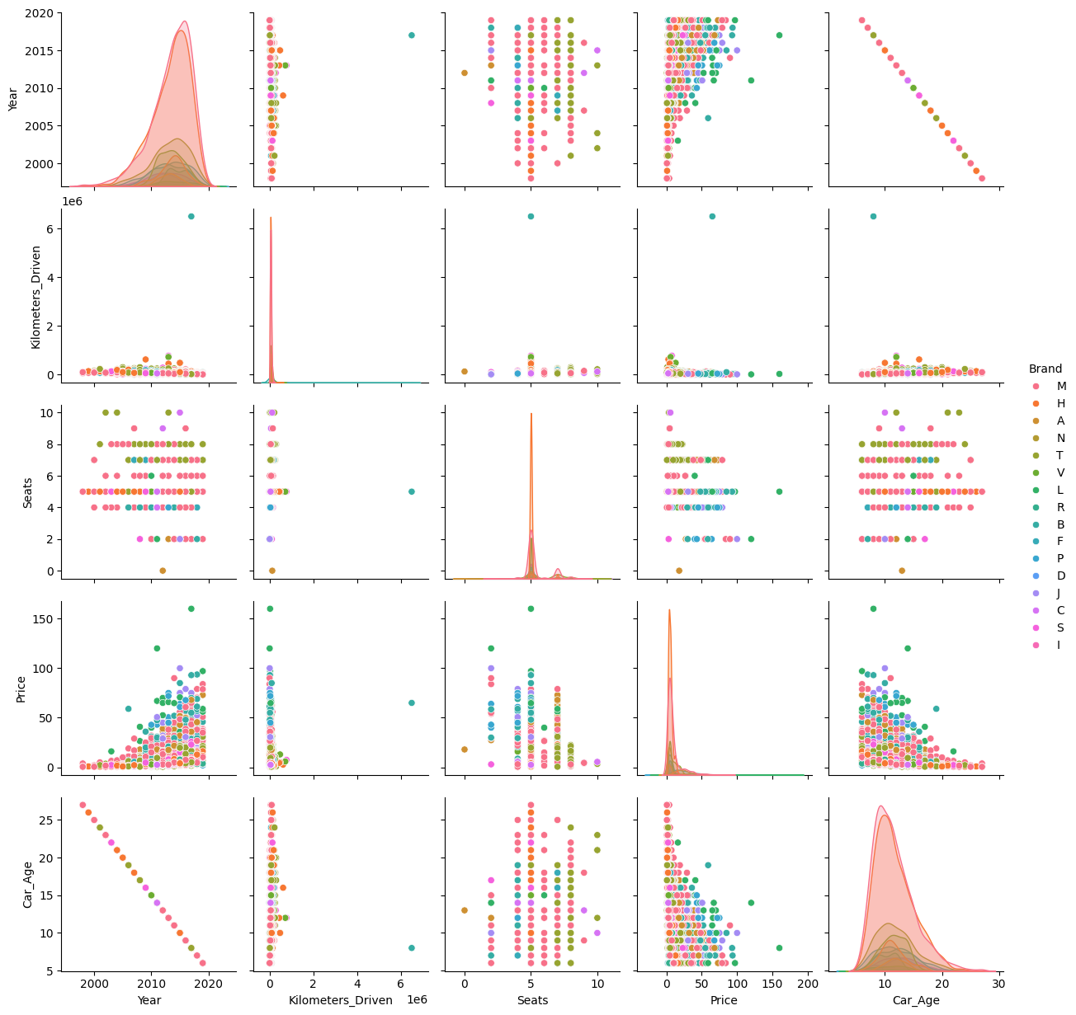

sns.pairplot(data=df, height=1.5, hue='Fuel_Type')

plt.show()

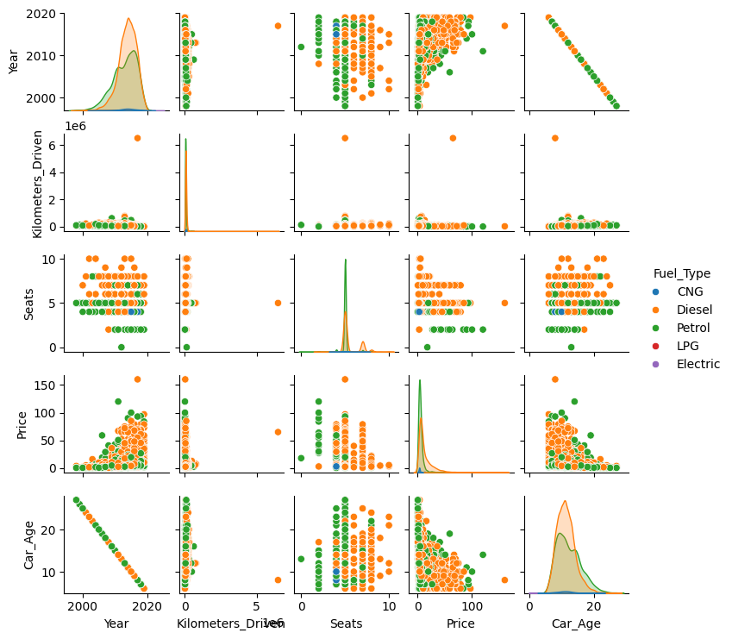

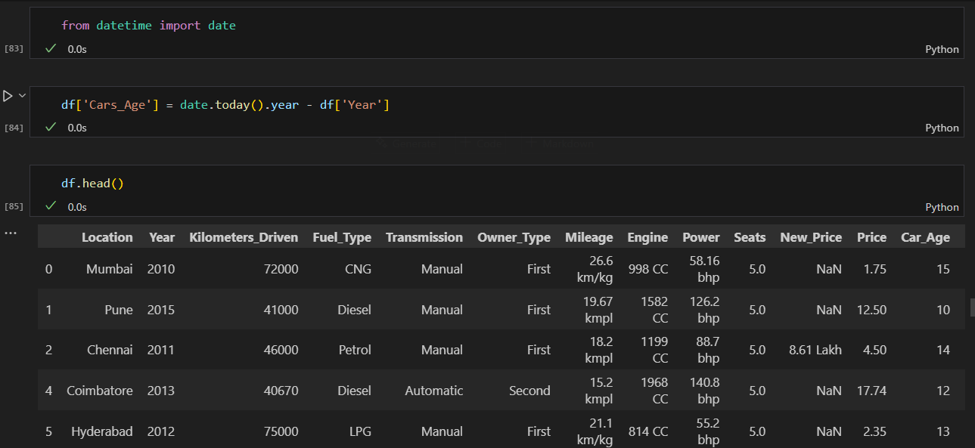

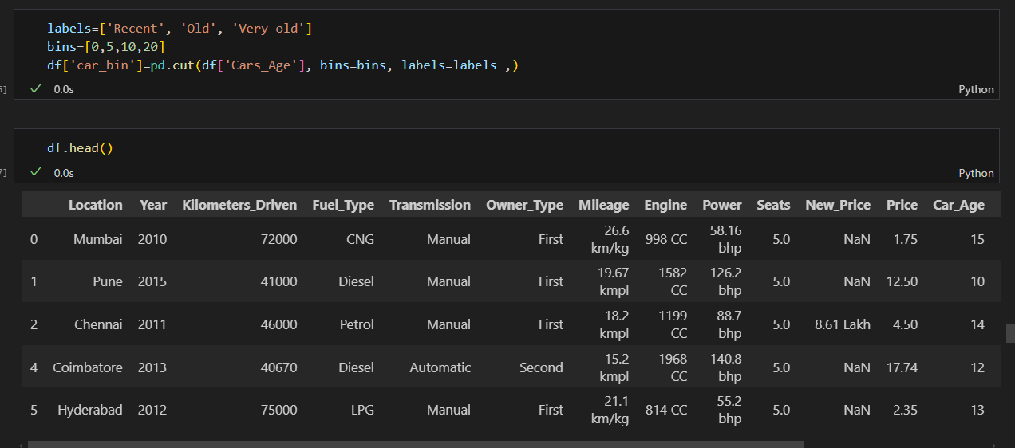

# Plot bar graph for car_bin distribution

df['car_bin'].value_counts().sort_index().plot(kind='bar', color='skyblue')

plt.title('Distribution of Cars by Age Bin')

plt.xlabel('Car Age Bin')

plt.ylabel('Number of Cars')

plt.xticks(rotation=0)

plt.show()

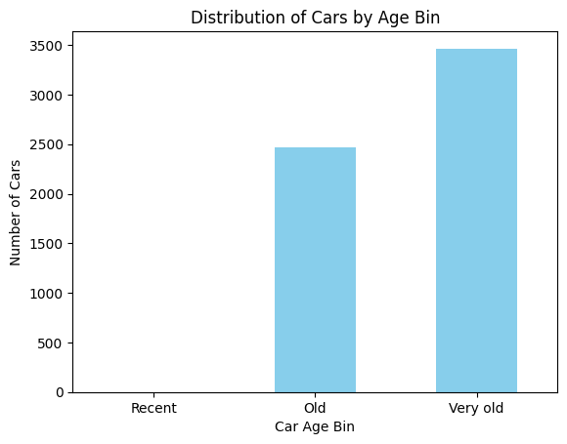

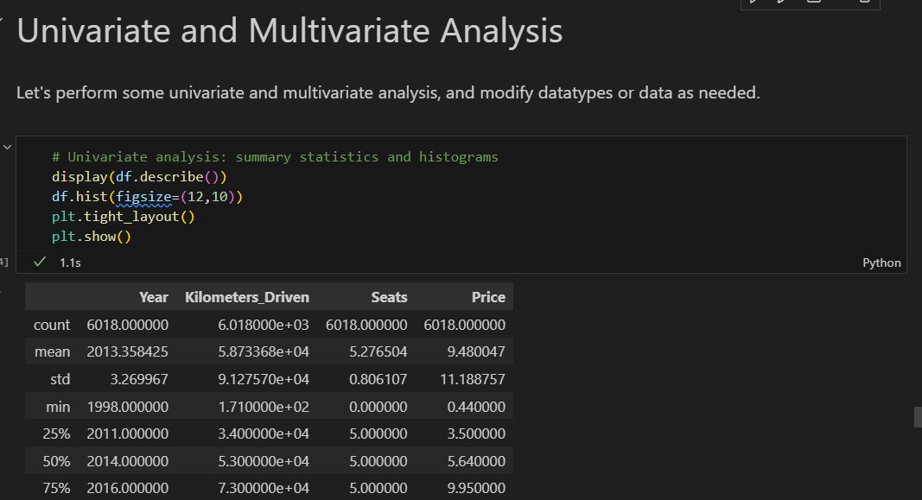

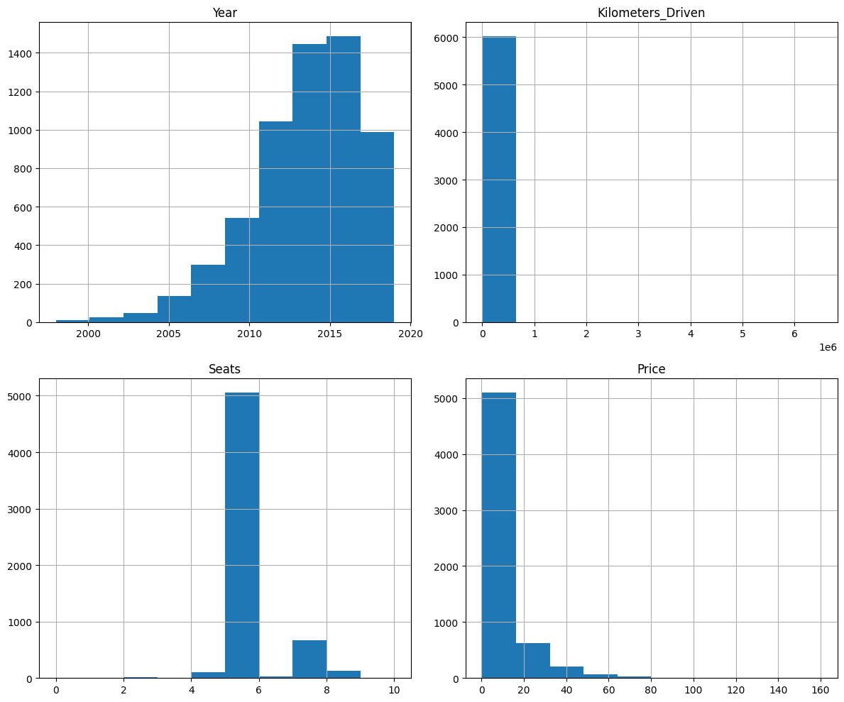

# Multivariate analysis: correlation heatmap and pairplot

corr = df.corr(numeric_only=True)

plt.figure(figsize=(10,8))

sns.heatmap(corr, annot=True, cmap='coolwarm')

plt.title('Correlation Heatmap')

plt.show()

sns.pairplot(df.select_dtypes(include=[np.number]))

plt.show()

