

**AI/ML Programming**

**MCA-475**

**Assignment – 02**

***BY***

**HIMANSHU HEDA (24225013)**

**SUBMITTED TO**

**Dr. Manjula Shannhog**

**SCHOOL OF SCIENCES**

**2024-25**

**Importing Libraries**

import pandas as pd

import numpy as np

import matplotlib.pyplot as plt

import seaborn as sns

from datetime import date

df = pd.read_csv('./Dataset/Diwali_Sales_Data.csv')

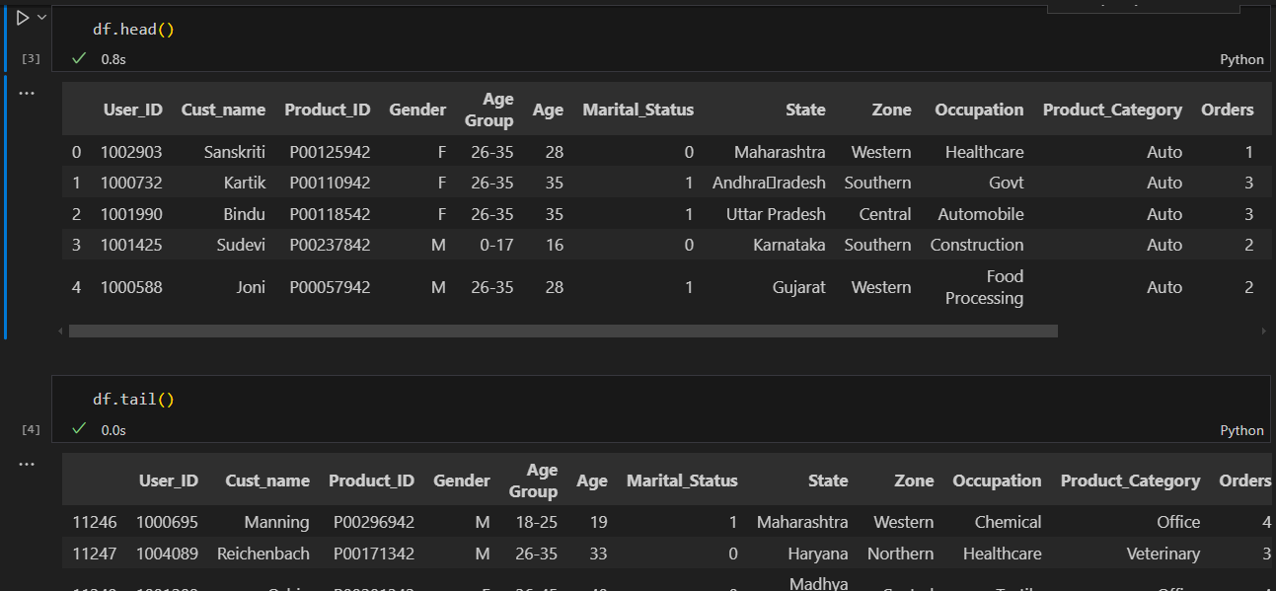

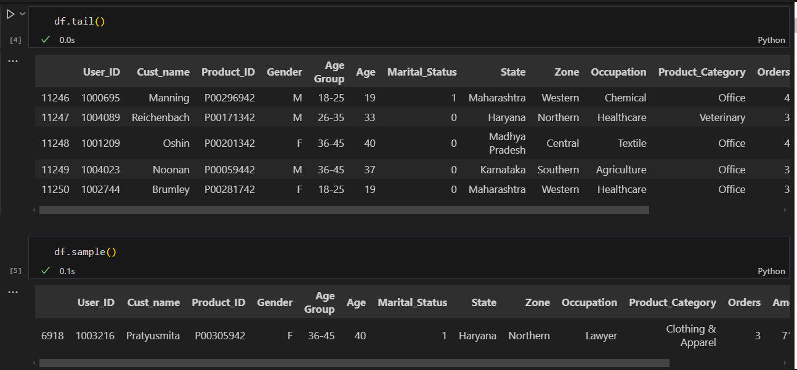

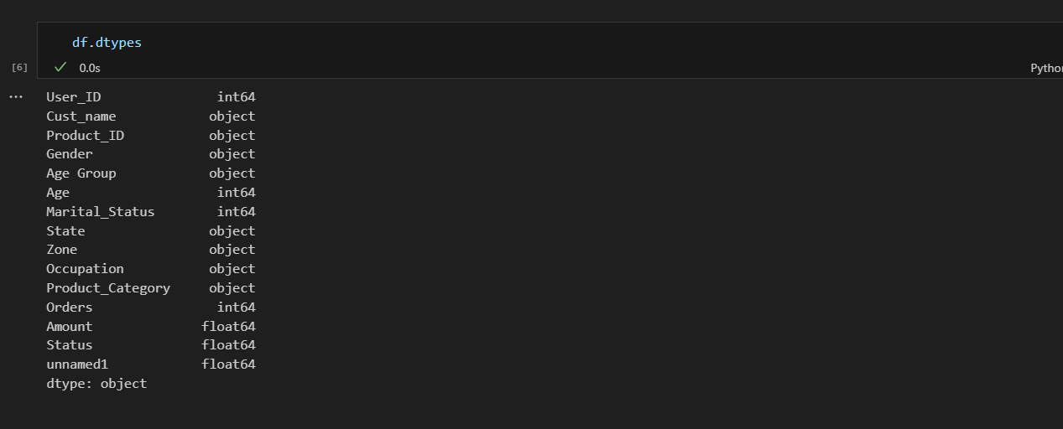

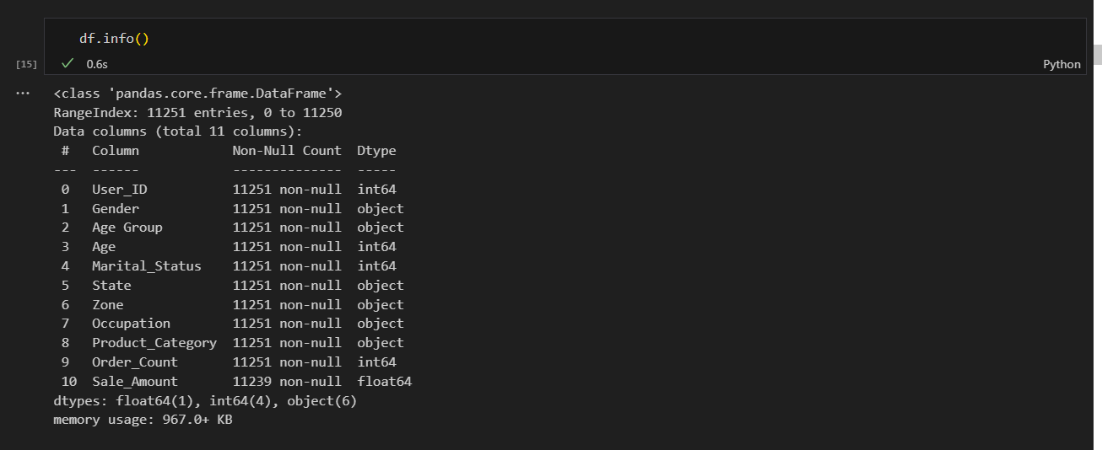

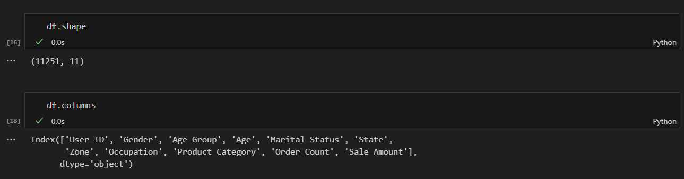

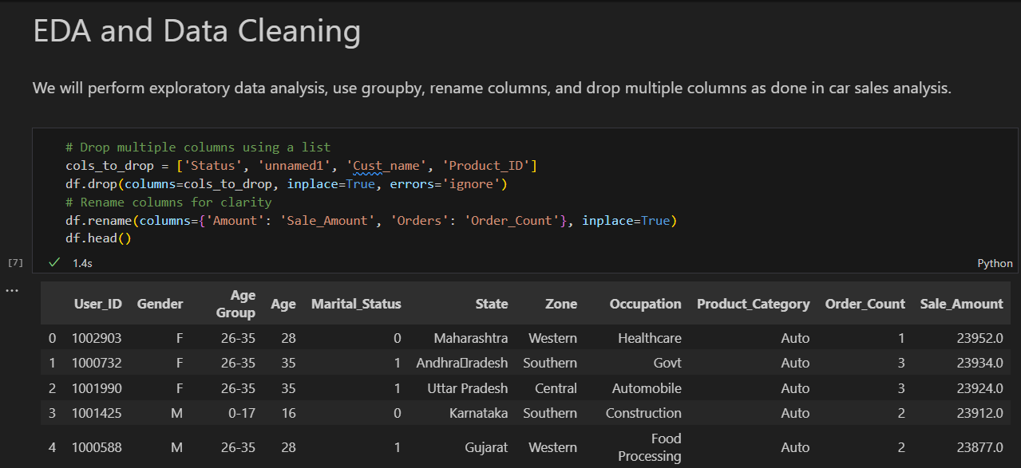

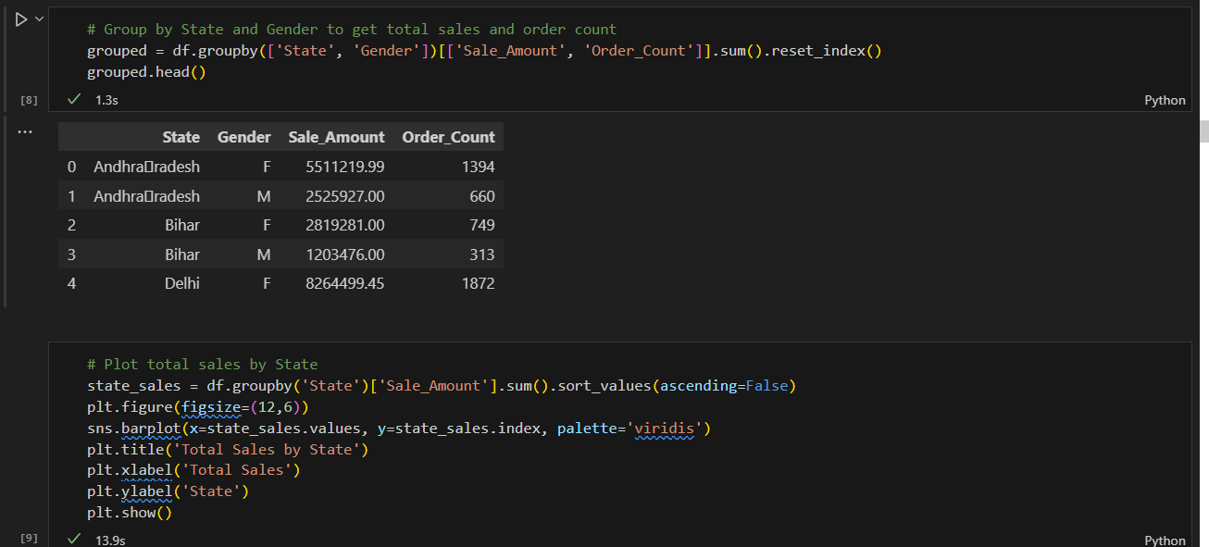

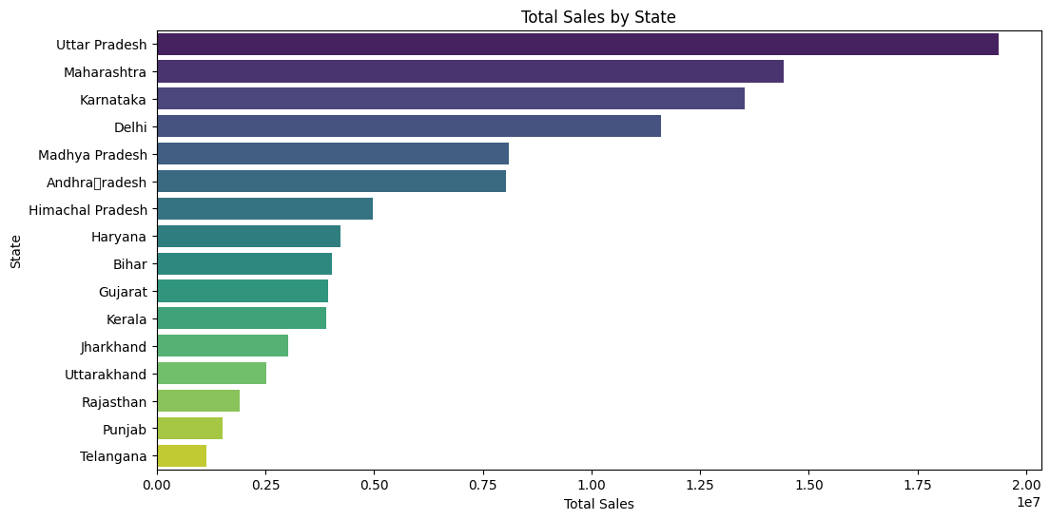

df.groupby('Gender')['Sale_Amount'].sum().plot(kind='pie', autopct='%1.1f%%', figsize=(8, 8), title='Sales Distribution')

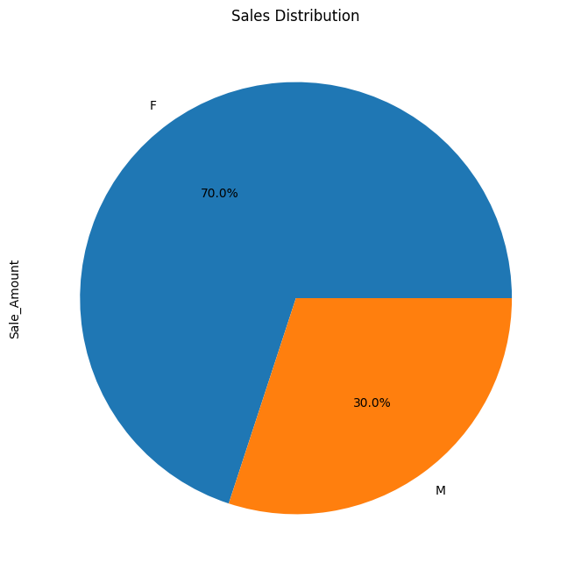

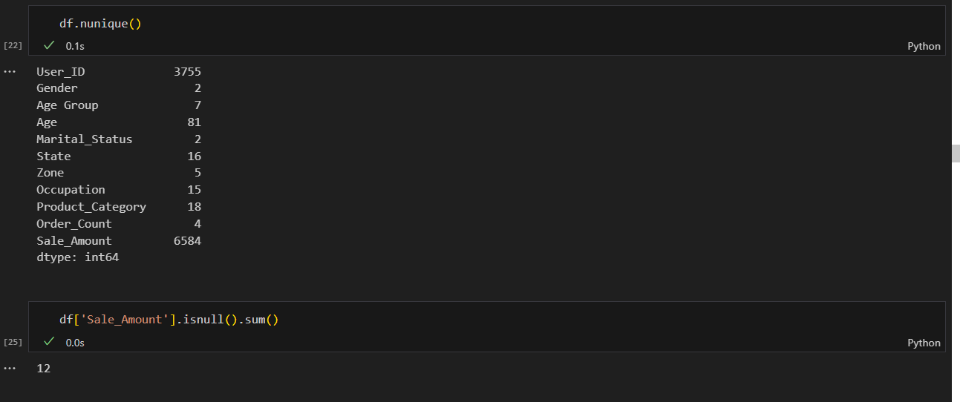

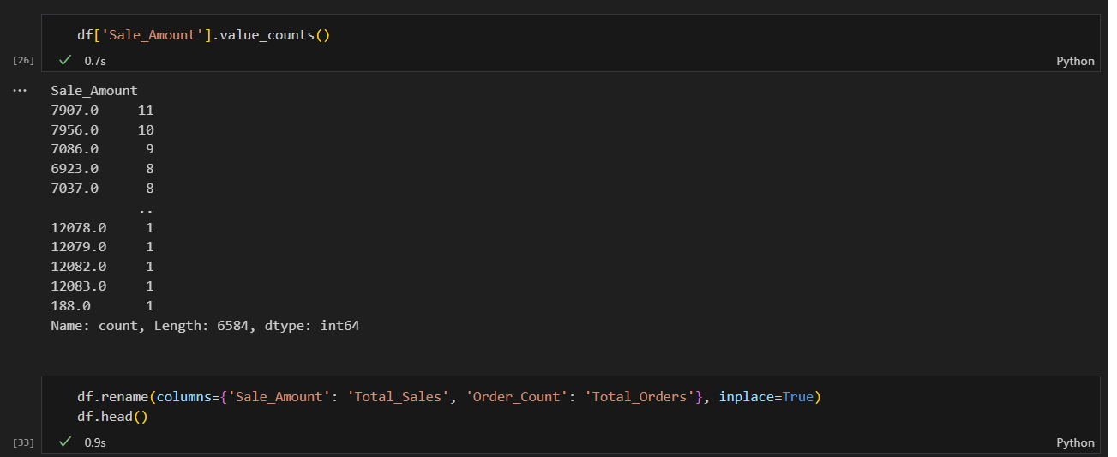

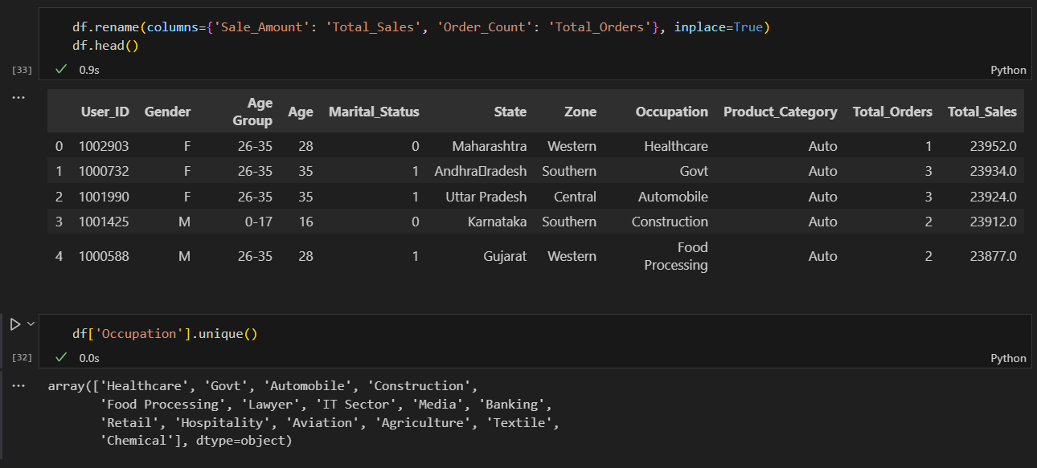

# Analyze unique User_IDs and perform groupby operations

unique_users = df['User_ID'].nunique()

print(f'Total unique users: {unique_users}')

# Group by User_ID to get total orders and sales per user

user_group = df.groupby('User_ID').agg({

    'Total_Orders': 'sum',

    'Total_Sales': ['sum', 'mean', 'count']

}).reset_index()

user_group.columns = ['User_ID', 'Total_Orders', 'Total_Sales_Sum', 'Total_Sales_Mean', 'Order_Count']

user_group.head()

# Find top 10 users by total sales

top_users = user_group.sort_values('Total_Sales_Sum', ascending=False).head(10)

print('Top 10 users by total sales:')

print(top_users)

# Plot top 10 users by total sales

plt.figure(figsize=(10,5))

sns.barplot(data=top_users, x='User_ID', y='Total_Sales_Sum', palette='crest')

plt.title('Top 10 Users by Total Sales')

plt.xlabel('User ID')

plt.ylabel('Total Sales')

plt.xticks(rotation=45)

plt.tight_layout()

plt.show()

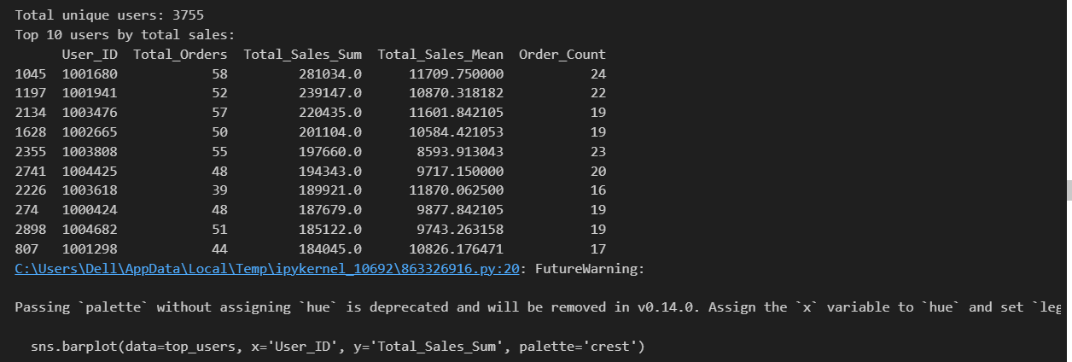

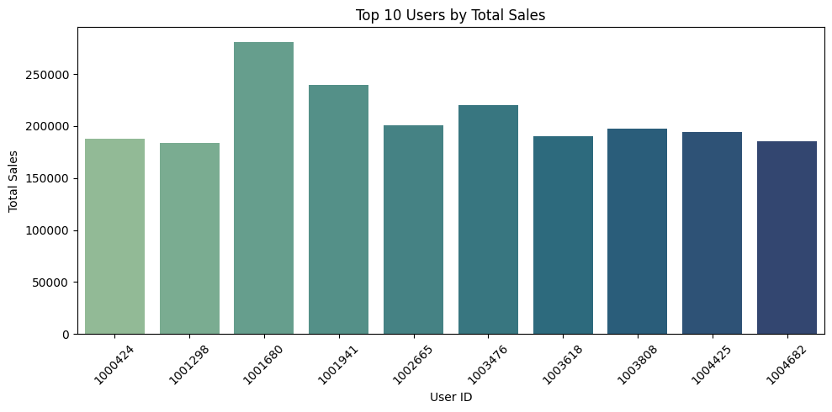

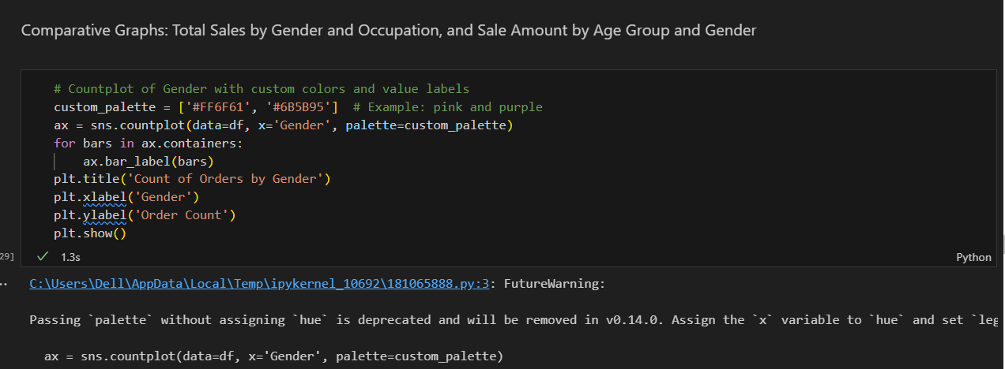

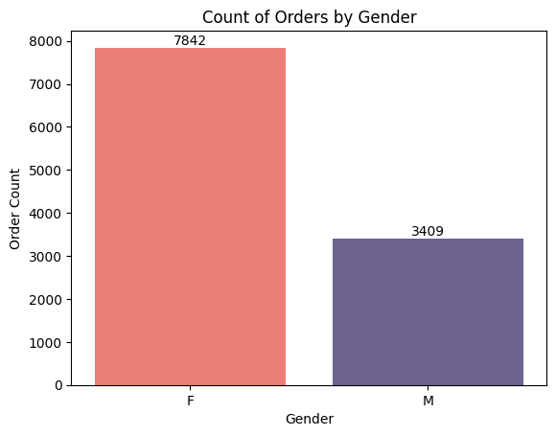

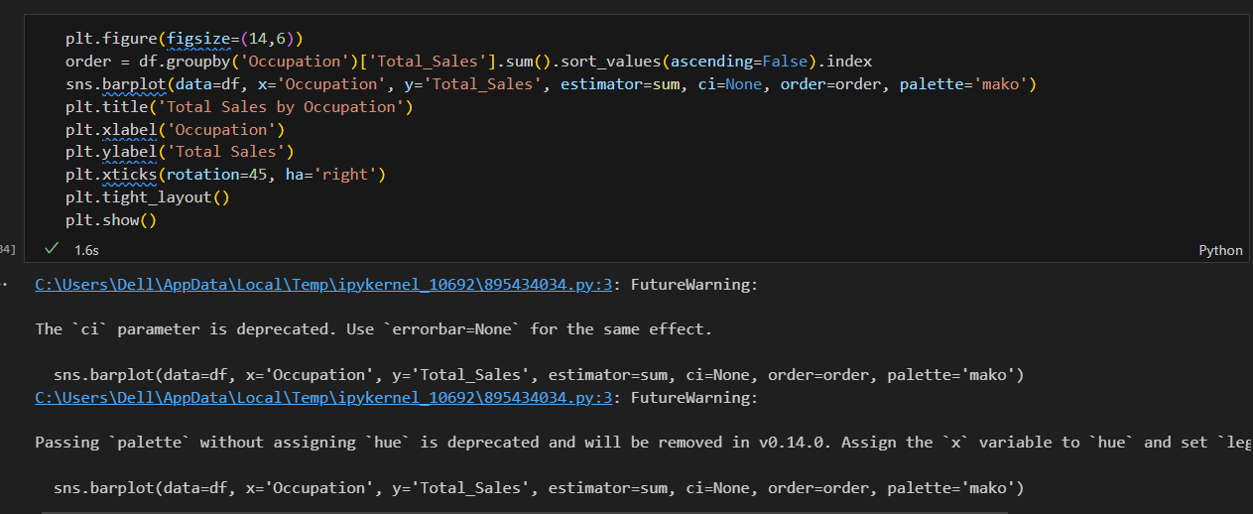

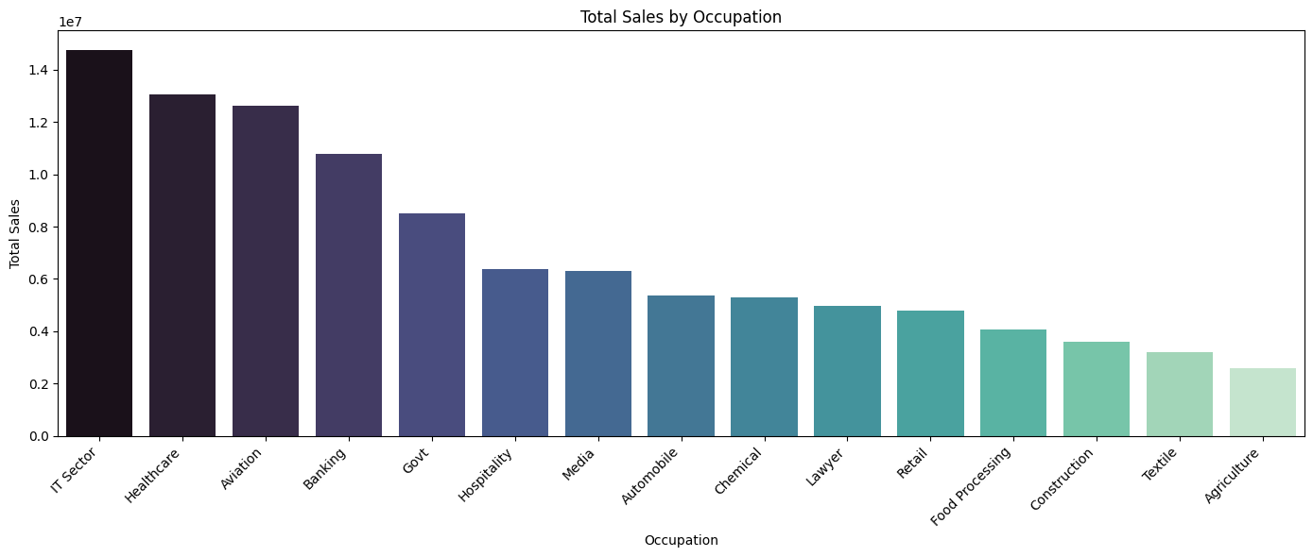

plt.figure(figsize=(12,6))

sns.boxplot(data=df, x='Age Group', y='Total_Sales', hue='Gender', palette=custom_palette)

plt.title('Sale Amount Distribution by Age Group and Gender')

plt.xlabel('Age Group')

plt.ylabel('Total Sales')

plt.legend(title='Gender')

plt.show()

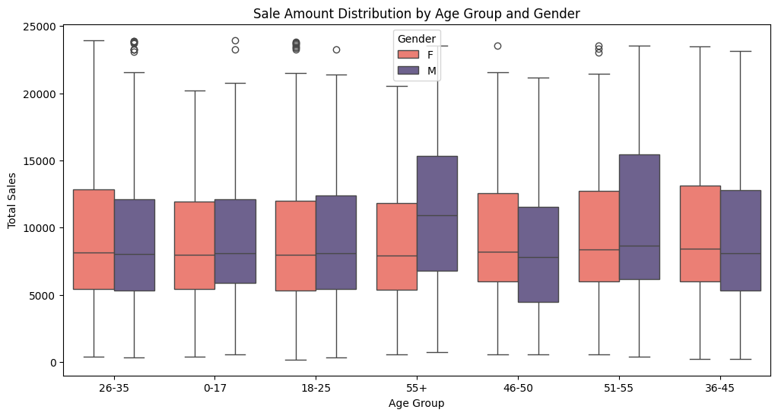



state_gender_group = df.groupby(['State', 'Gender']).agg({'Total_Sales': 'sum', 'Total_Orders': 'sum'}).reset_index()

top_states = state_gender_group.groupby('State')['Total_Sales'].sum().sort_values(ascending=False).head(10).index

filtered = state_gender_group[state_gender_group['State'].isin(top_states)]

plt.figure(figsize=(16,7))

sns.barplot(data=filtered, x='State', y='Total_Sales', hue='Gender', palette=custom_palette)

plt.title('Total Sales by State and Gender (Top 10 States)')

plt.xlabel('State')

plt.ylabel('Total Sales')

plt.xticks(rotation=45, ha='right')

plt.legend(title='Gender')

plt.tight_layout()

plt.show()

plt.figure(figsize=(16,7))

sns.barplot(data=filtered, x='State', y='Total_Orders', hue='Gender', palette=custom_palette)

plt.title('Total Orders by State and Gender (Top 10 States)')

plt.xlabel('State')

plt.ylabel('Total Orders')

plt.xticks(rotation=45, ha='right')

plt.legend(title='Gender')

plt.tight_layout()

plt.show()

