

**AI/ML Programming**

**MCA-475**

**Assignment – 03**

***BY***

**SHRUTI PRIYA (24225045)**

**SUBMITTED TO**

**Dr. Manjula Shannhog**

**SCHOOL OF SCIENCES**

**2024-25**

**Importing Libraries**

import pandas as pd

import numpy as np

import matplotlib.pyplot as plt

import seaborn as sns

from datetime import date

df = pd.read_csv('./Dataset/Salary_dataset.csv')

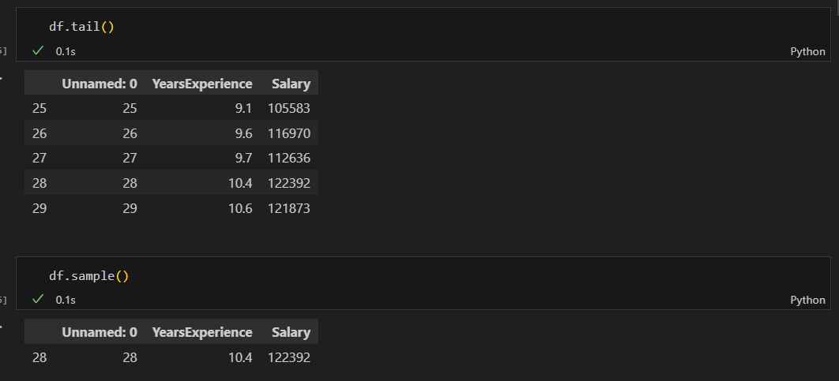

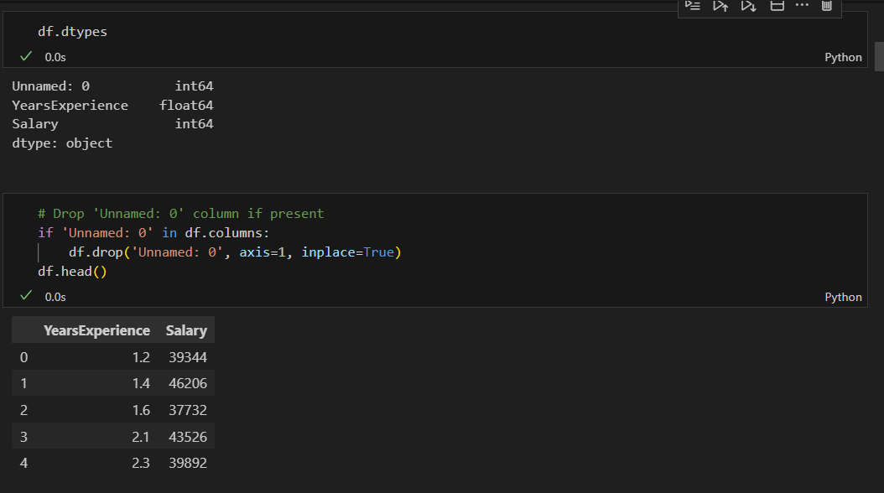

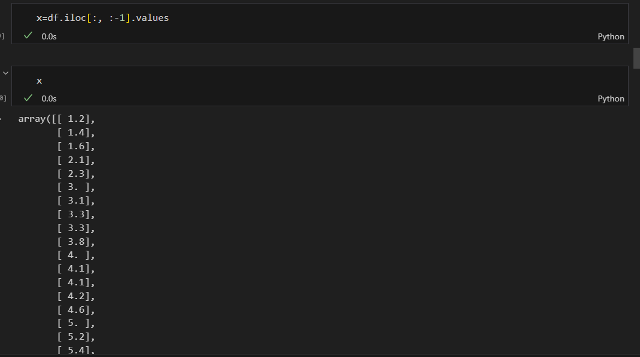

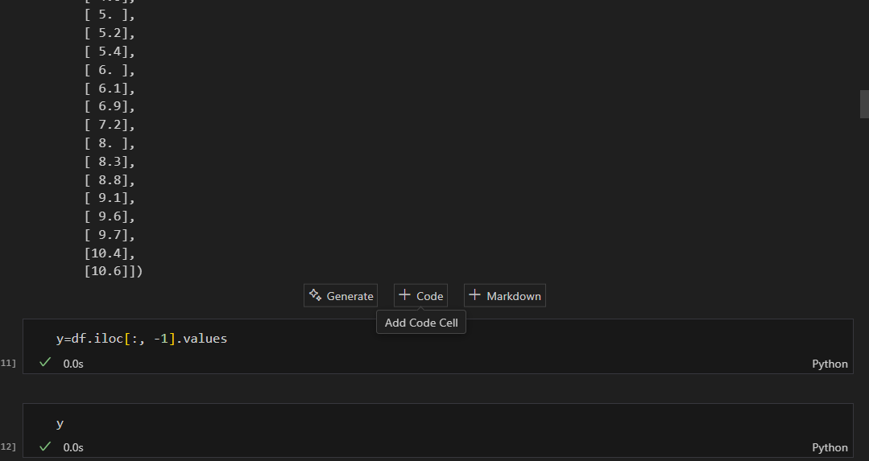

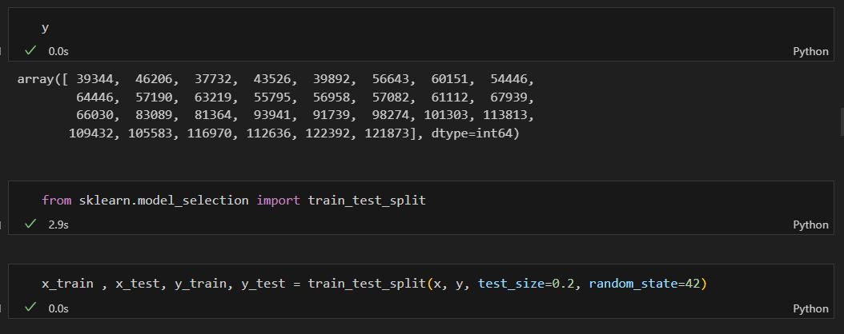

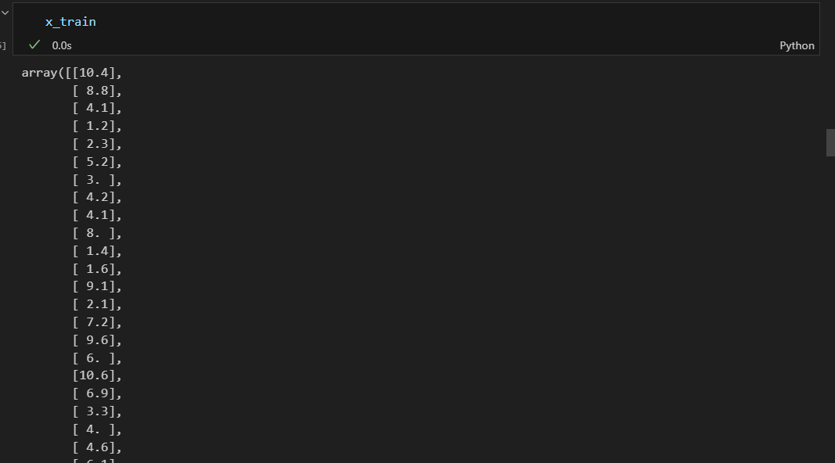

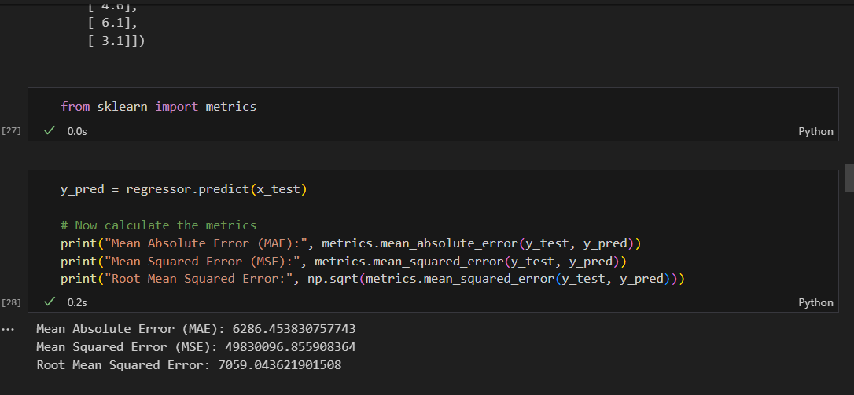

# Visualize Salary vs Years of Experience

plt.figure(figsize=(10,6))

sns.scatterplot(x=df['YearsExperience'], y=df['Salary'], color='royalblue', s=80)

plt.title('Salary vs Years of Experience')

plt.xlabel('Years of Experience')

plt.ylabel('Salary')

plt.grid(True)

plt.show()

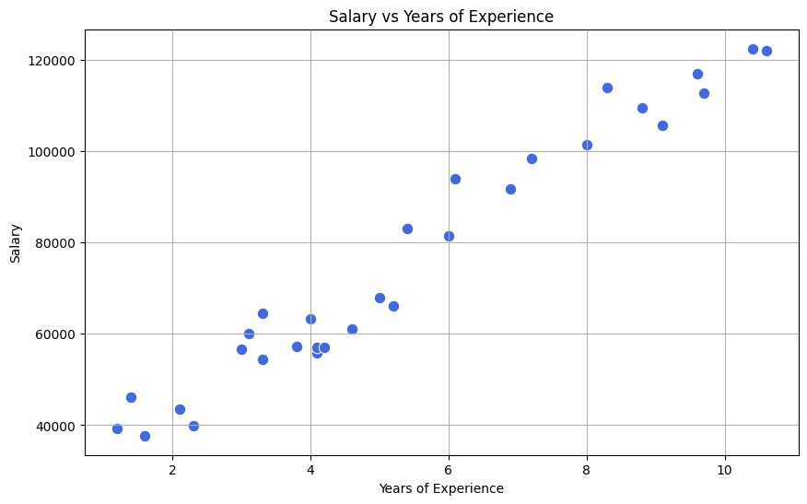

# Regression line plot

plt.figure(figsize=(10,6))

sns.regplot(x=df['YearsExperience'], y=df['Salary'], color='darkorange', line_kws={'color':'red'})

plt.title('Regression: Salary vs Years of Experience')

plt.xlabel('Years of Experience')

plt.ylabel('Salary')

plt.grid(True)

plt.show()

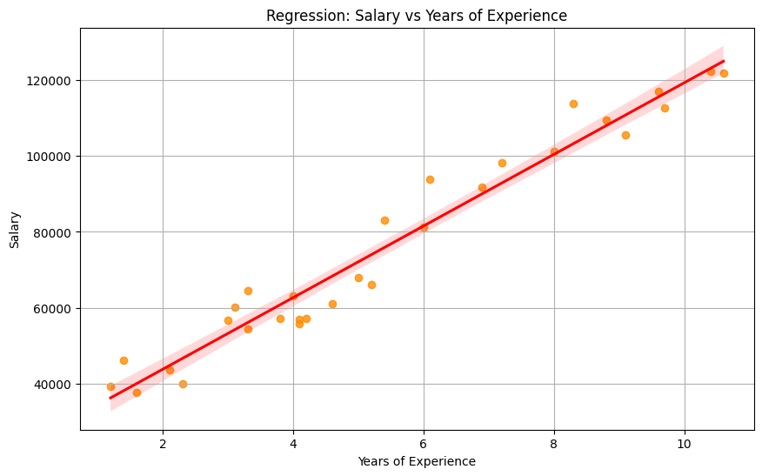

# More graphical presentations for Salary dataset

plt.figure(figsize=(10,6))

sns.histplot(df['Salary'], bins=10, kde=True, color='teal')

plt.title('Distribution of Salary')

plt.xlabel('Salary')

plt.ylabel('Frequency')

plt.grid(True)

plt.show()

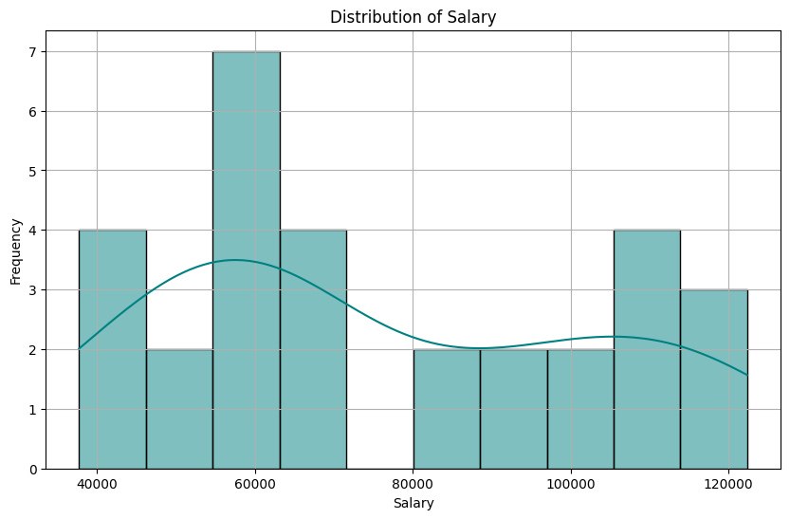

plt.figure(figsize=(10,6))

sns.boxplot(x=df['Salary'], color='orchid')

plt.title('Boxplot of Salary')

plt.xlabel('Salary')

plt.grid(True)

plt.show()

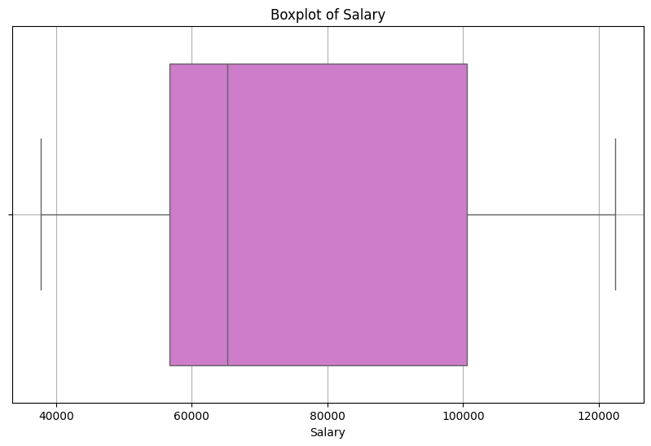

plt.figure(figsize=(10,6))

sns.kdeplot(df['YearsExperience'], shade=True, color='navy')

plt.title('KDE Plot of Years of Experience')

plt.xlabel('Years of Experience')

plt.ylabel('Density')

plt.grid(True)

plt.show()

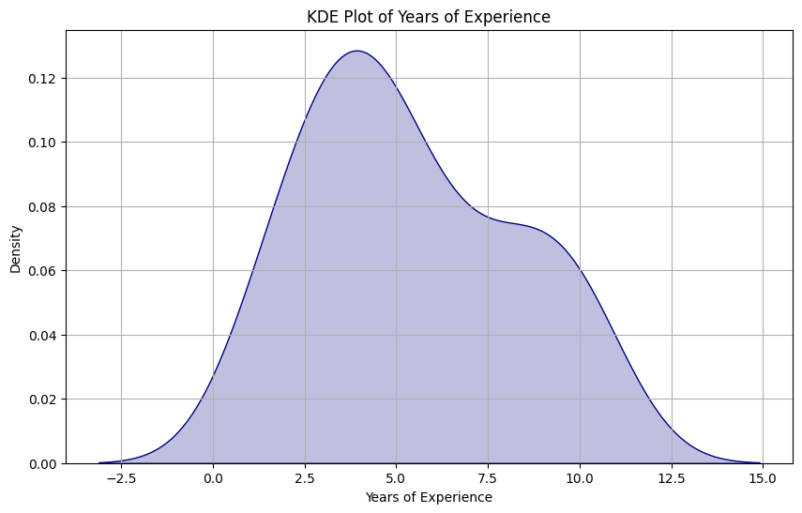

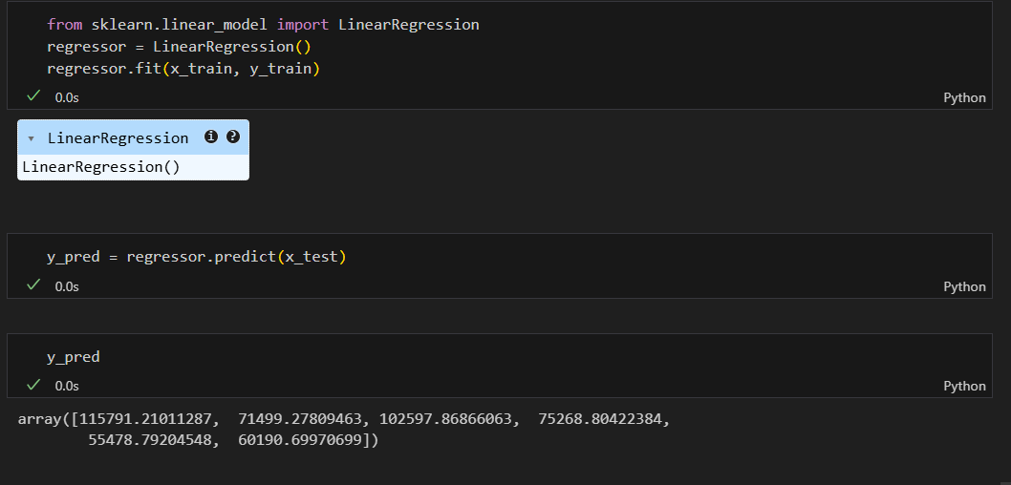

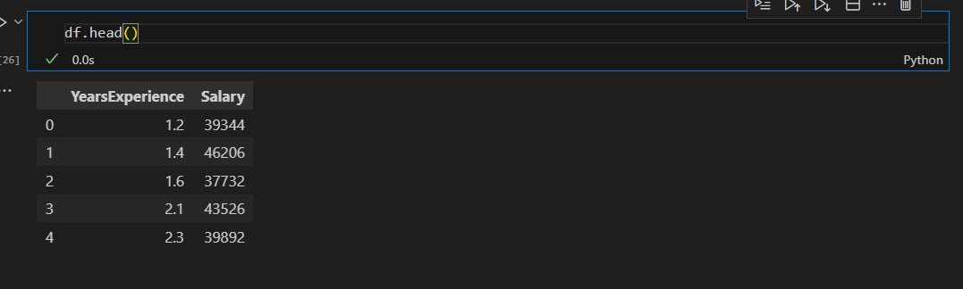

plt.scatter(x_train, y_train, color='green')

plt.plot(x_train,regressor.predict(x_train))

plt.show()

