

**AI ML(MCA 475)**

**Lab Assignment-05**

**BY**

**Himanshu Heda (24225013)**

**SUBMITTED TO**

**Prof. ManjulaShanbhog**

**SCHOOL OF SCIENCES**

**2024-2025**

# Multiple Regression on Tips Dataset

Libraries Used

import numpy as np

import pandas as pd

import matplotlib.pyplot as plt

import seaborn as sns

from sklearn.model_selection import train_test_split

from sklearn.linear_model import LinearRegression

from sklearn.metrics import r2_score,mean_squared_error

from scipy import stats

df=pd.read_csv("C:/Users/samdc/OneDrive/Desktop/AI ML/tips - tips.csv")

# Exploratory Dataset Analysis

df.head()

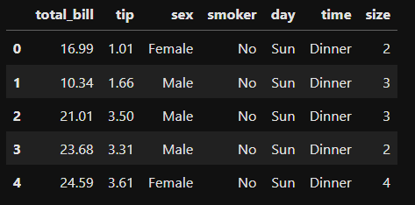

df.sample(7)

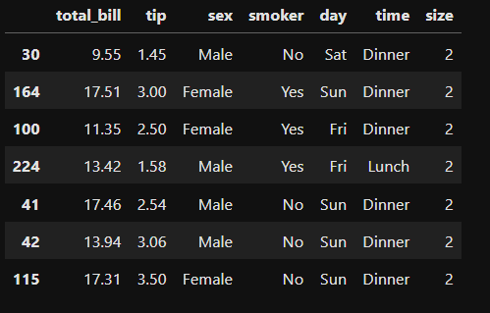

df.describe()

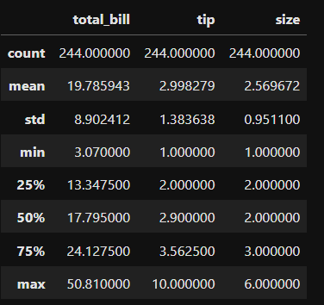

df.dtypes

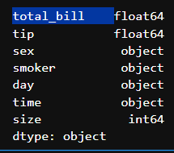

df.isnull().sum()

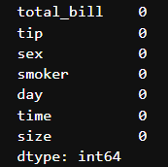

**Visualization**

**plt.figure(figsize=(8, 5))**

sns.histplot(df['total_bill'], bins=30, kde=True)

plt.title('Distribution of Total Bill')

plt.xlabel('Total Bill')

plt.ylabel('Frequency')

plt.show()

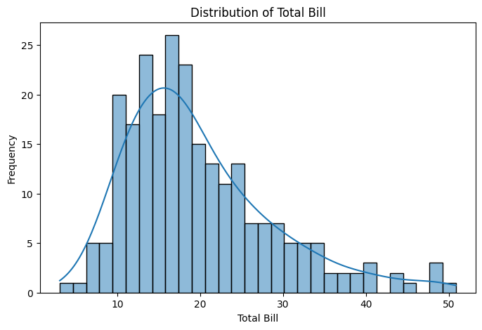

**plt.figure(figsize=(8, 5))**

sns.boxplot(x='day', y='tip', data=df)

plt.title('Tip Distribution by Day')

plt.xlabel('Day')

plt.ylabel('Tip')

plt.show()

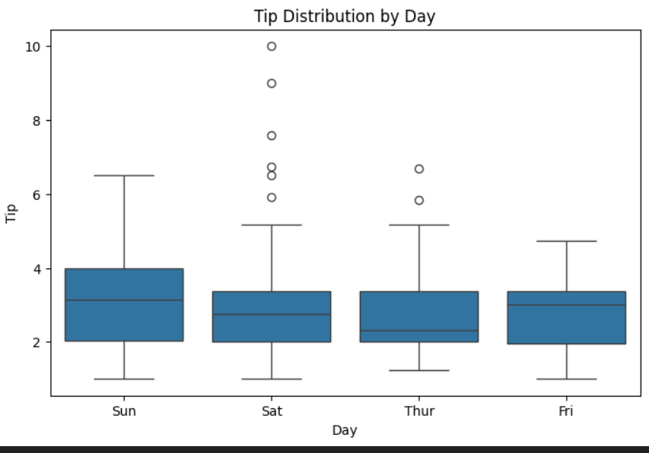

**plt.figure(figsize=(6, 4))**

sns.countplot(x='smoker', data=df)

plt.title('Count of Smokers vs Non-Smokers')

plt.show()

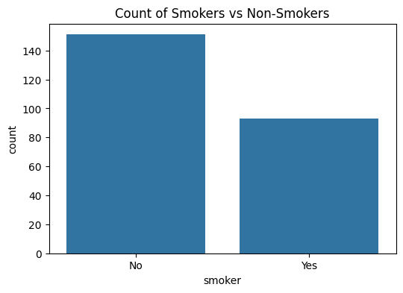

**plt.figure(figsize=(8, 5))**

sns.scatterplot(x='total_bill', y='tip', hue='sex', data=df)

plt.title('Tip vs Total Bill Colored by Sex')

plt.xlabel('Total Bill')

plt.ylabel('Tip')

plt.show()

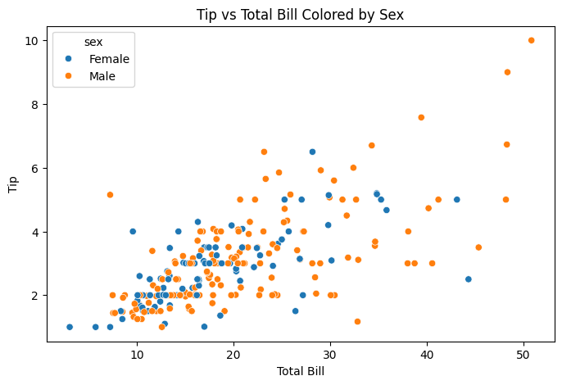

**numeric_df = df.select_dtypes(include=['float64', 'int64'])  # Select only numeric columns**

plt.figure(figsize=(8, 6))

sns.heatmap(numeric_df.corr(), annot=True, cmap='coolwarm')

plt.title('Correlation Heatmap of Numeric Features')

plt.show()

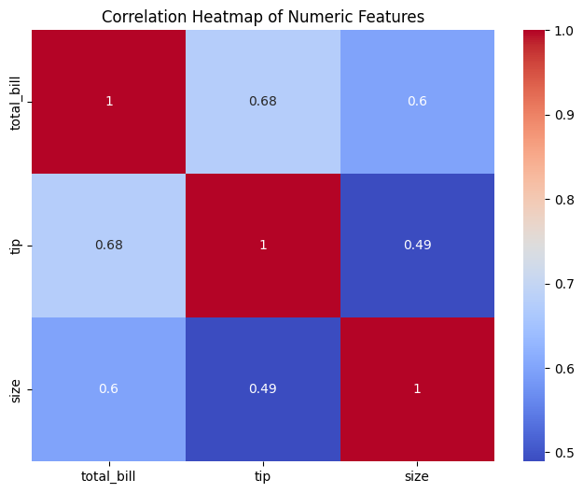

**Outlier detection (IQR and Z-score) for numerical columns**

num_cols=df.select_dtypes(include=[np.number]).columns

Q1=df[num_cols].quantile(0.25)

Q3=df[num_cols].quantile(0.75)

print("Quartile 1 :\n",Q1)

print("Quartile 3 :\n",Q3)

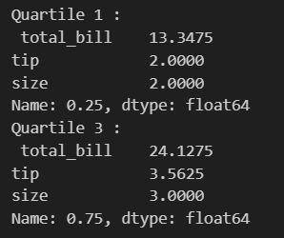

IQR=Q3-Q1

iqr_outlier_mask = (df[num_cols] < (Q1 - 1.5 * IQR)) | (df[num_cols] > (Q3 + 1.5 * IQR))

iqr_outlier=((df[num_cols]<Q1-(1.5*IQR)) | (df[num_cols]>Q3 +(1.5*IQR))).sum()

z = np.abs(stats.zscore(df[num_cols]))

zscore_outlier_mask = z > 3

outlier_zscore = (z > 3).sum(axis=0)

print("IQR outliers:\n", iqr_outlier)

print("Z-score outliers:\n", outlier_zscore)

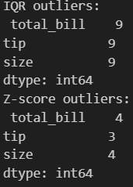

for col in num_cols:

    plt.figure(figsize=(10,4))

    plt.subplot(1,2,1)

    sns.histplot(df[col], kde=True)

    plt.title(f'Histogram: {col}')

    plt.subplot(1,2,2)

    sns.boxplot(x=df[col])

    plt.title(f'Boxplot: {col}')

    plt.tight_layout()

    plt.show()

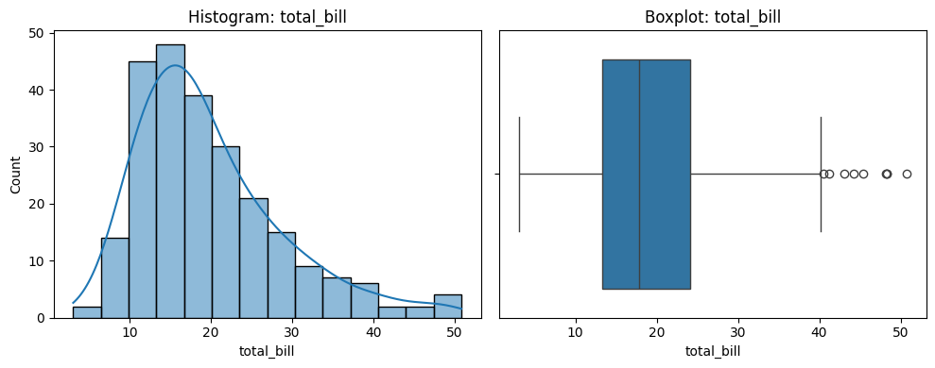

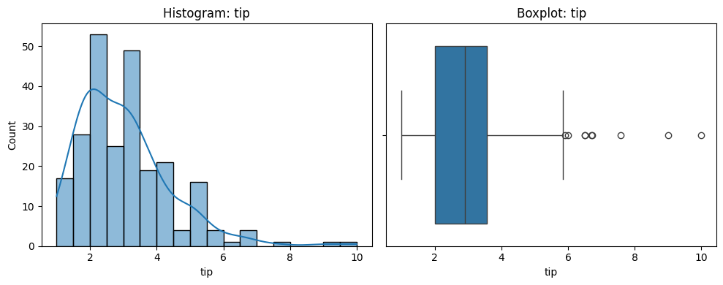



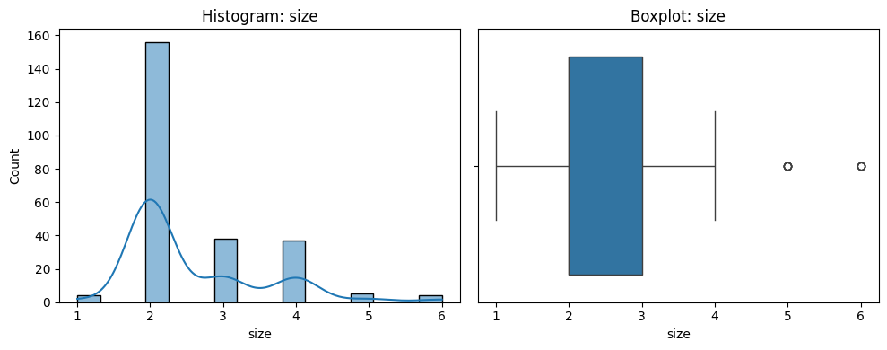

# Combine masks: rows with outliers by either method

combined_outlier_mask = iqr_outlier_mask.any(axis=1) | zscore_outlier_mask.any(axis=1)

# Create cleaned dataset by removing outlier rows

df_cleaned = df[~combined_outlier_mask].copy()

# Check shapes before and after

print("Original shape:", df.shape)

print("Cleaned shape:", df_cleaned.shape)



## Multilinear regression

X = pd.get_dummies(df_cleaned.drop('tip', axis=1), drop_first=True)

y = df_cleaned['tip']

X_train, X_test, y_train, y_test = train_test_split(X, y, test_size=0.2, random_state=42)

model = LinearRegression()

model.fit(X_train, y_train)

y_pred = model.predict(X_test)

print("Mean Squared Error:", mse)

print("R-squared:", r2)



print("Coefficients:", model.coef_)

print("Intercept:", model.intercept_)



# Scatter plot: Actual vs Predicted

plt.figure(figsize=(8, 6))

sns.scatterplot(x=y_test, y=y_pred)

plt.xlabel('Actual Tip')

plt.ylabel('Predicted Tip')

plt.title('Actual vs Predicted Tips')

plt.plot([y_test.min(), y_test.max()], [y_test.min(), y_test.max()], 'r--')  # Perfect fit line

plt.show()

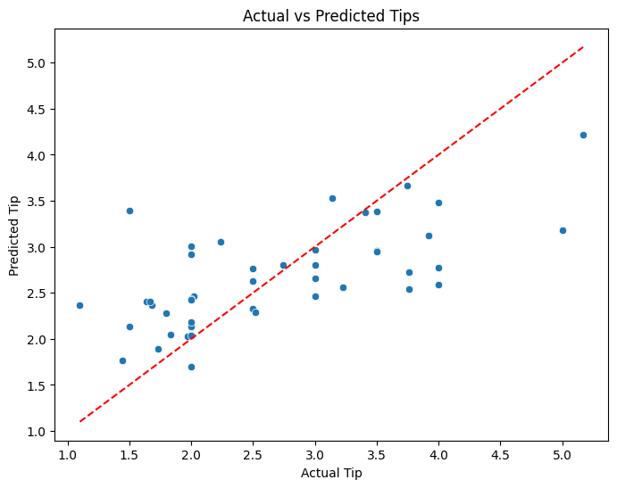

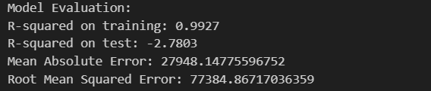

# Histogram: Residuals

residuals = y_test - y_pred

plt.figure(figsize=(8, 6))

sns.histplot(residuals, kde=True, bins=20)

plt.title('Residuals Distribution')

plt.xlabel('Residuals')

plt.show()

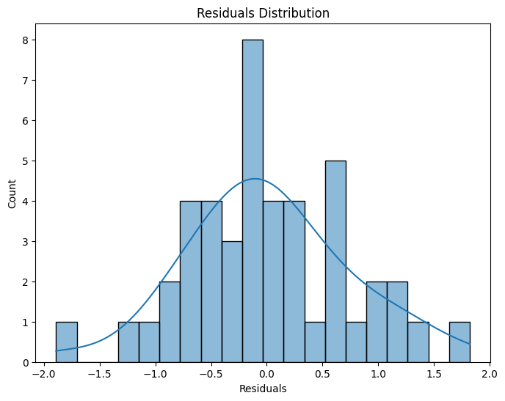

plt.plot(y_test.values, label='Actual', color='red', linewidth=2)

plt.scatter(range(len(y_pred)), y_pred, label='Predicted', color='blue')

plt.title('Actual vs Predicted')

plt.xlabel('Sample Index')

plt.ylabel('Target Value')

plt.show()

