

**Advance Python Programming**

**MCA-372**

**CIA – 01**

***BY***

**HIMANSHU HEDA (24225013)**

**SUBMITTED TO**

**Dr. Manjula Shannhog**

**SCHOOL OF SCIENCES**

**2024-25**

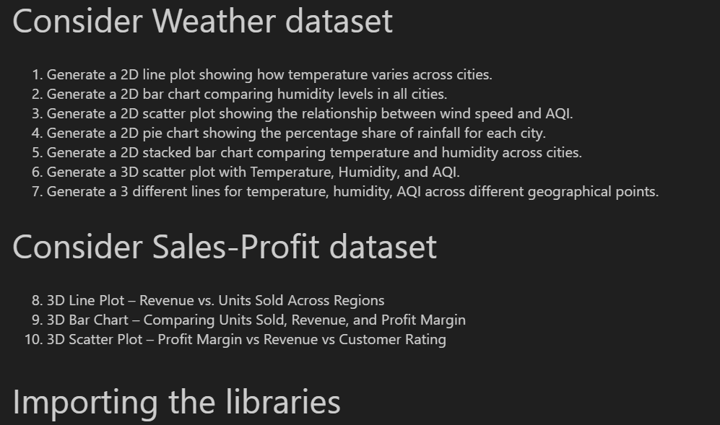

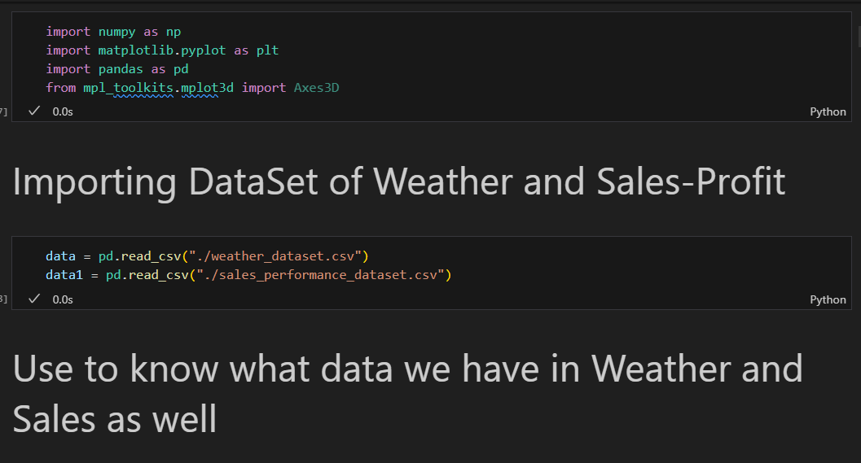

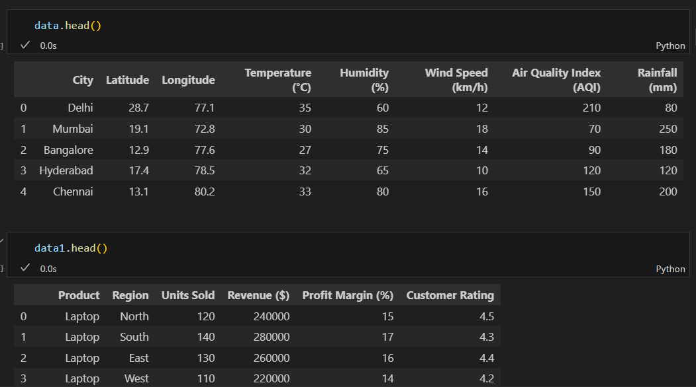

import numpy as np

import matplotlib.pyplot as plt

import pandas as pd

from mpl_toolkits.mplot3d import Axes3D

data = pd.read_csv("./weather_dataset.csv")

data1 = pd.read_csv("./sales_performance_dataset.csv")

data.head()

data1.head()

# 1. 2D Line plot - Temperature Variation across cities (Line plot)

plt.figure(figsize=(15, 5))

plt.plot(data['City'], data['Temperature (°C)'], marker='o', linestyle='-', color='black')

plt.xlabel("Cities")

plt.ylabel("Temperature (°C)")

plt.title("Temperature Variation Across Cities")

plt.grid()

plt.show()

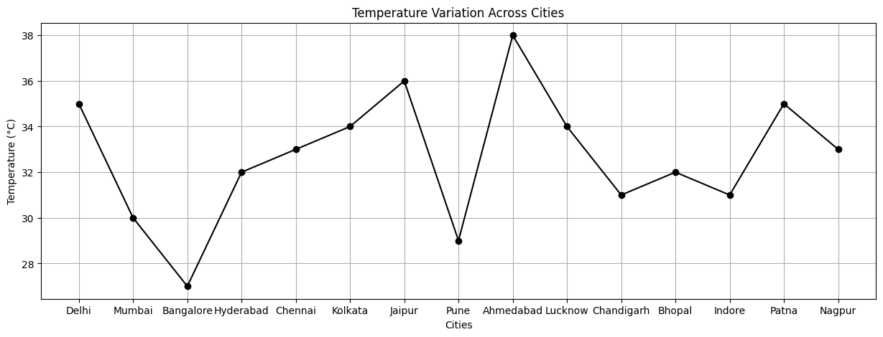

# 2. 2D Bar Chart - Humidity Levels

plt.figure(figsize=(18, 5))

plt.bar(data['City'], data['Humidity (%)'], color='red')

plt.xlabel("Cities")

plt.ylabel("Humidity (%)")

plt.title("Humidity Levels Across Cities")

plt.show()

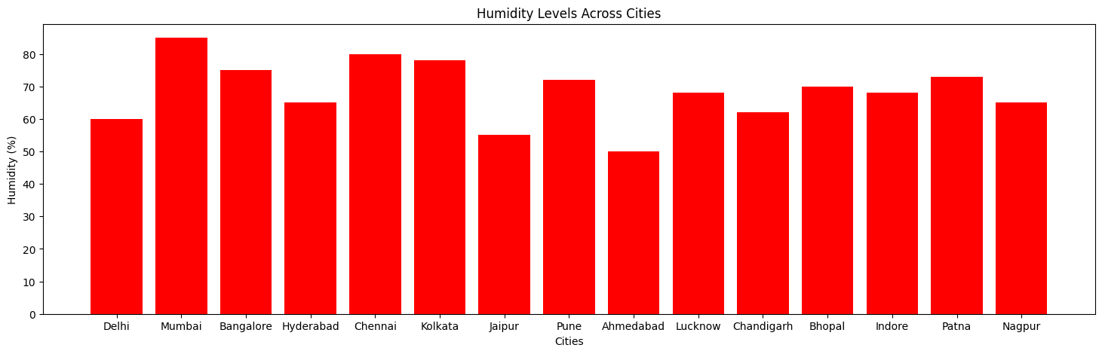

# 3. 2D Scatter Plot - Wind Speed vs AQI

plt.figure(figsize=(10, 5))

plt.scatter(data['Wind Speed (km/h)'], data['Air Quality Index (AQI)'], color='g')

plt.xlabel("Wind Speed (km/h)")

plt.ylabel("Air Quality Index (AQI)")

plt.title("Wind Speed vs AQI")

plt.grid()

plt.show()

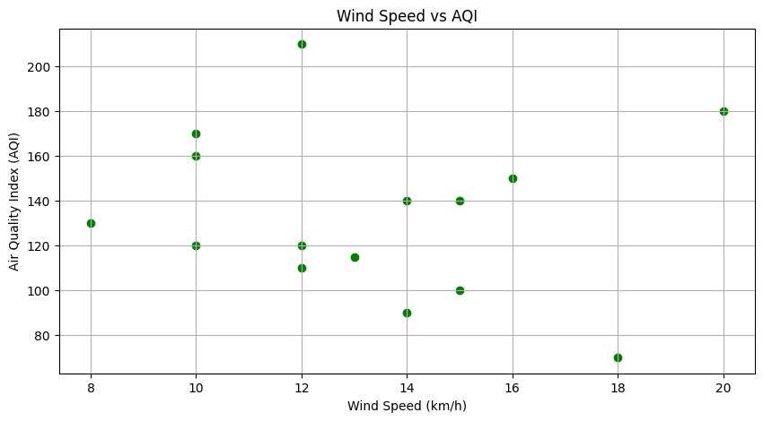

# 4. 2D Pie Chart - Rainfall Distribution

plt.figure(figsize=(7, 7))

plt.pie(data['Rainfall (mm)'], labels=data['City'], autopct='%1.1f%%', colors=['red', 'green', 'blue', 'w', 'yellow'])

plt.title("Rainfall Distribution Across Cities")

plt.show()

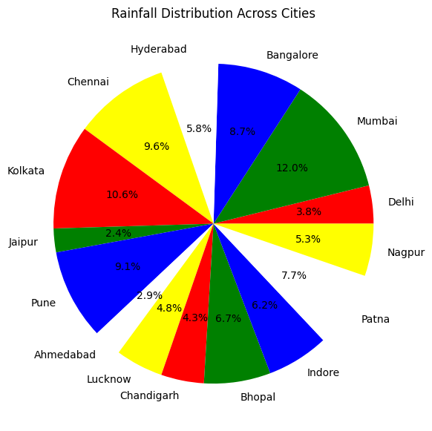

# 5. 2D Stacked Bar Chart - Temperature & Humidity

plt.figure(figsize=(18, 5))

bar_width = 0.5

plt.bar(data['City'], data['Temperature (°C)'], color='r', label='Temperature')

plt.bar(data['City'], data['Humidity (%)'], color='g', bottom=data['Temperature (°C)'], label='Humidity')

plt.xlabel("Cities")

plt.ylabel("Values")

plt.title("Temperature and Humidity Across Cities")

plt.legend()

plt.show()

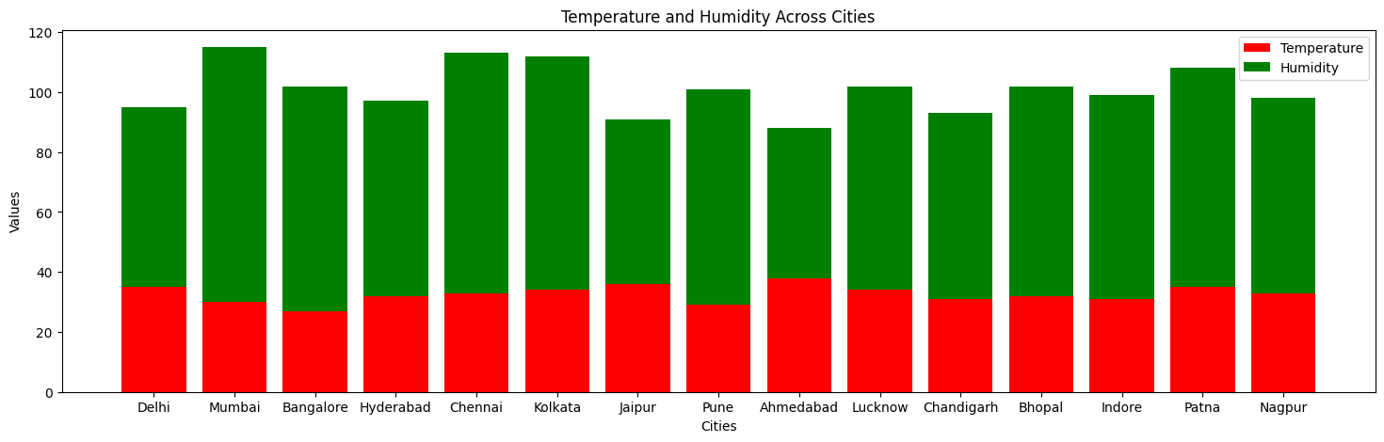

# 6. 3D Scatter Plot - Temperature, Humidity, AQI

fig = plt.figure(figsize=(8, 6))

ax = fig.add_subplot(111, projection='3d')

ax.scatter(data['Temperature (°C)'], data['Humidity (%)'], data['Air Quality Index (AQI)'], color='orange')

ax.set_xlabel("Temperature (°C)")

ax.set_ylabel("Humidity (%)")

ax.set_zlabel("AQI")

ax.set_title("3D Scatter Plot - Temperature, Humidity, AQI")

plt.show()

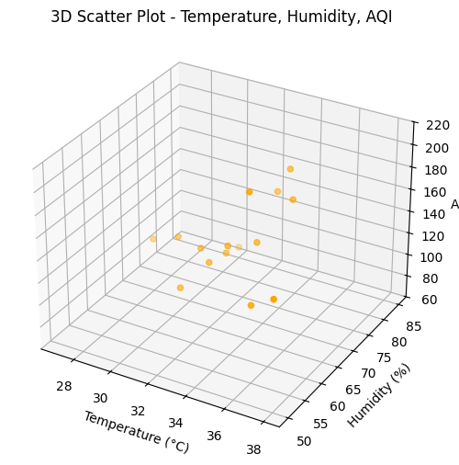

# 7. 2D Line plot - Temperature, Humidity, AQI over Geographic Points

plt.figure(figsize=(12, 5))

plt.plot(data['Latitude'], data['Temperature (°C)'], marker='o', linestyle='-', color='r', label='Temperature')

plt.plot(data['Latitude'], data['Humidity (%)'], marker='s', linestyle='-', color='b', label='Humidity')

plt.plot(data['Latitude'], data['Air Quality Index (AQI)'], marker='^', linestyle='-', color='g', label='AQI')

plt.xlabel("Latitude")

plt.ylabel("Values")

plt.title("Variation of Temperature, Humidity, and AQI")

plt.legend()

plt.grid()

plt.show()

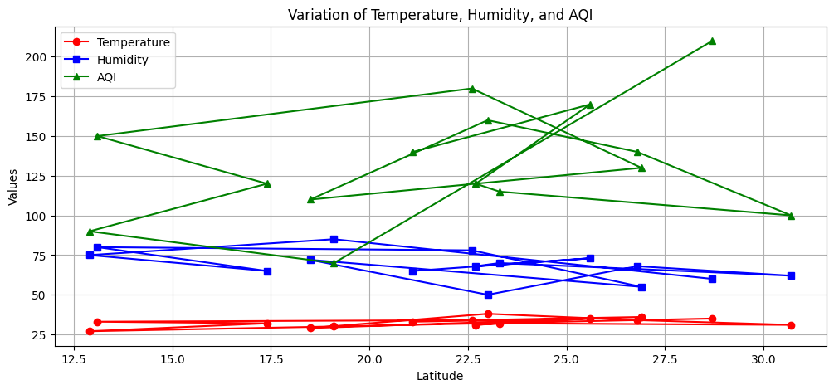

#8: 3D Line Plot – Revenue vs. Units Sold Across Regions

import pandas as pd

import matplotlib.pyplot as plt

from mpl_toolkits.mplot3d import Axes3D

revenue = df["Revenue ($)"]

units_sold = df["Units Sold"]

regions = df["Region"]

# Convert regions to numeric indices for plotting

region_indices = range(len(regions))  # Convert categorical region names to numeric indices

# Create a 3D line plot

fig = plt.figure(figsize=(10, 7))

ax = fig.add_subplot(111, projection='3d')

ax.plot(region_indices, units_sold, revenue, marker='o', linestyle='-', color='blue', label="Revenue vs. Units Sold")

# Label axes

ax.set_xlabel("Region")

ax.set_ylabel("Units Sold")

ax.set_zlabel("Revenue ($)")

ax.set_title("3D Line Plot – Revenue vs. Units Sold Across Regions")

ax.set_xticks(region_indices)

ax.set_xticklabels(regions, rotation=45)

plt.legend()

plt.show()

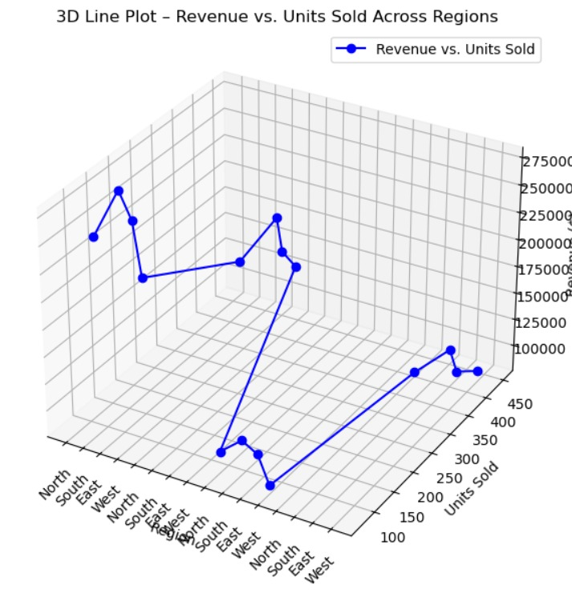

# 9. 3D Bar Chart - Units Sold, Revenue, Profit Margin

fig = plt.figure(figsize=(8, 6))

ax = fig.add_subplot(111, projection='3d')

x_indexes = np.arange(len(data1['Region']))

ax.bar(x_indexes, data1['Units Sold'], zs=0, zdir='y', color='b', label='Units Sold')

ax.bar(x_indexes, data1['Revenue ($)'], zs=1, zdir='y', color='r', label='Revenue')

ax.bar(x_indexes, data1['Profit Margin (%)'], zs=2, zdir='y', color='g', label='Profit Margin')

ax.set_xticks(x_indexes)

ax.set_xticklabels(data1['Region'])

ax.set_xlabel("Regions")

ax.set_ylabel("Category")

ax.set_zlabel("Values")

ax.set_title("3D Bar Chart - Sales Data Comparison")

ax.legend()

plt.show()

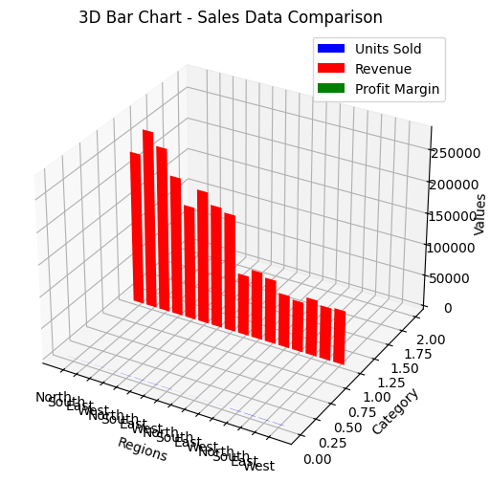

# 10. 3D Scatter Plot - Profit Margin vs Revenue vs Customer Rating

fig = plt.figure(figsize=(8, 6))

ax = fig.add_subplot(111, projection='3d')

ax.scatter(data1['Profit Margin (%)'], data1['Revenue ($)'], data1['Customer Rating'], color='orange')

ax.set_xlabel("Profit Margin (%)")

ax.set_ylabel("Revenue")

ax.set_zlabel("Customer Rating")

ax.set_title("3D Scatter Plot - Profit Margin vs Revenue vs Customer Rating")

plt.show()

