

**Advance Python Programming**

**MCA-372**

**Assignment – 06**

***BY***

**HIMANSHU HEDA (24225013)**

**SUBMITTED TO**

**Dr. Manjula Shannhog**

**SCHOOL OF SCIENCES**

**2024-25**

**Importing The Libraries**

import numpy as np

import matplotlib.pyplot as plt

import matplotlib.animation as animation

from IPython.display import HTML

**Sol 1 : -- Lets Animate the Circle With the Help of Animation Function**

plt.ioff()

fig, ax = plt.subplots()

ax.set_xlim(-5, 5)

ax.set_ylim(-5, 5)

circle = plt.Circle((0, 0), 1, fill=False, edgecolor='blue')

ax.add_patch(circle)

def update(frame):

    circle.set_radius(1 + 0.5 * np.sin(frame / 20))

    return circle,

ani = animation.FuncAnimation(fig, update, frames=np.arange(0, 100, 1), interval=50, blit=True)

HTML(ani.to_jshtml())

**Output:**

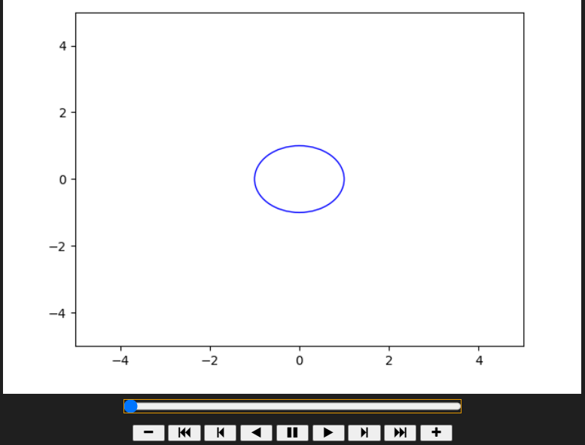

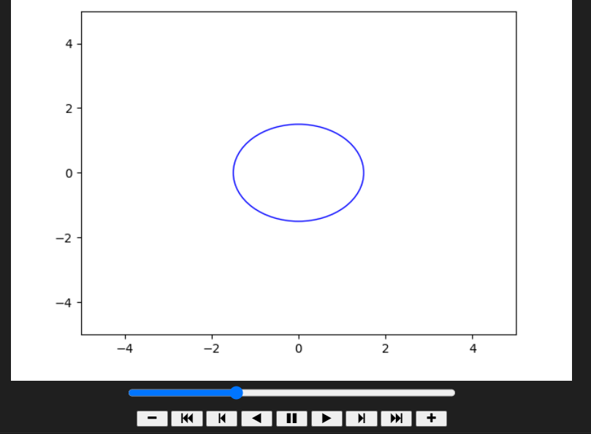

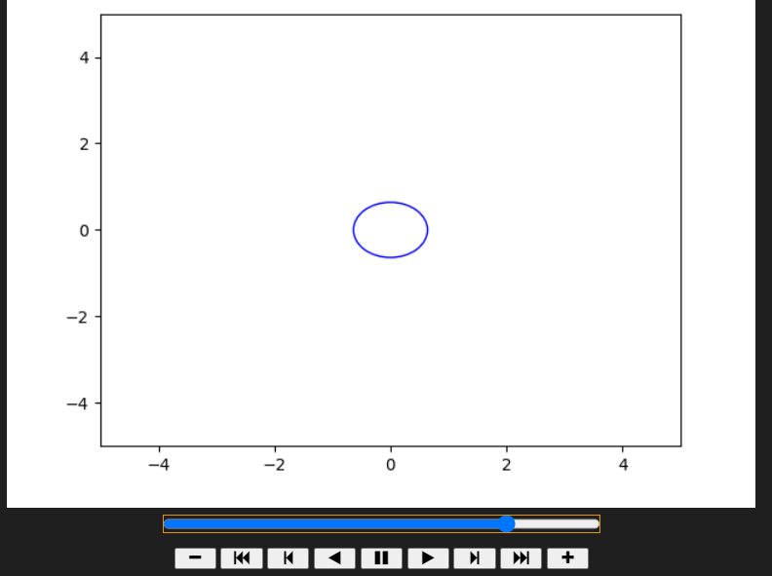

**Sol 2 :-- Lets Animate the Dot animation which move from right to left Diagonal**

plt.ioff()

fig, ax = plt.subplots()

ax.set_xlim(-5, 5)

ax.set_ylim(-5, 5)

dot, = ax.plot([], [], 'ro')

def update(frame):

    x = 5 - frame / 10

    y = 5 - frame / 10

    dot.set_data(x, y)

    return dot,

ani = animation.FuncAnimation(fig, update, frames=np.arange(0, 100, 1), interval=50, blit=True)

HTML(ani.to_jshtml())

**Output :**

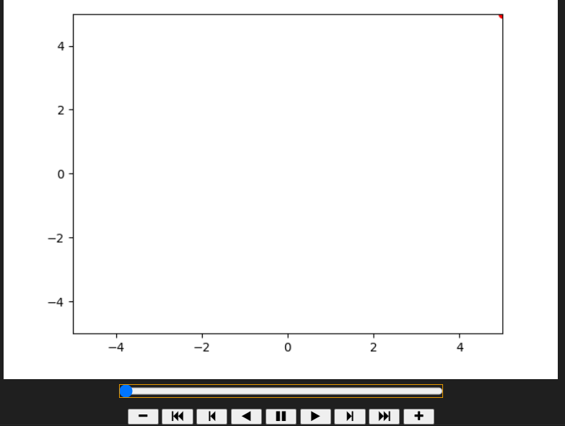

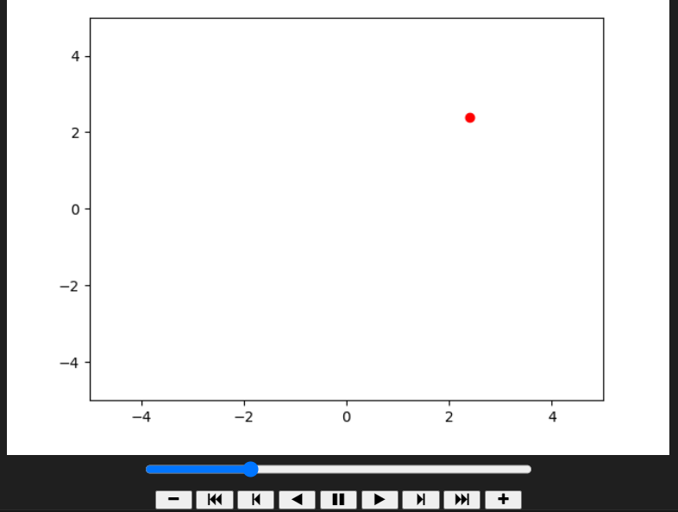

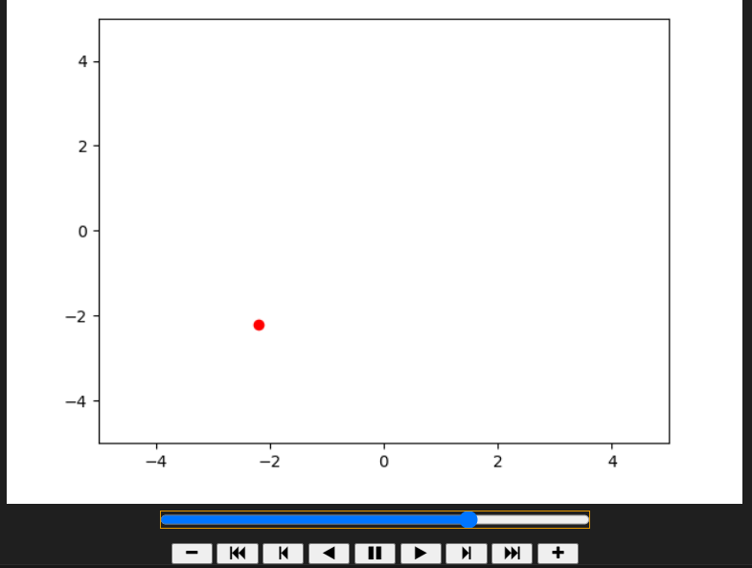

**Sol 3:-- Lets Draw the House**

import matplotlib.pyplot as plt

plt.ioff()

fig, ax = plt.subplots(figsize=(6, 6))

ax.set_xlim(-2, 2)

ax.set_ylim(-2, 2)

# Draw the house

plt.plot([-1, 1], [-1, -1], 'k-', linewidth=3)  # Bottom line

plt.plot([-1, -1], [-1, 0.5], 'k-', linewidth=3)  # Left wall

plt.plot([1, 1], [-1, 0.5], 'k-', linewidth=3)  # Right wall

plt.plot([-1, 1], [0.5, 0.5], 'k-', linewidth=3)  # Top of house

plt.plot([-1, 0], [0.5, 1.5], 'k-', linewidth=3)  # Left roof

plt.plot([1, 0], [0.5, 1.5], 'k-', linewidth=3)  # Right roof

# Draw the door

plt.plot([-0.2, -0.2], [-1, -0.5], 'k-', linewidth=3)  # Left side of door

plt.plot([0.2, 0.2], [-1, -0.5], 'k-', linewidth=3)  # Right side of door

plt.plot([-0.2, 0.2], [-0.5, -0.5], 'k-', linewidth=3)  # Top of door

plt.show()

**Output**

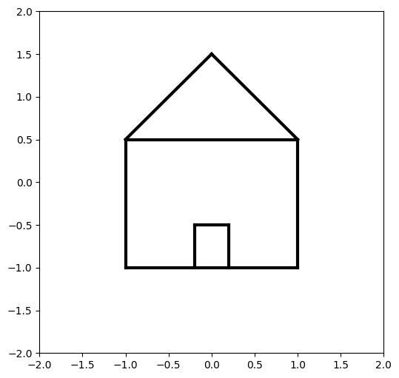

**Sol 4 :-- Plot all the states Except Rajasthan and Gujarat**

**Importing the Libraries**

import geopandas as gpd

import matplotlib.pyplot as plt

**Lets Load the Shape File to Fetch the Data**

india = gpd.read_file("./India/Indian_States.shp")

**Lets Check the Data Which is Present**

india.head()



india.info()

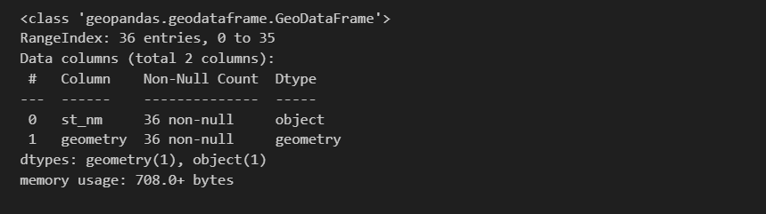

plt.ioff()

# Filter out Rajasthan and Gujarat

excepted_states = india[~india["st_nm"].isin(["Rajasthan", "Gujarat"])]

fig, ax = plt.subplots(figsize=(15, 15))

excepted_states.plot(ax=ax, color="lightgreen", edgecolor="black")

plt.title("All States Except Rajasthan and Gujarat")

plt.show()

**Output**

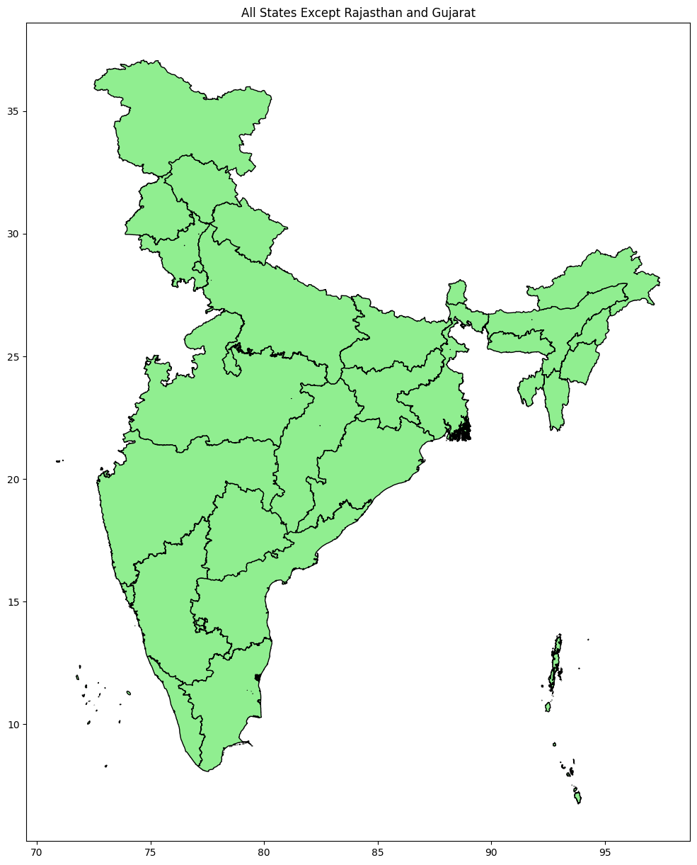

**Sol 5 : --Lets Draw only Western inidan states in a map**

plt.ioff()

# Select Western Indian states

western_states = india[india["st_nm"].isin(["Rajasthan", "Gujarat", "Maharashtra", "Goa"])]

# Define colors for each state

colors = {

    "Rajasthan": "red",

    "Gujarat": "green",

    "Maharashtra": "blue",

    "Goa": "purple"

}

fig, ax = plt.subplots(figsize=(15, 15))

for state_name, color in colors.items():

    state = western_states[western_states["st_nm"] == state_name]

    state.plot(ax=ax, color=color, edgecolor="black", label=state_name)

plt.title("Western Indian States")

plt.legend()

plt.show()

**Output**

