

**Advance Python Programming**

**MCA-372**

**Assignment – 01**

***BY***

**HIMANSHU HEDA (24225013)**

**SUBMITTED TO**

**Dr. Manjula Shannhog**

**SCHOOL OF SCIENCES**

**2024-25**

**3D Axes :**

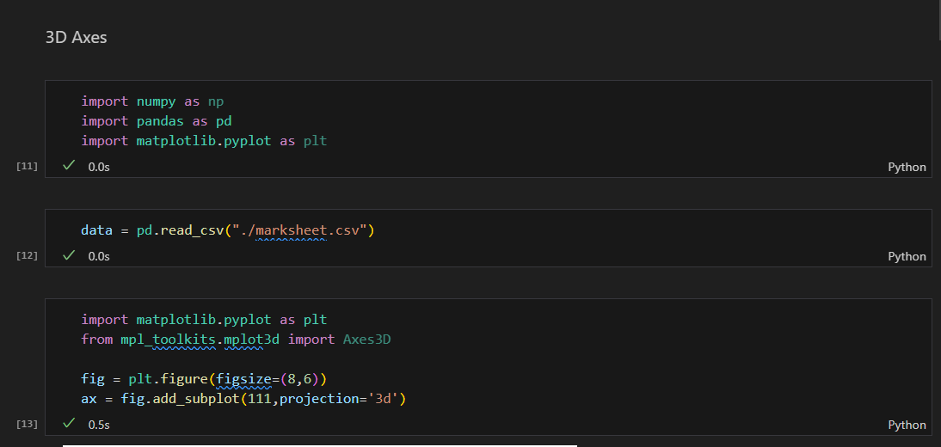

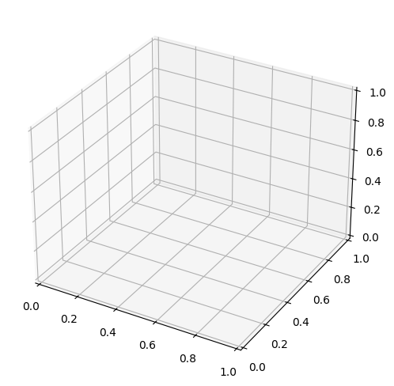

import matplotlib.pyplot as plt

import numpy as np

from mpl_toolkits.mplot3d import Axes3D

fig = plt.figure(figsize=(8,6))

ax = fig.add_subplot(111,projection='3d')

z_sci = np.zeros(len(data['id']))

z_math = np.ones(len(data['id']))

ax.plot(data['id'],data['Science'],z_sci,color='green',label='Science')

ax.plot(data['id'],data['Maths'],z_math,color='red',linestyle='dotted',label='Maths')

ax.set_xlabel("ID")

ax.set_ylabel("Marks")

ax.set_zlabel("Subject")

plt.title("3D plot of marks of students in Science and Maths")

ax.legend()

plt.show()

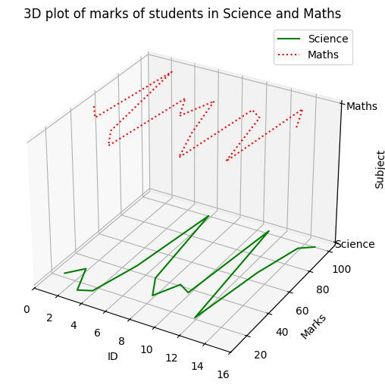

z_sci = np.zeros(len(data['id']))

z_math = np.ones(len(data['id']))

z_hist = np.full(len(data['id']),2)

fig = plt.figure(figsize=(8,6))

ax = fig.add_subplot(111,projection='3d')

ax.plot(data['id'],data['Science'],z_sci,color='green',label='Science')

ax.plot(data['id'],data['Maths'],z_math,color='red',linestyle='dotted',label='Maths')

ax.plot(data['id'],data['History'],z_hist,color='blue',linestyle='dotted',label='History')

ax.set_xlabel("ID")

ax.set_ylabel("Marks")

ax.set_zlabel("Subject")

for i in range(len(data['id'])):

    ax.text(data['id'].values[i],data['Science'].values[i],z_sci[i],data['id'].values[i])

    ax.text(data['id'].values[i],data['Maths'].values[i],z_sci[i],data['id'].values[i])

    ax.text(data['id'].values[i],data['History'].values[i],z_sci[i],data['id'].values[i])

ax.set_zticks([0,1,2])

ax.set_zticklabels(['Science','Maths','History'])

plt.title("3D plot of marks of students in Science, Maths and History")

ax.legend()

plt.show()

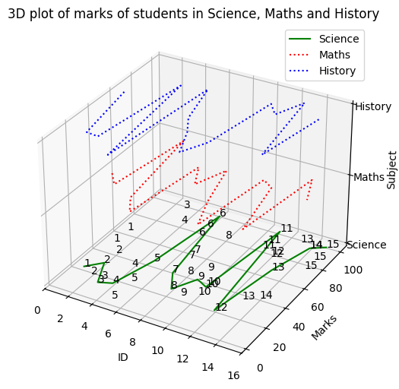

from mpl_toolkits.mplot3d import Axes3D

fig=plt.figure(figsize=(20,15))

ax=fig.add_subplot(121,projection='3d')

ax1=fig.add_subplot(122,projection='3d')

z_sci =np.zeros(len(data['id']))

z_maths=np.ones(len(data['id']))

z_hist=np.multiply(z_maths,2)

ax.plot(data['id'],data['Science'],z_sci,color='green',label='Science')

ax.plot(data['id'],data['Maths'],z_maths,color='red',linestyle="dashdot",label='Maths')

ax.plot(data['id'],data['History'],z_hist,color='blue',linestyle="dotted",label='History')

ax1.plot(data['id'],data['English'],z_sci,color='blue',linestyle="dashdot",label='English')

ax1.plot(data['id'],data['Maths'],z_maths,color='green',linestyle="dotted",label='Maths')

for i in range(len(data['id'])):

    ax.text(data['id'].values[i],data['Science'].values[i],z_sci[i],data['Science'].values[i])

    ax.text(data['id'].values[i],data['Maths'].values[i],z_maths[i],data['Maths'].values[i])

    ax.text(data['id'].values[i],data['History'].values[i],z_hist[i],data['History'].values[i])

    ax1.text(data['id'].values[i],data['English'].values[i],z_sci[i],data['English'].values[i])

    ax1.text(data['id'].values[i],data['Maths'].values[i],z_maths[i],data['Maths'].values[i])

ax.set_xlabel('ID')

ax1.set_xlabel('ID')

ax.set_ylabel('Marks')

ax1.set_ylabel('Marks')

ax.set_zticks([0,1,2])

ax1.set_zticks([0,1,])

ax.set_zticklabels(["Science","Maths","History"])

ax1.set_zticklabels(["English","Maths"])

ax.set_title('3d Marks Graph')

ax1.set_title('3d Marks Graph')

ax.legend()

ax1.legend()

plt.show()

