

**Advance Python Programming**

**MCA-372**

**Assignment – 02**

***BY***

**HIMANSHU HEDA (24225013)**

**SUBMITTED TO**

**Dr. Manjula Shannhog**

**SCHOOL OF SCIENCES**

**2024-25**

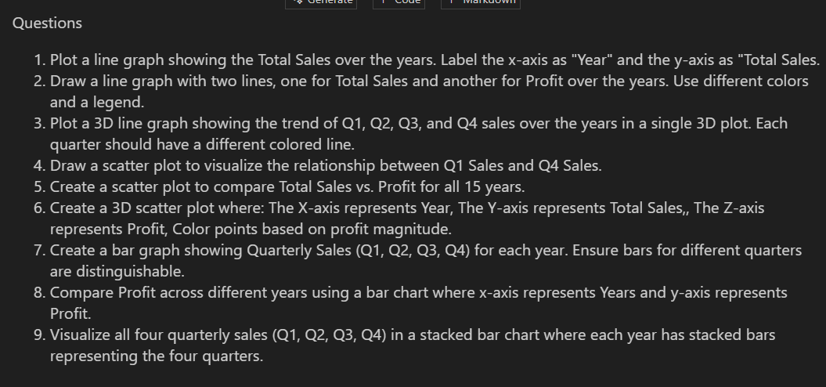

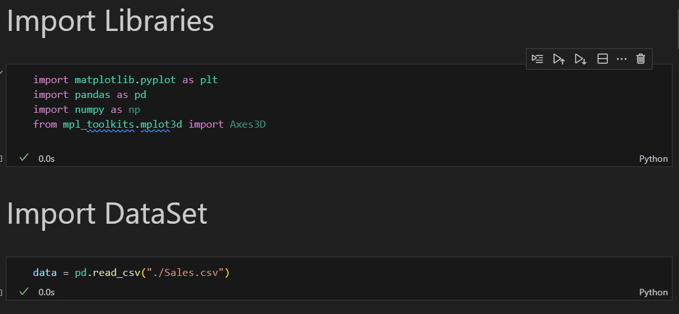

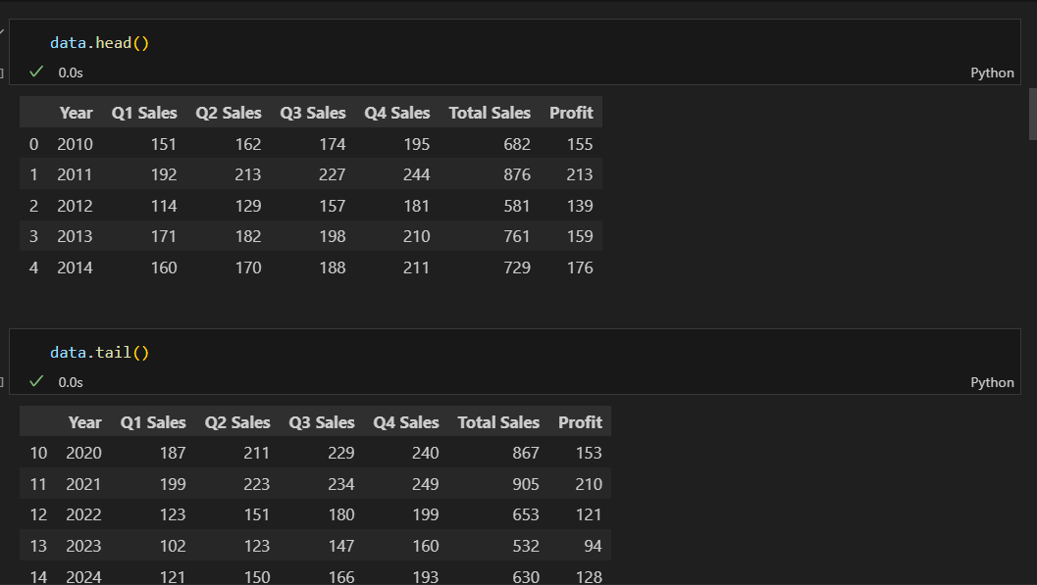

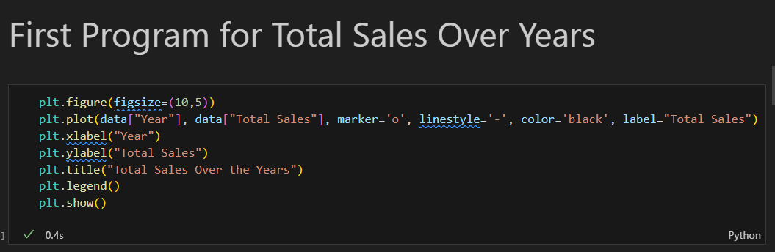

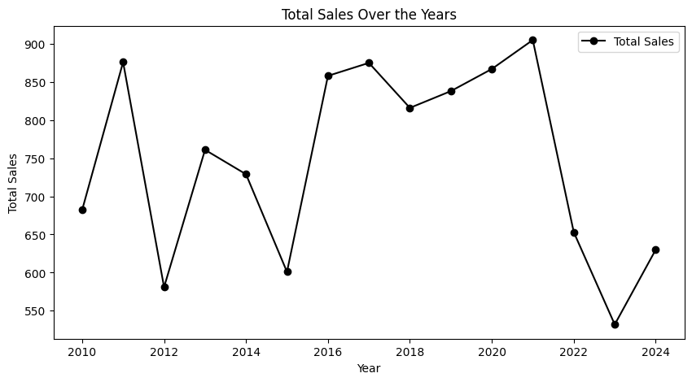

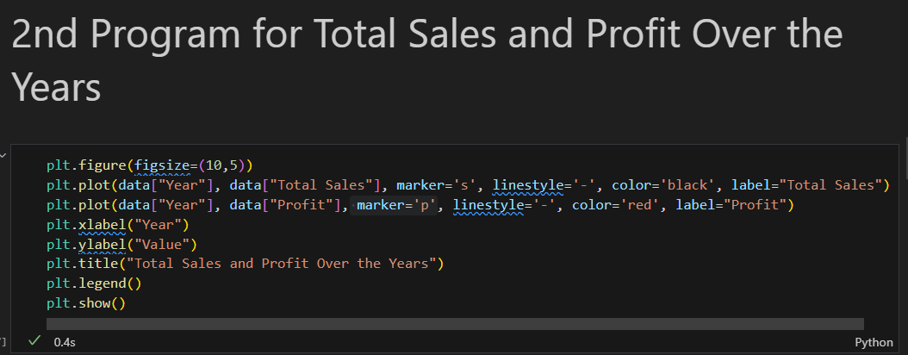

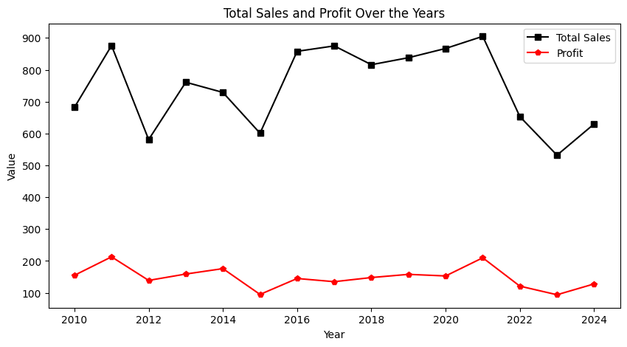

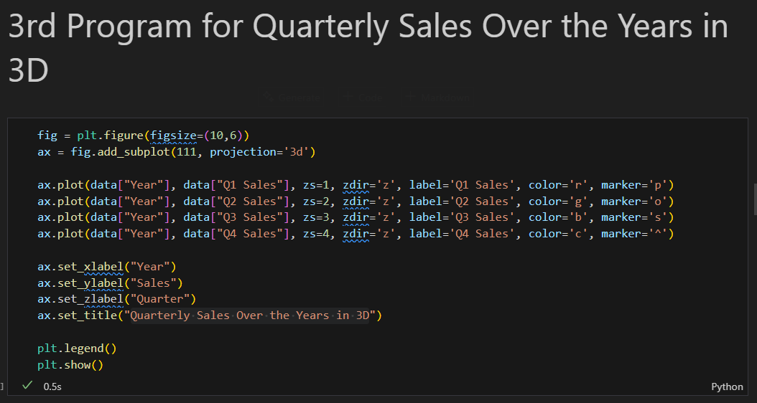

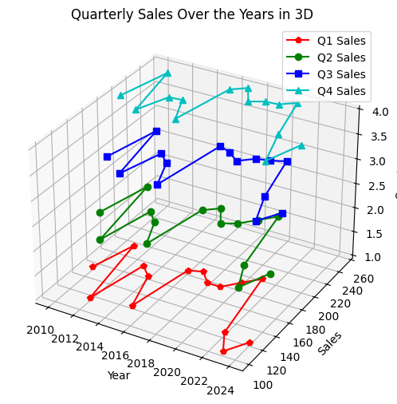

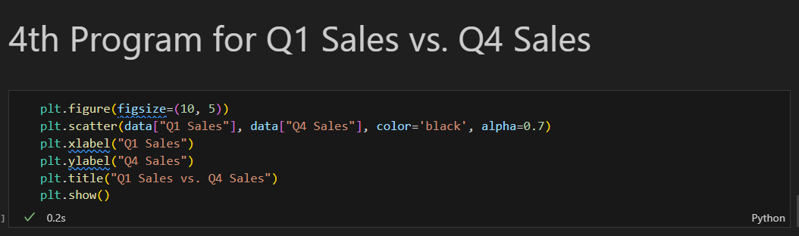

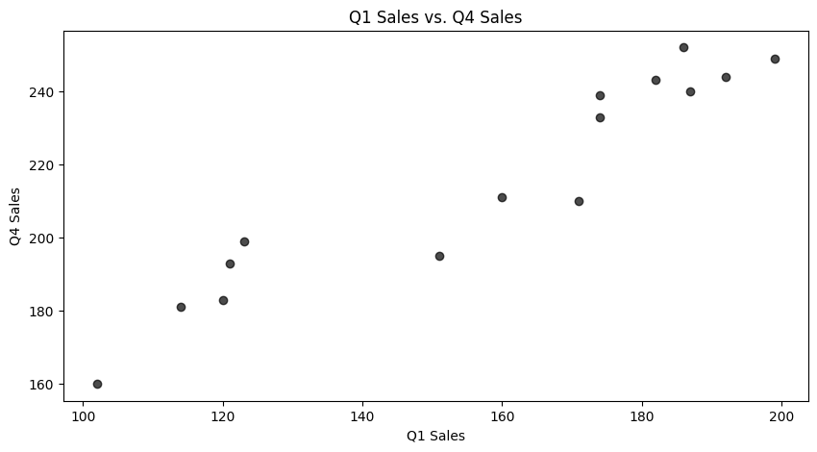

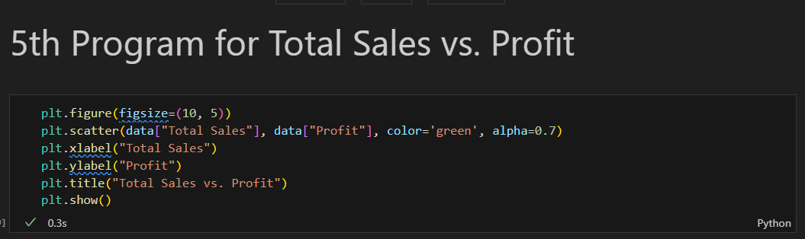

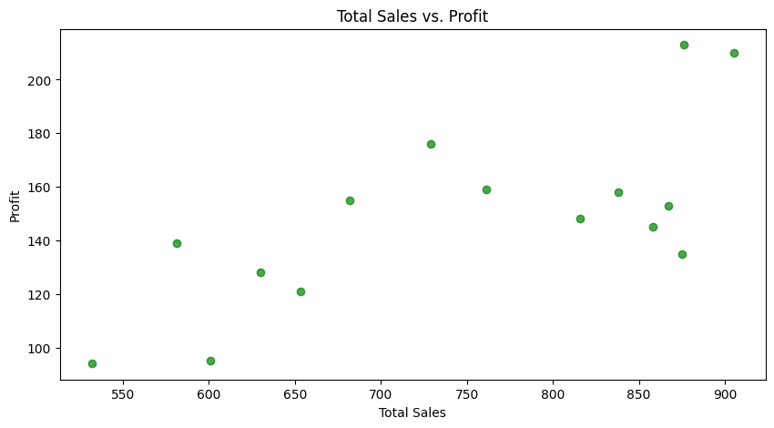

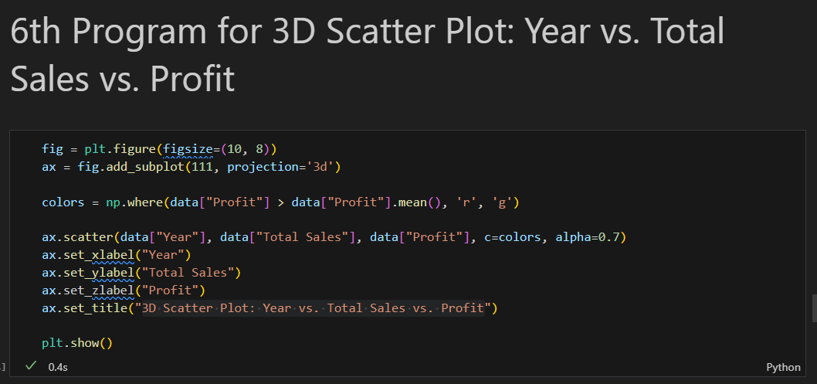

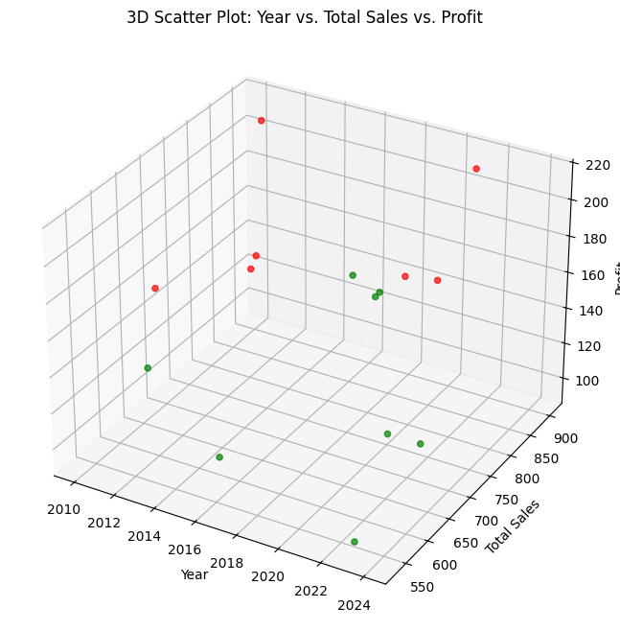

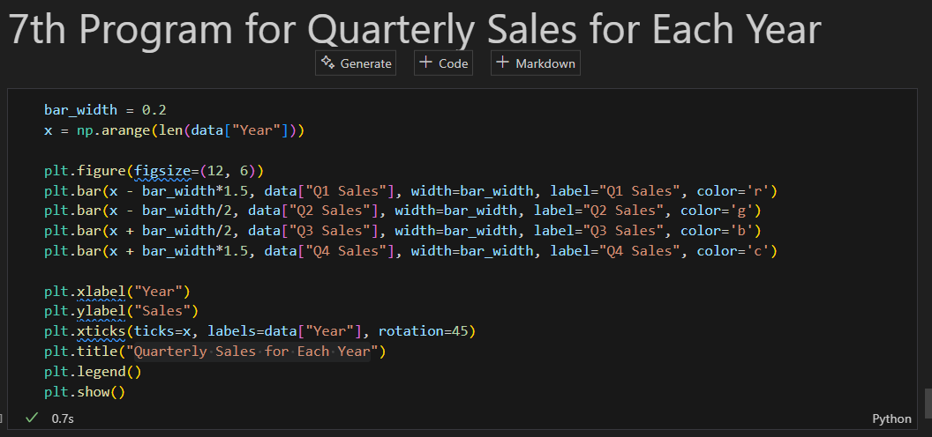

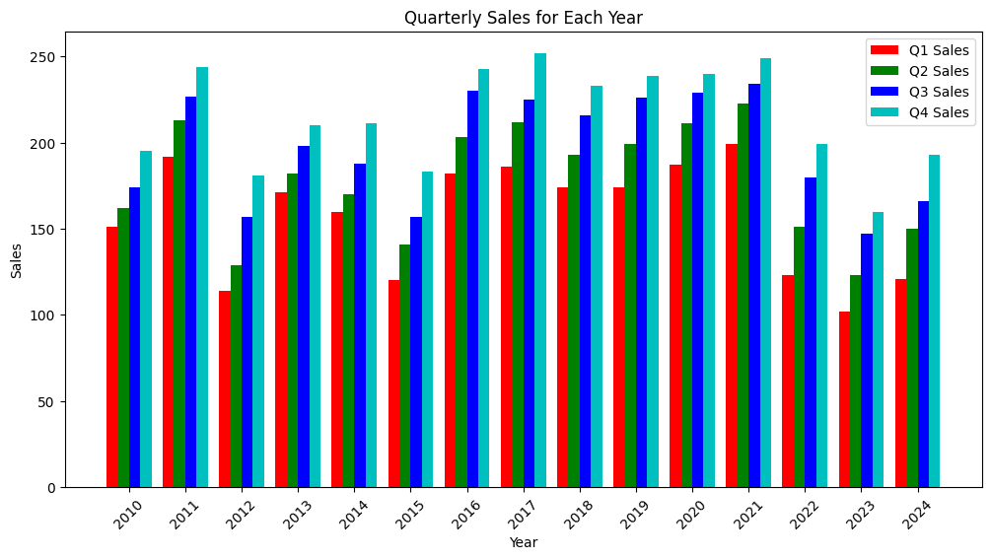

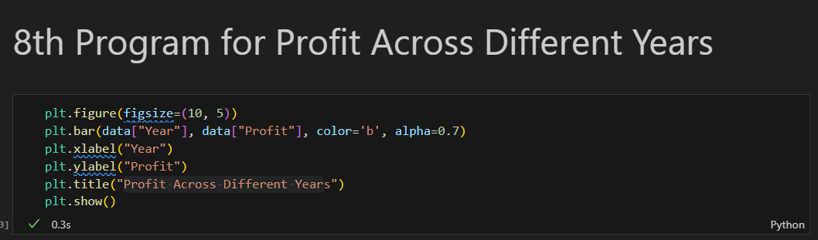

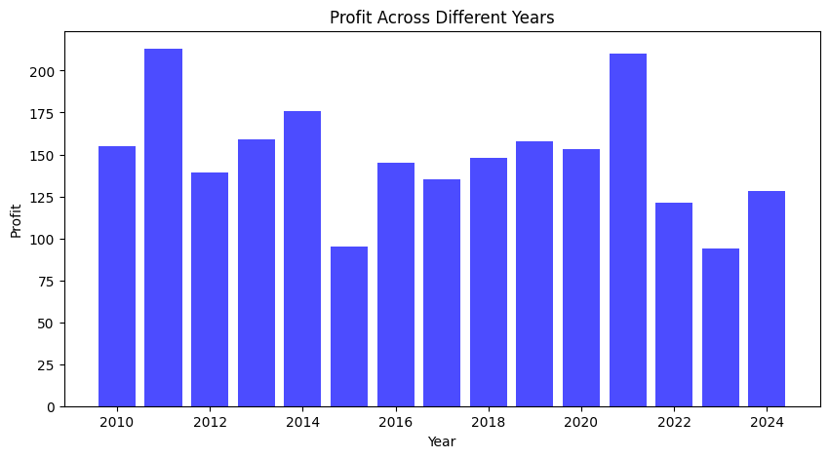



plt.figure(figsize=(12, 6))

plt.bar(data["Year"], data["Q1 Sales"], label="Q1 Sales", color='r')

plt.bar(data["Year"], data["Q2 Sales"], bottom=data["Q1 Sales"], label="Q2 Sales", color='g')

plt.bar(data["Year"], data["Q3 Sales"], bottom=data["Q1 Sales"] + data["Q2 Sales"], label="Q3 Sales", color='b')

plt.bar(data["Year"], data["Q4 Sales"], bottom=data["Q1 Sales"] + data["Q2 Sales"] + data["Q3 Sales"], label="Q4 Sales", color='c')

plt.xlabel("Year")

plt.ylabel("Total Quarterly Sales")

plt.title("Quarterly Sales Stacked Bar Chart")

plt.legend()

plt.show()

