

**Advance Python Programming**

**MCA-372**

**Assignment – 05**

***BY***

**HIMANSHU HEDA (24225013)**

**SUBMITTED TO**

**Dr. Manjula Shannhog**

**SCHOOL OF SCIENCES**

**2024-25**

**Basemap :**

**Importing Libraries**

from mpl_toolkits.basemap import Basemap

import matplotlib.pyplot as plt

**Code for Map**

map = Basemap()

map.drawcoastlines()

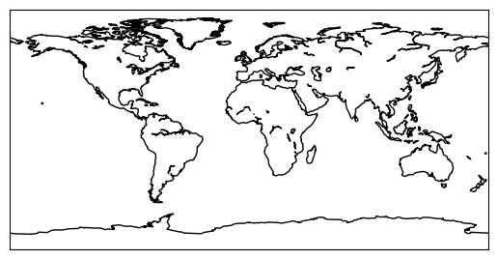

map.fillcontinents(color='coral',lake_color='aqua')

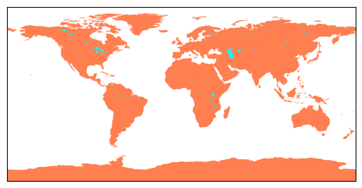

map.drawmapboundary(fill_color='aqua')



map = Basemap(resolution='c',projection='mill')

map.drawcoastlines()

map.fillcontinents(color='g',lake_color='aqua')

map.drawmapboundary(color='black', fill_color='aqua')

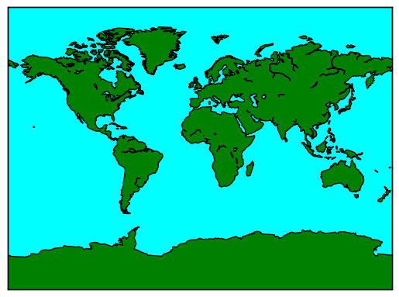

**To Represent Indian River**

india = Basemap(68,5,97,38,projection="merc")

# india.set_size(1000,1000)

india.drawcountries(linewidth=3)

india.drawcoastlines(linewidth=3)

india.drawrivers(color='b')

india.drawmapboundary(color='black')

plt.show()

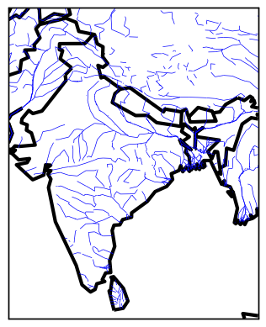

**Creating Map as an Satellite View**

india=Basemap(llcrnrlon=68,llcrnrlat=5,urcrnrlon=97,urcrnrlat=38,projection='mill')

# india = Basemap(68,5,97,38,projection="merc")

india.bluemarble()

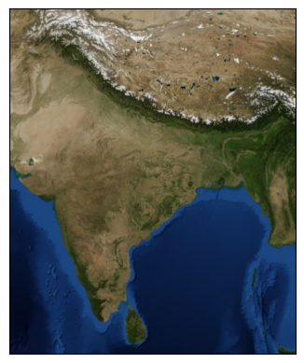

**Creating map of india which shows small components**

plt.figure(figsize=(8, 6))

m = Basemap(projection="merc", llcrnrlat=5, urcrnrlat=40, llcrnrlon=65, urcrnrlon=100, resolution='i')

m.drawcoastlines()

m.drawcountries()

m.drawstates(linewidth=1, color="black")

m.drawmapboundary(fill_color="aqua")

m.fillcontinents(color="beige", lake_color="aqua")

plt.title("Map of India")

plt.show()

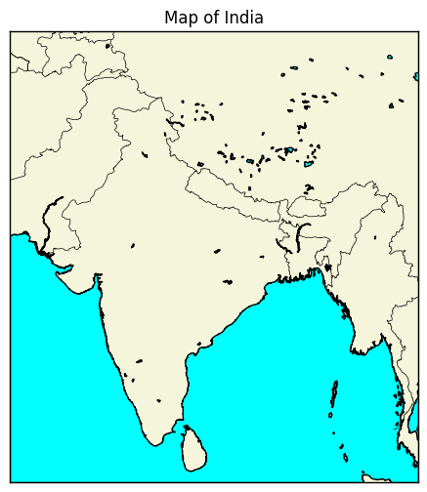

**Creating the mazor cities in India on the Map of India**

plt.figure(figsize=(8, 6))

m = Basemap(projection="merc", llcrnrlat=5, urcrnrlat=40, llcrnrlon=65, urcrnrlon=100, resolution='i')

m.drawcoastlines()

m.drawcountries()

m.drawstates(linewidth=1, color="black")

m.drawmapboundary(fill_color="aqua")

m.fillcontinents(color="beige", lake_color="aqua")

plt.title("Map of India")

cities = {

    "Delhi": (28.6139, 77.2090),

    "Mumbai": (19.0760, 72.8777),

    "Kolkata": (22.5726, 88.3639),

    "Chennai": (13.0827, 80.2707),

    "Bangalore": (12.9716, 77.5946)

}

# Plot cities on the map

for city, (lat,lon) in cities.items():

    x , y = m(lon, lat)

    m.scatter(x,y,marker='o', color='Red', s=100, label=city)

    plt.text(x,y,city,fontsize=10, ha='left',color='black')

plt.title("Major Cities in India")

plt.show()

