

**Advance Python Programming**

**MCA-372**

**Assignment – 06**

***BY***

**HIMANSHU HEDA (24225013)**

**SUBMITTED TO**

**Dr. Manjula Shannhog**

**SCHOOL OF SCIENCES**

**2024-25**

**Basemap :**

**Importing Libraries**

from mpl_toolkits.basemap import Basemap

import matplotlib.pyplot as plt

**Que 1 :** **Implement the below code that shows the connection between cities**

plt.figure(figsize=(8, 6))

m = Basemap(projection="merc", llcrnrlat=5, urcrnrlat=40, llcrnrlon=65, urcrnrlon=100, resolution="l")

m.drawcoastlines()

m.drawcountries()

m.drawstates()

delhi = (28.6139, 77.2090)

mumbai = (19.0760, 72.8777)

x_delhi, y_delhi = m(delhi[1], delhi[0])

x_mumbai, y_mumbai = m(mumbai[1], mumbai[0])

m.scatter(x_delhi, y_delhi, marker="o", color="red", s=100, label="Delhi")

m.scatter(x_mumbai, y_mumbai, marker="o", color="blue", s=100, label="Mumbai")

m.plot([x_delhi, x_mumbai], [y_delhi, y_mumbai], linestyle="dashed", color="black", linewidth=2)

plt.title("Distance between Delhi and Mumbai")

plt.legend()

plt.text(x_delhi, y_delhi, "Delhi", fontsize=12, ha="right")

plt.text(x_mumbai, y_mumbai, "Mumbai", fontsize=12, ha="right")

plt.show()

**Output :**

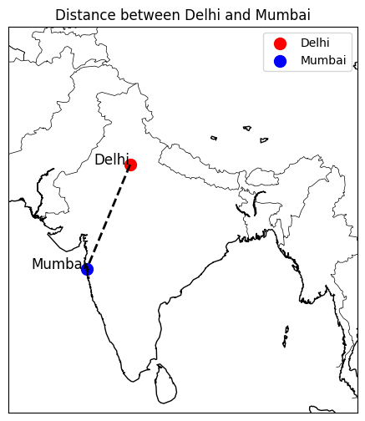

**Que 2 : Spot the below cities in the Indian Map  
Ahmadabad, Hyderabad, Lucknow, Jaipur, Agra**

plt.figure(figsize=(8, 6))

m = Basemap(projection="merc", llcrnrlat=5, urcrnrlat=40, llcrnrlon=65, urcrnrlon=100, resolution="l")

m.drawcoastlines()

m.drawcountries()

m.drawstates()

# Coordinates of the cities

cities = {

    "Ahmadabad": (23.0225, 72.5714),

    "Hyderabad": (17.3850, 78.4867),

    "Lucknow": (26.8467, 80.9462),

    "Jaipur": (26.9124, 75.7873),

    "Agra": (27.1767, 78.0081)

}

# Plot cities on the map

for city, (lat, lon) in cities.items():

    x, y = m(lon, lat)

    m.scatter(x, y, marker='o', s=100, label=city)

    plt.text(x, y, city, fontsize=10, ha='left', color='black')

plt.title("Major Cities in India")

plt.legend()

plt.show()

**Output :**

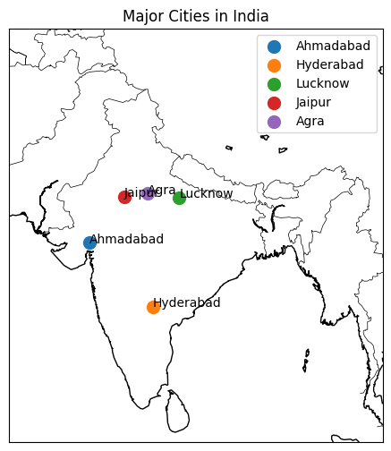

**Que 3 : Spot the below cities and connect them Pune to Ranchi**

import matplotlib.pyplot as plt

from mpl_toolkits.basemap import Basemap

plt.figure(figsize=(8, 6))

m = Basemap(projection="merc", llcrnrlat=5, urcrnrlat=40, llcrnrlon=65, urcrnrlon=100, resolution="l")

m.drawcoastlines()

m.drawcountries()

m.drawstates()

# Coordinates of the cities

cities = {

    "Pune": (18.5204, 73.8567),

    "Ranchi": (23.3441, 85.3096)

}

# Plot cities on the map

for city, (lat, lon) in cities.items():

    x, y = m(lon, lat)

    m.scatter(x, y, marker='o', s=100, label=city)

    plt.text(x, y, city, fontsize=10, ha='left', color='black')

# Draw a line between Pune and Ranchi

x_pune, y_pune = m(cities["Pune"][1], cities["Pune"][0])

x_ranchi, y_ranchi = m(cities["Ranchi"][1], cities["Ranchi"][0])

m.plot([x_pune, x_ranchi], [y_pune, y_ranchi], linestyle="dashed", color="blue", linewidth=2)

plt.title("Major Cities in India")

plt.legend()

plt.show()

**Output :**

