
Advance Python Programming
MCA-372
Assignment – 08
BY
HIMANSHU HEDA (24225013)
SUBMITTED TO
Dr. Manjula Shannhog
SCHOOL OF SCIENCES
2024-25

Create an Form 1 Website using Streamlit Library :
import streamlit as st

form = st.form('my_form')

name = form.text_input('Your Name')
age = form.number_input('Your Age',min_value=0,max_value=100)
submitted = form.form_submit_button('Submit')

if submitted:
st.write(f'Hello : {name}')
st.write(f'You are {age} Years Old')

Output :
To run the Output for Streamlit you need to write an command in the terminal that is “streamlit run form1.py“

Form 1:
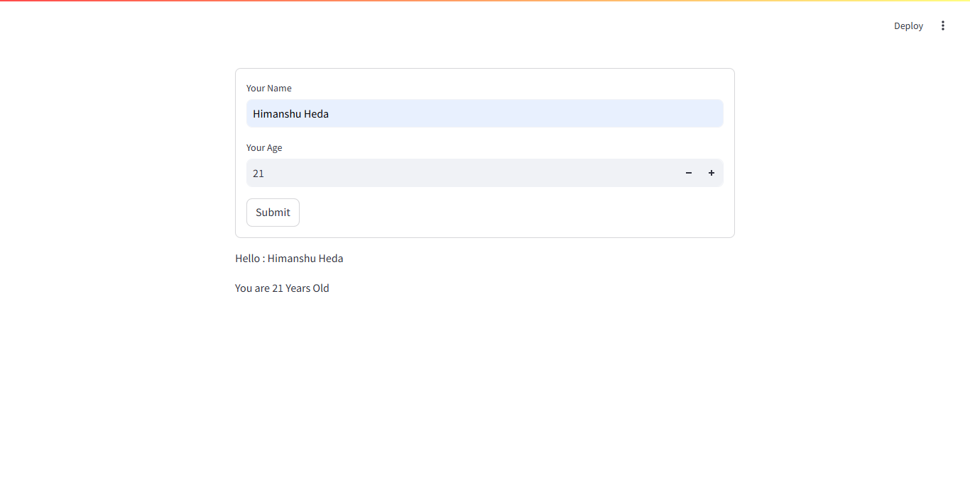

Create an Form 2 Website using Streamlit Library :
import streamlit as st

st.title("Simple Web App eith Form")

st.write("Fill out the From below and click on the submit button to see the output")

with st.form('my_form'):
name = st.text_input('Your Name')
email = st.text_input('Your Email')
age = st.number_input('Your Age',min_value=18,max_value=100)
feedback = st.text_area('Your Feedback')

submitted = st.form_submit_button('Submit')

if submitted:
st.success(f'Thank you {name} for your feedback')
st.write(f'**Hello :** {name}')
st.write(f'**Your Email :** {email}')
st.write(f'**Your Age :** {age}')
st.write(f'**Your Feedback :** {feedback}')

Output :
To run the Output for Streamlit you need to write an command in the terminal that is “streamlit run form2.py“

Form 2:
