
Advance Python Programming
MCA-372
CIA – 02
BY
HIMANSHU HEDA (24225013)
SUBMITTED TO
Dr. Manjula Shannhog
SCHOOL OF SCIENCES
2024-25
1. Use Excel dataset and draw the graph
Bar chart of Breed vs average Energy_Level
Pie chart of Favorite_Toy distribution
Line graph of Age_Months vs Weight_kg
Print which breed has highest Energy level, most favorite toy, which age has least weight and most
weight on the website.
Display them on Website using Streamlit

Ques 1 :
import streamlit as st
import pandas as pd
import matplotlib.pyplot as plt

# Title of the app
st.title("🐱 Kitten Data Analysis Dashboard")

# Load the dataset
data = pd.read_csv("./big_kitten_dataset.csv")

# Display the dataset preview
st.subheader("Dataset Preview")
st.write(data.head())

# 1. Bar chart: Breed vs Average Energy Level
st.subheader("Bar Chart: Breed vs Average Energy Level")
avg_energy = data.groupby("Breed")["Energy_Level"].mean()
st.bar_chart(avg_energy)

# 2. Pie chart: Favorite Toy Distribution
st.subheader("Pie Chart: Favorite Toy Distribution")
toy_distribution = data["Favorite_Toy"].value_counts()
fig, ax = plt.subplots()
ax.pie(toy_distribution, labels=toy_distribution.index, autopct="%1.1f%%", startangle=90)
ax.set_title("Favorite Toy Distribution")
st.pyplot(fig)

# 3. Line graph: Age (Months) vs Weight (kg)
st.subheader("Line Graph: Age (Months) vs Weight (kg)")
data_sorted = data.sort_values("Age_Months")
fig, ax = plt.subplots()
ax.plot(data_sorted["Age_Months"], data_sorted["Weight_kg"], marker="o", color="green")
ax.set_xlabel("Age (Months)")
ax.set_ylabel("Weight (kg)")
ax.set_title("Age (Months) vs Weight (kg)")
st.pyplot(fig)

# 4. Insights
st.subheader("Insights")
highest_energy_breed = avg_energy.idxmax()
most_favorite_toy = toy_distribution.idxmax()
min_weight_age = data.loc[data["Weight_kg"].idxmin(), "Age_Months"]
max_weight_age = data.loc[data["Weight_kg"].idxmax(), "Age_Months"]

st.write(f"Breed with the highest average Energy Level: **{highest_energy_breed}**")
st.write(f"Most favorite toy: **{most_favorite_toy}**")
st.write(f"Age with the least weight: **{min_weight_age} months**")
st.write(f"Age with the most weight: **{max_weight_age} months**")

Output :
You Can Run it by entering the command in the terminal by using
“streamlit run Que1.py”
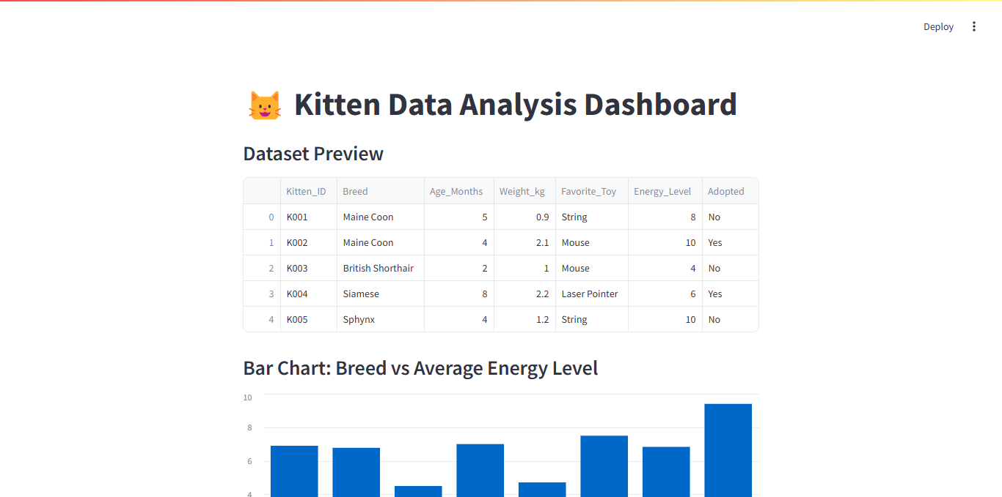
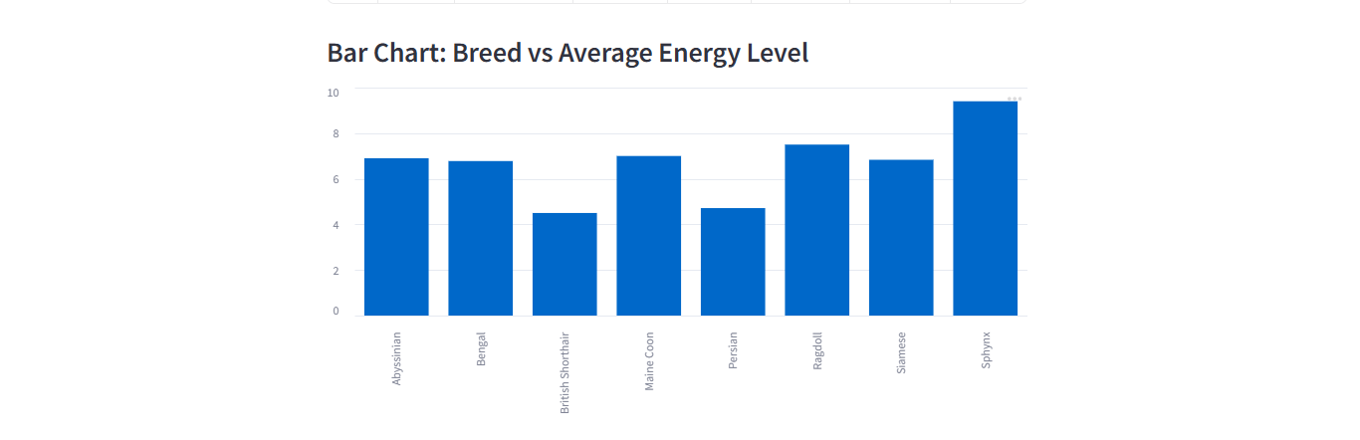
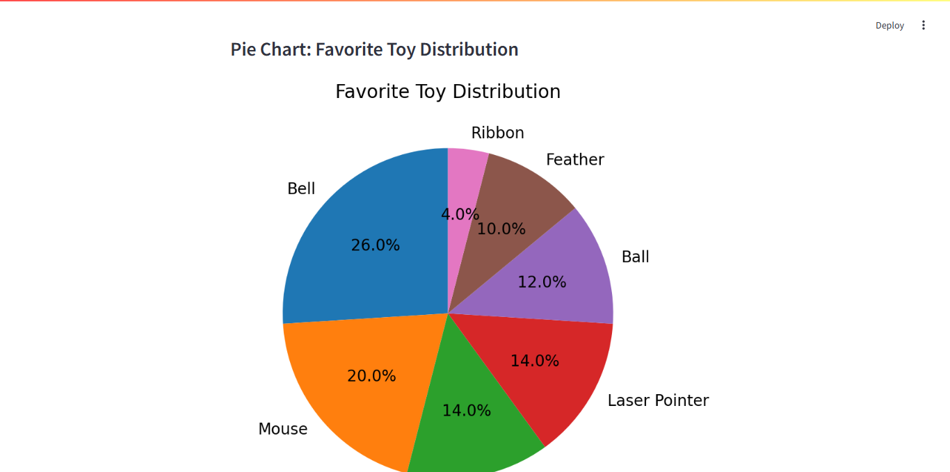

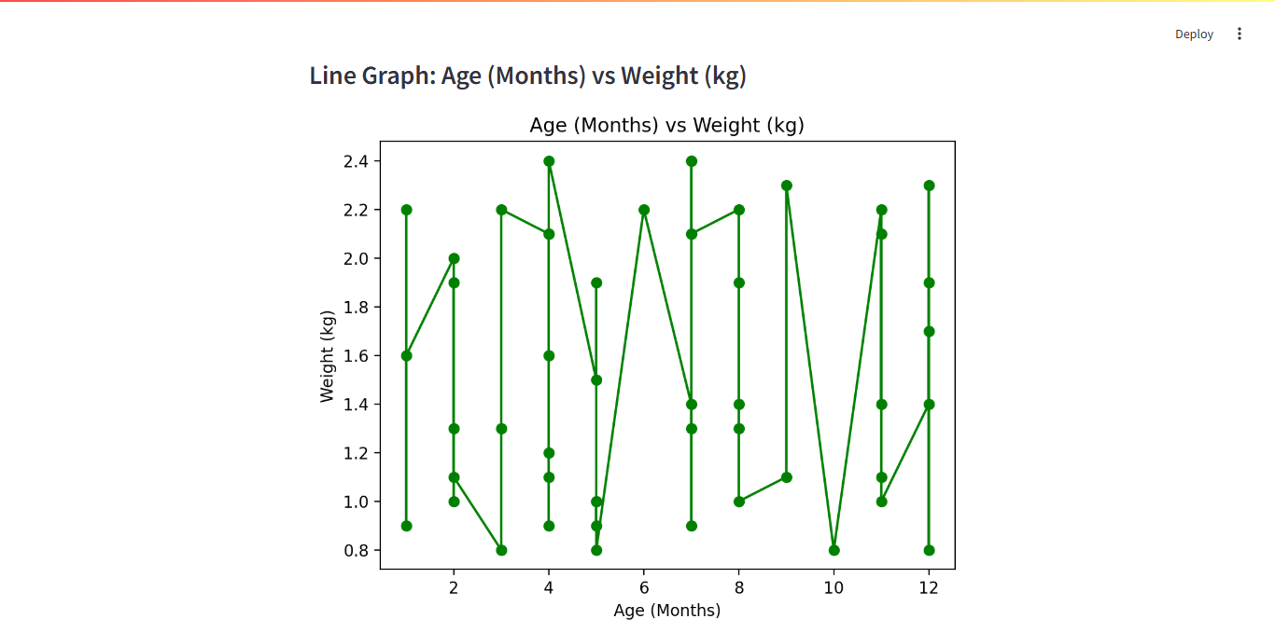
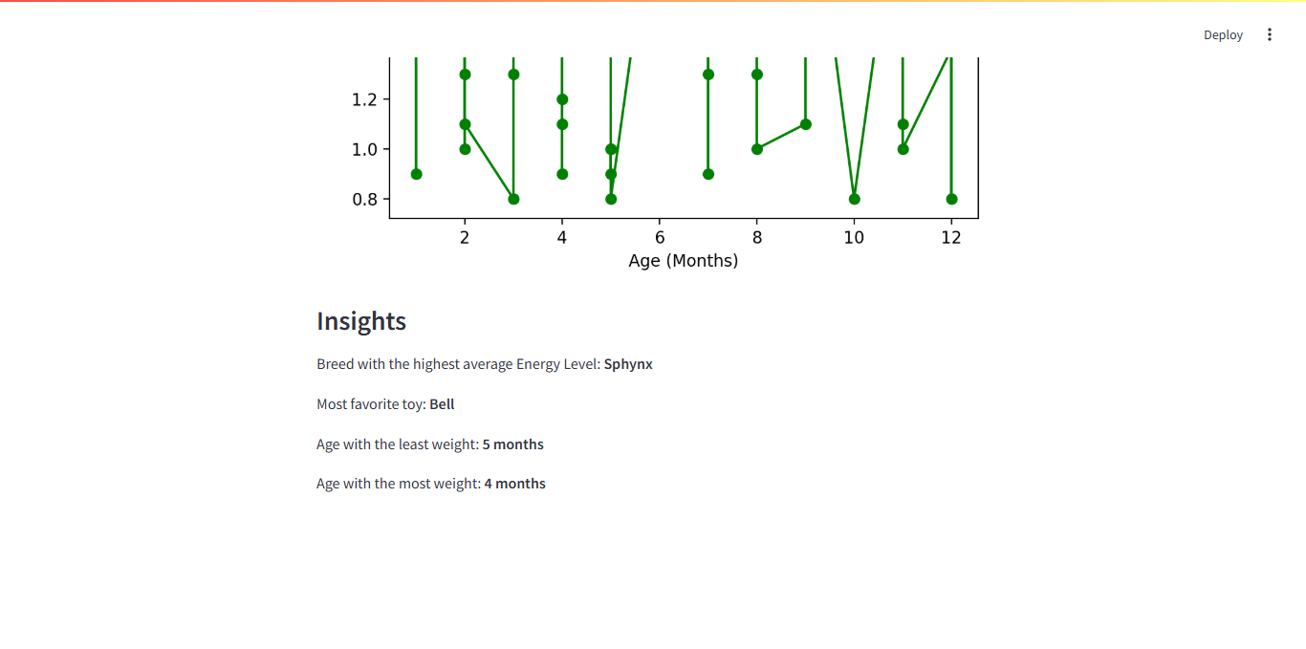

Ques 2 :
2. Consider the image,
1) Get the details about the image
2) make the image squared image
3) Consider the original image and crop it to get only the face of the kitten.
4) Apply filter
5) Flip and rotate the image, customize
6) Apply enchancement features

Output :
Importing Library :
from PIL import Image
Importing Image :
image = Image.open("./white-kitten.jpg")

## 1. Get the Details about the image

