
Advance Python Programming
MCA-372
Assignment – 07
BY
HIMANSHU HEDA (24225013)
SUBMITTED TO
Dr. Manjula Shannhog
SCHOOL OF SCIENCES
2024-25

Create an Portfolio Website using Streamlit Library :

import streamlit as st

# Set Page Title
st.set_page_config(page_title="My Portfolio", page_icon="🌟", layout="wide")

# Sidebar Navigation
st.sidebar.title("Navigation")
page = st.sidebar.radio("Go to", ["Home", "About", "Contact"])

# Home Page
if page == "Home":
st.title("Welcome to My Portfolio! 🚀")

# Create columns for parallel layout
col1, col2 = st.columns([1, 2]) # Adjust width ratio as needed

with col1:
st.image("./coder.png", width=500, use_container_width=False) # Fixed image width

with col2:
st.markdown("## Hello! I am **Himanshu Heda**, a passionate developer 🚀")
st.write("This is a simple portfolio web app built using Python and Streamlit.")
st.success("Explore the different sections using the sidebar.")

# About Me Section
st.markdown("### 👋 About Me")
st.write("""
I am Himanshu Heda, a passionate and driven software developer with a flair for problem-solving and a love for technology.
I specialize in Web Design, Web Development, and Application Development, and continuously explore new avenues to expand my technical horizons.
My projects reflect my commitment to creating innovative and user-friendly solutions.
""")

# Add Skills Section Below
st.markdown("---") # Separator
st.markdown("### 🚀 My Skills & Expertise")

col3, col4 = st.columns([1, 2]) # Split for skills layout

with col3:
st.markdown("#### Programming Languages")
st.markdown("""
- **Proficient**: Python, JavaScript, C, Java
- **Familiar**: SQL, PHP
""")

with col4:
st.markdown("#### Development Stacks")
st.markdown("""
- **Frontend**: HTML, CSS (Bootstrap), JavaScript, ReactJS
- **Backend**: Python, PHP, SQLite, MySQL
- **Tools & Platforms**: Git, GitHub, XAMPP Server
""")

# About Page
elif page == "About":
st.title("About Me")
st.markdown("""
- 🔭 **Tech Enthusiast & Developer**
- 💻 Skills: Python, JavaScript, Web Development
- 🌱 Currently Learning: AI & Open Source Contributions
- 🎯 Passion: Building impactful software solutions
- 📫 Connect with me on [GitHub](https://github.com/HimanshuHeda) & [Portfolio](https://himanshuheda.vercel.app/)
""")
st.info("I love coding and solving real-world problems through technology.")

# Contact Page
elif page == "Contact":
st.title("Contact Me 📞")
st.write("Feel free to reach out for collaborations or inquiries!")

with st.form("contact_form"):
name = st.text_input("Your Name")
email = st.text_input("Your Email")
message = st.text_area("Your Message")

submit_button = st.form_submit_button("Submit")

if submit_button:
st.success(f"Thank you {name}, I will get back to you soon!")

# Footer
st.markdown("---")
st.markdown("<p style='text-align: center;'>Made with ❤️ by Himanshu Heda</p>", unsafe_allow_html=True)

Output :
To run the Output for Streamlit you need to write an command in the terminal that is “streamlit run portfolio.py“

Home Page :
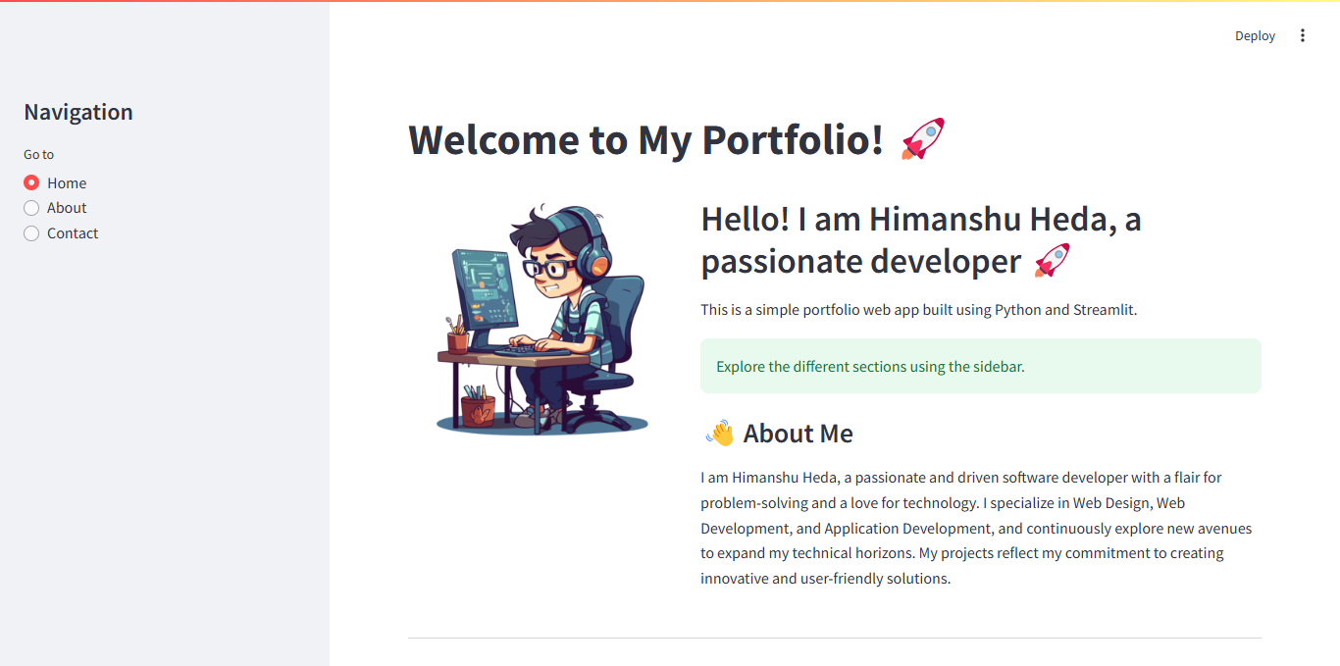

About Page :
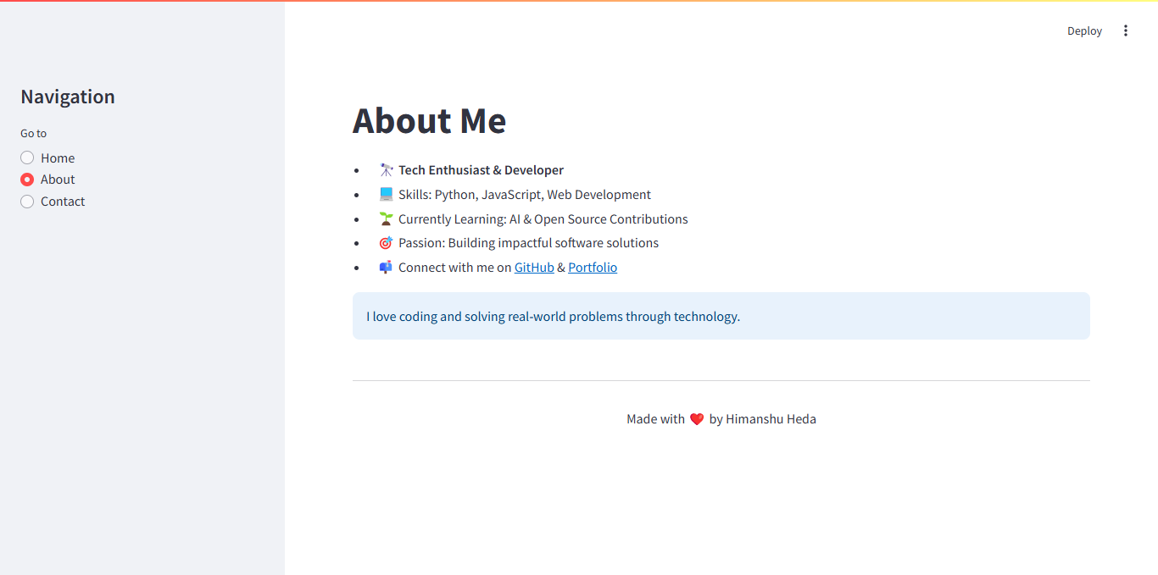

Contact Page :
