

**Computer Vision**

**MCA-574**

**Lab – 04**

***BY***

**HIMANSHU HEDA (24225013)**

**SUBMITTED TO**

**Dr. Preety Shoran**

**SCHOOL OF SCIENCES**

**2024-25**

**Lab 4: MRI Brain Scan Processing & Tumor Detection**

**Objective:**

* Sharpen MRI images to enhance structural details
* Detect circular tumor-like patterns using template matching
* Analyze the effect of template rotation on detection accuracy
* Compare edge detection with sharpening

**Task 1: Load and Display MRI Image**

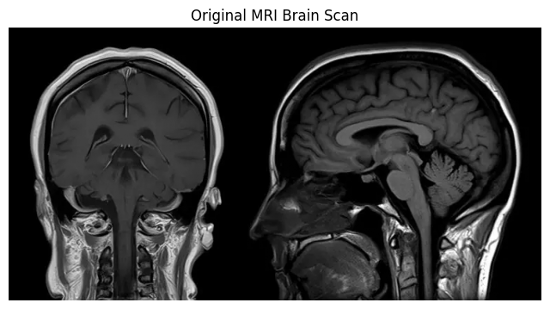

An MRI brain scan was loaded and displayed in grayscale. Initial observation revealed distinct regions of the brain, including gray matter, white matter, and the surrounding skull. The image provides a baseline for evaluating the effects of subsequent processing steps.

**Task 2: Sharpening Images (Convolution)**

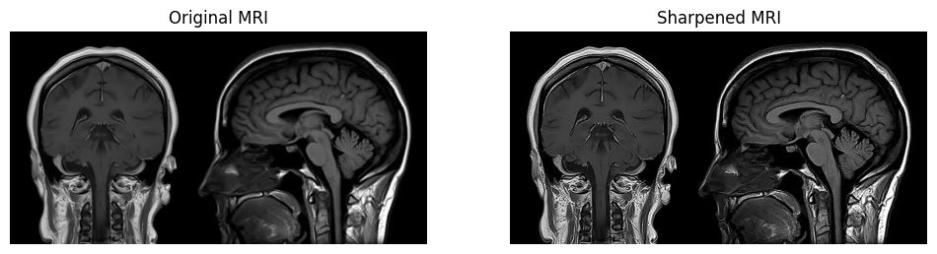

A sharpening filter was applied to the MRI image using a convolution operation. The purpose was to enhance the edges and fine structural details within the brain scan.

**Observation:** Comparing the two images, the sharpened version exhibits more prominent edges and clearer boundaries between different tissue types. Fine textures within the brain structure appear more defined, which could aid a radiologist in identifying subtle anomalies.

**Task 3: Pattern Detection (Correlation) & Circular Template (simulating a tumor)**

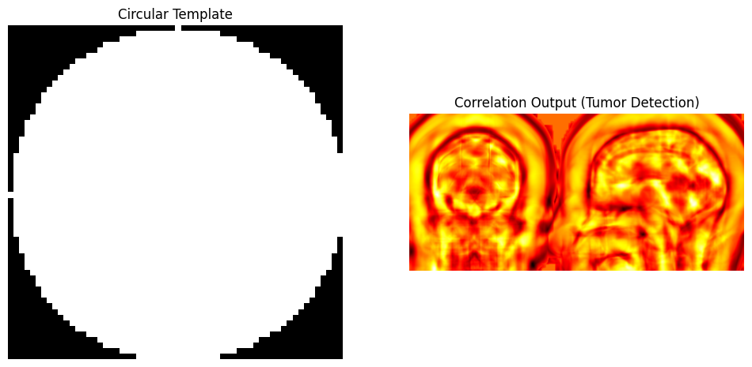

A circular template was created to simulate a simple, round tumor. Template matching using correlation was then performed on the sharpened image to identify regions that matched this pattern.

**Highlight detected Region with a Rectangle box:**

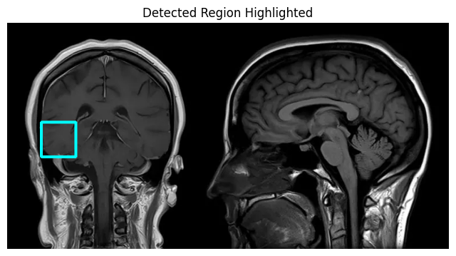

**Observation:** The correlation process successfully identified a region in the upper-right quadrant of the brain scan that closely matched the circular template. This area corresponds to the brightest point in the correlation map, indicating the highest degree of similarity.

**Task 4: Rotation Experiment Rotate template by 45° and 90° :**

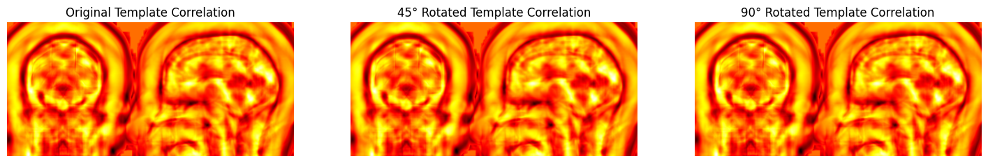

To test the robustness of the pattern detection method, the circular template was rotated by 45° and 90°, and the correlation process was repeated.

**Observation:** The detection accuracy was significantly impacted by template rotation. While the original template yielded a strong match, the correlation score for the rotated templates was visibly lower. This demonstrates that standard template matching is not rotation-invariant and may fail to detect a feature if its orientation in the image does not precisely match the template's orientation.

**Challenge - Edge Detection:**

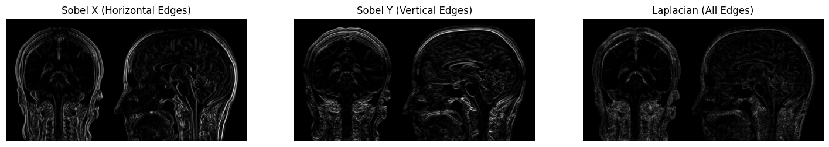

**1. Compare the original vs sharpened image. Which details are more prominent?**

In the sharpened picture, the edges and delimiters between various brain tissues come out much more strongly. Minor details and textures on the cerebral cortex that are [softer] in original image are more precipitated and clearer. This boosts the entire framework in a way on the lines of better coachability.

**2. Where are tumor-like patterns detected in the correlation output?**

The upper-right area of the brain scan showed that the solid mass is tumor-like. This position is with the part of the highest intensity (the most intense place) off the correlation map which makes sense because this first place best matches the given circular template.

**3. How does template rotation affect detection accuracy?**

Template rotation has been found to have a drastic effect of cutting detection accuracy. During the experiment, it was seen that turning the template 45deg and 90deg led to a significantly smaller signal of correlation though the shape was 45deg away. This is one drawback of this method in a large measure; it is very sensitive to the direction of what is being detected.

**4. Suggest methods to detect tumors of different shapes or orientations.**

In order to break out of the same limitation of simple template matching, there are a few more robust methods that may be used:

* **Template Banks:** Accompany a set of templates of different rotations, scales, and shapes. The picture would be compared to this whole bank and the chances of discovering a match would be increased.
* **Invariant Feature Descriptors:** These make use of features detection algorithms (such as SIFT or SURF) which are rotation and scale invariant by their nature. These techniques scan through keypoints according to their local descriptors as opposed to a strict template.
* **Machine Learning & Deep Learning:** The optimal approach in the current age is the implementation of a Convolutional Neural Network (CNN). On a scale of a large set of MRI scans with annotated tumors of different shapes, size, and orientation, a CNN can be trained. It is very robust and precise as it automatically develops the capacity to detect the intricate attributes that distinguish a tumor.

**4. Discussion and Real-World Applications**

This laboratory experiment highlights why, as well as how far, classical computer vision can be necessary in medical imaging. Although sharpening, which can work well at attaching additional detail to the images so that humans can analyze them, and template matching, which can detect some simple and known patterns, all of the above are not robust enough to guarantee reliable, real-life diagnostics.

In clinical practice, automated systems are important to help radiologists analyze the number of scans generated each day which are huge in number. The methods discussed in this paper are the conceptual basis of the higher-level systems. As an example, suspicious regions of interest can be displayed by automated detection algorithms and enable radiologists to focus their attention on the suspicious one more effectively. This will result in quicker diagnoses, a decrease in the risk of human error, and improved patient outcomes because of the possibility to plan the treatment faster and more effectively. The use of the AI-based approaches proposed by CNNs to transition to use the mentioned tool to achieve the required accuracy and reliability is a significant part of modern diagnostic systems.