
Computer Vision
MCA-574
Assignment – 03
BY
HIMANSHU HEDA (24225013)
SUBMITTED TO
Dr. Preety Shoran
SCHOOL OF SCIENCES
2024-25
1. You are designing an object recognition system. Discuss which color model you would use for color segmentation and justify your choice.

Sol. Object Recognition System: Color Model for Segmentation
Discussion: For color segmentation in an object recognition system, the HSV (Hue, Saturation, Value) color model is generally preferred over RGB.
Justification:
- Perceptual Uniformity: HSV is more perceptually uniform than RGB. This means that changes in H, S, or V components correspond more closely to how humans perceive color differences. In RGB, a small change in one component can lead to a large perceptual shift, making it harder to define color ranges for segmentation.
- Decoupling of Color and Intensity: HSV decouples color information (Hue and Saturation) from brightness (Value). This is a significant advantage for segmentation because:
  - Hue: Represents the pure color (e.g., red, green, blue) and is robust to variations in lighting intensity. An object's intrinsic color remains largely the same even under different brightness conditions.
  - Saturation: Indicates the "purity" or "vibrancy" of the color.
  - Value: Represents the brightness or intensity. This decoupling allows you to segment objects based on their actual color without being heavily affected by shadows or varying illumination, which would drastically change the R, G, and B values.
- Intuitive Color Selection: It's often easier to define thresholds for specific colors in HSV (e.g., "red objects have a hue between X and Y") than in RGB, where the three channels are highly correlated.

Diagram:
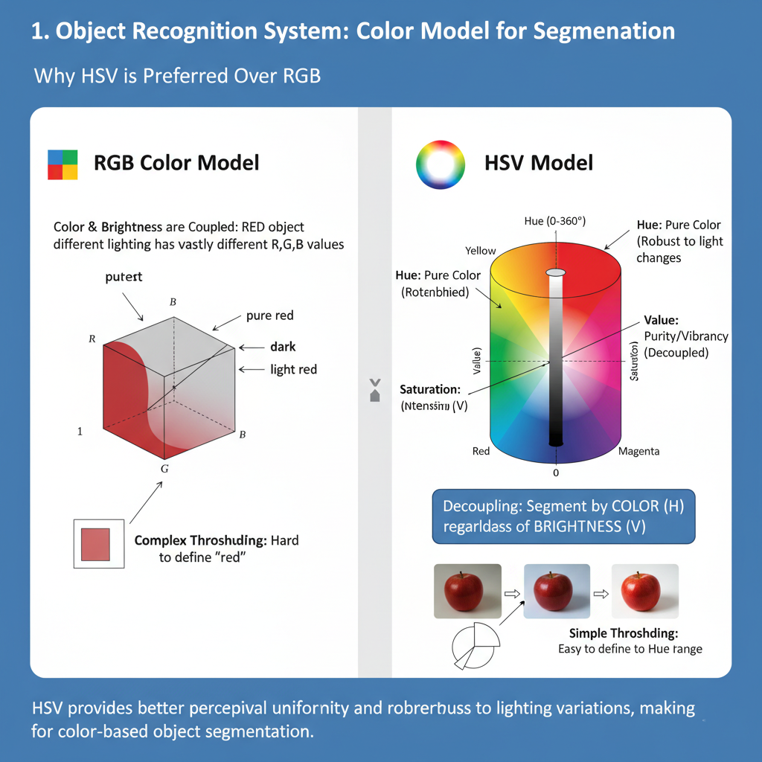

2. During image augmentation for a deep learning dataset, explain why geometric transformations (like flipping and rotation) are used.

Sol. Image Augmentation: Geometric Transformations
Explanation: Geometric transformations (like flipping, rotation, scaling, cropping, translation) are crucial for image augmentation in deep learning datasets because they help to:
- Increase Dataset Size: Deep learning models require vast amounts of data to learn effectively. Augmentation artificially expands the training dataset without collecting new images.
- Improve Model Robustness and Generalization:
  - Invariance to Pose/Viewpoint: By presenting the model with different orientations (rotations, flips) or positions (translations) of the same object, the model learns to recognize the object regardless of its exact pose or where it appears in the image. This makes the model invariant to such changes.
  - Reduced Overfitting: A model trained on a more diverse set of images is less likely to memorize specific training examples (overfit) and more likely to generalize well to unseen real-world data.
  - Simulate Real-World Variations: Objects in the real world rarely appear in the exact same orientation or position. Augmentation helps simulate these natural variations.

Diagram:
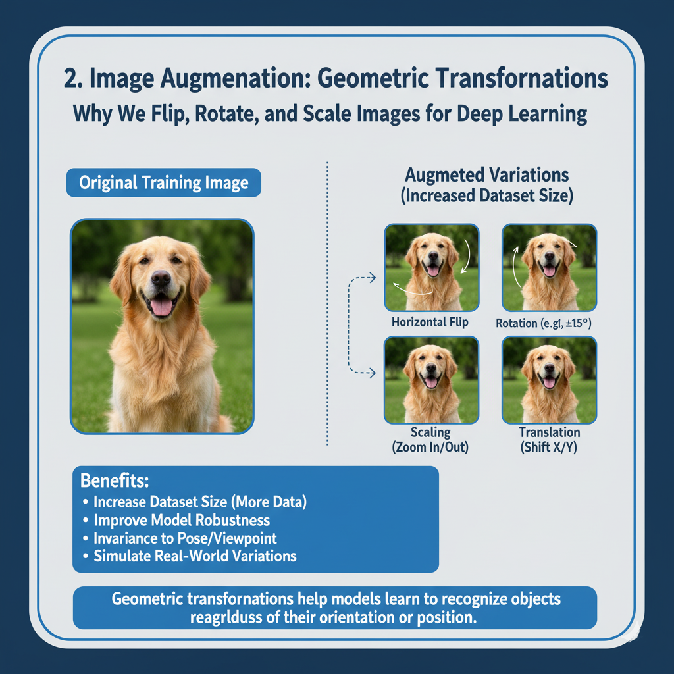

3. You are developing a medical imaging tool that analyzes thermal images. Which color model would be most suitable and why?

Sol. Medical Imaging Tool (Thermal Images): Suitable Color Model
Discussion: For analyzing thermal images, the Grayscale (or a pseudo-colored grayscale representation) is often the most suitable color model. However, if a "color model" in the traditional sense is required to map thermal data to visible colors, then a pseudo-color mapping (which is essentially applying a colormap to a grayscale image) is used, often based on variations of HSV or specialized thermal colormaps.
Justification:
- Thermal Data is Monochromatic: Thermal cameras measure temperature, which is a single intensity value per pixel, not three distinct color channels like visible light (RGB). Therefore, the raw data is inherently grayscale (representing temperature magnitude).
- Quantitative Interpretation: In medical thermal imaging (thermography), the absolute temperature and temperature differences are critical. A grayscale representation (where hotter corresponds to brighter, or colder to darker) directly and clearly conveys this quantitative information without introducing the perceptual complexities of full-color models.
- Pseudo-Coloring for Visualization: While the underlying data is grayscale, it's common to apply "pseudo-coloring" (e.g., a rainbow, iron, or hot-cold colormap) to grayscale thermal images. This is not a true color model in the sense of RGB or HSV capturing scene colors, but rather a mapping where:
  - Different temperature ranges are assigned distinct colors from a predefined palette.
  - This enhances visibility of subtle temperature variations, making abnormalities (e.g., inflammation, poor circulation) more apparent to the human eye.
  - The choice of colormap can be application-specific to highlight particular ranges of interest. While HSV components (especially Hue and Value) can be used to construct such colormaps, the direct data representation is single-channel.

Diagram:
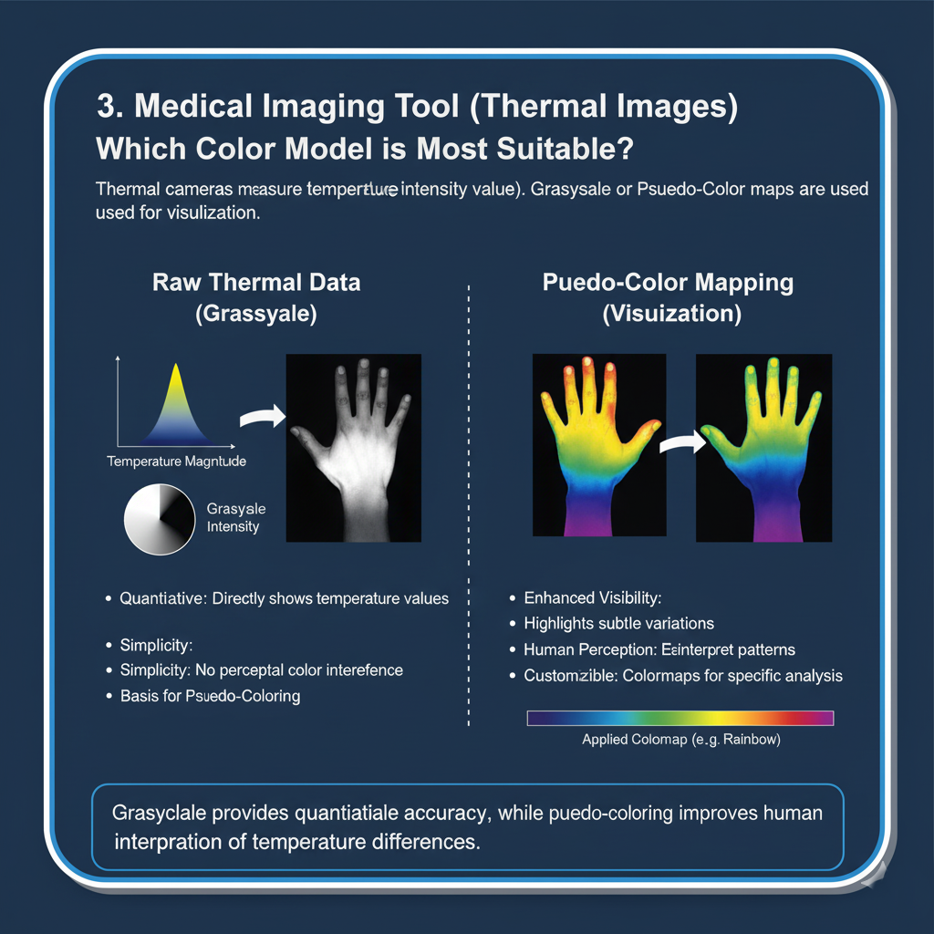

4. In a satellite image, geometric distortion has occurred due to the angle of capture. Describe how geometric transformations can be applied to correct this distortion.

Sol. Satellite Image: Correcting Geometric Distortion
Explanation: Geometric distortion in satellite images (e.g., foreshortening, skew, scale variations) due to the camera's angle of capture can be corrected using geometric transformations, specifically image warping or rectification. This process involves mapping the distorted image pixels to their correct spatial locations.
How Geometric Transformations Are Applied:
- Identify Ground Control Points (GCPs): These are easily identifiable features in both the distorted satellite image and a reference (undistorted) map or another accurately georeferenced image. GCPs could be road intersections, specific buildings, or landmarks. You need at least 3-4 non-collinear GCPs for affine transformations, and more for higher-order polynomial transformations.
- Define a Transformation Model: Based on the type of distortion, a suitable mathematical transformation model is chosen:
  - Affine Transformation: Handles translation, rotation, scaling, and shear. Good for less complex distortions.
  - Polynomial Transformation (e.g., 2nd or 3rd order): Can correct more complex, non-linear distortions across the image.
  - Projective (Homography) Transformation: Ideal for perspective distortions when mapping between a 3D scene plane and a 2D image plane.
- Calculate Transformation Parameters: Using the GCPs, the system calculates the parameters (coefficients) of the chosen transformation model that best map the distorted coordinates to the reference coordinates. This creates a transformation matrix or a set of equations.
- Apply Inverse Transformation and Resampling:
  - For each pixel in the output (corrected) image, the inverse transformation is used to find its corresponding location in the input (distorted) image.
  - Since this corresponding location often falls between pixels, resampling (interpolation) is used to determine the pixel value. Common resampling methods include:
    - Nearest Neighbor: Uses the value of the closest input pixel. Fast, but can cause blockiness.
    - Bilinear Interpolation: Uses a weighted average of the 4 closest input pixels. Smoother results.
    - Bicubic Interpolation: Uses a weighted average of the 16 closest input pixels. Produces the smoothest results, but is computationally more intensive.

Diagram:
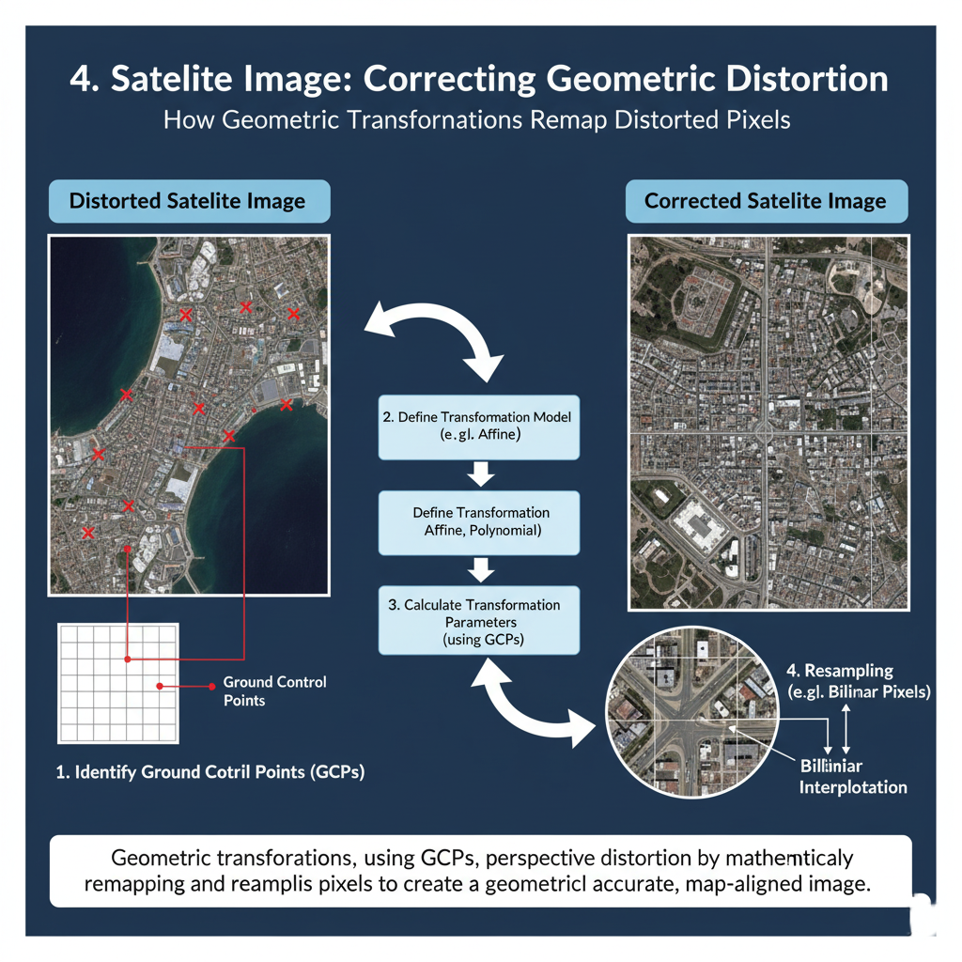

5. A digital artist wants to recolor a photograph to achieve a specific color tone. Explain how color space conversion and pixel manipulation can help in this task.

Sol. Digital Artist: Recolor Photograph
Explanation: A digital artist wanting to recolor a photograph to achieve a specific color tone can effectively use color space conversion and pixel manipulation in conjunction.
How it helps:
- Color Space Conversion:
  - From RGB to HSV/HSL: The original photograph is typically in the RGB color space. Converting it to HSV (Hue, Saturation, Value) or HSL (Hue, Saturation, Lightness) is immensely helpful for recoloring because these spaces separate color (Hue) from its intensity (Value/Lightness) and vibrancy (Saturation).
  - Targeted Adjustments:
    - Hue: To change the fundamental "color" of objects (e.g., turning a blue sky purple), the artist can shift the hue component of specific pixels or regions.
    - Saturation: To make colors more vibrant or muted, the artist can adjust the saturation component.
    - Value/Lightness: To brighten or darken colors without changing their hue or saturation, the artist can modify the value or lightness component.
  - Masking and Selection: Often, an artist doesn't want to recolor the entire image. They can use selection tools (masks) to isolate specific objects or areas (e.g., just the shirt, just the background) before applying color adjustments in the HSV/HSL space.
  - Example (Sepia Tone): To create a sepia tone, one might reduce saturation across the image and then subtly shift hues towards a warm, yellowish-brown range, while potentially adjusting overall lightness/contrast.
- Pixel Manipulation:
  - Direct Channel Adjustment (in RGB or other spaces): While less intuitive for hue shifts, direct manipulation of R, G, B channels can be used for more subtle color grading, contrast adjustments, or to remove color casts. For example, reducing the blue channel can warm up an image.
  - Color Balance: Tools that allow balancing the red, green, and blue components in shadows, midtones, and highlights (often operating in an RGB-like space) are a form of sophisticated pixel manipulation for color toning.
  - Lookup Tables (LUTs): Advanced pixel manipulation can involve applying a Lookup Table, which is essentially a pre-defined mapping of input color values to output color values. Artists can create or apply LUTs to achieve complex color grading effects (e.g., cinematic looks, vintage feels) that affect millions of pixels uniformly.
  - Blending Modes: When working with multiple layers, blending modes manipulate how the pixel values of one layer interact with the layer(s) below to produce a combined color. This is powerful for non-destructive recoloring.
By converting to a more perceptually intuitive color space like HSV/HSL, the artist gains finer, more isolated control over the color characteristics. Then, pixel manipulation techniques, whether direct or via more complex tools like LUTs, allow for precise application of these changes to achieve the desired aesthetic.
Diagram:
