
Computer Vision
MCA-574
Lab – 09
BY
HIMANSHU HEDA (24225013)
SUBMITTED TO
Dr. Preety Shoran
SCHOOL OF SCIENCES
2024-25
Texture Analysis in Satellite Imagery Using Wavelet Transform
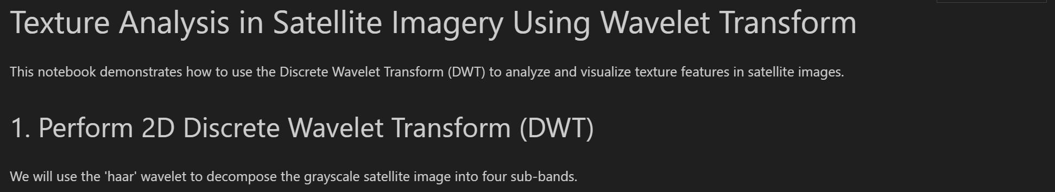
import cv2
import numpy as np
import matplotlib.pyplot as plt
import pywt

# Load satellite image (replace with your filename if needed)
img = cv2.imread('earth.png', cv2.IMREAD_GRAYSCALE)
if img is None:
raise Exception('Image not found!')

# Perform 2D DWT using 'haar' wavelet
coeffs2 = pywt.dwt2(img, 'haar')
LL, (LH, HL, HH) = coeffs2

plt.figure(figsize=(12,8))
plt.subplot(2,2,1)
plt.imshow(LL, cmap='gray')
plt.title('LL (Approximation)')
plt.axis('off')

plt.subplot(2,2,2)
plt.imshow(LH, cmap='gray')
plt.title('LH (Horizontal details)')
plt.axis('off')

plt.subplot(2,2,3)
plt.imshow(HL, cmap='gray')
plt.title('HL (Vertical details)')
plt.axis('off')

plt.subplot(2,2,4)
plt.imshow(HH, cmap='gray')
plt.title('HH (Diagonal details)')
plt.axis('off')
plt.tight_layout()

plt.show()

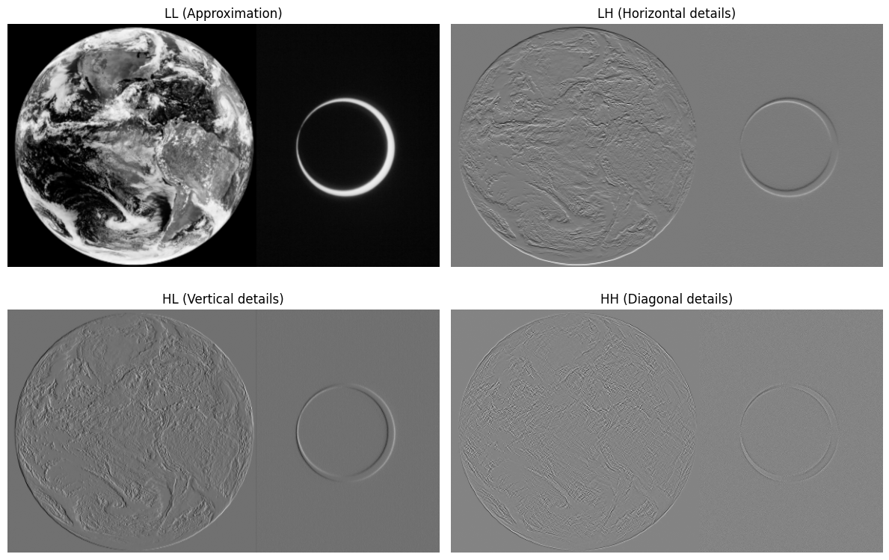

# Reconstruct the image using inverse DWT
reconstructed = pywt.idwt2((LL, (LH, HL, HH)), 'haar')
reconstructed = np.clip(reconstructed, 0, 255).astype(np.uint8)

plt.figure(figsize=(10,5))

plt.subplot(1,2,1)
plt.imshow(img, cmap='gray')
plt.title('Original Image')
plt.axis('off')

plt.subplot(1,2,2)
plt.imshow(reconstructed, cmap='gray')
plt.title('Reconstructed Image (IDWT)')
plt.axis('off')

plt.tight_layout()

plt.show()

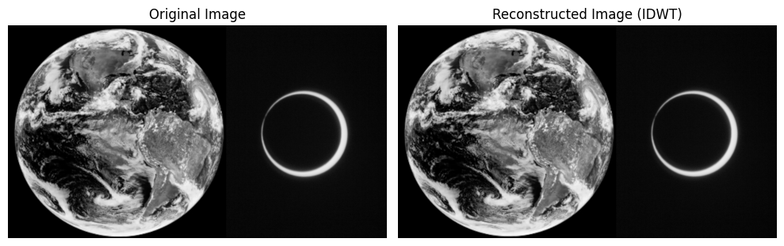

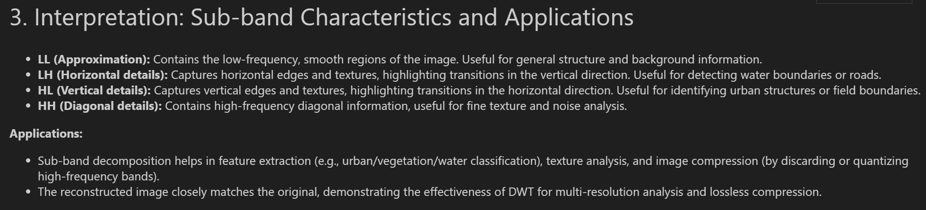

LL (Approximation) Sub-band: This sub-band represents the low-frequency components of the image, essentially a downsampled and smoothed version of the original. It captures the overall structure and dominant features of the image, such as large urban areas, extensive vegetation, and broad water bodies. It's often used as a compressed version of the image.
LH (Horizontal Details) Sub-band: This sub-band contains the high-frequency components in the horizontal direction. It highlights horizontal edges and lines within the image, which can correspond to structures like roads, building outlines that run horizontally, or changes in vegetation density across horizontal spans.
HL (Vertical Details) Sub-band: This sub-band represents the high-frequency components in the vertical direction. It emphasizes vertical edges and lines, such as the vertical walls of buildings, river banks, or boundaries between different land covers that have a vertical orientation.
HH (Diagonal Details) Sub-band: This sub-band captures high-frequency components in the diagonal directions. It highlights diagonal edges and textures, which are often present in complex patterns found in urban areas, agricultural fields with specific planting patterns, or natural terrain features that aren't strictly horizontal or vertical.

Restoration of Degraded Medical Images Using Spatial Filtering

import cv2
import numpy as np
import matplotlib.pyplot as plt
from scipy.signal import wiener

# Load grayscale medical image (replace with your filename if needed)
img = cv2.imread('mri.jpeg', cv2.IMREAD_GRAYSCALE)
if img is None:
raise Exception('Image not found!')

# Add Gaussian noise
def add_gaussian_noise(image, sigma):
gauss = np.random.normal(0, sigma, image.shape).astype(np.float32)
noisy = image.astype(np.float32) + gauss
return np.clip(noisy, 0, 255).astype(np.uint8)

# Add Salt & Pepper noise
def add_salt_pepper_noise(image, density):
noisy = image.copy()
num_salt = np.ceil(density * image.size * 0.5).astype(int)
num_pepper = np.ceil(density * image.size * 0.5).astype(int)

# Salt
coords = [np.random.randint(0, i - 1, num_salt) for i in image.shape]
noisy[coords[0], coords[1]] = 255

# Pepper
coords = [np.random.randint(0, i - 1, num_pepper) for i in image.shape]
noisy[coords[0], coords[1]] = 0
return noisy

# Add Speckle noise
def add_speckle_noise(image, var):
gauss = np.random.randn(*image.shape) * var
noisy = image + image * gauss
return np.clip(noisy, 0, 255).astype(np.uint8)

# Example: Add noise with density 0.05
gauss_img = add_gaussian_noise(img, sigma=20)
sp_img = add_salt_pepper_noise(img, density=0.05)
speckle_img = add_speckle_noise(img, var=0.1)

plt.figure(figsize=(12,4))
plt.subplot(1,4,1)
plt.imshow(img, cmap='gray')
plt.title('Original')
plt.axis('off')

plt.subplot(1,4,2)
plt.imshow(gauss_img, cmap='gray')
plt.title('Gaussian Noise')
plt.axis('off')

plt.subplot(1,4,3)
plt.imshow(sp_img, cmap='gray')
plt.title('Salt & Pepper')
plt.axis('off')

plt.subplot(1,4,4)
plt.imshow(speckle_img, cmap='gray')
plt.title('Speckle Noise')
plt.axis('off')

plt.tight_layout()
plt.show()

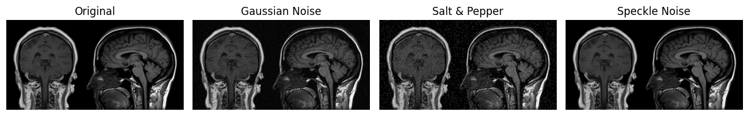

# Linear Filters
mean_3 = cv2.blur(gauss_img, (3,3))
mean_5 = cv2.blur(gauss_img, (5,5))
gauss_filt_3 = cv2.GaussianBlur(gauss_img, (3,3), 1)
gauss_filt_5 = cv2.GaussianBlur(gauss_img, (5,5), 1)

# Non-Linear Filters
median_3 = cv2.medianBlur(sp_img, 3)
median_5 = cv2.medianBlur(sp_img, 5)
wiener_3 = wiener(speckle_img, (3,3))
wiener_5 = wiener(speckle_img, (5,5))
wiener_3 = np.clip(wiener_3, 0, 255).astype(np.uint8)
wiener_5 = np.clip(wiener_5, 0, 255).astype(np.uint8)

plt.figure(figsize=(15,8))
plt.subplot(2,3,1)
plt.imshow(mean_3, cmap='gray')
plt.title('Mean Filter 3x3 (Gaussian Noise)')
plt.axis('off')

plt.subplot(2,3,2)
plt.imshow(gauss_filt_3, cmap='gray')
plt.title('Gaussian Filter 3x3 (Gaussian Noise)')
plt.axis('off')

plt.subplot(2,3,3)
plt.imshow(median_3, cmap='gray')
plt.title('Median Filter 3x3 (Salt & Pepper)')
plt.axis('off')

plt.subplot(2,3,4)
plt.imshow(mean_5, cmap='gray')
plt.title('Mean Filter 5x5 (Gaussian Noise)')
plt.axis('off')

plt.subplot(2,3,5)
plt.imshow(wiener_3, cmap='gray')
plt.title('Wiener Filter 3x3 (Speckle)')
plt.axis('off')

plt.subplot(2,3,6)
plt.imshow(wiener_5, cmap='gray')
plt.title('Wiener Filter 5x5 (Speckle)')
plt.axis('off')

plt.tight_layout()
plt.show()

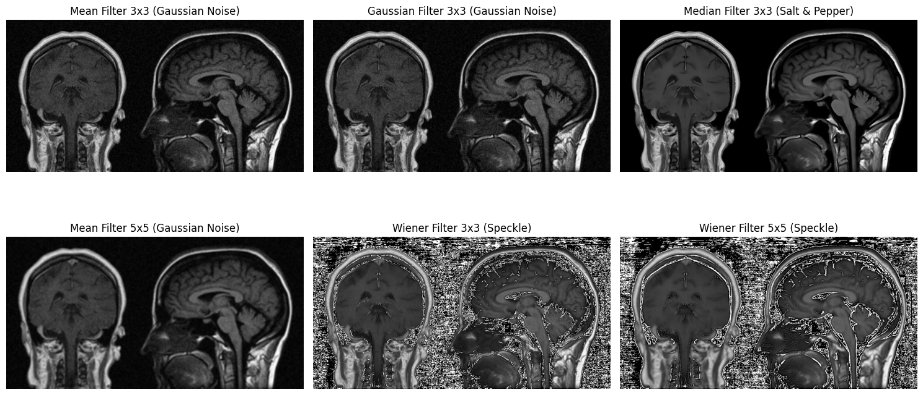
def mse(img1, img2):
return np.mean((img1.astype(np.float32) - img2.astype(np.float32)) ** 2)

def psnr(img1, img2):
mse_val = mse(img1, img2)
if mse_val == 0:
return float('inf')
return 20 * np.log10(255.0 / np.sqrt(mse_val))

print('PSNR and MSE for Gaussian Noise:')
print('Mean 3x3:', psnr(img, mean_3), mse(img, mean_3))
print('Gaussian 3x3:', psnr(img, gauss_filt_3), mse(img, gauss_filt_3))
print('\nPSNR and MSE for Salt & Pepper Noise:')
print('Median 3x3:', psnr(img, median_3), mse(img, median_3))
print('\nPSNR and MSE for Speckle Noise:')
print('Wiener 3x3:', psnr(img, wiener_3), mse(img, wiener_3))

PSNR and MSE for Gaussian Noise:
Mean 3x3: 28.293522862999954 96.32257
Gaussian 3x3: 28.642445982682375 88.88649

PSNR and MSE for Salt & Pepper Noise:
Median 3x3: 33.7213377551099 27.602385

PSNR and MSE for Speckle Noise:
Wiener 3x3: 7.819565042093374 10742.958
