
Computer Vision
MCA-574
Lab – 12
BY
HIMANSHU HEDA (24225013)
SUBMITTED TO
Dr. Preety Shoran
SCHOOL OF SCIENCES
2024-25
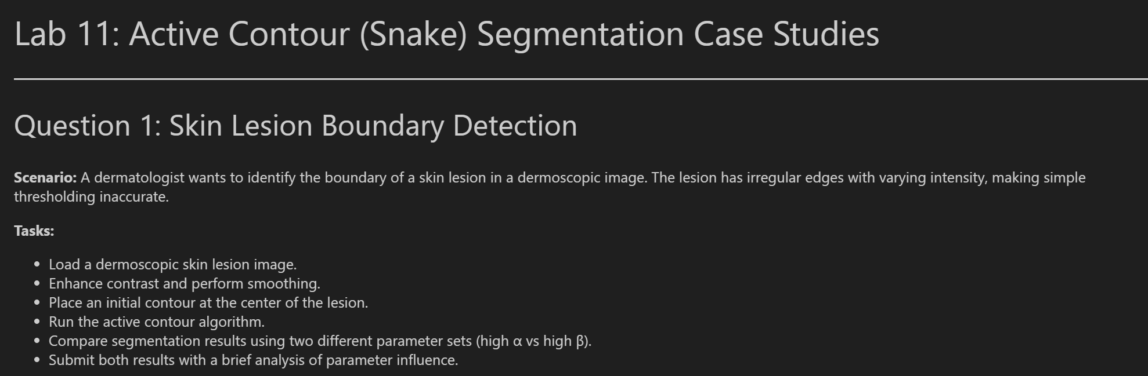
import numpy as np
import matplotlib.pyplot as plt
from skimage import io, color, filters, img_as_float
from skimage.segmentation import active_contour

# Load and preprocess the skin lesion image
img = img_as_float(io.imread('skin_lesion.jpg'))
if img.ndim == 3:
img_gray = color.rgb2gray(img)
else:
img_gray = img

# Enhance contrast and smooth
img_eq = filters.rank.equalize((img_gray * 255).astype(np.uint8), footprint=np.ones((30,30)))
img_smooth = filters.gaussian(img_eq, sigma=2)

# Display preprocessed image
plt.figure(figsize=(6,6))
plt.imshow(img_smooth, cmap='gray')
plt.title('Preprocessed Skin Lesion')
plt.axis('off')
plt.show()
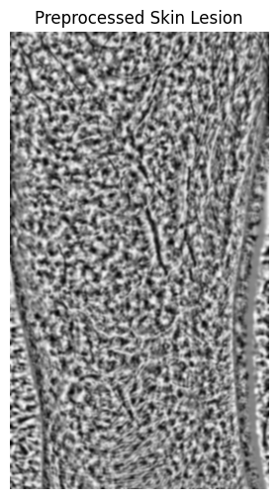
# Place initial contour (circle at center)
s = np.linspace(0, 2*np.pi, 400)
r = img_smooth.shape[0] // 2
c = img_smooth.shape[1] // 2
radius = min(r, c) // 2
init = np.array([r + radius*np.sin(s), c + radius*np.cos(s)]).T

plt.figure(figsize=(6,6))
plt.imshow(img_smooth, cmap='gray')
plt.plot(init[:, 1], init[:, 0], '--r', lw=2)
plt.title('Initial Contour')
plt.axis('off')
plt.show()
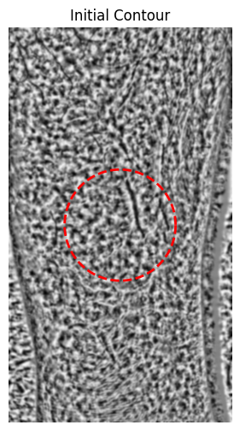
# Run active contour: high alpha (elasticity), low beta (smoothness)
snake1 = active_contour(img_smooth, init, alpha=0.8, beta=0.1, gamma=0.01, max_num_iter=300)

# Run active contour: low alpha, high beta
snake2 = active_contour(img_smooth, init, alpha=0.1, beta=1.0, gamma=0.01, max_num_iter=300)

# Display results
fig, ax = plt.subplots(1,2, figsize=(12,6))
ax[0].imshow(img_smooth, cmap='gray')
ax[0].plot(snake1[:, 1], snake1[:, 0], '-b', lw=2)
ax[0].set_title('High α (Elasticity), Low β (Smoothness)')
ax[0].axis('off')
ax[1].imshow(img_smooth, cmap='gray')
ax[1].plot(snake2[:, 1], snake2[:, 0], '-g', lw=2)
ax[1].set_title('Low α, High β')
ax[1].axis('off')
plt.show()

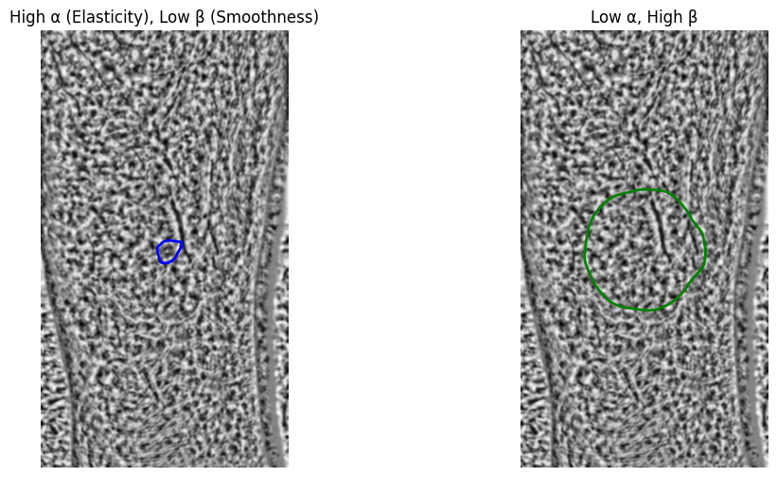
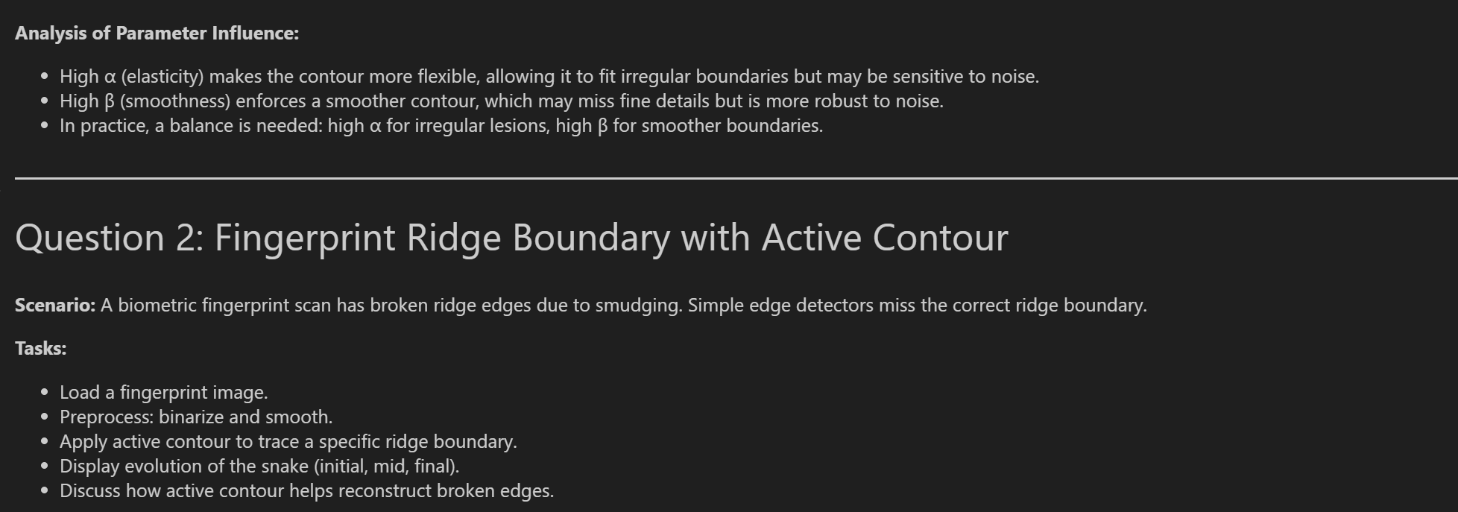
# Load and preprocess fingerprint image
img_fp = img_as_float(io.imread('fingerprint.jpg'))
if img_fp.ndim == 3:
img_fp_gray = color.rgb2gray(img_fp)
else:
img_fp_gray = img_fp

# Binarize and smooth
thresh = filters.threshold_otsu(img_fp_gray)
img_fp_bin = img_fp_gray > thresh
img_fp_smooth = filters.gaussian(img_fp_bin, sigma=1)

plt.figure(figsize=(6,6))
plt.imshow(img_fp_smooth, cmap='gray')
plt.title('Preprocessed Fingerprint')
plt.axis('off')
plt.show()
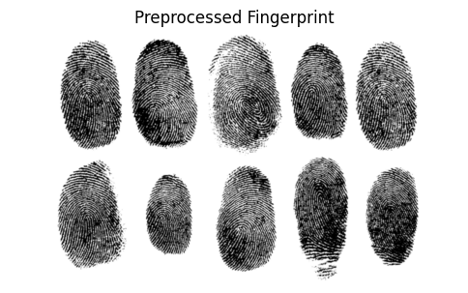
# Place initial contour (roughly along a ridge)
s = np.linspace(0, 2*np.pi, 200)
r = img_fp_smooth.shape[0] // 2
c = img_fp_smooth.shape[1] // 2
radius = min(r, c) // 3
init_fp = np.array([r + radius*np.sin(s), c + radius*np.cos(s)]).T

plt.figure(figsize=(6,6))
plt.imshow(img_fp_smooth, cmap='gray')
plt.plot(init_fp[:, 1], init_fp[:, 0], '--r', lw=2)
plt.title('Initial Contour (Fingerprint Ridge)')
plt.axis('off')
plt.show()
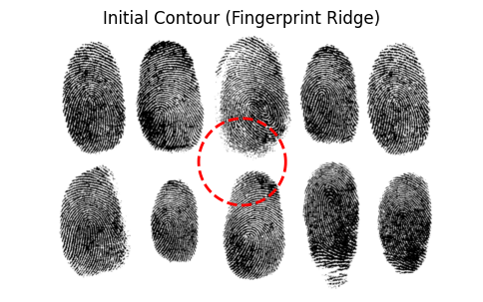

# Run active contour and show evolution
snake_fp_init = init_fp.copy()
snake_fp_mid = active_contour(img_fp_smooth, snake_fp_init, alpha=0.5, beta=0.5, gamma=0.01, max_num_iter=100)
snake_fp_final = active_contour(img_fp_smooth, snake_fp_mid, alpha=0.5, beta=0.5, gamma=0.01, max_num_iter=200)

fig, ax = plt.subplots(1,3, figsize=(18,6))
ax[0].imshow(img_fp_smooth, cmap='gray')
ax[0].plot(snake_fp_init[:, 1], snake_fp_init[:, 0], '--r', lw=2)
ax[0].set_title('Initial Snake')
ax[0].axis('off')
ax[1].imshow(img_fp_smooth, cmap='gray')
ax[1].plot(snake_fp_mid[:, 1], snake_fp_mid[:, 0], '--b', lw=2)
ax[1].set_title('Mid Evolution')
ax[1].axis('off')
ax[2].imshow(img_fp_smooth, cmap='gray')
ax[2].plot(snake_fp_final[:, 1], snake_fp_final[:, 0], '-g', lw=2)
ax[2].set_title('Final Snake')
ax[2].axis('off')
plt.show()

