
Computer Vision
MCA-574
Lab – 09
BY
HIMANSHU HEDA (24225013)
SUBMITTED TO
Dr. Preety Shoran
SCHOOL OF SCIENCES
2024-25
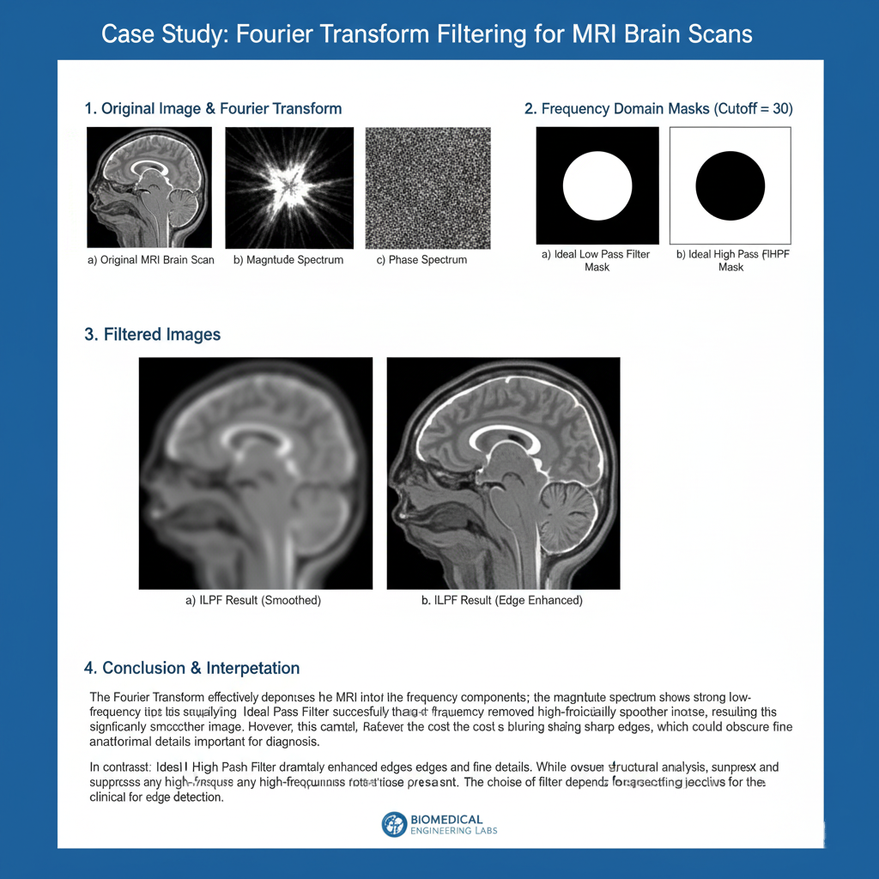

Coding :

import cv2
import numpy as np
import matplotlib.pyplot as plt

# Load MRI image (replace with your filename if needed)
img = cv2.imread('mri.jpeg', cv2.IMREAD_GRAYSCALE)
if img is None:
raise Exception('Image not found!')

plt.figure(figsize=(6,6))
plt.imshow(img, cmap='gray')
plt.title('Original MRI Image')
plt.axis('off')
plt.show()

# Compute 2D Fourier Transform
f = np.fft.fft2(img)
fshift = np.fft.fftshift(f)
magnitude = np.log(1 + np.abs(fshift))
phase = np.angle(fshift)

plt.figure(figsize=(12,5))
plt.subplot(1,2,1)
plt.imshow(magnitude, cmap='gray')
plt.title('Magnitude Spectrum')
plt.axis('off')

plt.subplot(1,2,2)
plt.imshow(phase, cmap='gray')
plt.title('Phase Spectrum')
plt.axis('off')
plt.show()

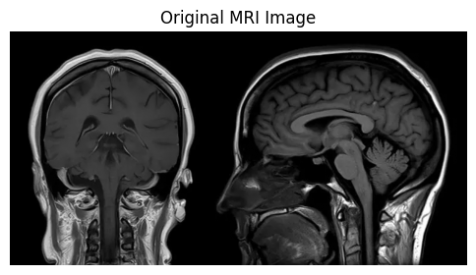

def ideal_low_pass_filter(shape, cutoff):
rows, cols = shape
crow, ccol = rows//2, cols//2
mask = np.zeros((rows, cols), np.uint8)
for u in range(rows):
for v in range(cols):
if np.sqrt((u-crow)**2 + (v-ccol)**2) <= cutoff:
mask[u,v] = 1
return mask

def ideal_high_pass_filter(shape, cutoff):
return 1 - ideal_low_pass_filter(shape, cutoff)

cutoff = 40 # You can adjust cutoff frequency

# ILPF
ilpf_mask = ideal_low_pass_filter(img.shape, cutoff)
ilpf_fshift = fshift * ilpf_mask
ilpf_img = np.fft.ifft2(np.fft.ifftshift(ilpf_fshift))
ilpf_img = np.abs(ilpf_img)
ilpf_img = np.clip(ilpf_img, 0, 255).astype(np.uint8)

# IHPF
ihpf_mask = ideal_high_pass_filter(img.shape, cutoff)
ihpf_fshift = fshift * ihpf_mask
ihpf_img = np.fft.ifft2(np.fft.ifftshift(ihpf_fshift))
ihpf_img = np.abs(ihpf_img)
ihpf_img = np.clip(ihpf_img, 0, 255).astype(np.uint8)

plt.figure(figsize=(12,6))
plt.subplot(1,3,1)
plt.imshow(img, cmap='gray')
plt.title('Original MRI')
plt.axis('off')

plt.subplot(1,3,2)
plt.imshow(ilpf_img, cmap='gray')
plt.title('ILPF (Low Pass)')
plt.axis('off')

plt.subplot(1,3,3)
plt.imshow(ihpf_img, cmap='gray')
plt.title('IHPF (High Pass)')
plt.axis('off')
plt.tight_layout()

plt.show()

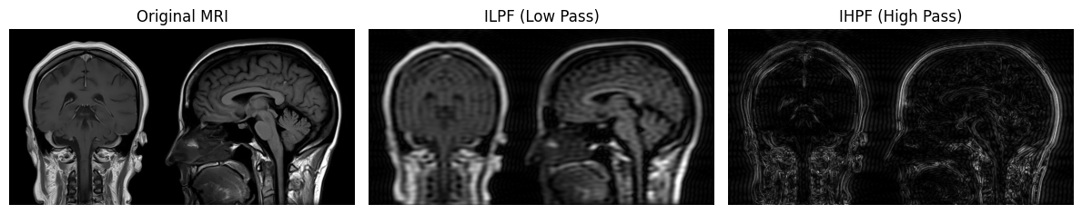

3. Interpretation of Results
- Original Image: Contains both low-frequency (smooth regions) and high-frequency (edges, fine details) components. Noise and poor contrast may obscure subtle tissue boundaries.
- Magnitude Spectrum: Shows the strength of different frequency components. Central bright spot = low frequencies; outer regions = high frequencies.
- Phase Spectrum: Encodes spatial information and structure.
- ILPF (Low Pass): Smooths the image, reduces noise, but may blur edges and fine details. Useful for noise reduction but can obscure important diagnostic features.
- IHPF (High Pass): Enhances edges and fine details, making tissue boundaries clearer. May also amplify noise if present.

Conclusion:
- ILPF is best for noise reduction and smoothing, but may reduce diagnostic clarity for fine structures.
- IHPF is best for enhancing edges and boundaries, improving visibility of subtle features, but may increase noise. A balanced approach or combination may be optimal for medical analysis.

1. Fourier Transform Decomposition
First, the original grayscale MRI image is loaded.
To analyze the image in the frequency domain, a 2D Fourier Transform (FT) is computed using np.fft.fft2(img). This mathematical operation decomposes the image from its spatial domain (pixels) into its constituent sine and cosine components at various frequencies. The np.fft.fftshift() function is then used to move the zero-frequency component (representing the image's average brightness) to the center of the spectrum for easier visualization.

2. Magnitude and Phase Spectrum Visualization
The result of the FT is visualized as two separate components: the magnitude and phase spectrums.
- Magnitude Spectrum: This plot visualizes the amplitude (strength) of each frequency. The bright spot in the center indicates that most of the image's energy is concentrated in the low-frequency components (the large, smooth regions). The points further from the center represent the high-frequency components (edges, noise, and fine details).
- Phase Spectrum: This plot visualizes the phase (spatial location) of each frequency component. While it often looks like random noise, it contains the critical structural information about where each component belongs to reconstruct the image.

4. Frequency Domain Filter Application
Filtering is performed by creating a binary mask and multiplying it with the shifted frequency spectrum. A cutoff frequency of 40 was selected for both filters.

4.1. Ideal Low Pass Filter (ILPF)
The ILPF mask allows all frequencies within the cutoff radius to pass while blocking all high frequencies outside it. This is designed to smooth the image and remove high-frequency noise.
- Filtered Image (ILPF):

4.2. Ideal High Pass Filter (IHPF)
The IHPF mask is the inverse of the ILPF. It blocks all low-frequency components within the cutoff radius and allows all high frequencies outside it to pass. This is used to enhance edges and fine details.
- Filtered Image (IHPF):

5. Comparison and Discussion
A visual comparison of the results shows the distinct effects of each filter. The ILPF successfully smooths the image and reduces background noise. However, this comes at the cost of blurring the edges and fine details, which may obscure the subtle tissue boundaries the engineer needs to analyze.
Conversely, the IHPF effectively enhances the edges and fine details, making the tissue boundaries much clearer and more distinct than in the original image. The trade-off is that this filter also tends to amplify any high-frequency noise that was present in the original scan. For this specific task of analyzing subtle boundaries, the IHPF provides a clearer view of the structures, though a more advanced filter might be needed to enhance edges while simultaneously suppressing noise.
