
Computer Vision
MCA-574
Lab – 03
BY
HIMANSHU HEDA (24225013)
SUBMITTED TO
Dr. Preety Shoran
SCHOOL OF SCIENCES
2024-25
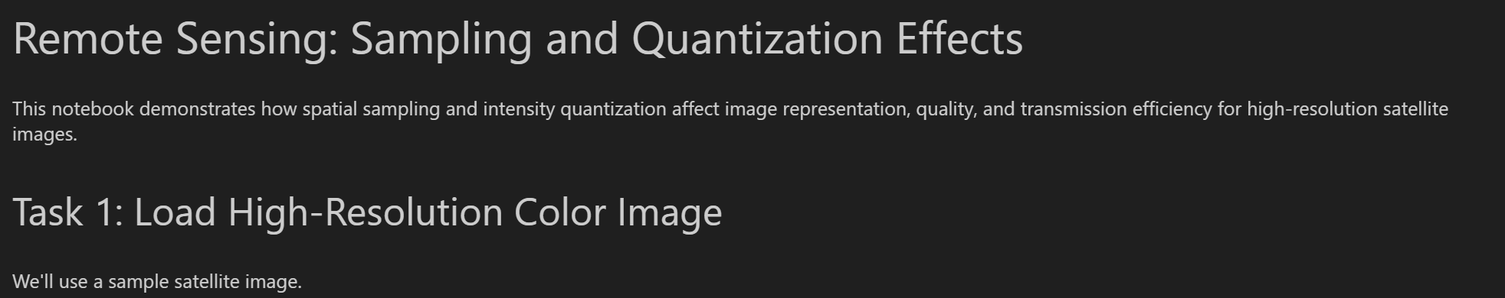
import cv2
import numpy as np
import matplotlib.pyplot as plt

# Load high-resolution color image
img = cv2.imread('moon.webp')
if img is None:
raise Exception('Image not found!')

img_rgb = cv2.cvtColor(img, cv2.COLOR_BGR2RGB)
plt.imshow(img_rgb)
plt.title('Original High-Resolution Image')
plt.axis('off')
plt.show()

Output:
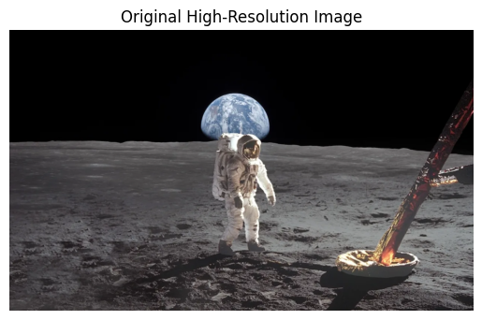

# Resize image to different resolutions
img_512 = cv2.resize(img_rgb, (512, 512))
img_256 = cv2.resize(img_rgb, (256, 256))
img_128 = cv2.resize(img_rgb, (128, 128))

plt.figure(figsize=(15,5))

plt.subplot(1,3,1)
plt.imshow(img_512)
plt.title('512x512')
plt.axis('off')

plt.subplot(1,3,2)
plt.imshow(img_256)
plt.title('256x256')
plt.axis('off')

plt.subplot(1,3,3)
plt.imshow(img_128)
plt.title('128x128')
plt.axis('off')

plt.show()

Output: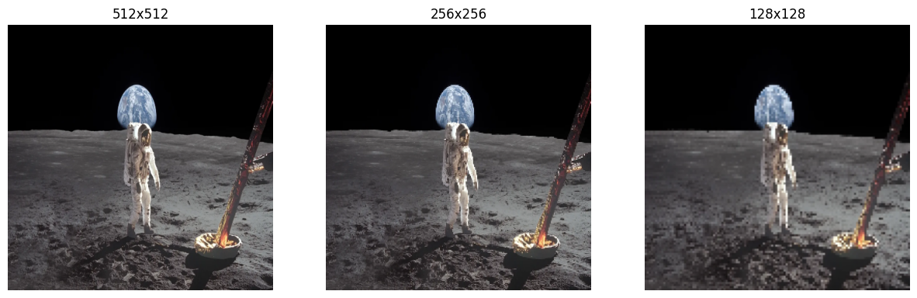

# Convert to grayscale for quantization
gray_512 = cv2.cvtColor(img_512, cv2.COLOR_RGB2GRAY)

# Quantize to 256, 64, and 16 levels
def quantize(img, levels):
step = 256 // levels
return (img // step) * step

q_256 = quantize(gray_512, 256)
q_64 = quantize(gray_512, 64)
q_16 = quantize(gray_512, 16)

plt.figure(figsize=(15,5))
plt.subplot(1,3,1)
plt.imshow(q_256, cmap='gray')
plt.title('256 Levels')
plt.axis('off')

plt.subplot(1,3,2)
plt.imshow(q_64, cmap='gray')
plt.title('64 Levels')
plt.axis('off')

plt.subplot(1,3,3)
plt.imshow(q_16, cmap='gray')
plt.title('16 Levels')
plt.axis('off')

plt.show()

Output:
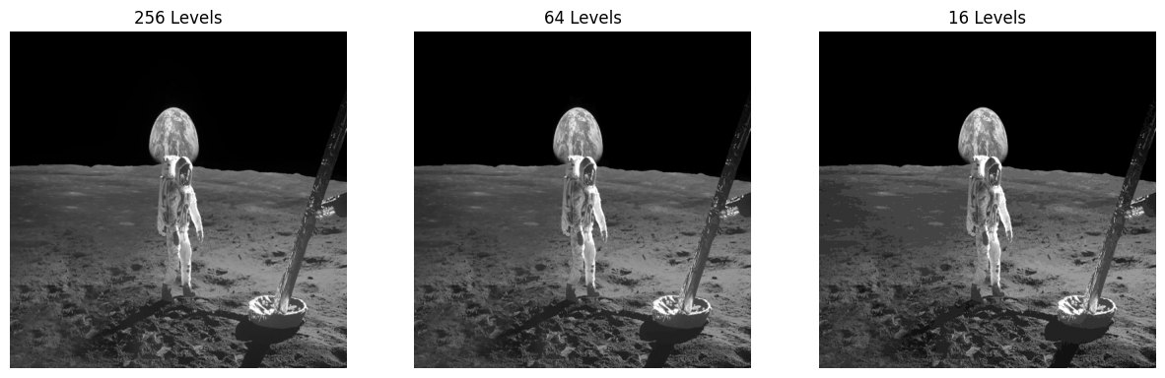
# Calculate and print image sizes (in bytes)
import sys
sizes = [img_512.nbytes, img_256.nbytes, img_128.nbytes]
quant_sizes = [q_256.nbytes, q_64.nbytes, q_16.nbytes]

print('Resolution Data Sizes (bytes):')
print(f'512x512: {sizes[0]} | 256x256: {sizes[1]} | 128x128: {sizes[2]}')
print('Quantized Data Sizes (bytes):')
print(f'256 levels: {quant_sizes[0]} | 64 levels: {quant_sizes[1]} | 16 levels: {quant_sizes[2]}')

Output :
Resolution Data Sizes (bytes):
512x512: 786432 | 256x256: 196608 | 128x128: 49152
Quantized Data Sizes (bytes):
256 levels: 262144 | 64 levels: 262144 | 16 levels: 262144

Task 5: Questions & Discussion

Q1: Trade-off between image quality and data size
- Reducing resolution and quantization levels decreases data size, but also degrades visual quality. Essential details may be lost if levels are too low.

Q2: Importance of selecting appropriate sampling and quantization levels
- For applications needing fine detail (e.g., urban mapping, crop analysis), higher resolution and more gray levels are needed.
- For quick transmission or rough monitoring (e.g., weather, IoT sensors), lower levels may suffice.

Q3: Real-world implications for satellite imaging or IoT camera-based systems
- Satellite images for scientific analysis require high fidelity, but bandwidth is limited. Adaptive compression (region-based, multi-resolution) is often used.
- IoT cameras may use aggressive quantization/sampling to save power and bandwidth, but must balance with the need for actionable information.

Summary Table:
Setting | Data Size | Visual Quality | Use Case Example
High Resolution, 256 Levels | Large | Excellent | Scientific mapping
Low Resolution, 16 Levels | Small | Poor | Quick event detection
Medium, 64 Levels | Moderate | Good | General monitoring

