
Computer Vision
MCA-574
Lab – 10
BY
HIMANSHU HEDA (24225013)
SUBMITTED TO
Dr. Preety Shoran
SCHOOL OF SCIENCES
2024-25
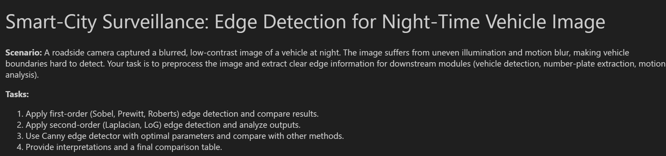
import cv2
import numpy as np
import matplotlib.pyplot as plt
from scipy import ndimage

# Load the image (assume vehicle_night.png is in the working directory)
img = cv2.imread('vehicle_night.jpg', cv2.IMREAD_COLOR)
if img is None:
raise FileNotFoundError('vehicle_night.jpg not found.')

# Convert to grayscale
gray = cv2.cvtColor(img, cv2.COLOR_BGR2GRAY)

# Enhance contrast using CLAHE
clahe = cv2.createCLAHE(clipLimit=2.0, tileGridSize=(8,8))
enhanced = clahe.apply(gray)

# Display original and enhanced images
plt.figure(figsize=(12,5))
plt.subplot(1,2,1)
plt.imshow(gray, cmap='gray')
plt.title('Original Grayscale')
plt.axis('off')
plt.subplot(1,2,2)
plt.imshow(enhanced, cmap='gray')
plt.title('Contrast Enhanced (CLAHE)')
plt.axis('off')
plt.show()

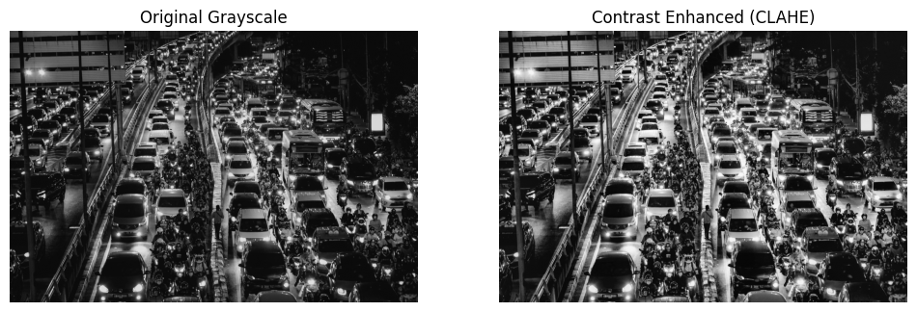

# Sobel Edge Detection
sobelx = cv2.Sobel(enhanced, cv2.CV_64F, 1, 0, ksize=3)
sobely = cv2.Sobel(enhanced, cv2.CV_64F, 0, 1, ksize=3)
sobel = cv2.magnitude(sobelx, sobely)
sobel = np.uint8(np.clip(sobel, 0, 255))

# Prewitt Edge Detection
prewitt_kernelx = np.array([[1,0,-1],[1,0,-1],[1,0,-1]])
prewitt_kernely = np.array([[1,1,1],[0,0,0],[-1,-1,-1]])
prewittx = ndimage.convolve(enhanced, prewitt_kernelx)
prewitty = ndimage.convolve(enhanced, prewitt_kernely)
prewitt = np.hypot(prewittx, prewitty)
prewitt = np.uint8(np.clip(prewitt, 0, 255))

# Roberts Edge Detection
roberts_kernelx = np.array([[1, 0], [0, -1]])
roberts_kernely = np.array([[0, 1], [-1, 0]])
robertsx = ndimage.convolve(enhanced, roberts_kernelx)
robertsy = ndimage.convolve(enhanced, roberts_kernely)
roberts = np.hypot(robertsx, robertsy)
roberts = np.uint8(np.clip(roberts, 0, 255))

# Display edge maps
plt.figure(figsize=(15,5))
plt.subplot(1,3,1)
plt.imshow(sobel, cmap='gray')
plt.title('Sobel Edge Map')
plt.axis('off')
plt.subplot(1,3,2)
plt.imshow(prewitt, cmap='gray')
plt.title('Prewitt Edge Map')
plt.axis('off')
plt.subplot(1,3,3)
plt.imshow(roberts, cmap='gray')
plt.title('Roberts Edge Map')
plt.axis('off')
plt.show()

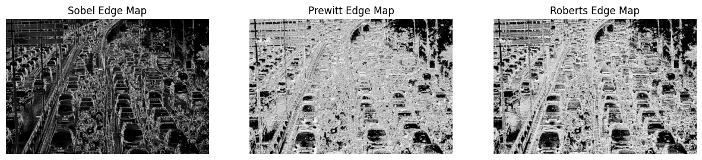
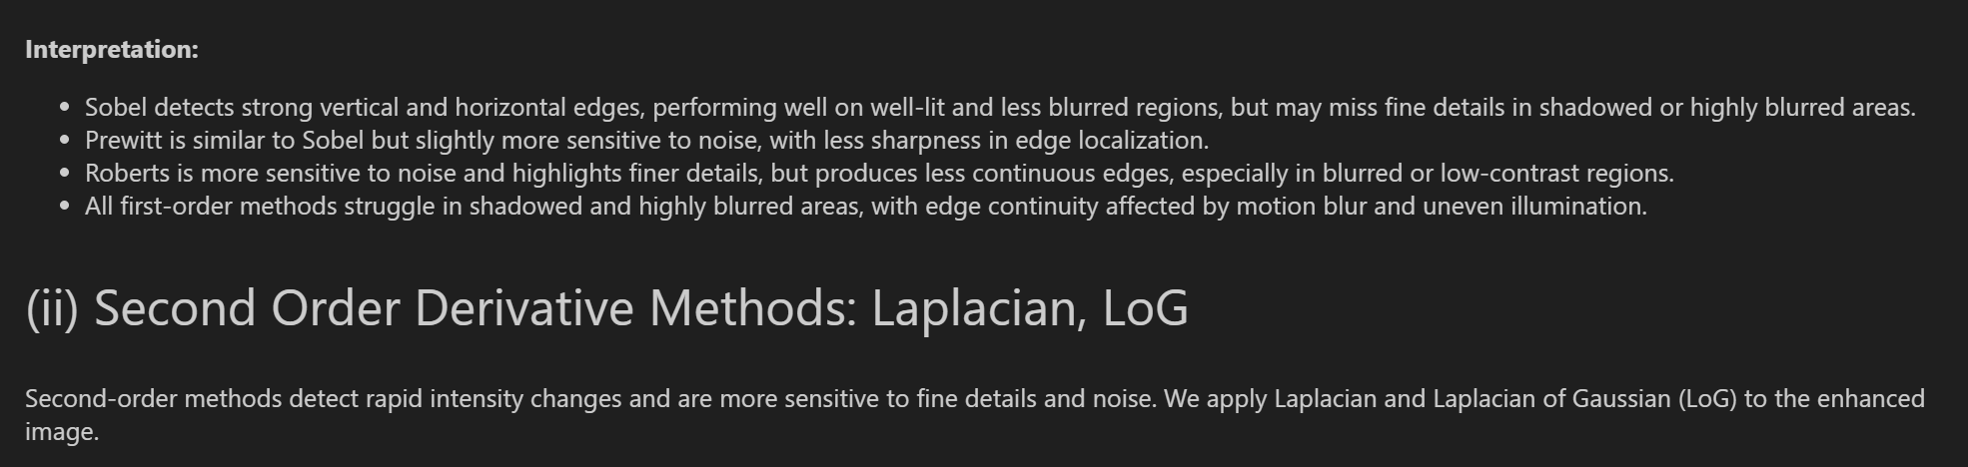
# Laplacian Edge Detection
laplacian = cv2.Laplacian(enhanced, cv2.CV_64F, ksize=3)
laplacian = np.uint8(np.clip(np.abs(laplacian), 0, 255))

# Laplacian of Gaussian (LoG)
log_blur = cv2.GaussianBlur(enhanced, (5,5), 1.0)
log = cv2.Laplacian(log_blur, cv2.CV_64F, ksize=3)
log = np.uint8(np.clip(np.abs(log), 0, 255))

# Display edge maps
plt.figure(figsize=(10,5))
plt.subplot(1,2,1)
plt.imshow(laplacian, cmap='gray')
plt.title('Laplacian Edge Map')
plt.axis('off')
plt.subplot(1,2,2)
plt.imshow(log, cmap='gray')
plt.title('LoG Edge Map')
plt.axis('off')
plt.show()

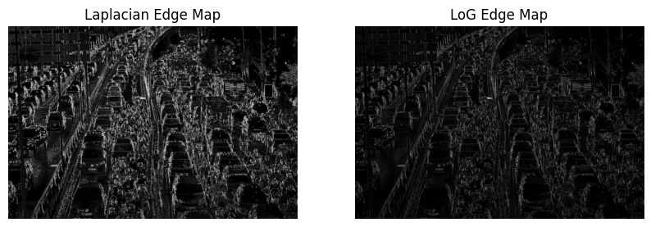

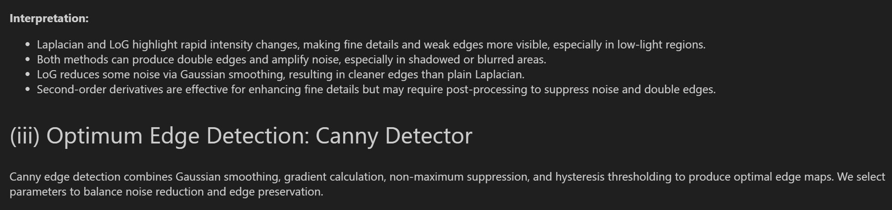
# Canny Edge Detection
sigma = 1.2 # Gaussian smoothing parameter
low_thresh = 40
high_thresh = 100

canny = cv2.Canny(enhanced, low_thresh, high_thresh, apertureSize=3, L2gradient=True)

plt.figure(figsize=(6,5))
plt.imshow(canny, cmap='gray')
plt.title(f'Canny Edge Map (σ={sigma}, thresholds={low_thresh}/{high_thresh})')
plt.axis('off')
plt.show()

