//  Write a C program to find the whether a number is palindrome or not.

#include <stdio.h>

int main() {

    int num, reversedNum = 0, remainder, originalNum;

    // Input from the user

    printf("Enter an integer: ");

    scanf("%d", &num);

    originalNum = num; // Store the original number

    // Reverse the number

    while (num != 0) {

        remainder = num % 10; // Get the last digit

        reversedNum = reversedNum * 10 + remainder; // Build the reversed number

        num /= 10; // Remove the last digit

    }

    // Check if the original number and reversed number are the same

    if (originalNum == reversedNum) {

        printf("%d is a palindrome.\n", originalNum);

    } else {

        printf("%d is not a palindrome.\n", originalNum);

    }

    return 0;

}

**Output : --**

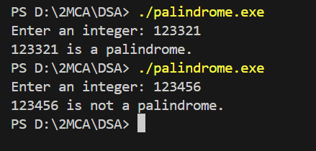

// Write a C program to generate a Fibonacci series.

#include <stdio.h>

int main() {

    int n, i;

    unsigned long long first = 0, second = 1, next;

    // Ask the user for the number of terms

    printf("Enter the number of terms in the Fibonacci series: ");

    scanf("%d", &n);

    // Print the Fibonacci series

    printf("Fibonacci Series: \n");

    for (i = 0; i < n; i++) {

        if (i <= 1) {

            next = i; // The first two terms are 0 and 1

        } else {

            next = first + second; // Next term is the sum of the previous two

            first = second; // Update first to the second term

            second = next; // Update second to the next term

        }

        printf("%llu ", next); // Print the current term

    }

    printf("\n"); // New line after the series

    return 0;

}

**Output : --**

