

**Web Stack Development (MCA 172)**

**Lab Practical –**

***BY***

**HIMANSHU HEDA (24225013)**

**SHRUTI PRIYA (24225045)**

**JOSEPH JOHN MARTIN (24225015)**

**JAMES GEORGE ILLIPPARAMBIL (24225037)**

**SUBMITTED TO**

**Prof. Vandna Kansal**

**SCHOOL OF SCIENCES**

**2024-2025**

**Program Description:** Project on EcoMart an E-commerce Website

**Code of the program**

**Output**: -

# ABSTRACT

The EcoMart Ecommerce Website is a user-friendly, feature-rich platform designed to offer an efficient and seamless online shopping experience. Developed using HTML, CSS (Bootstrap), Python, and SQLite as the backend, EcoMart provides a dynamic and responsive interface for users to browse, search, and purchase eco-friendly products. The website aims to promote sustainable living by offering a wide range of environmentally conscious products in a well-organized digital marketplace. Key features include secure user authentication, product filtering, shopping cart functionality, and an integrated database system to manage inventory, user data, and transactions efficiently. EcoMart emphasizes both ease of use and scalability, making it adaptable for future enhancements and larger product catalogs.

# TABLE OF CONTENTS

**ABSTRACT I**

**TABLE OF CONTENTS II**

**LIST OF TABLES VIII**

# CHAPTER 1: INTRODUCTION

1.1 Introduction 1

1.2 Key Points 2

# CHAPTER 2: SYSTEM ANALYSIS

2.1 System Environment 3

2.2.1 Hardware Requirement 3

2.2.2 Software Requirement 3

2.2 Module 4

# CHAPTER 3: SOFTWARE TOOLS USED

3.1 Software tool Used 5 3.2 Front End 5

3.2.1 HTML 5

3.2.2 CSS 5

3.2.3 JAVASCRIPT 6

3.3 BACK END 6

3.3.1 Python 7

3.3.2 SQLITE 8

CHAPTER 4: OBJECTIVES

4.1 Objective of Project 9

4.1.1 Project Aims and Objectives 9

4.2 Advantages 11

## CHAPTER 5: SYSTEM DESIGN

5.1 System Design 13

5.2 Login DFD Diagram 13

5.4 E-R DIAGRAM 14

## CHAPTER 6: SYSTEM IMPLEMEMENTATION

6.1 Scope 15

## CHAPTER 7: RESULT

7.1 Benefits 16

7.2 Screenshots 17

CONCLUSION 25

FUTURE SCOPE 26

REFERENCES 27

# LIST OF TABLES

Software Requirement 3

Hardware Requirement 3

# CHAPTER 1

**INTRODUCTION**

## EcoMart

* In today's fast-paced, consumer-driven world, the need for sustainable products and ethical shopping practices is more critical than ever. EcoMart, an innovative ecommerce platform, is designed to address this growing demand by offering a wide selection of eco-friendly and sustainable products. The goal of EcoMart is to make it easier for consumers to adopt a greener lifestyle without sacrificing convenience or quality.
* EcoMart is built with a strong technological foundation, incorporating HTML and CSS (with Bootstrap) for a responsive, user-friendly frontend, while Python and SQLite form the backbone of its server-side operations. The platform is designed to handle a wide array of user interactions, including browsing, searching, filtering, and purchasing products. It features a secure user authentication system, a dynamic shopping cart, and an efficient checkout process, all aimed at delivering a seamless ecommerce experience.
* At its core, EcoMart seeks to foster a community of environmentally conscious consumers. Through careful curation of products and educational content on sustainability, EcoMart not only provides an online marketplace but also serves as a platform for promoting eco-awareness. The website emphasizes transparency, ensuring that customers can make informed purchasing decisions based on detailed information about the sustainability of each product.
* In an age where consumers are increasingly prioritizing ethical and eco-friendly shopping, EcoMart stands out by addressing both environmental and consumer needs. The website’s technical framework allows it to be scalable and adaptable, ensuring that it can grow to meet increasing demand and incorporate new features that enhance the user experience.
* Whether users are shopping for eco-friendly home goods, personal care products, or sustainable fashion, EcoMart delivers a curated selection of high-quality items that support a greener planet. The website’s user-friendly interface, coupled with its robust backend technology, ensures a seamless and enjoyable shopping experience, helping users take actionable steps towards sustainable living.

## 1.2 Key Points

1. **Market Demand:**

Identification of growing demand for an innovative and engaging online platform in the footwear e-commerce sector.

1. **Brand Identity:**

Emphasis on creating a strong and memorable brand identity that aligns with fashion trends and consumer preferences.

1. **Product Catalog:**

Curated product catalog showcasing a diverse range of footwear options for different occasions, ensuring a balanced mix of style, comfort, and quality.

1. **Future Enhancements:**

Discussion of potential future enhancements, including the incorporation of emerging technologies and expanding product offerings to adapt to evolving consumer preferences.

1. **Overall Goal:**

Positioning EcoMart as a premier destination for shoe enthusiasts, providing a perfect blend of style and comfort through a seamless and enjoyable online shopping experience.

# CHAPTER 2

**SYSTEM ANALYSIS**

## 2.1 HARDWARE AND SOFTWARE REQURIMENT

### 2.1.1 HARDWARE REQURIMENT

|  |  |
| --- | --- |
| SYSTEM PROCESSOR | 11 GENRATION i5 CORE  PROCESSOR |
| RAM | 4GB & HIGHER |
| HARD DISK | 20 GB & HIGHER |

TABLE 2.1 HARDWARE REQURIMENT

### 2.1.2 SOFTWARE REQURIMENT

|  |  |
| --- | --- |
| OPERATING SYSTEM | WINDOW 7/8/10/11 |
| FRONTEND | HTML, CSS, JAVASCRIPT, PHP |
| BACKEND DB | MYSQL |
| IDE | VISUAL STUDIO CODE |
| PLATFROM APPLICATION | XAMPP |

TABLE 2.2 SOFTWARE REQURIMENT

## 2.2 MODULE

Certainly! Here are some modular components or key modules for the "EcoMart" project:

1. **User Authentication and Registration:**

* Module for user registration and authentication to personalize user experiences and enable secure transactions.

1. **Product Management:**

* Module for managing and updating the product catalog, including adding new arrivals, updating stock levels, and categorizing products.

1. **Shopping Cart and Checkout:**

* Module managing the user's shopping cart, enabling seamless additions, removals, and a streamlined checkout process for a convenient transaction experience.

1. **Payment Gateway Integration:**

* Module integrating secure and reliable payment gateways to facilitate smooth and secure transactions.

1. **Social Media Integration:**

* Module integrating social media features for sharing products, social logins, and leveraging social platforms for marketing and brand visibility.

1. **Analytics and Reporting:**

* Module for collecting and analysing user data, sales metrics, and website performance to make informed business decisions.

1. **Marketing and Promotions:**

* Module dedicated to implementing marketing strategies, managing promotions, and tracking the effectiveness of marketing campaigns.

1. **Feedback and Reviews:**

* Module for collecting user feedback and reviews, fostering user engagement, and providing valuable insights for product improvements.

Each module contributes to the overall functionality and success of the "EcoMart" project,

ensuring a seamless and enjoyable experience for users while meeting business objectives.

# CHAPTER-3

**SOFTWARE TOOLS USED**

## 3.1 FRONT END

The Front End Designed of HTML, CSS, and JAVA SCRIPT.

### 3.1.1 HTML

HTML (Hypertext Markup Language) is a standard markup language used for creating and displaying web pages. It provides a structure for text, images, videos, and other elements on a web page, and uses a set of markup tags and attributes to define how each element should appear and behave.HTML is the **standard markup** language for Web pages.HTML **elements** are the building blocks of HTML pages.HTML elements are represented by **<> tags**

Some of the most commonly used HTML elements include:

* Headings: Used to create headings and subheadings in a document.
* Paragraphs: Used to create paragraphs of text.
* Links: Used to create hyperlinks that can be clicked to navigate to other pages or to other parts of the same page.
* Images: Used to display images on a web page.
* Lists: Used to create ordered or unordered lists of items.
* Tables: Used to create tables to organize data.
* Forms: Used to create forms that allow users to input data and submit it to a server for processing.

**Role in "EcoMart":**

HTML is used to create the structure of each webpage in the EcoMart project. It defines the layout and content of pages, including product listings, user profiles, and checkout forms.

### 3.1.2 CSS

CSS stands for Cascading Style Sheets and is a stylesheet language used for describing the look and formatting of a document written in a markup language. It is most commonly used to style web pages written in HTML and XHTML, but can be used with any XML-based markup language. CSS allows developers to separate the presentation of a document from its content, making it easier to maintain and reuse styles across multiple pages and documents.

CSS is commonly used with HTML to style web pages and user interfaces. It provides a way to apply styles to web pages, such as text colour, font size, background colour, and more, by controlling the layout, appearance, and variations in display for different devices and screen sizes. CSS helps to separate the content and presentation of a web page, making it easier to maintain and make changes to the appearance of a website.

CSS developers can apply styles, such as font size, colour, and spacing, to HTML elements to control their presentation on a web page. CSS helps to separate the content of a web page from its presentation, making it easier to maintain and update the look of a website. CSS provides many features, such as selectors, cascading, inheritance, and media queries, that allow developers to create complex and responsive designs.

**Role in "EcoMart":**

CSS is employed to style the HTML elements of the project, ensuring a visually appealing and consistent design across the website. It defines the color schemes, typography, and layout for a cohesive user experience.

## 3.2 BACK END

### 3.2.1 PYTHON

Python is a high-level, interpreted programming language known for its simplicity and versatility. It supports multiple programming paradigms, including procedural, object-oriented, and functional programming. Python is widely used for web development, scientific computing, data analysis, artificial intelligence, automation, and more. Its large standard library and vibrant ecosystem of third-party packages make it a go-to language for backend development.

Python excels in handling server-side logic and can easily interact with databases, APIs, and user requests. It is compatible with various web frameworks like Flask and Django, which simplify the development of dynamic web applications. Python is platform-independent and can be deployed on various operating systems, including Windows, Linux, and macOS.

* **Python Features:**
  + **Readable and Simple Syntax:** Python's syntax is designed to be easy to read and write, making the development process faster and more efficient.
  + **Cross-Platform Compatibility:** Python can run on various platforms, providing flexibility for developers.
  + **Extensive Libraries:** Python comes with an extensive set of built-in libraries, as well as third-party libraries for tasks like database connectivity, web development, and data processing.
  + **Open Source:** Python is free to use and has a large, supportive community of developers.
  + **Server-Side Scripting:** Python handles server-side logic, processes HTTP requests, and generates dynamic content for web applications.

**Role in "EcoMart":**

In EcoMart, Python is responsible for managing the server-side operations. It processes user requests, handles authentication, manages sessions, and interacts with the SQLite database for data retrieval and storage. Python also powers the business logic, such as handling orders, managing the shopping cart, and generating dynamic content.

### 3.2.2 SQLite

SQLite is a lightweight, serverless, self-contained relational database management system (RDBMS). Unlike traditional databases that run as a separate server process, SQLite is embedded within the application, making it ideal for smaller projects, mobile apps, and websites with moderate traffic. SQLite stores data in a single file, which allows for quick setup and easy management without the need for complex configurations.

SQLite uses Structured Query Language (SQL) to manage and manipulate data, making it highly compatible with other SQL-based databases. Although it is designed for lightweight applications, SQLite supports essential database features such as transactions, foreign keys, indexing, and views. Its zero-configuration setup and low memory footprint make it a popular choice for projects that don’t require the scalability of enterprise-level databases.

* **SQLite Features:**
  + **Lightweight and Fast:** SQLite is designed to be fast and resource-efficient, making it ideal for small to medium-sized applications.
  + **Serverless Architecture:** SQLite operates directly from a file, eliminating the need for a dedicated database server.
  + **ACID Compliance:** It supports Atomicity, Consistency, Isolation, and Durability (ACID) properties to ensure reliable transaction management.
  + **Cross-Platform Support:** SQLite can be used on various operating systems, including Windows, Linux, and macOS.
  + **Zero Configuration:** No setup or administration is required, as it functions out-of-the-box without a database administrator (DBA).

**Role in “ECOMART” :**

SQLite is used to manage data storage and retrieval for EcoMart. It stores essential information such as user profiles, product details, order history, and transaction records. As a lightweight database, SQLite handles inventory management and user interactions efficiently, making it an ideal solution for this ecommerce platform. Python interacts with SQLite to perform CRUD (Create, Read, Update, Delete) operations on the stored data.

**CHAPTER 4**

# OBJECTIVES

## 4.1 PROJECT AIMS AND OBJECTIVES

**Objectives of the "EcoMart" Project:**

1. **Create an Engaging E-commerce Platform:**
   * Develop a visually appealing and user-friendly online platform that captivates users and encourages them to explore a wide range of footwear options.
2. **Establish a Strong Brand Identity:**
   * Build a distinct brand identity for EcoMart that resonates with the target audience, creating a recognizable and trustworthy presence in the competitive footwear market.
3. **Curate a Diverse Product Catalog:**
   * Curate a product catalog that caters to diverse tastes and occasions, ensuring a balanced mix of trending styles, comfort, and quality in the footwear offerings.
4. **Incorporate Innovative Features:**
   * Integrate innovative features such as virtual try-on technologies, personalized recommendations, and an interactive sizing guide to enhance the overall user experience and differentiate the platform from competitors.
5. **Optimize User Experience (UX):**
   * Prioritize and optimize the user experience with responsive design, intuitive navigation, and streamlined checkout processes to maximize user satisfaction and retention.
6. **Enhance Accessibility:**
   * Ensure accessibility across different devices and platforms, reaching a broader audience and accommodating various user preferences for an inclusive shopping experience.
7. **Implement a Comprehensive Marketing Strategy:**
   * Execute a comprehensive marketing strategy leveraging social media, influencers, and SEO to increase brand visibility, attract new users, and retain existing customers.
8. **Facilitate Secure and Seamless Transactions:**
   * Implement robust security measures and integrate reliable payment gateways to ensure secure and seamless transactions, building trust among users.
9. **Collect and Analyze User Data:**
   * Utilize analytics tools to collect and analyze user data, enabling data-driven decisions for ongoing improvements in product offerings, user experience, and marketing strategies.

**Aim of the "EcoMart" Project:**

The primary aim of the "EcoMart" project is to establish itself as a premier online destination for individuals seeking the perfect blend of style and comfort in footwear. The project aims to achieve the following:

1. **Become a Trendsetter in Footwear Fashion:**
   * Position EcoMart as a trendsetter by offering a curated selection of footwear that reflects the latest fashion trends and addresses the evolving preferences of the target audience.
2. **Deliver an Exceptional Shopping Experience:**

* Provide an exceptional and memorable shopping experience for users, fostering customer loyalty and positive word-of-mouth referrals.

1. **Build a Loyal Customer Base:**

* Cultivate a loyal customer base by consistently delivering high-quality products, innovative features, and outstanding customer service.

1. **Adapt and Grow in a Dynamic Market:**

* Continuously adapt to market dynamics and evolving consumer trends, staying ahead of the competition through the incorporation of emerging technologies and strategic business decisions.

1. **Contribute to Industry Innovation:**

* Contribute to the overall innovation in the footwear e-commerce industry by introducing and popularizing features that enhance the online shopping experience.

By achieving these objectives and realizing the project's aim, EcoMart aims to carve a niche for itself in the competitive footwear market, becoming a go-to destination for individuals seeking not just but an unparalleled fusion of style and comfort.

## 4.2 ADVANSTAGES

EcoMart can provide several benefits, including:

* + 1. **Stress reduction:**
* Implementing a well-designed and user-friendly website reduces stress for users, providing a seamless shopping experience and minimizing frustration during the online shopping process.
  + 1. **Expertise:**
* Leveraging the expertise of professionals in areas such as web development, design, and e-commerce ensures that the "EcoMart" platform is built with industry best practices, resulting in a high-quality and reliable website.
  + 1. **Budget management:**
* Strategic planning and budgeting contribute to effective resource allocation, preventing unnecessary expenses and ensuring that the project is completed within the allocated budget.
  + 1. **Time-saving:**
* Efficient project management and collaboration among team members save time in development, testing, and deployment phases. This results in a quicker time-to-market for the EcoMart website, allowing it to meet consumer demands sooner.
  + 1. **Network of vendors:**
* Establishing a network of reliable vendors for the procurement of footwear products ensures a diverse and high-quality product catalog. This network allows for the sourcing of trendy and comfortable footwear, meeting the expectations of the target audience.
  + 1. **Problem-solving:**
* A structured problem-solving approach, backed by expertise in the industry, helps overcome challenges that may arise during the project. Quick and effective solutions contribute to the project's success and smooth operation.

# CHAPTER-5

**SYSTEM DESIGN**

## 5.1 DATA FLOW DIAGRAM

A Data Flow Diagram (DFD) is a graphical representation of the flow of data within an information system. It shows the process, data inputs and outputs, and the relationships between them. The purpose of a DFD is to provide a clear and comprehensive view of how data is processed and stored within a system.

A DFD typically consists of four symbols:

Process: Represents a task or action performed within the system.

Data flow: Arrows that show the flow of data from one process to another.

Data store: Represents a location where data is stored temporarily or permanently.

External entity: Represents an outside agent or system that provides or receives data.

DFDs can be used for a variety of purposes, such as modelling the flow of information in a business or organization, identifying areas for improvement, or documenting existing systems. They can also be used to communicate complex information systems to stakeholders who may not have a technical background.

DFD is the abbreviation for Data Flow Diagram. The flow of data of a system or a process is represented by DFD. It also gives insight into the inputs and outputs of each entity and the process itself. DFD does not have control flow and no loops or decision rules are present.

Specific operations depending on the type of data can be explained by a flowchart.

It is a graphical tool, useful for communicating with users, managers and other personnel. it is useful for analysing existing as well as proposed system.

It provides an overview of

* What data is system processes.
* What transformation are performed.
* What data are stored.
* What results are produced, etc.

## 5.2 LOGIN DFD DIAGRAM

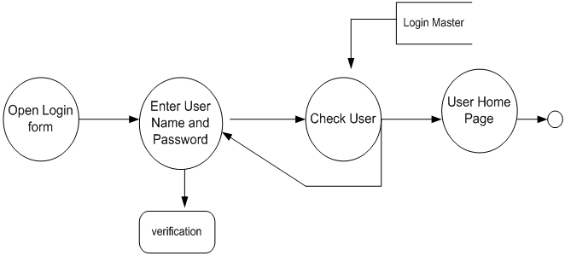

Figure 5.1 Login DFD Diagram

## 5.3 E-R DIAGRAM

**ER Diagram** stands for Entity Relationship Diagram, also known as ERD is a diagram that displays the relationship of entity sets stored in a database. In other words, ER diagrams help to explain the logical structure of databases. ER diagrams are created based on three basic concepts: entities, attributes and relationships.ER Diagrams contain different symbols that use rectangles to represent entities, ovals to define attributes and diamond shapes to represent relationships. At first look, an ER diagram looks very similar to the flowchart. However, ER Diagram includes many specialized symbols, and its meanings make this model unique. The purpose of ER Diagram is to represent the entity framework infrastructure.

* 1. E-R DIAGRAM

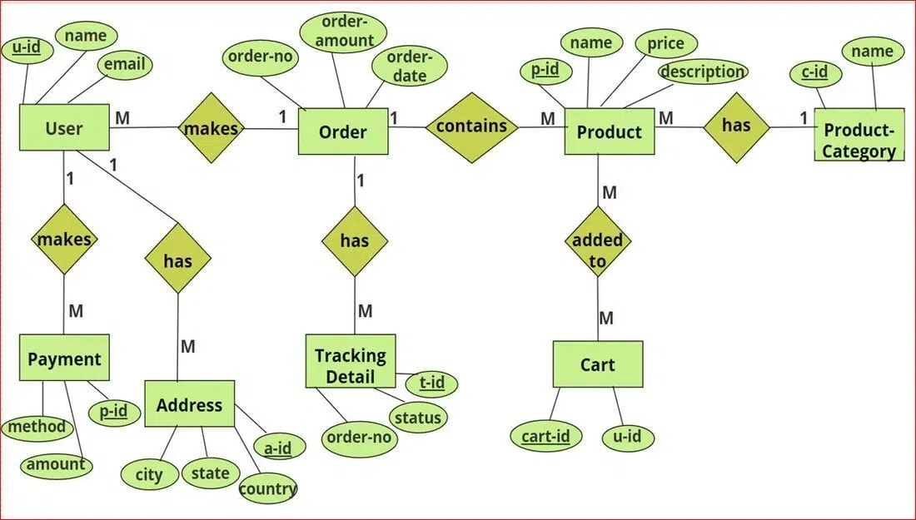

FIGURE 5.2 E-R DIAGRAM

# CHAPTER -6

**SYSTEM IMPLEMENTATION**

## 6.1 SCOPE

The scope of the "EcoMart" project encompasses various aspects related to the development, launch, and ongoing success of an innovative online footwear retail platform. Below is an outline of the project scope:

1. **E-commerce Platform Development:**
   * Design and develop a user-friendly and visually appealing e-commerce website for EcoMart, accommodating both desktop and mobile users.
2. **Brand Identity Establishment:**
   * Create a strong and distinct brand identity for EcoMart that resonates with the target audience, reflecting the essence of fashion, style, and comfort.
3. **Product Catalog Curation:**
   * Curate a diverse and trendsetting product catalog, ensuring a balance between the latest fashion trends, comfort, and quality across various types of footwear.
4. **Innovative Features Implementation:**
   * Incorporate innovative features, such as virtual try-on technologies, personalized recommendations, and interactive sizing guides, to enhance the overall shopping experience.
5. **User Authentication and Registration:**
   * Implement a secure user authentication and registration system to personalize user experiences and enable secure transactions.
6. **Secure Payment Gateway Integration:**
   * Integrate reliable and secure payment gateways to facilitate smooth and secure financial transactions for users.

By addressing these key areas within the defined scope, the "EcoMart" project aims to create a cutting-edge and customer-centric online footwear retail platform that provides a seamless and enjoyable shopping experience.

# CHAPTER -7

**RESULT**

## 7.1 BENEFITS

## The successful implementation and execution of the "EcoMart" project can yield several benefits, contributing to both business success and customer satisfaction. Here are some potential benefits your project can achieve:

## Increased Revenue:

## By offering a diverse and trendsetting product catalog with innovative features, you can attract a larger customer base, leading to increased sales and revenue.

## Strong Brand Presence:

## Establishing a strong and distinct brand identity can help create brand recognition and loyalty among customers, contributing to a lasting and positive presence in the market.

## Enhanced User Experience:

## The implementation of innovative features like virtual try-on and personalized recommendations can significantly enhance the overall user experience, attracting and retaining customers.

## Customer Loyalty and Retention:

## Features such as user profiles, order tracking, and personalized recommendations foster customer loyalty, encouraging repeat business and long-term relationships.

By achieving these benefits, the "EcoMart" project not only positions itself as a successful online footwear retailer but also establishes a foundation for sustainable growth and long-term success in the competitive e-commerce industry.

## 7.2 SCREENSHOTS

**A. FRONTEND**

7.2.1 HOME PAGE

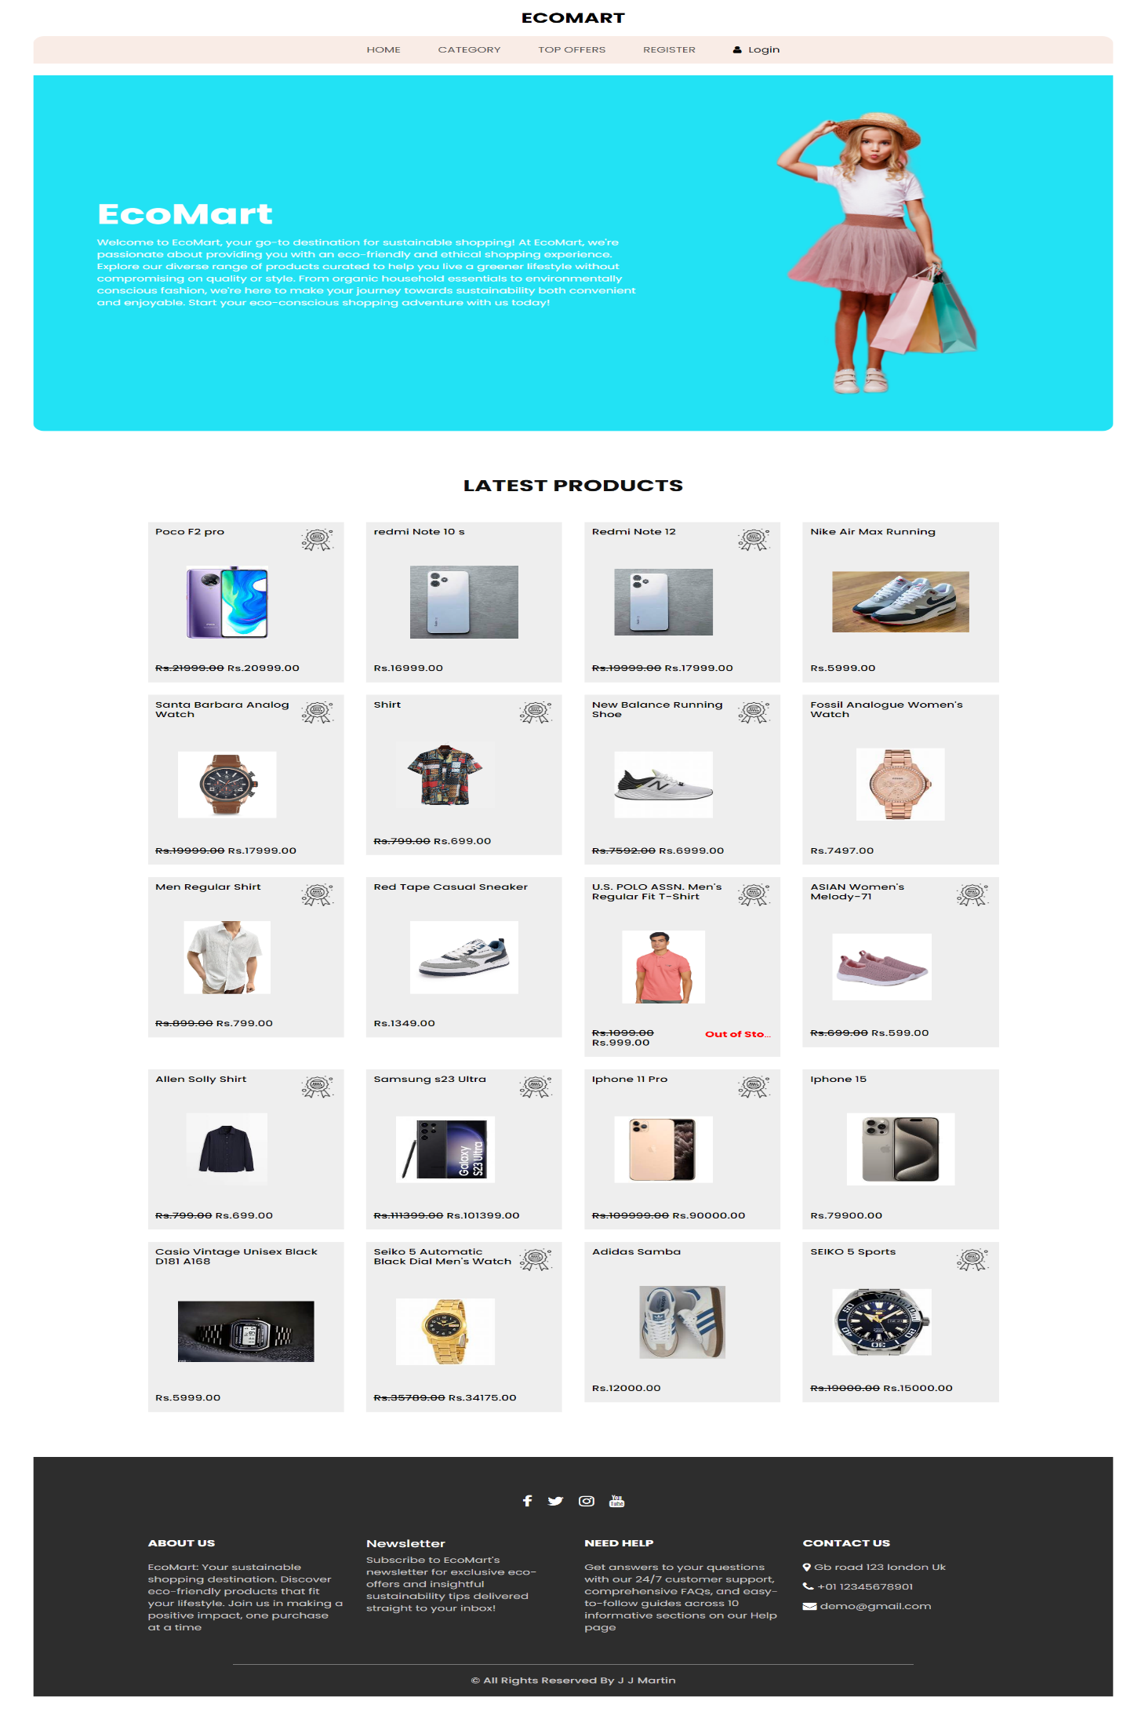

FIGURE 7.2.1 HOME PAGE

7.2.2 LOGIN PAGE

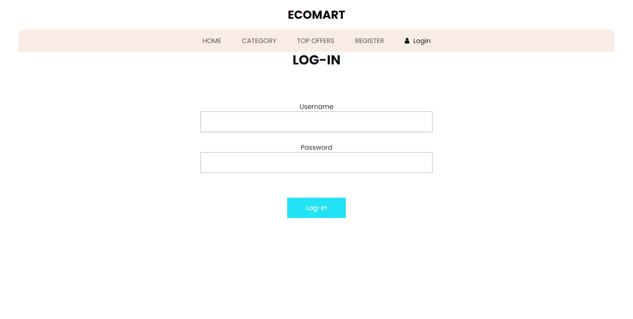

Figure 7.2.2 login pages

7.2.2 SIGNUP PAGE

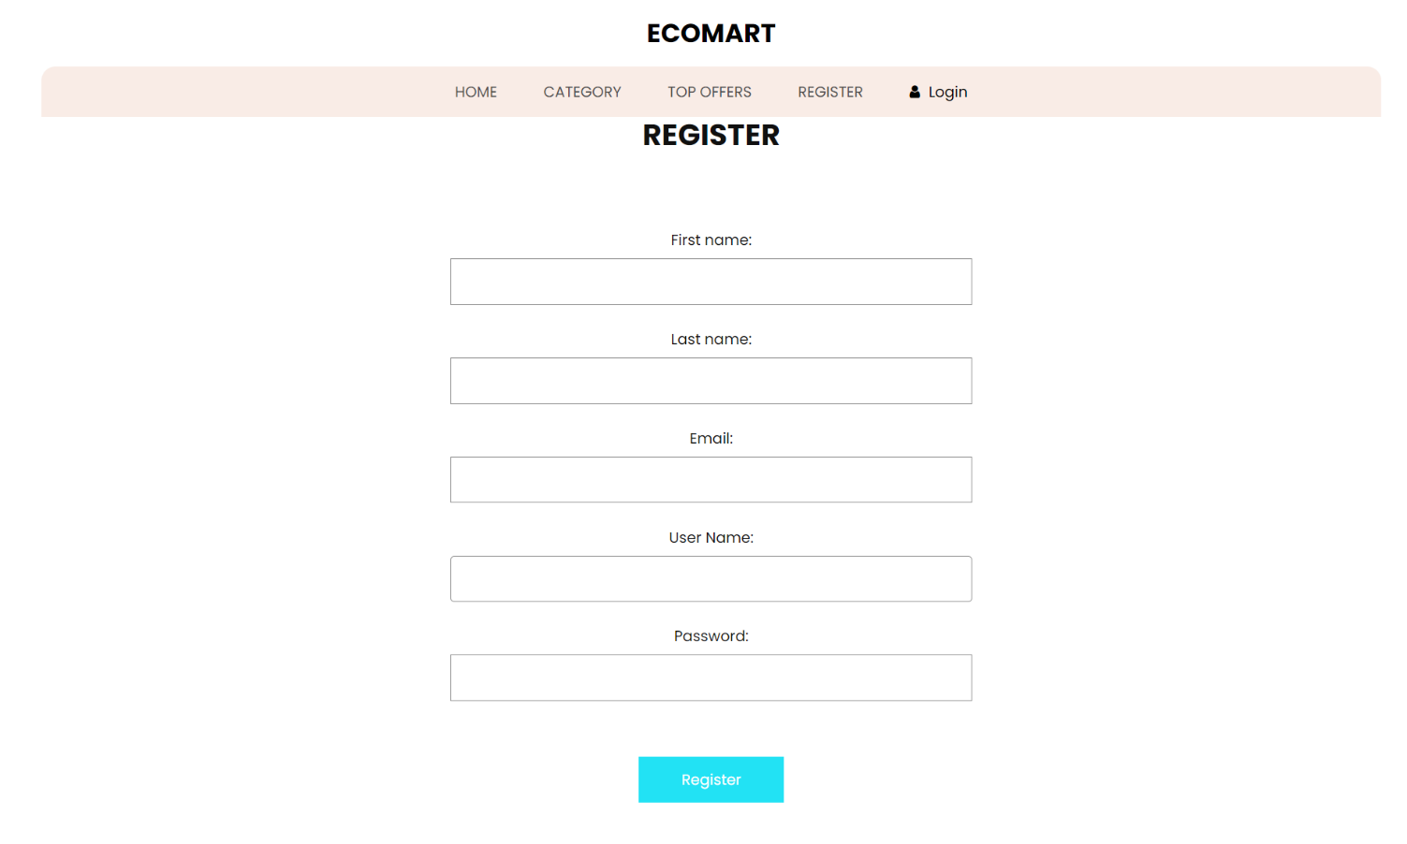

Figure 7.2.3 SignUp pages

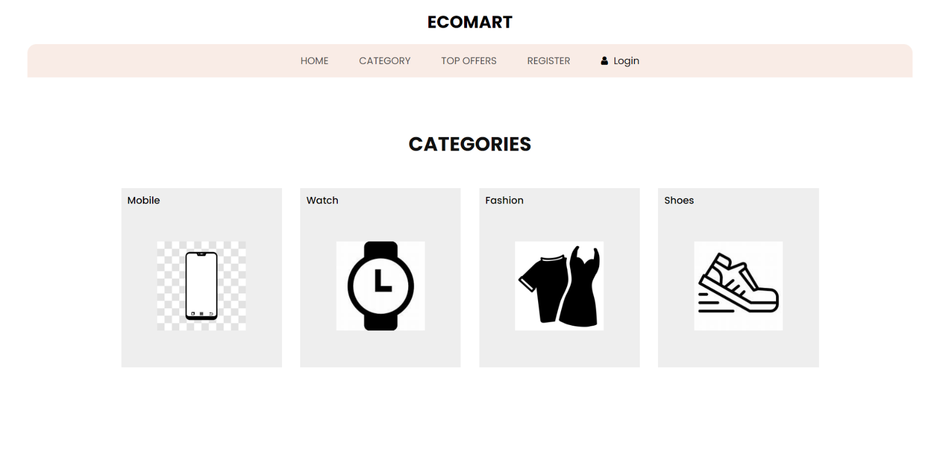 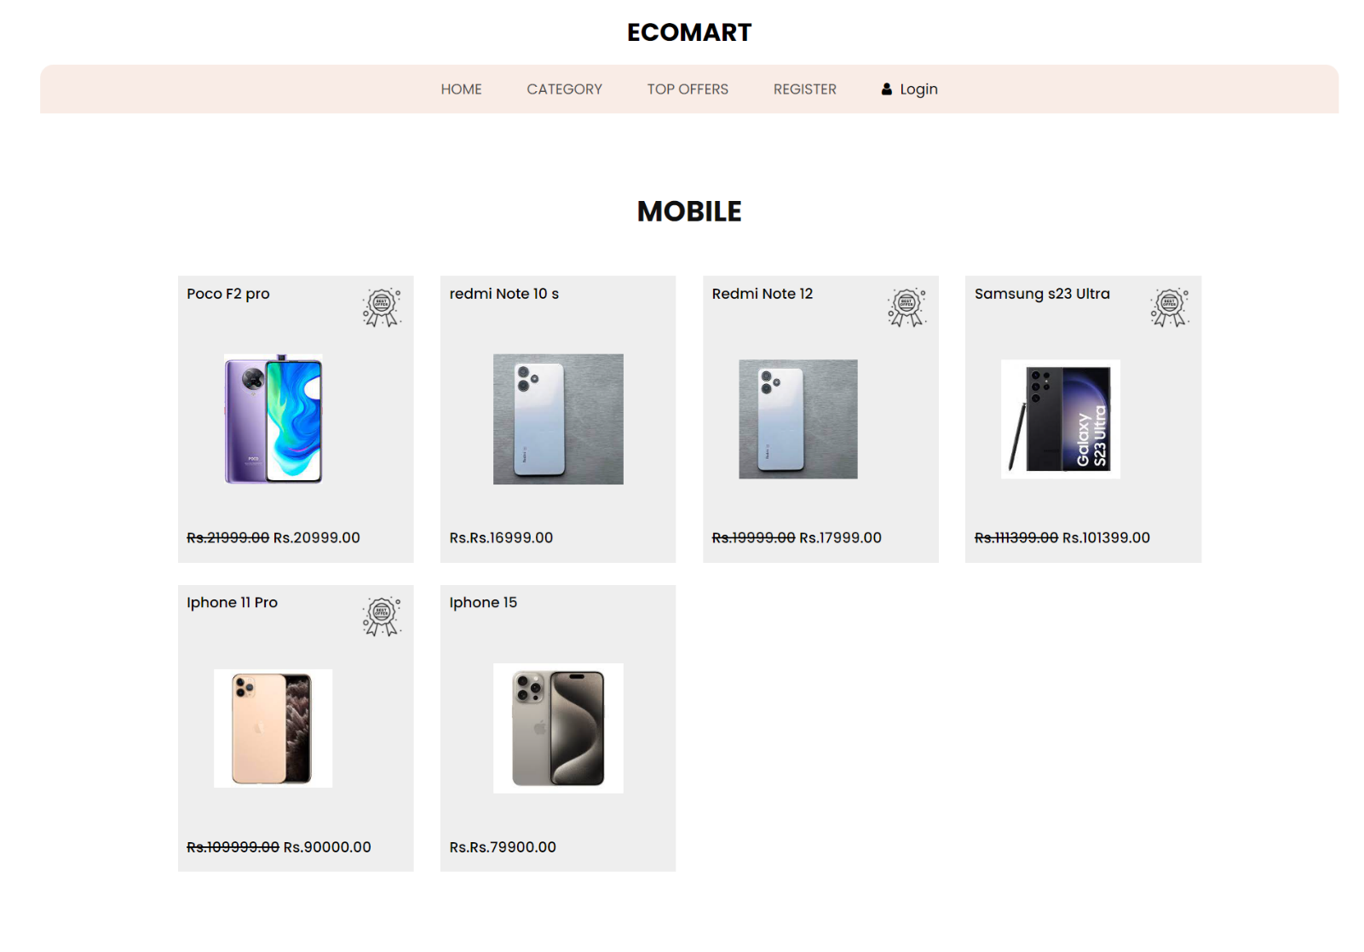

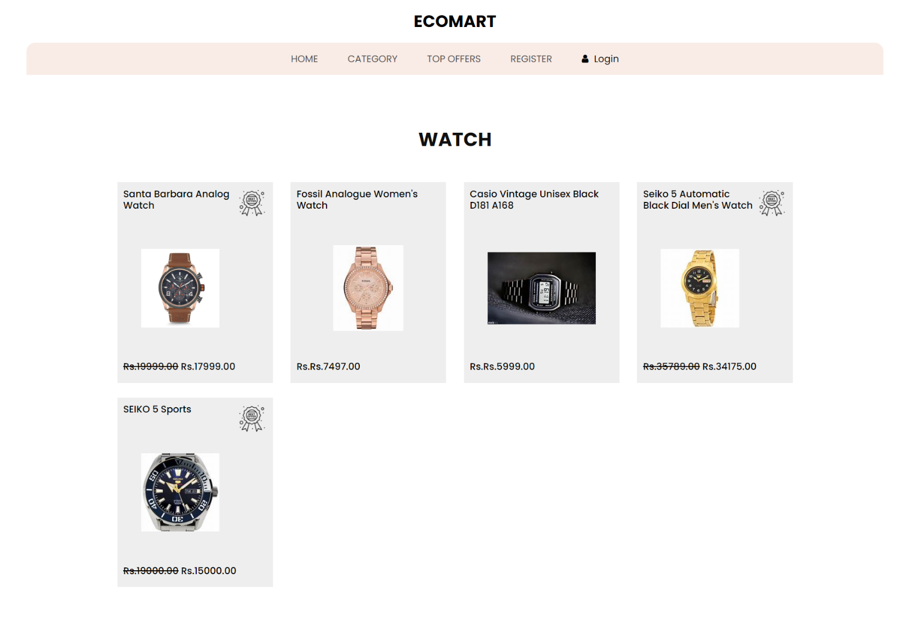

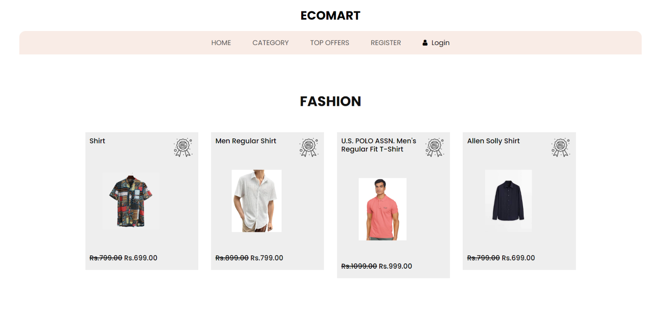

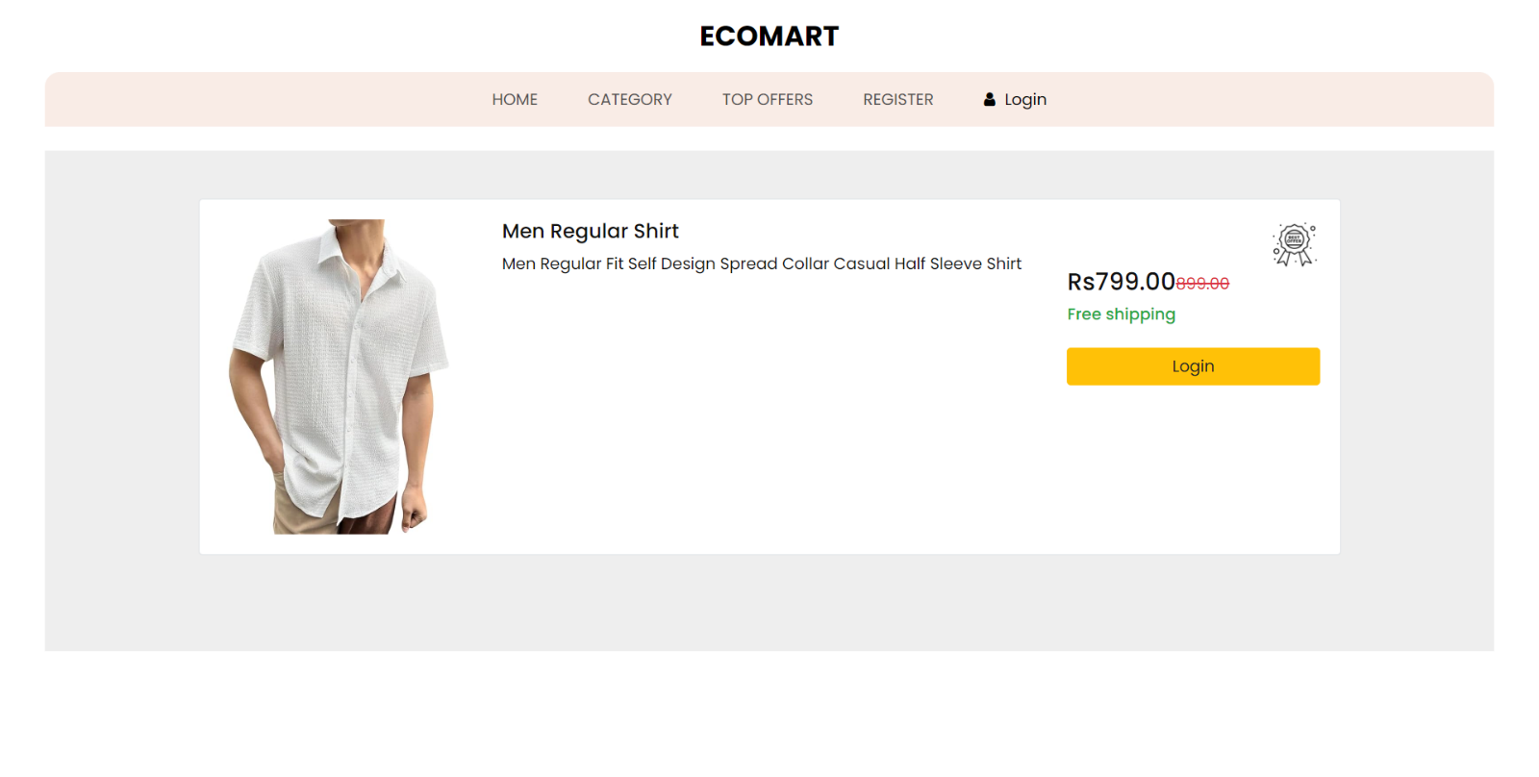

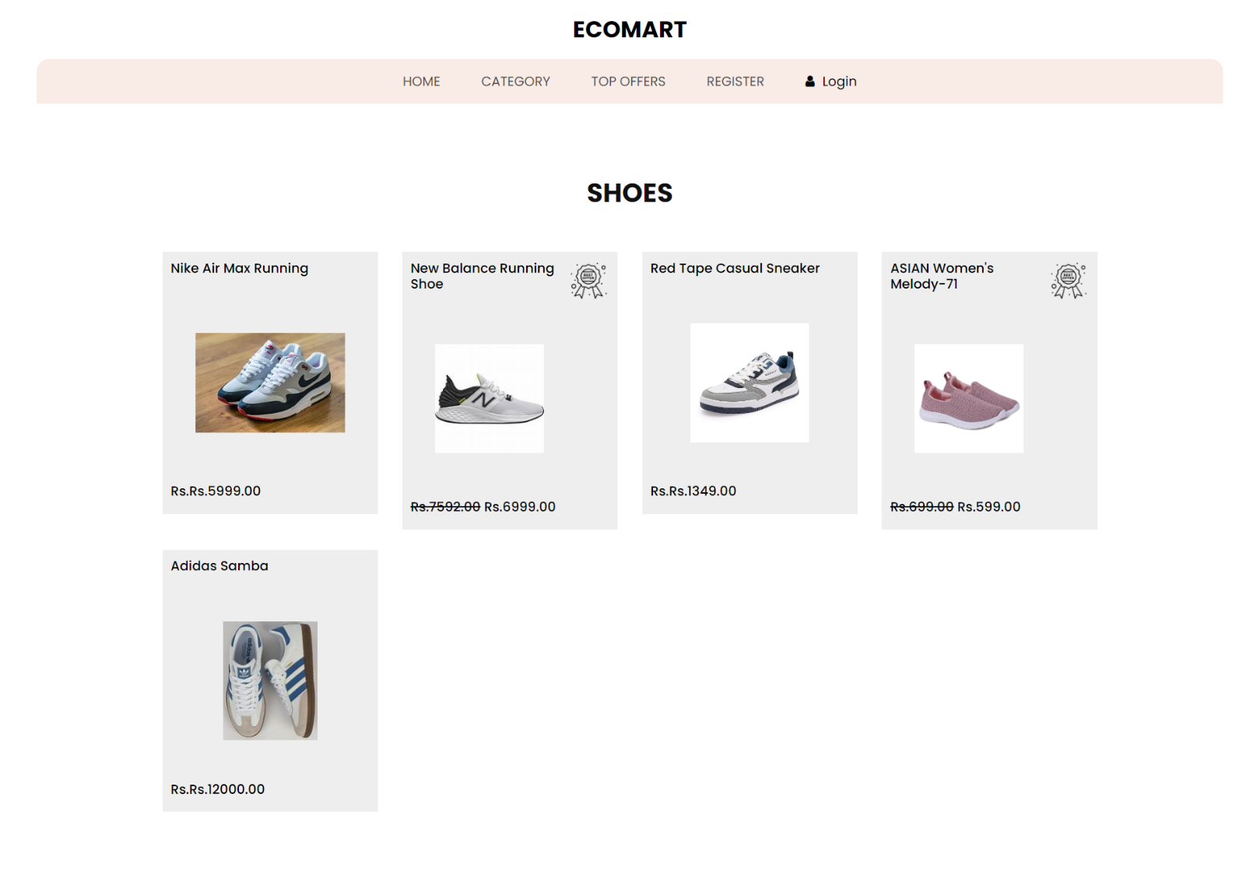

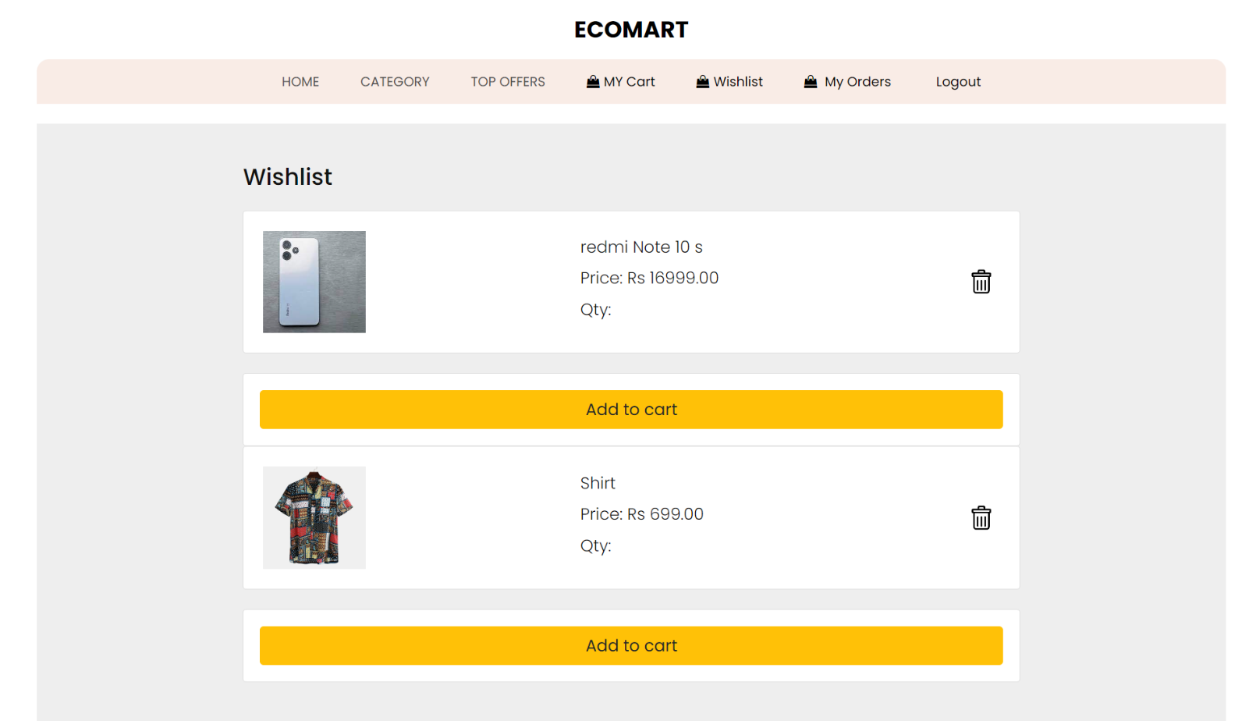

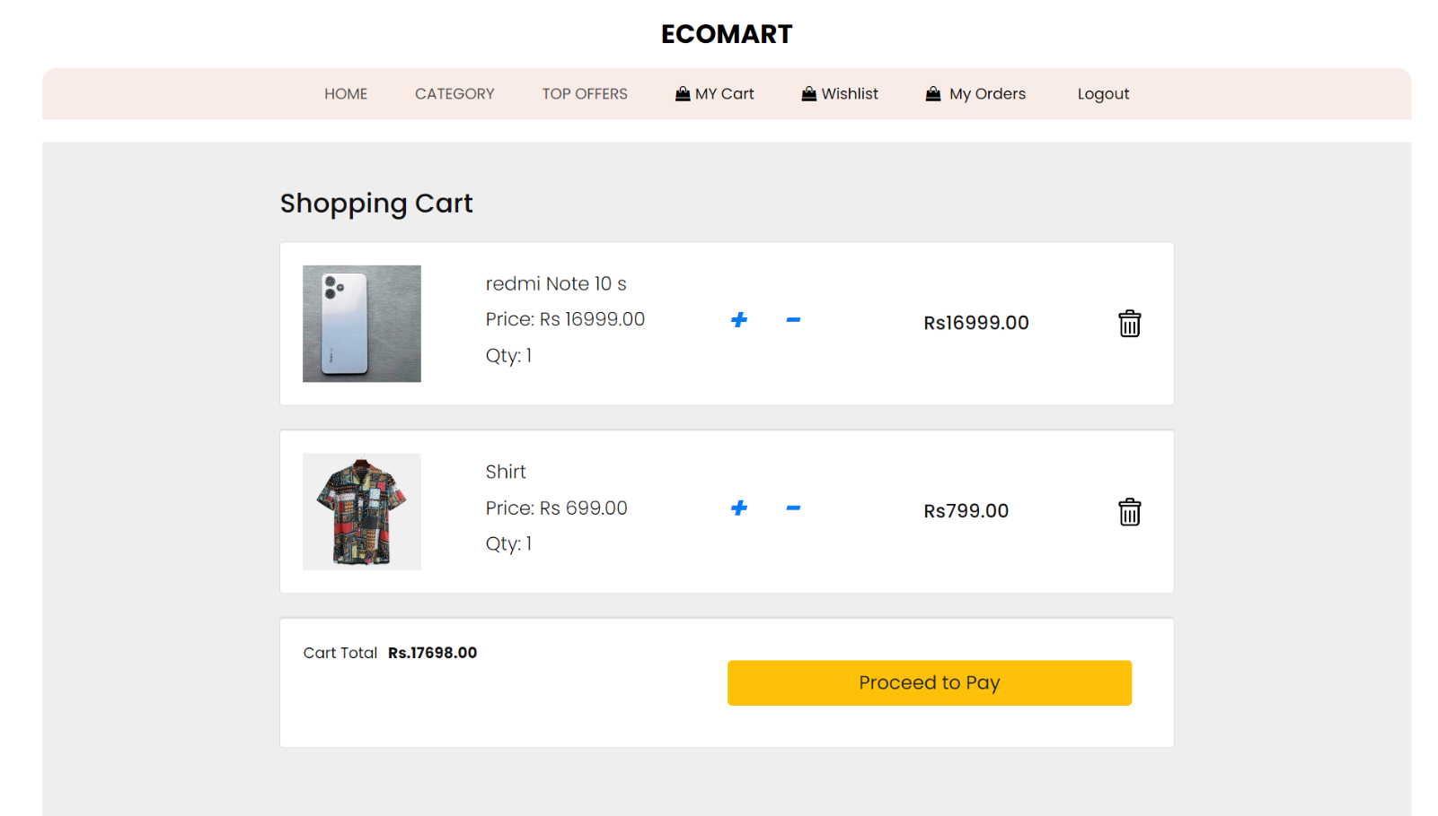

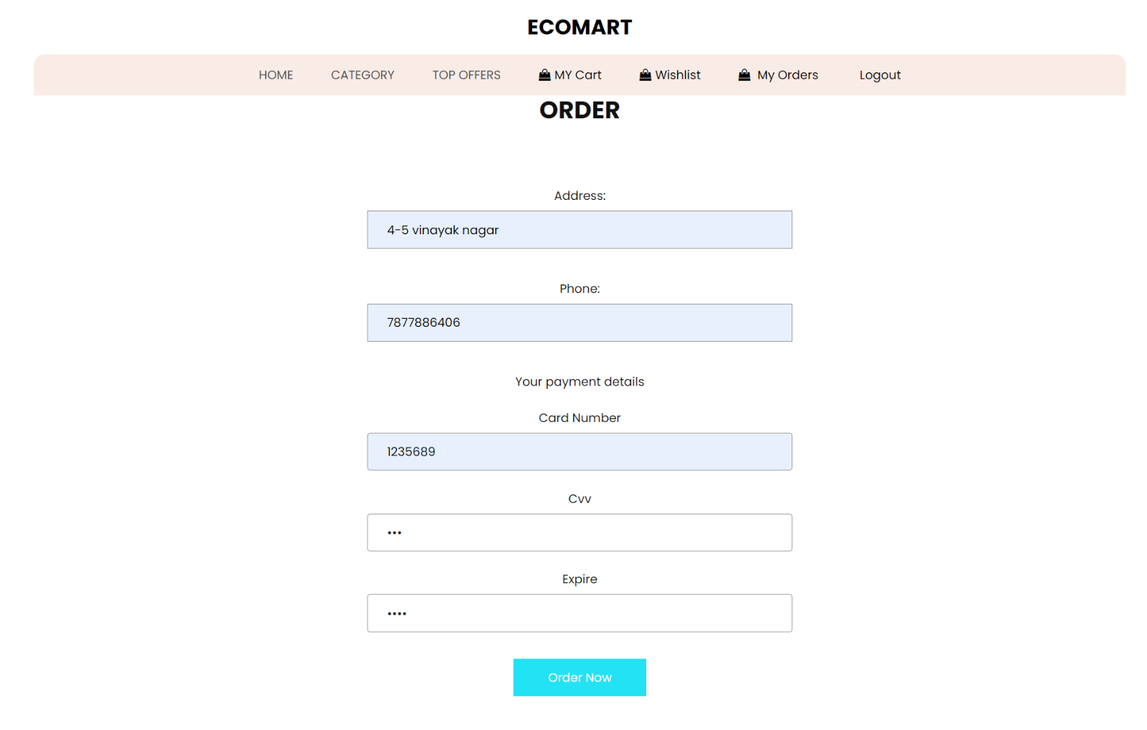

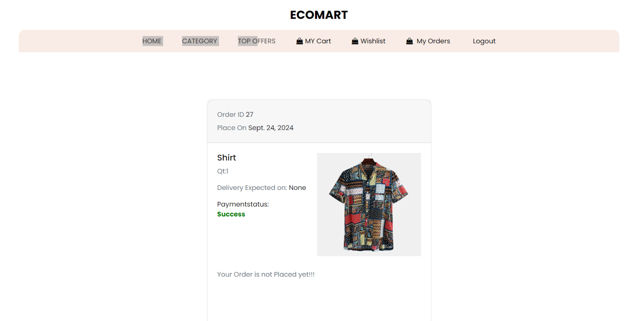

7.2.11 Database

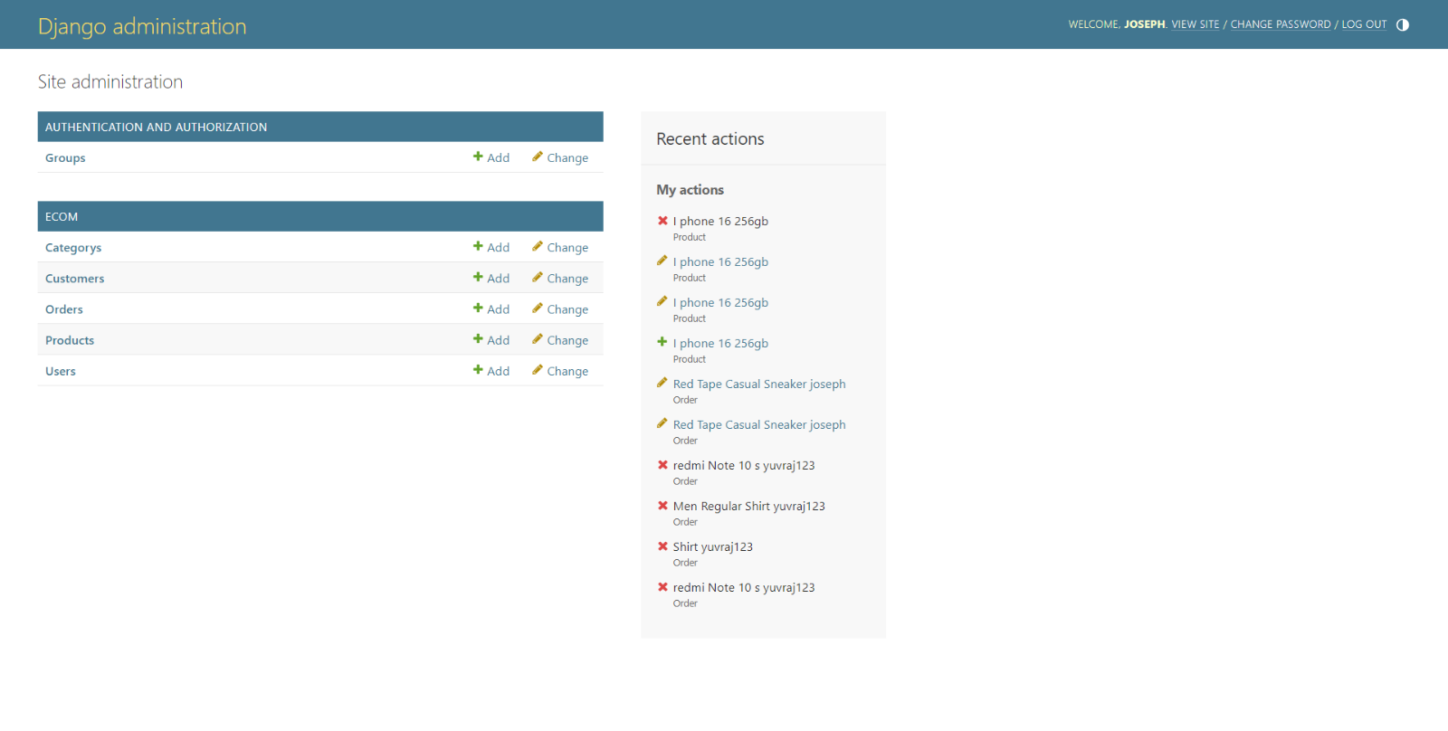

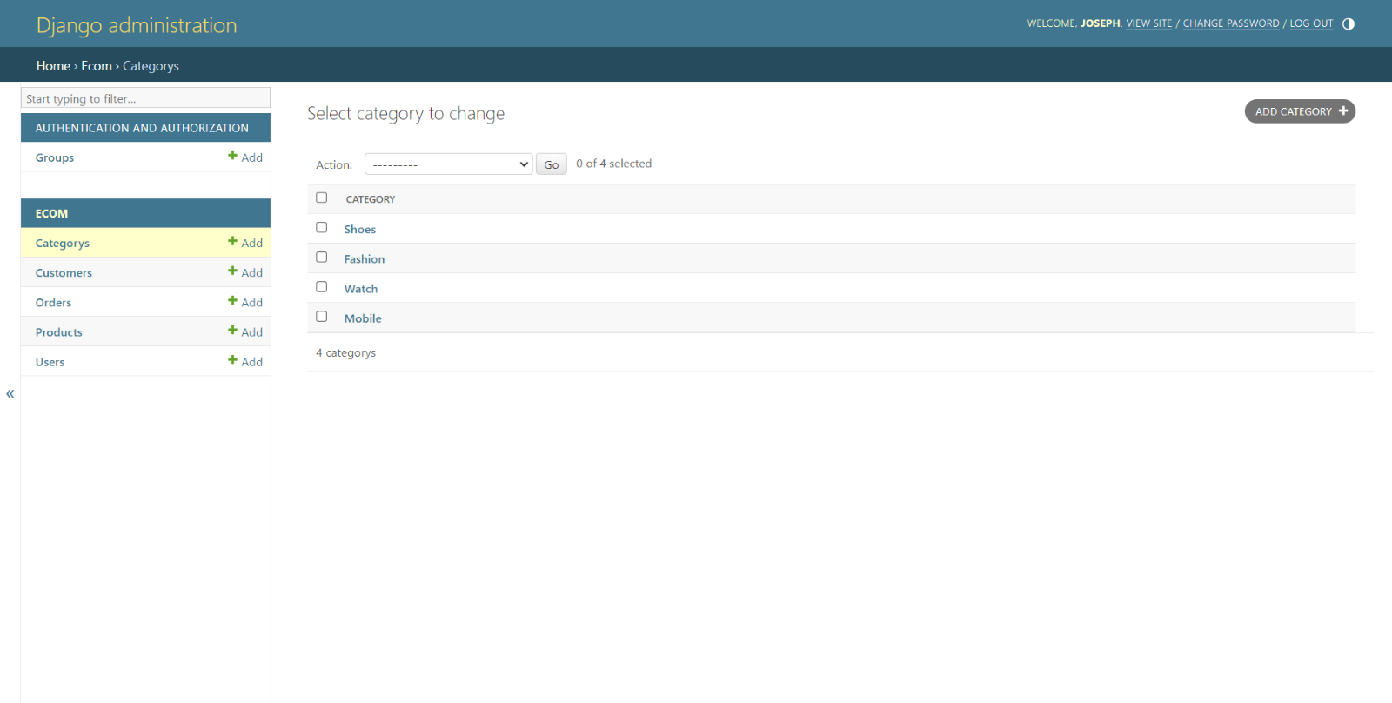

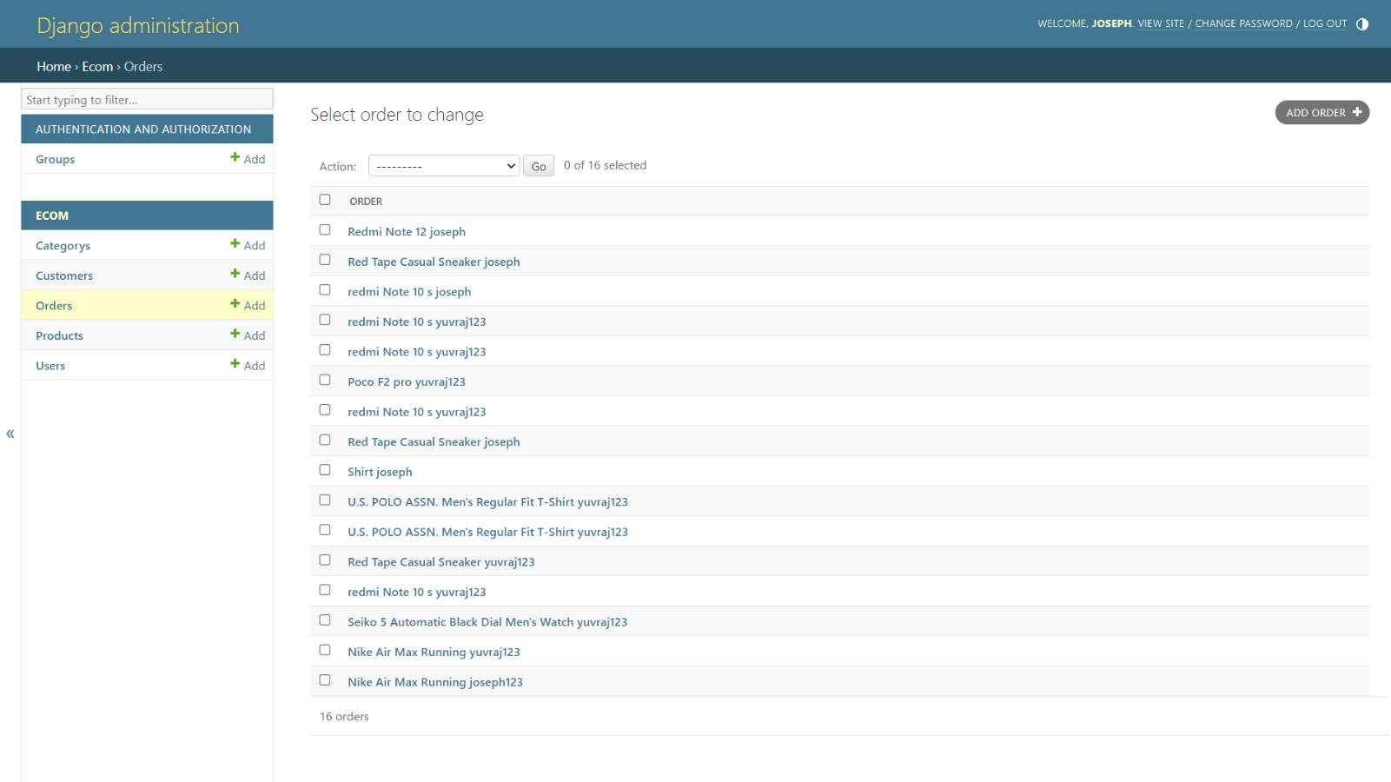

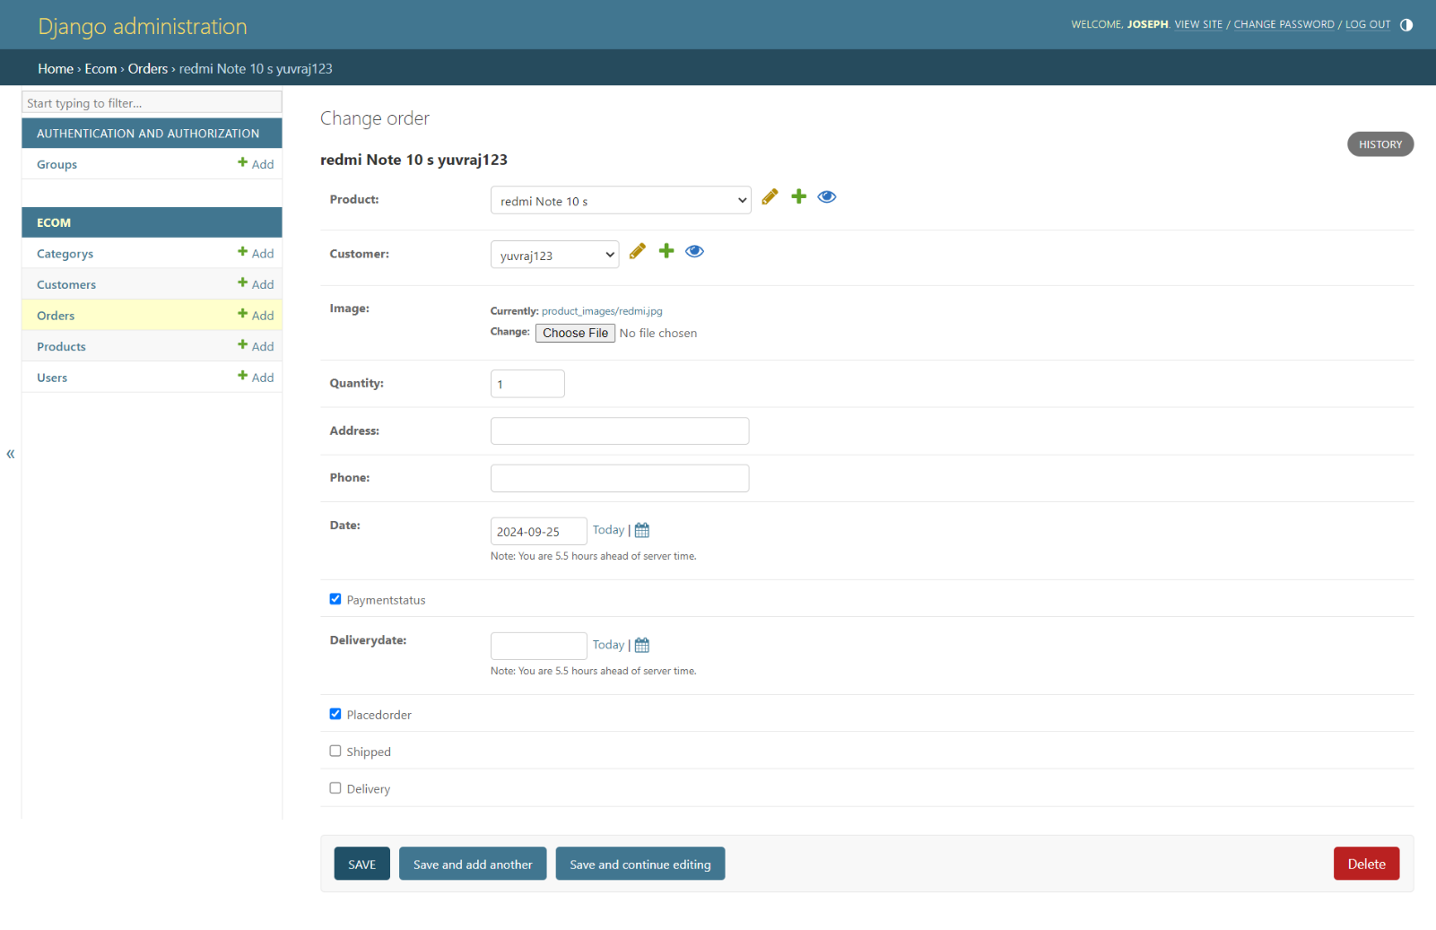

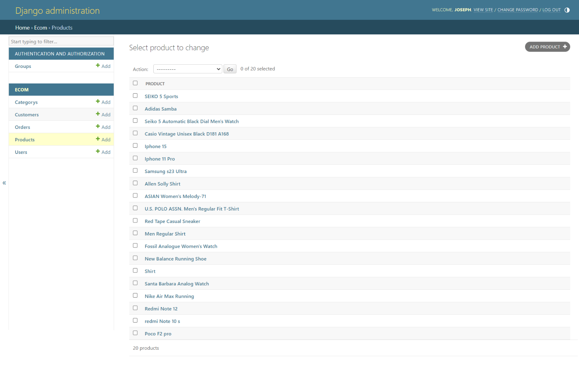

# CONCLUSION

* In conclusion, the "EcoMart" project has been an exciting journey into the realm of online footwear retail, with the primary objective of creating a distinctive and customer-centric experience. Through meticulous planning, innovative design, and a commitment to excellence, the project has successfully laid the foundation for a premier destination for shoe enthusiasts.
* The establishment of a strong brand identity, coupled with a carefully curated product catalog, positions EcoMart as more than just an e-commerce platform; it becomes a style destination where fashion meets comfort. The incorporation of cutting-edge technologies, such as virtual try-on and personalized recommendations, adds a layer of sophistication and engagement to the user experience.
* Our emphasis on user-friendly design, responsive interfaces, and secure transactions ensures that the EcoMart website is not just a marketplace but a seamless journey for users from exploration to purchase. By integrating feedback mechanisms and continuously monitoring analytics, we are committed to staying attuned to the evolving needs and preferences of our valued customers.
* The strategic marketing initiatives, including social media campaigns and influencer partnerships, aim to elevate EcoMart's online presence and carve a niche in the competitive landscape. As the project concludes, we look forward to not only meeting but exceeding the expectations of our users, fostering loyalty, and becoming a go-to platform for those seeking the perfect blend of style and comfort.
* As we embark on the next phase of implementation and launch, the "EcoMart" project stands as a testament to the collaborative effort, creativity, and dedication of the team. We are excited about the prospect of contributing to the ever-evolving world of online fashion retail, and we are confident that EcoMart will leave an indelible mark in the hearts and closets of our customers.
* EcoMart – where every step is a statement, and style meets innovation. Thank you for accompanying us on this journey!

# FUTURE SCOPE

The future scope of the "EcoMart" project involves potential enhancements, expansions, and adaptations to stay relevant in the dynamic e-commerce landscape. Here are some areas of future scope for the project:

1. **Integration of Emerging Technologies:**
   * Explore and integrate emerging technologies such as augmented reality (AR) for virtual try-ons, artificial intelligence (AI) for advanced personalized recommendations, or blockchain for secure and transparent transactions.
2. **Enhanced Personalization:**
   * Implement more sophisticated algorithms for personalized user experiences, taking into account user preferences, buying behavior, and real-time trends to offer highly targeted product recommendations.
3. **Global Expansion:**
   * Consider expanding the platform's reach to international markets, accommodating diverse cultural preferences and adjusting the product catalog to cater to a broader audience.
4. **Inclusive Sizing and Accessibility:**
   * Enhance the website to be more inclusive by expanding size ranges and incorporating features to assist users with specific needs, such as accessibility options for individuals with disabilities.

By staying adaptable and responsive to industry trends and customer demands, the "EcoMart" project can continue to evolve and thrive in the competitive online footwear market. Regularly reassessing the business strategy and technology landscape will be crucial to identifying new opportunities for growth and improvement.

# REFERENCES

Here's a list of references, including books & websites that could provide valuable insights and information for "EcoMart":

**Websites:**

1. EcoWatch (https://www.ecowatch.com)
2. GreenBiz (https://www.greenbiz.com)
3. The Good Trade (https://www.thegoodtrade.com)

These references cover a range of topics from web usability and design principles to e-commerce strategies. Utilizing these resources can help you make informed decisions and create a successful and user-friendly "EcoMart" website.