

**Java Programming**

**MCA-272**

**Lab Practical – 02**

***BY***

**HIMANSHU HEDA (24225013)**

**SUBMITTED TO**

**Dr. Manjula Shannhog**

**SCHOOL OF SCIENCES**

**2024-25**

**Program 1 : --**

**1) Write a program to calculate the Division of a student, apply constructor overloading and method over overloading depending on the number of subject. (<50% Fail, 50 -60 % Pass, 60- 74% First Division, Above Distinction)**

// 1) Write a program to calculate the Division of a student, apply constructor overloading and method over overloading

// depending on the number of subject. (<50% Fail, 50 -60 % Pass, 60- 74% First Division, Above Distinction)

package Assignment;

class Student {

    private String name;

    private int[] marks;

    // Constructor for a single subject

    public Student(String name, int mark) {

        this.name = name;

        this.marks = new int[] { mark };

    }

    // Constructor for multiple subjects

    public Student(String name, int[] marks) {

        this.name = name;

        this.marks = marks;

    }

    public String calculateDivision() {

        int totalMarks = 0;

        for (int mark : marks) {

            totalMarks += mark;

        }

        double percentage = (double) totalMarks / marks.length;

        if (percentage < 50) {

            return "Fail";

        } else if (percentage < 60) {

            return "Pass";

        } else if (percentage < 75) {

            return "First Division";

        } else {

            return "Distinction";

        }

    }

    public String getName() {

        return name;

    }

}

// Example usage

public class StudentDivision {

    public static void main(String[] args) {

        Student student2 = new Student("Himanshu", new int[] { 70, 80, 90 });

        System.out.println(student2.getName() + " has " + student2.calculateDivision() + ".");

        Student student1 = new Student("Anugraha", new int[] { 45, 55, 60 });

        System.out.println(student1.getName() + " has " + student1.calculateDivision() + ".");

        Student student3 = new Student("Abhi", new int[] { 10, 40, 30 });

        System.out.println(student3.getName() + " has " + student3.calculateDivision() + ".");

    }

}

**OUTPUT : --**

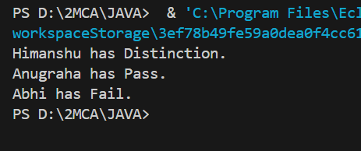

**Program 2 : --**

**2) Write a program to calculate the room rent of a restaurant depending on the number of stays.**

package Assignment;

class Library {

    private String bookTitle;

    public Library(String bookTitle) {

        this.bookTitle = bookTitle;

    }

    public int calculateFine(int daysLate) {

        if (daysLate <= 15) {

            return 0; // No fine

        } else {

            return (daysLate - 15) * 2; // Rs 2 fine per day after 15 days

        }

    }

    public String getBookTitle() {

        return bookTitle;

    }

}

// Example usage

public class LibraryFine {

    public static void main(String[] args) {

        Library book1 = new Library("Python Programming");

        int fine1 = book1.calculateFine(10);

        System.out.println("Fine for '" + book1.getBookTitle() + "' returned 10 days late: Rs " + fine1);

        Library book2 = new Library("Data Structures");

        int fine2 = book2.calculateFine(20);

        System.out.println("Fine for '" + book2.getBookTitle() + "' returned 20 days late: Rs " + fine2);

    }

}

**OUTPUT : --**

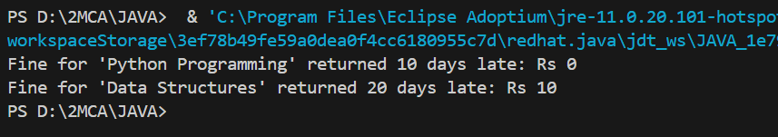

**Program 3 : --**

**3) Write a program to calculate the fine of a library book if applicable, (less than or equal to 15 days - no find , more than 15 days, per day Rs 2 Fine.)**

package Assignment;

class Restaurant {

    private String roomType;

    public Restaurant(String roomType) {

        this.roomType = roomType;

    }

    public double calculateRent(int stays) {

        switch (roomType) {

            case "Standard":

                return stays * 1000; // Rent per stay in Standard room

            case "Deluxe":

                return stays * 1500; // Rent per stay in Deluxe room

            case "Suite":

                return stays * 2000; // Rent per stay in Suite room

            default:

                return 0;

        }

    }

}

// Example usage

public class RoomRent {

    public static void main(String[] args) {

        Restaurant room1 = new Restaurant("Standard");

        System.out.println("Total rent for 3 stays in Standard room: Rs " + room1.calculateRent(3));

        Restaurant room2 = new Restaurant("Suite");

        System.out.println("Total rent for 2 stays in Suite room: Rs " + room2.calculateRent(2));

    }

}

**OUTPUT : --**

