

**Java Programming**

**MCA-272**

**Assignment – 07**

***BY***

**HIMANSHU HEDA (24225013)**

**SUBMITTED TO**

**Dr. Manjula Shannhog**

**SCHOOL OF SCIENCES**

**2024-25**

**Thread Creation using extends : --**

package Thread;

class thread1 extends Thread {

    @Override

    public void run() {

        // Code to execute in the new thread

        for (int i = 0; i < 5; i++) {

            System.out.println("Hello Guys");

        }

    }

}

class thread2 extends Thread {

    @Override

    public void run() {

        // Code to execute in the new thread

        for (int i = 0; i < 5; i++) {

            System.out.println("My name is Himanshu Heda");

        }

    }

}

public class thread_creation {

    public static void main(String[] args) {

        thread1 thread = new thread1();

        thread.start(); // Starts the thread

        thread2 thread2 = new thread2();

        thread2.start(); // Starts another thread

    }

}

**Output : --**

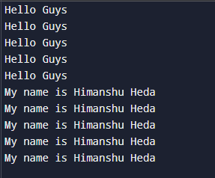

**Thread Creation using interface : --**

package Thread;

class Thread1 implements Runnable {

    @Override

    public void run() {

        for (int i = 0; i < 5; i++) {

            System.out.println("Its a beautiful day");

        }

    }

}

class Thread2 implements Runnable {

    @Override

    public void run() {

        for (int i = 0; i < 5; i++) {

            System.out.println("Enjoy the day");

        }

    }

}

public class thread_interface {

    public static void main(String[] args) {

        // Create instances of Runnable

        Thread1 t1 = new Thread1();

        Thread2 t2 = new Thread2();

        // Create Thread objects and pass the Runnable instances

        Thread thread1 = new Thread(t1, "Thread-1");

        Thread thread2 = new Thread(t2, "Thread-2");

        // Start the threads

        thread1.start();

        thread2.start();

    }

}

**Output : --**

