

**Java Programming**

**MCA-272**

**Assignment – 09**

***BY***

**HIMANSHU HEDA (24225013)**

**SUBMITTED TO**

**Dr. Manjula Shannhog**

**SCHOOL OF SCIENCES**

**2024-25**

1. **Tabbed Pane : --**

package Tabnedpane_and_Event;

import javax.swing.*;

import java.awt.*;

public class TabbedPane {

    public static void main(String[] args) {

        // Create a new JFrame

        JFrame frame = new JFrame("TabbedPane Example");

        frame.setDefaultCloseOperation(JFrame.EXIT_ON_CLOSE);

        // Create a new JTabbedPane

        JTabbedPane tabbedPane = new JTabbedPane();

        // Create two panels

        JPanel panel1 = new JPanel();

        panel1.add(new JLabel("This is panel 1"));

        panel1.setBackground(Color.RED);

        JPanel panel2 = new JPanel();

        panel2.add(new JLabel("This is panel 2"));

        panel2.setBackground(Color.GREEN);

        // Add the panels to the tabbed pane

        tabbedPane.addTab("Panel 1", panel1);

        tabbedPane.addTab("Panel 2", panel2);

        // Add the tabbed pane to the frame

        frame.getContentPane().add(tabbedPane);

        // Set the frame size and make it visible

        frame.setSize(400, 300);

        frame.setVisible(true);

    }

}

**Output : --**

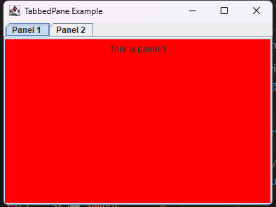

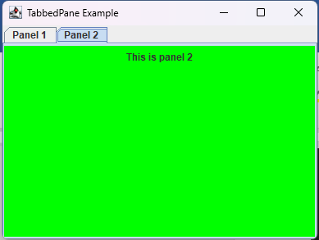

1. **TabbedPaneEvent : --**

package Tabnedpane_and_Event;

import javax.swing.*;

import javax.swing.event.ChangeEvent;

import javax.swing.event.ChangeListener;

import java.awt.*;

public class TabbedPaneEvent {

    public static void main(String[] args) {

        // Create a new JFrame

        JFrame frame = new JFrame("TabbedPane Event Example");

        frame.setDefaultCloseOperation(JFrame.EXIT_ON_CLOSE);

        // Create a new JTabbedPane

        JTabbedPane tabbedPane = new JTabbedPane();

        // Create two panels

        JPanel panel1 = new JPanel();

        panel1.add(new JLabel("This is panel 1"));

        panel1.setBackground(Color.RED);

        JPanel panel2 = new JPanel();

        panel2.add(new JLabel("This is panel 2"));

        panel2.setBackground(Color.GREEN);

        // Add the panels to the tabbed pane

        tabbedPane.addTab("Panel 1", panel1);

        tabbedPane.addTab("Panel 2", panel2);

        // Add a change listener to the tabbed pane

        tabbedPane.addChangeListener(new ChangeListener() {

            @Override

            public void stateChanged(ChangeEvent e) {

                int selectedIndex = tabbedPane.getSelectedIndex();

                System.out.println("Selected tab: " + selectedIndex);

            }

        });

        // Add the tabbed pane to the frame

        frame.getContentPane().add(tabbedPane);

        // Set the frame size and make it visible

        frame.setSize(400, 300);

        frame.setVisible(true);

    }

}

**OUTPUT : --**





