

**Java Programming**

**MCA-272**

**Lab Practical – 02**

***BY***

**HIMANSHU HEDA (24225013)**

**SUBMITTED TO**

**Dr. Manjula Shannhog**

**SCHOOL OF SCIENCES**

**2024-25**

// 1) Create a class Calculator with methods for basic operations: Addition,

// Subtraction, Multiplication, and Division. Overload the add and multiply

// methods to handle operations for both integers and floating-point

// numbers. Use the this keyword to reference instance variables if needed.

package ESE;

public class Calculator {

    // Addition method for integers

    int add(int a, int b) {

        return a + b;

    }

    // Addition method for floating-point numbers

    double add(double a, double b) {

        return a + b;

    }

    // Subtraction method for integers

    int sub(int a, int b) {

        return a - b;

    }

    // Subtraction method for floating-point numbers

    double sub(double a, double b) {

        return a - b;

    }

    // Multiplication method for integers

    int mul(int a, int b) {

        return a * b;

    }

    // Multiplication method for floating-point numbers

    double mul(double a, double b) {

        return a * b;

    }

    // Division method for integers

    int div(int a, int b) {

        if (b == 0) {

            throw new ArithmeticException("Division by zero is not allowed.");

        }

        return a / b;

    }

    // Division method for floating-point numbers

    double div(double a, double b) {

        if (b == 0.0) {

            throw new ArithmeticException("Division by zero is not allowed.");

        }

        return a / b;

    }

    // Main method for testing the Calculator class

    public static void main(String[] args) {

        Calculator calc = new Calculator();

        // Testing integer operations

        System.out.println("Integer Addition: " + calc.add(15, 6));

        System.out.println("Integer Subtraction: " + calc.sub(30, 20));

        System.out.println("Integer Multiplication: " + calc.mul(17, 13));

        System.out.println("Integer Division: " + calc.div(60, 20));

        // Testing floating-point operations

        System.out.println("Floating-point Addition: " + calc.add(15.5, 13.23));

        System.out.println("Floating-point Subtraction: " + calc.sub(1.3, 2.5));

        System.out.println("Floating-point Multiplication: " + calc.mul(8.5, 10.2));

        System.out.println("Floating-point Division: " + calc.div(2.5, 9.2));

    }

}

**OUTPUT : --**

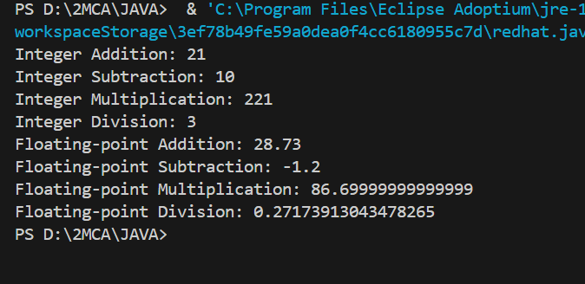

// 2)Design a Java class Employee to represent an employee with the

// following features: employeeId , salary workingHoursPerWeek. All the

// attributes should be private.

// (Can use getter and setter methods for each attribute.)

// If the working hours per week exceed 40, the employee is eligible for a

// bonus of 10% of the base salary.The bonus should be added to the salary.

// Use the toal salary of the person. Take atlest 2 objects one whose working

// hours exceeds 40 and other less than 40. Display all the values of the

// object. Use constructor to initialize the employee&#39;s attributes.

package ESE;

public class Employee {

    // Private attributes

    private int empId;

    private double salary;

    private int workingHoursPerWeek;

    // Constructor to initialize the employee's attributes

    Employee(int empId, double salary, int workingHoursPerWeek) {

        this.empId = empId;

        this.salary = salary;

        this.workingHoursPerWeek = workingHoursPerWeek;

    }

    // Getter and setter for employeeId

    int getEmployeeId() {

        return empId;

    }

    void setEmployeeId(int empId) {

        this.empId = empId;

    }

    // Getter and setter for salary

    double getSalary() {

        return salary;

    }

    void setSalary(double salary) {

        this.salary = salary;

    }

    // Getter and setter for workingHoursPerWeek

    int getWorkingHoursPerWeek() {

        return workingHoursPerWeek;

    }

    void setWorkingHoursPerWeek(int workingHoursPerWeek) {

        this.workingHoursPerWeek = workingHoursPerWeek;

    }

    // Method to calculate total salary including bonus if applicable

    double calculateTotalSalary() {

        double totalSalary = salary;

        if (workingHoursPerWeek > 40) {

            totalSalary += salary * 0.10; // Adding 10% bonus

        }

        return totalSalary;

    }

    // Method to display employee details

    void displayEmployeeDetails() {

        System.out.println("Employee ID: " + empId);

        System.out.println("Base Salary: " + salary);

        System.out.println("Working Hours Per Week: " + workingHoursPerWeek);

        System.out.println("Total Salary (with bonus if applicable): " + calculateTotalSalary());

        System.out.println("------------------------------");

    }

    // Main method to test the Employee class

    public static void main(String[] args) {

        // Creating two Employee objects

        Employee emp1 = new Employee(101, 50000, 49);

        Employee emp2 = new Employee(102, 60000, 40);

        // Displaying employee details

        emp1.displayEmployeeDetails();

        emp2.displayEmployeeDetails();

    }

}

**Output : --**

