

**Java Programming**

**MCA-272**

**ESE – 02**

***BY***

**HIMANSHU HEDA (24225013)**

**SUBMITTED TO**

**Dr. Manjula Shannhog**

**SCHOOL OF SCIENCES**

**2024-25**

Program 1: --

// Base class for Core Subjects

class CoreSubjects {

    int marks1, marks2, marks3;

    int totalCoreMarks;

    double percentageCore;

    // Constructor to initialize core subject marks

    CoreSubjects(int marks1, int marks2, int marks3) {

        this.marks1 = marks1;

        this.marks2 = marks2;

        this.marks3 = marks3;

        // Calculate total and percentage

        totalCoreMarks = marks1 + marks2 + marks3;

        percentageCore = (totalCoreMarks / 3.0);

    }

    // Method to display core subject results

    void displayCoreResults() {

        System.out.println("Total Marks in Core Subjects: " + totalCoreMarks);

        System.out.println("Percentage in Core Subjects: " + percentageCore + "%");

    }

}

// Derived class for Elective Subjects

class ElectiveSubjects extends CoreSubjects {

    int elective1, elective2;

    int totalElectiveMarks;

    double percentageElective;

    // Constructor to initialize elective subject marks

    ElectiveSubjects(int marks1, int marks2, int marks3, int elective1, int elective2) {

        super(marks1, marks2, marks3);

        this.elective1 = elective1;

        this.elective2 = elective2;

        // Calculate total and percentage

        totalElectiveMarks = elective1 + elective2;

        percentageElective = (totalElectiveMarks / 2.0);

    }

    // Method to display elective subject results

    void displayElectiveResults() {

        System.out.println("Total Marks in Elective Subjects: " + totalElectiveMarks);

        System.out.println("Percentage in Elective Subjects: " + percentageElective + "%");

    }

    // Method to display overall results

    void displayOverallResults() {

        int totalMarks = totalCoreMarks + totalElectiveMarks;

        double overallPercentage = (totalMarks / 5.0);

        System.out.println("Total Marks: " + totalMarks);

        System.out.println("Overall Percentage: " + overallPercentage + "%");

    }

}

// Main class to run the program

public class StudentMarks {

    public static void main(String[] args) {

        // Hardcoded marks for two students

        ElectiveSubjects student1 = new ElectiveSubjects(85, 90, 78, 88, 92);

        ElectiveSubjects student2 = new ElectiveSubjects(75, 80, 70, 82, 85);

        // Display results for student 1

        System.out.println("Results for Student 1:");

        student1.displayCoreResults();

        student1.displayElectiveResults();

        student1.displayOverallResults();

        // Display results for student 2

        System.out.println("\nResults for Student 2:");

        student2.displayCoreResults();

        student2.displayElectiveResults();

        student2.displayOverallResults();

    }

}

**OUTPUT : --**

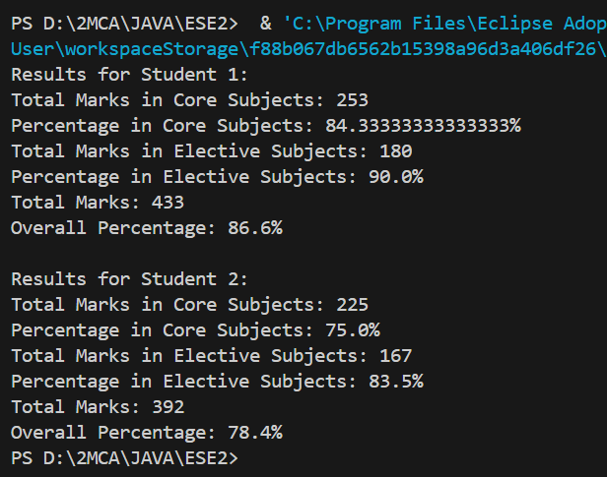

**2nd Program : --**

// Base class

class Base {

    int x;

    int y;

    Base(int x, int y) {

        this.x = x;

        this.y = y;

    }

}

// Derived class 1

class Derived1 extends Base {

    int z;

    Derived1(int x, int y, int z) {

        super(x, y);

        this.z = z;

    }

    int add() {

        return x + y + z;

    }

}

// Derived class 2

class Derived2 extends Base {

    int t;

    Derived2(int x, int y, int t) {

        super(x, y);

        this.t = t;

    }

    int multiply() {

        return x * y * t;

    }

}

// Derived class 3 that inherits from Derived1

class Derived3 extends Derived1 {

    int d;

    Derived3(int x, int y, int z, int d) {

        super(x, y, z);

        this.d = d;

    }

    int calculate() {

        return d * (x + y + z);

    }

}

// Main class to demonstrate functionality

public class Main {

    public static void main(String[] args) {

        // Create an instance of Derived1

        Derived1 derived1 = new Derived1(1, 2, 3);

        System.out.println("Sum of x, y, z in Derived1: " + derived1.add());

        // Create an instance of Derived2

        Derived2 derived2 = new Derived2(1, 2, 3);

        System.out.println("Product of x, y, t in Derived2: " + derived2.multiply());

        // Create an instance of Derived3

        Derived3 derived3 = new Derived3(1, 2, 3, 4);

        System.out.println("Result of d * (x + y + z) in Derived3: " + derived3.calculate());

    }

}

**Output : --**

