// 1. (a)Calculate the percentage secured by the student given 6 subjects marks

// 1. (b)Check the division secured by the student 0-39 percent fail 40-49 second class 60-74 first class 75 are distinction.

import java.util.Scanner;

public class student {

    public static void main(String[] args) {

        Scanner scanner = new Scanner(System.in);

        // Array to hold marks of 6 subjects

        int[] marks = new int[6];

        int totalMarksObtained = 0;

        int totalMarksPossible = 600; // Assuming each subject is out of 100

        // Input marks for 6 subjects

        System.out.println("Enter the marks obtained in 6 subjects (out of 100):");

        for (int i = 0; i < 6; i++) {

            System.out.print("Subject " + (i + 1) + ": ");

            marks[i] = scanner.nextInt();

            totalMarksObtained += marks[i]; // Sum the marks

        }

        // Calculate percentage

        double percentage = (double) totalMarksObtained / totalMarksPossible * 100;

        System.out.printf("Percentage secured: %.2f%%\n", percentage);

        // Determine division

        String division;

        if (percentage < 40) {

            division = "Fail";

        }

        else if (percentage >= 40 && percentage < 60) {

            division = "Second Class";

        }

        else if (percentage >= 60 && percentage < 75) {

            division = "First Class";

        }

        else {

            division = "Distinction";

        }

        System.out.println("Division secured: " + division);

        // Close the scanner

        scanner.close();

    }

}

**Output: --**

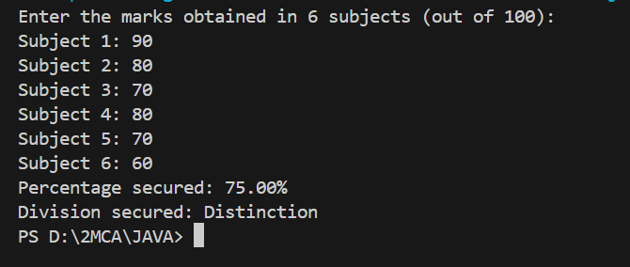

// 2. (a)Generate odd numbers from 100 to 500.

// 2. (b)Print any table and add

//          2*1 = 2

//          2*2 = 4

//          sum of products

public class table {

    public static void main(String[] args) {

        // Part (a): Generate odd numbers from 100 to 500

        System.out.println("Odd numbers from 100 to 500:");

        for (int i = 101; i <= 500; i += 2) {

            System.out.print(i + " ");

        }

        System.out.println(); // New line for better readability

        // Part (b): Print the multiplication table for 2

        int number = 2;

        int sumOfProducts = 0;

        System.out.println("Multiplication table for " + number + ":");

        for (int i = 1; i <= 10; i++) {

            int product = number * i;

            System.out.println(number + " * " + i + " = " + product);

            sumOfProducts += product; // Accumulate the sum of products

        }

        // Print the sum of products

        System.out.println("Sum of products: " + sumOfProducts);

    }

}

**Output : --**

