

**Java Programming**

**MCA-272**

**Assignment – 04**

***BY***

**HIMANSHU HEDA (24225013)**

**SUBMITTED TO**

**Dr. Manjula Shannhog**

**SCHOOL OF SCIENCES**

**2024-25**

**Program 1 : --**

public class arg1 {

    public static void main(String[] args) {

        int a,b,c;

        a = Integer.parseInt(args[0]);

        b = Integer.parseInt(args[1]);

        c = a + b;

        System.out.println("So the Result is : " + c);

    }

}

**OUTPUT : --**

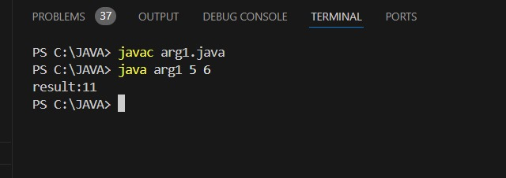

**Program 2 : --**

public class arg2 {

    public static void main(String[] args) {

        int n, sum=0;

        n = args.length;

        for (int i = 0; i < n; i++) {

            sum += Integer.parseInt(args[i]);

        }

        System.out.println("Result = " + sum);

    }

}

**OUTPUT : --**

