
NLDL Programming
MCA-575
Assignment – 06
BY
SHRUTI PRIYA (24225045)
SUBMITTED TO
Dr. Manjula Shannhog
SCHOOL OF SCIENCES
2025-26
Importing the Libraries

import tensorflow
from tensorflow import keras
from tensorflow.keras import Sequential
from tensorflow.keras.layers import Dense, Flatten
from tensorflow.keras.datasets import mnist

import matplotlib.pyplot as plt

(x_train, y_train), (x_test, y_test) = mnist.load_data()

Downloading data from https://storage.googleapis.com/tensorflow/tf-keras-datasets/mnist.npz
[1m11490434/11490434[0m [32m━━━━━━━━━━━━━━━━━━━━[0m[37m[0m [1m9s[0m 1us/step

x_test

array([[[0, 0, 0, ..., 0, 0, 0],
[0, 0, 0, ..., 0, 0, 0],
[0, 0, 0, ..., 0, 0, 0],
...,
[0, 0, 0, ..., 0, 0, 0],
[0, 0, 0, ..., 0, 0, 0],
[0, 0, 0, ..., 0, 0, 0]],

[[0, 0, 0, ..., 0, 0, 0],
[0, 0, 0, ..., 0, 0, 0],
[0, 0, 0, ..., 0, 0, 0],
...,
[0, 0, 0, ..., 0, 0, 0],
[0, 0, 0, ..., 0, 0, 0],
[0, 0, 0, ..., 0, 0, 0]],

[[0, 0, 0, ..., 0, 0, 0],
[0, 0, 0, ..., 0, 0, 0],
[0, 0, 0, ..., 0, 0, 0],
...,
[0, 0, 0, ..., 0, 0, 0],
[0, 0, 0, ..., 0, 0, 0],
[0, 0, 0, ..., 0, 0, 0]],

...,

[[0, 0, 0, ..., 0, 0, 0],
[0, 0, 0, ..., 0, 0, 0],
[0, 0, 0, ..., 0, 0, 0],
...,
[0, 0, 0, ..., 0, 0, 0],
[0, 0, 0, ..., 0, 0, 0],
[0, 0, 0, ..., 0, 0, 0]],

[[0, 0, 0, ..., 0, 0, 0],
[0, 0, 0, ..., 0, 0, 0],
[0, 0, 0, ..., 0, 0, 0],
...,
[0, 0, 0, ..., 0, 0, 0],
[0, 0, 0, ..., 0, 0, 0],
[0, 0, 0, ..., 0, 0, 0]],

[[0, 0, 0, ..., 0, 0, 0],
[0, 0, 0, ..., 0, 0, 0],
[0, 0, 0, ..., 0, 0, 0],
...,
[0, 0, 0, ..., 0, 0, 0],
[0, 0, 0, ..., 0, 0, 0],
[0, 0, 0, ..., 0, 0, 0]]], shape=(10000, 28, 28), dtype=uint8)

x_train

array([[[0, 0, 0, ..., 0, 0, 0],
[0, 0, 0, ..., 0, 0, 0],
[0, 0, 0, ..., 0, 0, 0],
...,
[0, 0, 0, ..., 0, 0, 0],
[0, 0, 0, ..., 0, 0, 0],
[0, 0, 0, ..., 0, 0, 0]],

[[0, 0, 0, ..., 0, 0, 0],
[0, 0, 0, ..., 0, 0, 0],
[0, 0, 0, ..., 0, 0, 0],
...,
[0, 0, 0, ..., 0, 0, 0],
[0, 0, 0, ..., 0, 0, 0],
[0, 0, 0, ..., 0, 0, 0]],

[[0, 0, 0, ..., 0, 0, 0],
[0, 0, 0, ..., 0, 0, 0],
[0, 0, 0, ..., 0, 0, 0],
...,
[0, 0, 0, ..., 0, 0, 0],
[0, 0, 0, ..., 0, 0, 0],
[0, 0, 0, ..., 0, 0, 0]],

...,

[[0, 0, 0, ..., 0, 0, 0],
[0, 0, 0, ..., 0, 0, 0],
[0, 0, 0, ..., 0, 0, 0],
...,
[0, 0, 0, ..., 0, 0, 0],
[0, 0, 0, ..., 0, 0, 0],
[0, 0, 0, ..., 0, 0, 0]],

[[0, 0, 0, ..., 0, 0, 0],
[0, 0, 0, ..., 0, 0, 0],
[0, 0, 0, ..., 0, 0, 0],
...,
[0, 0, 0, ..., 0, 0, 0],
[0, 0, 0, ..., 0, 0, 0],
[0, 0, 0, ..., 0, 0, 0]],

[[0, 0, 0, ..., 0, 0, 0],
[0, 0, 0, ..., 0, 0, 0],
[0, 0, 0, ..., 0, 0, 0],
...,
[0, 0, 0, ..., 0, 0, 0],
[0, 0, 0, ..., 0, 0, 0],
[0, 0, 0, ..., 0, 0, 0]]], shape=(60000, 28, 28), dtype=uint8)

x_train.shape

(60000, 28, 28)

x_train[10]

array([[ 0, 0, 0, 0, 0, 0, 0, 0, 0, 0, 0, 0, 0,
0, 0, 0, 0, 0, 0, 0, 0, 0, 0, 0, 0, 0,
0, 0],
[ 0, 0, 0, 0, 0, 0, 0, 0, 0, 0, 0, 0, 0,
0, 0, 0, 0, 0, 0, 0, 0, 0, 0, 0, 0, 0,
0, 0],
[ 0, 0, 0, 0, 0, 0, 0, 0, 0, 0, 0, 0, 0,
0, 0, 0, 0, 0, 0, 0, 0, 0, 0, 0, 0, 0,
0, 0],
[ 0, 0, 0, 0, 0, 0, 0, 0, 0, 0, 0, 0, 0,
0, 0, 0, 0, 0, 0, 0, 0, 0, 0, 0, 0, 0,
0, 0],
[ 0, 0, 0, 0, 0, 0, 0, 0, 0, 0, 0, 42, 118,
219, 166, 118, 118, 6, 0, 0, 0, 0, 0, 0, 0, 0,
0, 0],
[ 0, 0, 0, 0, 0, 0, 0, 0, 0, 0, 103, 242, 254,
254, 254, 254, 254, 66, 0, 0, 0, 0, 0, 0, 0, 0,
0, 0],
[ 0, 0, 0, 0, 0, 0, 0, 0, 0, 0, 18, 232, 254,
254, 254, 254, 254, 238, 70, 0, 0, 0, 0, 0, 0, 0,
0, 0],
[ 0, 0, 0, 0, 0, 0, 0, 0, 0, 0, 0, 104, 244,
254, 224, 254, 254, 254, 141, 0, 0, 0, 0, 0, 0, 0,
0, 0],
[ 0, 0, 0, 0, 0, 0, 0, 0, 0, 0, 0, 0, 207,
254, 210, 254, 254, 254, 34, 0, 0, 0, 0, 0, 0, 0,
0, 0],
[ 0, 0, 0, 0, 0, 0, 0, 0, 0, 0, 0, 0, 84,
206, 254, 254, 254, 254, 41, 0, 0, 0, 0, 0, 0, 0,
0, 0],
[ 0, 0, 0, 0, 0, 0, 0, 0, 0, 0, 0, 0, 0,
24, 209, 254, 254, 254, 171, 0, 0, 0, 0, 0, 0, 0,
0, 0],
[ 0, 0, 0, 0, 0, 0, 0, 0, 0, 0, 0, 0, 91,
137, 253, 254, 254, 254, 112, 0, 0, 0, 0, 0, 0, 0,
0, 0],
[ 0, 0, 0, 0, 0, 0, 0, 0, 0, 0, 40, 214, 250,
254, 254, 254, 254, 254, 34, 0, 0, 0, 0, 0, 0, 0,
0, 0],
[ 0, 0, 0, 0, 0, 0, 0, 0, 0, 0, 81, 247, 254,
254, 254, 254, 254, 254, 146, 0, 0, 0, 0, 0, 0, 0,
0, 0],
[ 0, 0, 0, 0, 0, 0, 0, 0, 0, 0, 0, 110, 246,
254, 254, 254, 254, 254, 171, 0, 0, 0, 0, 0, 0, 0,
0, 0],
[ 0, 0, 0, 0, 0, 0, 0, 0, 0, 0, 0, 0, 73,
89, 89, 93, 240, 254, 171, 0, 0, 0, 0, 0, 0, 0,
0, 0],
[ 0, 0, 0, 0, 0, 0, 0, 0, 0, 0, 0, 0, 0,
0, 0, 1, 128, 254, 219, 31, 0, 0, 0, 0, 0, 0,
0, 0],
[ 0, 0, 0, 0, 0, 0, 0, 0, 0, 0, 0, 0, 0,
0, 0, 7, 254, 254, 214, 28, 0, 0, 0, 0, 0, 0,
0, 0],
[ 0, 0, 0, 0, 0, 0, 0, 0, 0, 0, 0, 0, 0,
0, 0, 138, 254, 254, 116, 0, 0, 0, 0, 0, 0, 0,
0, 0],
[ 0, 0, 0, 0, 0, 0, 19, 177, 90, 0, 0, 0, 0,
0, 25, 240, 254, 254, 34, 0, 0, 0, 0, 0, 0, 0,
0, 0],
[ 0, 0, 0, 0, 0, 0, 164, 254, 215, 63, 36, 0, 51,
89, 206, 254, 254, 139, 8, 0, 0, 0, 0, 0, 0, 0,
0, 0],
[ 0, 0, 0, 0, 0, 0, 57, 197, 254, 254, 222, 180, 241,
254, 254, 253, 213, 11, 0, 0, 0, 0, 0, 0, 0, 0,
0, 0],
[ 0, 0, 0, 0, 0, 0, 0, 140, 105, 254, 254, 254, 254,
254, 254, 236, 0, 0, 0, 0, 0, 0, 0, 0, 0, 0,
0, 0],
[ 0, 0, 0, 0, 0, 0, 0, 0, 7, 117, 117, 165, 254,
254, 239, 50, 0, 0, 0, 0, 0, 0, 0, 0, 0, 0,
0, 0],
[ 0, 0, 0, 0, 0, 0, 0, 0, 0, 0, 0, 0, 0,
0, 0, 0, 0, 0, 0, 0, 0, 0, 0, 0, 0, 0,
0, 0],
[ 0, 0, 0, 0, 0, 0, 0, 0, 0, 0, 0, 0, 0,
0, 0, 0, 0, 0, 0, 0, 0, 0, 0, 0, 0, 0,
0, 0],
[ 0, 0, 0, 0, 0, 0, 0, 0, 0, 0, 0, 0, 0,
0, 0, 0, 0, 0, 0, 0, 0, 0, 0, 0, 0, 0,
0, 0],
[ 0, 0, 0, 0, 0, 0, 0, 0, 0, 0, 0, 0, 0,
0, 0, 0, 0, 0, 0, 0, 0, 0, 0, 0, 0, 0,
0, 0]], dtype=uint8)

y_train

array([5, 0, 4, ..., 5, 6, 8], shape=(60000,), dtype=uint8)

plt.imshow(x_train[10], cmap='gray')

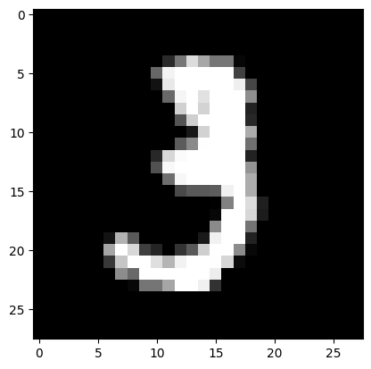

plt.imshow(x_train[0])

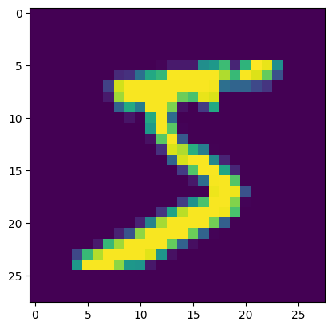

plt.imshow(x_train[1])

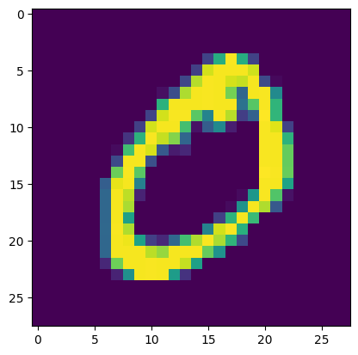

x_train.shape

(60000, 28, 28)

x_train[59999]

array([[ 0, 0, 0, 0, 0, 0, 0, 0, 0, 0, 0, 0, 0,
0, 0, 0, 0, 0, 0, 0, 0, 0, 0, 0, 0, 0,
0, 0],
[ 0, 0, 0, 0, 0, 0, 0, 0, 0, 0, 0, 0, 0,
0, 0, 0, 0, 0, 0, 0, 0, 0, 0, 0, 0, 0,
0, 0],
[ 0, 0, 0, 0, 0, 0, 0, 0, 0, 0, 0, 0, 0,
0, 0, 0, 0, 0, 0, 0, 0, 0, 0, 0, 0, 0,
0, 0],
[ 0, 0, 0, 0, 0, 0, 0, 0, 0, 0, 0, 0, 0,
0, 0, 0, 0, 0, 0, 0, 0, 0, 0, 0, 0, 0,
0, 0],
[ 0, 0, 0, 0, 0, 0, 0, 0, 0, 0, 0, 0, 0,
0, 0, 0, 0, 0, 0, 0, 0, 0, 0, 0, 0, 0,
0, 0],
[ 0, 0, 0, 0, 0, 0, 0, 0, 0, 0, 0, 0, 0,
0, 0, 0, 0, 0, 0, 0, 0, 0, 0, 0, 0, 0,
0, 0],
[ 0, 0, 0, 0, 0, 0, 0, 0, 0, 0, 0, 0, 0,
0, 0, 0, 38, 48, 48, 22, 0, 0, 0, 0, 0, 0,
0, 0],
[ 0, 0, 0, 0, 0, 0, 0, 0, 0, 0, 0, 0, 0,
62, 97, 198, 243, 254, 254, 212, 27, 0, 0, 0, 0, 0,
0, 0],
[ 0, 0, 0, 0, 0, 0, 0, 0, 0, 0, 0, 0, 67,
172, 254, 254, 225, 218, 218, 237, 248, 40, 0, 21, 164, 187,
0, 0],
[ 0, 0, 0, 0, 0, 0, 0, 0, 0, 0, 0, 89, 219,
254, 97, 67, 14, 0, 0, 92, 231, 122, 23, 203, 236, 59,
0, 0],
[ 0, 0, 0, 0, 0, 0, 0, 0, 0, 0, 25, 217, 242,
92, 4, 0, 0, 0, 0, 4, 147, 253, 240, 232, 92, 0,
0, 0],
[ 0, 0, 0, 0, 0, 0, 0, 0, 0, 0, 101, 255, 92,
0, 0, 0, 0, 0, 0, 105, 254, 254, 177, 11, 0, 0,
0, 0],
[ 0, 0, 0, 0, 0, 0, 0, 0, 0, 0, 167, 244, 41,
0, 0, 0, 7, 76, 199, 238, 239, 94, 10, 0, 0, 0,
0, 0],
[ 0, 0, 0, 0, 0, 0, 0, 0, 0, 0, 192, 121, 0,
0, 2, 63, 180, 254, 233, 126, 0, 0, 0, 0, 0, 0,
0, 0],
[ 0, 0, 0, 0, 0, 0, 0, 0, 0, 0, 190, 196, 14,
2, 97, 254, 252, 146, 52, 0, 0, 0, 0, 0, 0, 0,
0, 0],
[ 0, 0, 0, 0, 0, 0, 0, 0, 0, 0, 130, 225, 71,
180, 232, 181, 60, 0, 0, 0, 0, 0, 0, 0, 0, 0,
0, 0],
[ 0, 0, 0, 0, 0, 0, 0, 0, 0, 0, 130, 254, 254,
230, 46, 0, 0, 0, 0, 0, 0, 0, 0, 0, 0, 0,
0, 0],
[ 0, 0, 0, 0, 0, 0, 0, 0, 6, 77, 244, 254, 162,
4, 0, 0, 0, 0, 0, 0, 0, 0, 0, 0, 0, 0,
0, 0],
[ 0, 0, 0, 0, 0, 0, 0, 0, 110, 254, 218, 254, 116,
0, 0, 0, 0, 0, 0, 0, 0, 0, 0, 0, 0, 0,
0, 0],
[ 0, 0, 0, 0, 0, 0, 0, 131, 254, 154, 28, 213, 86,
0, 0, 0, 0, 0, 0, 0, 0, 0, 0, 0, 0, 0,
0, 0],
[ 0, 0, 0, 0, 0, 0, 66, 209, 153, 19, 19, 233, 60,
0, 0, 0, 0, 0, 0, 0, 0, 0, 0, 0, 0, 0,
0, 0],
[ 0, 0, 0, 0, 0, 0, 142, 254, 165, 0, 14, 216, 167,
0, 0, 0, 0, 0, 0, 0, 0, 0, 0, 0, 0, 0,
0, 0],
[ 0, 0, 0, 0, 0, 0, 90, 254, 175, 0, 18, 229, 92,
0, 0, 0, 0, 0, 0, 0, 0, 0, 0, 0, 0, 0,
0, 0],
[ 0, 0, 0, 0, 0, 0, 26, 229, 249, 176, 222, 244, 44,
0, 0, 0, 0, 0, 0, 0, 0, 0, 0, 0, 0, 0,
0, 0],
[ 0, 0, 0, 0, 0, 0, 0, 73, 193, 197, 134, 0, 0,
0, 0, 0, 0, 0, 0, 0, 0, 0, 0, 0, 0, 0,
0, 0],
[ 0, 0, 0, 0, 0, 0, 0, 0, 0, 0, 0, 0, 0,
0, 0, 0, 0, 0, 0, 0, 0, 0, 0, 0, 0, 0,
0, 0],
[ 0, 0, 0, 0, 0, 0, 0, 0, 0, 0, 0, 0, 0,
0, 0, 0, 0, 0, 0, 0, 0, 0, 0, 0, 0, 0,
0, 0],
[ 0, 0, 0, 0, 0, 0, 0, 0, 0, 0, 0, 0, 0,
0, 0, 0, 0, 0, 0, 0, 0, 0, 0, 0, 0, 0,
0, 0]], dtype=uint8)

y_train[59999]

np.uint8(8)

x_train

array([[[0, 0, 0, ..., 0, 0, 0],
[0, 0, 0, ..., 0, 0, 0],
[0, 0, 0, ..., 0, 0, 0],
...,
[0, 0, 0, ..., 0, 0, 0],
[0, 0, 0, ..., 0, 0, 0],
[0, 0, 0, ..., 0, 0, 0]],

[[0, 0, 0, ..., 0, 0, 0],
[0, 0, 0, ..., 0, 0, 0],
[0, 0, 0, ..., 0, 0, 0],
...,
[0, 0, 0, ..., 0, 0, 0],
[0, 0, 0, ..., 0, 0, 0],
[0, 0, 0, ..., 0, 0, 0]],

[[0, 0, 0, ..., 0, 0, 0],
[0, 0, 0, ..., 0, 0, 0],
[0, 0, 0, ..., 0, 0, 0],
...,
[0, 0, 0, ..., 0, 0, 0],
[0, 0, 0, ..., 0, 0, 0],
[0, 0, 0, ..., 0, 0, 0]],

...,

[[0, 0, 0, ..., 0, 0, 0],
[0, 0, 0, ..., 0, 0, 0],
[0, 0, 0, ..., 0, 0, 0],
...,
[0, 0, 0, ..., 0, 0, 0],
[0, 0, 0, ..., 0, 0, 0],
[0, 0, 0, ..., 0, 0, 0]],

[[0, 0, 0, ..., 0, 0, 0],
[0, 0, 0, ..., 0, 0, 0],
[0, 0, 0, ..., 0, 0, 0],
...,
[0, 0, 0, ..., 0, 0, 0],
[0, 0, 0, ..., 0, 0, 0],
[0, 0, 0, ..., 0, 0, 0]],

[[0, 0, 0, ..., 0, 0, 0],
[0, 0, 0, ..., 0, 0, 0],
[0, 0, 0, ..., 0, 0, 0],
...,
[0, 0, 0, ..., 0, 0, 0],
[0, 0, 0, ..., 0, 0, 0],
[0, 0, 0, ..., 0, 0, 0]]], shape=(60000, 28, 28), dtype=uint8)

x_test.shape

(10000, 28, 28)

x_train = x_train / 255.0

x_train[0]

array([[0. , 0. , 0. , 0. , 0. ,
0. , 0. , 0. , 0. , 0. ,
0. , 0. , 0. , 0. , 0. ,
0. , 0. , 0. , 0. , 0. ,
0. , 0. , 0. , 0. , 0. ,
0. , 0. , 0. ],
[0. , 0. , 0. , 0. , 0. ,
0. , 0. , 0. , 0. , 0. ,
0. , 0. , 0. , 0. , 0. ,
0. , 0. , 0. , 0. , 0. ,
0. , 0. , 0. , 0. , 0. ,
0. , 0. , 0. ],
[0. , 0. , 0. , 0. , 0. ,
0. , 0. , 0. , 0. , 0. ,
0. , 0. , 0. , 0. , 0. ,
0. , 0. , 0. , 0. , 0. ,
0. , 0. , 0. , 0. , 0. ,
0. , 0. , 0. ],
[0. , 0. , 0. , 0. , 0. ,
0. , 0. , 0. , 0. , 0. ,
0. , 0. , 0. , 0. , 0. ,
0. , 0. , 0. , 0. , 0. ,
0. , 0. , 0. , 0. , 0. ,
0. , 0. , 0. ],
[0. , 0. , 0. , 0. , 0. ,
0. , 0. , 0. , 0. , 0. ,
0. , 0. , 0. , 0. , 0. ,
0. , 0. , 0. , 0. , 0. ,
0. , 0. , 0. , 0. , 0. ,
0. , 0. , 0. ],
[0. , 0. , 0. , 0. , 0. ,
0. , 0. , 0. , 0. , 0. ,
0. , 0. , 0.01176471, 0.07058824, 0.07058824,
0.07058824, 0.49411765, 0.53333333, 0.68627451, 0.10196078,
0.65098039, 1. , 0.96862745, 0.49803922, 0. ,
0. , 0. , 0. ],
[0. , 0. , 0. , 0. , 0. ,
0. , 0. , 0. , 0.11764706, 0.14117647,
0.36862745, 0.60392157, 0.66666667, 0.99215686, 0.99215686,
0.99215686, 0.99215686, 0.99215686, 0.88235294, 0.6745098 ,
0.99215686, 0.94901961, 0.76470588, 0.25098039, 0. ,
0. , 0. , 0. ],
[0. , 0. , 0. , 0. , 0. ,
0. , 0. , 0.19215686, 0.93333333, 0.99215686,
0.99215686, 0.99215686, 0.99215686, 0.99215686, 0.99215686,
0.99215686, 0.99215686, 0.98431373, 0.36470588, 0.32156863,
0.32156863, 0.21960784, 0.15294118, 0. , 0. ,
0. , 0. , 0. ],
[0. , 0. , 0. , 0. , 0. ,
0. , 0. , 0.07058824, 0.85882353, 0.99215686,
0.99215686, 0.99215686, 0.99215686, 0.99215686, 0.77647059,
0.71372549, 0.96862745, 0.94509804, 0. , 0. ,
0. , 0. , 0. , 0. , 0. ,
0. , 0. , 0. ],
[0. , 0. , 0. , 0. , 0. ,
0. , 0. , 0. , 0.31372549, 0.61176471,
0.41960784, 0.99215686, 0.99215686, 0.80392157, 0.04313725,
0. , 0.16862745, 0.60392157, 0. , 0. ,
0. , 0. , 0. , 0. , 0. ,
0. , 0. , 0. ],
[0. , 0. , 0. , 0. , 0. ,
0. , 0. , 0. , 0. , 0.05490196,
0.00392157, 0.60392157, 0.99215686, 0.35294118, 0. ,
0. , 0. , 0. , 0. , 0. ,
0. , 0. , 0. , 0. , 0. ,
0. , 0. , 0. ],
[0. , 0. , 0. , 0. , 0. ,
0. , 0. , 0. , 0. , 0. ,
0. , 0.54509804, 0.99215686, 0.74509804, 0.00784314,
0. , 0. , 0. , 0. , 0. ,
0. , 0. , 0. , 0. , 0. ,
0. , 0. , 0. ],
[0. , 0. , 0. , 0. , 0. ,
0. , 0. , 0. , 0. , 0. ,
0. , 0.04313725, 0.74509804, 0.99215686, 0.2745098 ,
0. , 0. , 0. , 0. , 0. ,
0. , 0. , 0. , 0. , 0. ,
0. , 0. , 0. ],
[0. , 0. , 0. , 0. , 0. ,
0. , 0. , 0. , 0. , 0. ,
0. , 0. , 0.1372549 , 0.94509804, 0.88235294,
0.62745098, 0.42352941, 0.00392157, 0. , 0. ,
0. , 0. , 0. , 0. , 0. ,
0. , 0. , 0. ],
[0. , 0. , 0. , 0. , 0. ,
0. , 0. , 0. , 0. , 0. ,
0. , 0. , 0. , 0.31764706, 0.94117647,
0.99215686, 0.99215686, 0.46666667, 0.09803922, 0. ,
0. , 0. , 0. , 0. , 0. ,
0. , 0. , 0. ],
[0. , 0. , 0. , 0. , 0. ,
0. , 0. , 0. , 0. , 0. ,
0. , 0. , 0. , 0. , 0.17647059,
0.72941176, 0.99215686, 0.99215686, 0.58823529, 0.10588235,
0. , 0. , 0. , 0. , 0. ,
0. , 0. , 0. ],
[0. , 0. , 0. , 0. , 0. ,
0. , 0. , 0. , 0. , 0. ,
0. , 0. , 0. , 0. , 0. ,
0.0627451 , 0.36470588, 0.98823529, 0.99215686, 0.73333333,
0. , 0. , 0. , 0. , 0. ,
0. , 0. , 0. ],
[0. , 0. , 0. , 0. , 0. ,
0. , 0. , 0. , 0. , 0. ,
0. , 0. , 0. , 0. , 0. ,
0. , 0. , 0.97647059, 0.99215686, 0.97647059,
0.25098039, 0. , 0. , 0. , 0. ,
0. , 0. , 0. ],
[0. , 0. , 0. , 0. , 0. ,
0. , 0. , 0. , 0. , 0. ,
0. , 0. , 0. , 0. , 0.18039216,
0.50980392, 0.71764706, 0.99215686, 0.99215686, 0.81176471,
0.00784314, 0. , 0. , 0. , 0. ,
0. , 0. , 0. ],
[0. , 0. , 0. , 0. , 0. ,
0. , 0. , 0. , 0. , 0. ,
0. , 0. , 0.15294118, 0.58039216, 0.89803922,
0.99215686, 0.99215686, 0.99215686, 0.98039216, 0.71372549,
0. , 0. , 0. , 0. , 0. ,
0. , 0. , 0. ],
[0. , 0. , 0. , 0. , 0. ,
0. , 0. , 0. , 0. , 0. ,
0.09411765, 0.44705882, 0.86666667, 0.99215686, 0.99215686,
0.99215686, 0.99215686, 0.78823529, 0.30588235, 0. ,
0. , 0. , 0. , 0. , 0. ,
0. , 0. , 0. ],
[0. , 0. , 0. , 0. , 0. ,
0. , 0. , 0. , 0.09019608, 0.25882353,
0.83529412, 0.99215686, 0.99215686, 0.99215686, 0.99215686,
0.77647059, 0.31764706, 0.00784314, 0. , 0. ,
0. , 0. , 0. , 0. , 0. ,
0. , 0. , 0. ],
[0. , 0. , 0. , 0. , 0. ,
0. , 0.07058824, 0.67058824, 0.85882353, 0.99215686,
0.99215686, 0.99215686, 0.99215686, 0.76470588, 0.31372549,
0.03529412, 0. , 0. , 0. , 0. ,
0. , 0. , 0. , 0. , 0. ,
0. , 0. , 0. ],
[0. , 0. , 0. , 0. , 0.21568627,
0.6745098 , 0.88627451, 0.99215686, 0.99215686, 0.99215686,
0.99215686, 0.95686275, 0.52156863, 0.04313725, 0. ,
0. , 0. , 0. , 0. , 0. ,
0. , 0. , 0. , 0. , 0. ,
0. , 0. , 0. ],
[0. , 0. , 0. , 0. , 0.53333333,
0.99215686, 0.99215686, 0.99215686, 0.83137255, 0.52941176,
0.51764706, 0.0627451 , 0. , 0. , 0. ,
0. , 0. , 0. , 0. , 0. ,
0. , 0. , 0. , 0. , 0. ,
0. , 0. , 0. ],
[0. , 0. , 0. , 0. , 0. ,
0. , 0. , 0. , 0. , 0. ,
0. , 0. , 0. , 0. , 0. ,
0. , 0. , 0. , 0. , 0. ,
0. , 0. , 0. , 0. , 0. ,
0. , 0. , 0. ],
[0. , 0. , 0. , 0. , 0. ,
0. , 0. , 0. , 0. , 0. ,
0. , 0. , 0. , 0. , 0. ,
0. , 0. , 0. , 0. , 0. ,
0. , 0. , 0. , 0. , 0. ,
0. , 0. , 0. ],
[0. , 0. , 0. , 0. , 0. ,
0. , 0. , 0. , 0. , 0. ,
0. , 0. , 0. , 0. , 0. ,
0. , 0. , 0. , 0. , 0. ,
0. , 0. , 0. , 0. , 0. ,
0. , 0. , 0. ]])

plt.imshow(x_train[1300])

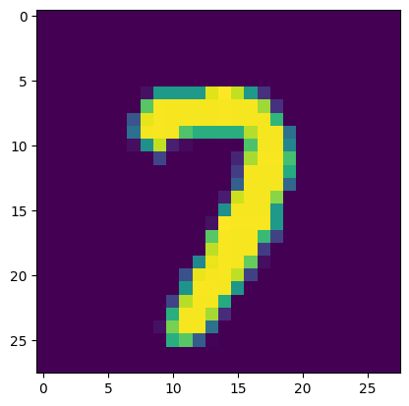

model = Sequential()

model.add(Flatten(input_shape=(28, 28)))
model.add(Dense(128, activation='relu'))
model.add(Dense(10, activation='softmax'))

c:\Users\himan\AppData\Local\Programs\Python\Python313\Lib\site-packages\keras\src\layers\reshaping\flatten.py:37: UserWarning: Do not pass an `input_shape`/`input_dim` argument to a layer. When using Sequential models, prefer using an `Input(shape)` object as the first layer in the model instead.
super().__init__(**kwargs)

model.summary()

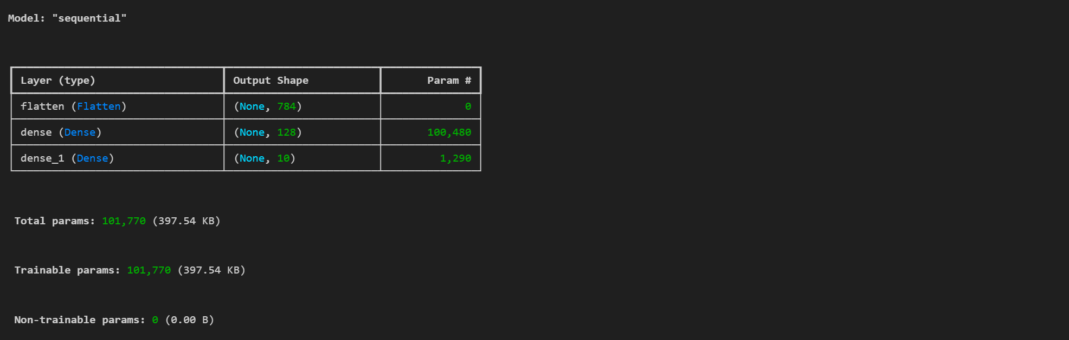

model.compile(loss='sparse_categorical_crossentropy', optimizer='adam', metrics=['accuracy'])

hist=model.fit(x_train, y_train, epochs=10, validation_split=0.2)

Epoch 1/10
[1m1500/1500[0m [32m━━━━━━━━━━━━━━━━━━━━[0m[37m[0m [1m9s[0m 5ms/step - accuracy: 0.9187 - loss: 0.2849 - val_accuracy: 0.9582 - val_loss: 0.1491
Epoch 2/10
[1m1500/1500[0m [32m━━━━━━━━━━━━━━━━━━━━[0m[37m[0m [1m11s[0m 7ms/step - accuracy: 0.9632 - loss: 0.1240 - val_accuracy: 0.9678 - val_loss: 0.1139
Epoch 3/10
[1m1500/1500[0m [32m━━━━━━━━━━━━━━━━━━━━[0m[37m[0m [1m11s[0m 7ms/step - accuracy: 0.9745 - loss: 0.0852 - val_accuracy: 0.9675 - val_loss: 0.1087
Epoch 4/10
[1m1500/1500[0m [32m━━━━━━━━━━━━━━━━━━━━[0m[37m[0m [1m10s[0m 7ms/step - accuracy: 0.9811 - loss: 0.0638 - val_accuracy: 0.9722 - val_loss: 0.0934
Epoch 5/10
[1m1500/1500[0m [32m━━━━━━━━━━━━━━━━━━━━[0m[37m[0m [1m10s[0m 7ms/step - accuracy: 0.9843 - loss: 0.0504 - val_accuracy: 0.9709 - val_loss: 0.0967
Epoch 6/10
[1m1500/1500[0m [32m━━━━━━━━━━━━━━━━━━━━[0m[37m[0m [1m10s[0m 7ms/step - accuracy: 0.9884 - loss: 0.0384 - val_accuracy: 0.9742 - val_loss: 0.0883
Epoch 7/10
[1m1500/1500[0m [32m━━━━━━━━━━━━━━━━━━━━[0m[37m[0m [1m10s[0m 7ms/step - accuracy: 0.9908 - loss: 0.0300 - val_accuracy: 0.9776 - val_loss: 0.0859
Epoch 8/10
[1m1500/1500[0m [32m━━━━━━━━━━━━━━━━━━━━[0m[37m[0m [1m11s[0m 7ms/step - accuracy: 0.9926 - loss: 0.0245 - val_accuracy: 0.9712 - val_loss: 0.1079
Epoch 9/10
[1m1500/1500[0m [32m━━━━━━━━━━━━━━━━━━━━[0m[37m[0m [1m10s[0m 7ms/step - accuracy: 0.9945 - loss: 0.0196 - val_accuracy: 0.9746 - val_loss: 0.0984
Epoch 10/10
[1m1500/1500[0m [32m━━━━━━━━━━━━━━━━━━━━[0m[37m[0m [1m11s[0m 7ms/step - accuracy: 0.9946 - loss: 0.0178 - val_accuracy: 0.9755 - val_loss: 0.0980

model.predict(x_test)

[1m313/313[0m [32m━━━━━━━━━━━━━━━━━━━━[0m[37m[0m [1m1s[0m 2ms/step

array([[0., 0., 0., ..., 1., 0., 0.],
[0., 0., 1., ..., 0., 0., 0.],
[0., 1., 0., ..., 0., 0., 0.],
...,
[0., 0., 0., ..., 0., 0., 0.],
[0., 0., 0., ..., 0., 0., 0.],
[0., 0., 0., ..., 0., 0., 0.]], shape=(10000, 10), dtype=float32)

y_prob = model.predict(x_test)

[1m313/313[0m [32m━━━━━━━━━━━━━━━━━━━━[0m[37m[0m [1m1s[0m 2ms/step

y_prob.argmax(axis=1)

array([7, 2, 1, ..., 4, 5, 6], shape=(10000,))

y_pred = y_prob.argmax(axis=1)

from sklearn.metrics import accuracy_score

acc = accuracy_score(y_test, y_pred)

acc

0.9748

plt.plot(hist.history['loss'])
plt.plot(hist.history['val_loss'])

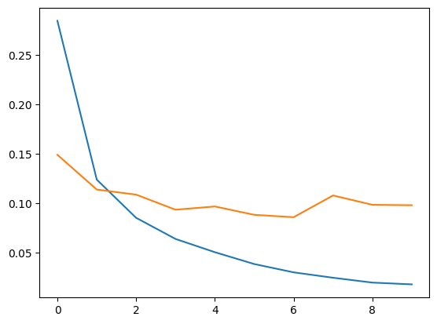

plt.imshow(x_test[1])

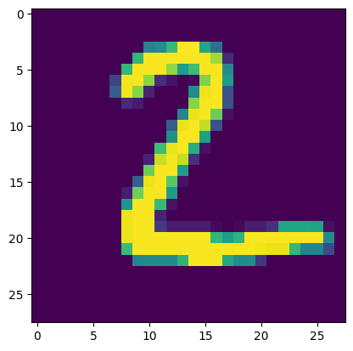

y_pred[1]

np.int64(2)

model.predict(x_test[1].reshape(1, 28, 28))

[1m1/1[0m [32m━━━━━━━━━━━━━━━━━━━━[0m[37m[0m [1m0s[0m 45ms/step
array([[0., 0., 1., 0., 0., 0., 0., 0., 0., 0.]], dtype=float32)

model.predict(x_test[1].reshape(1, 28, 28)).argmax(axis=1)

[1m1/1[0m [32m━━━━━━━━━━━━━━━━━━━━[0m[37m[0m [1m0s[0m 26ms/step

array([2])

