
NLDL Programming
MCA-575
Assignment – 01
BY
HIMANSHU HEDA (24225013)
SUBMITTED TO
Dr. Manjula Shannhog
SCHOOL OF SCIENCES
2025-26
Importing Libraries:
import numpy as np
import pandas as pd

Import Dataset:
df = pd.read_csv('./Dataset/customer.csv')

Shape:
df.shape

Head:
df.head()

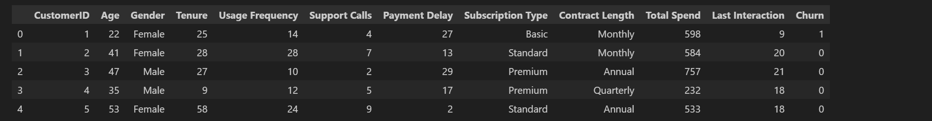

df.info()

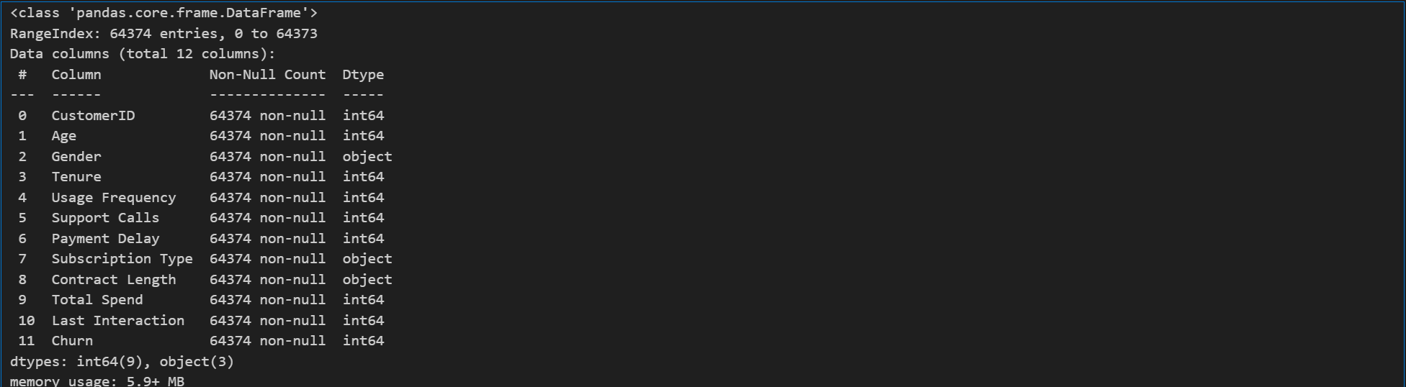

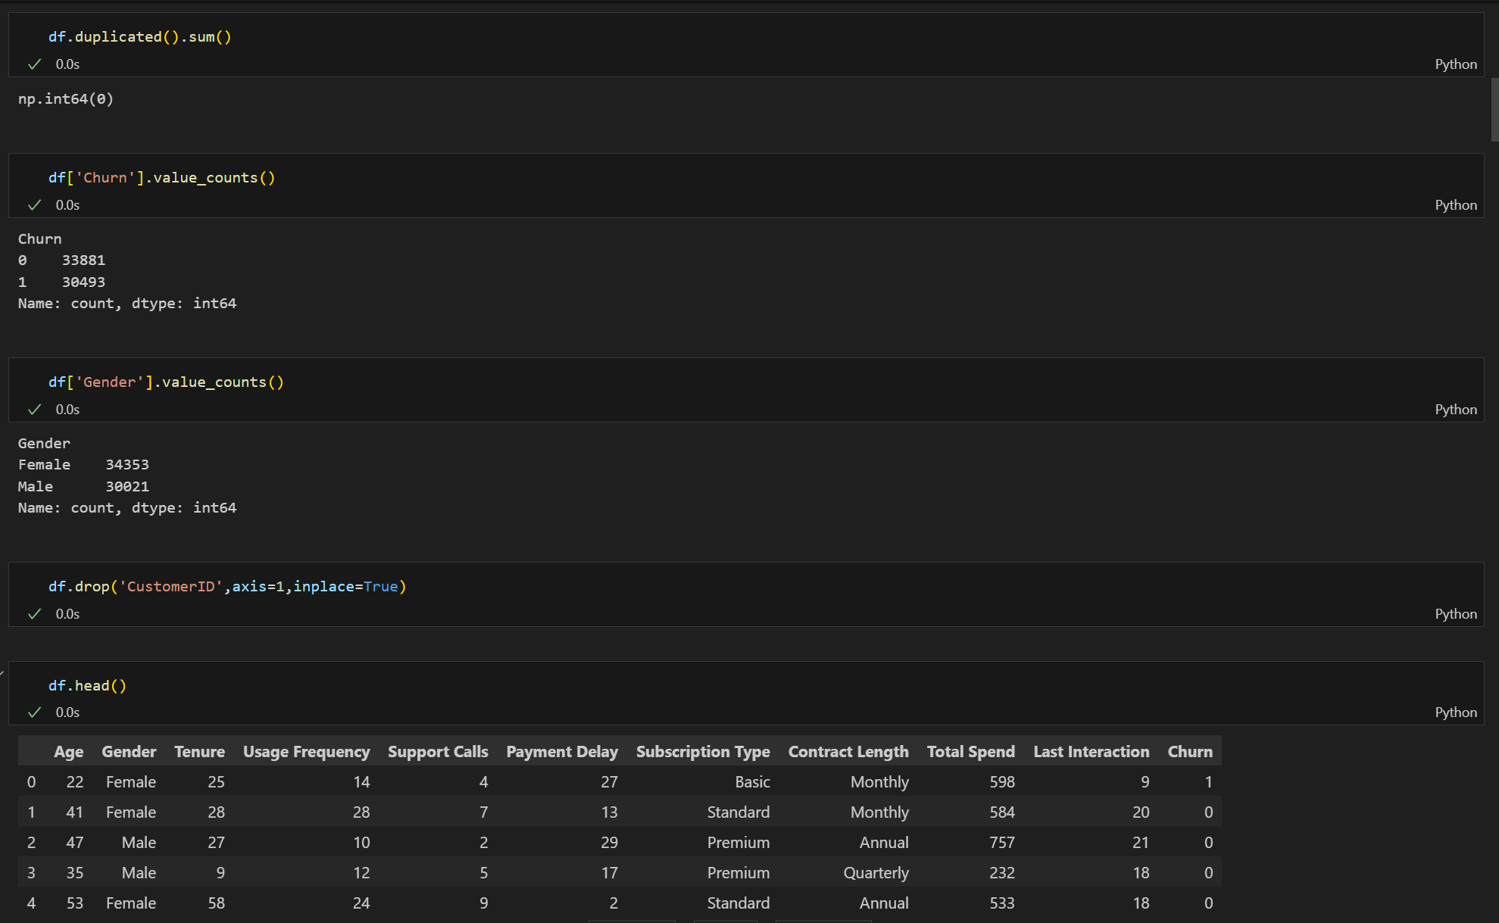

Unique:

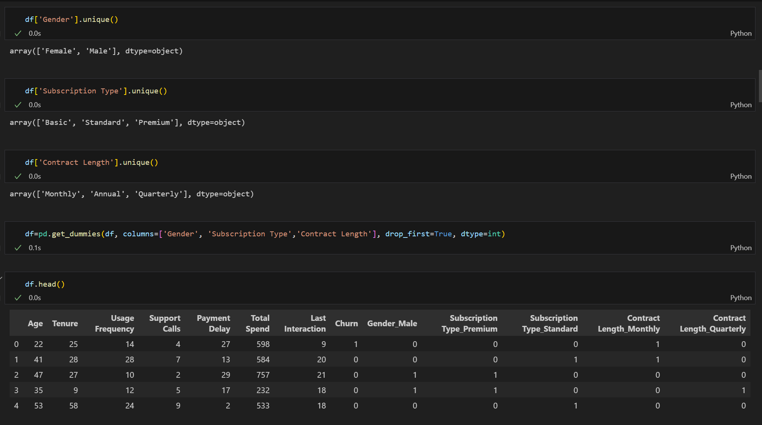

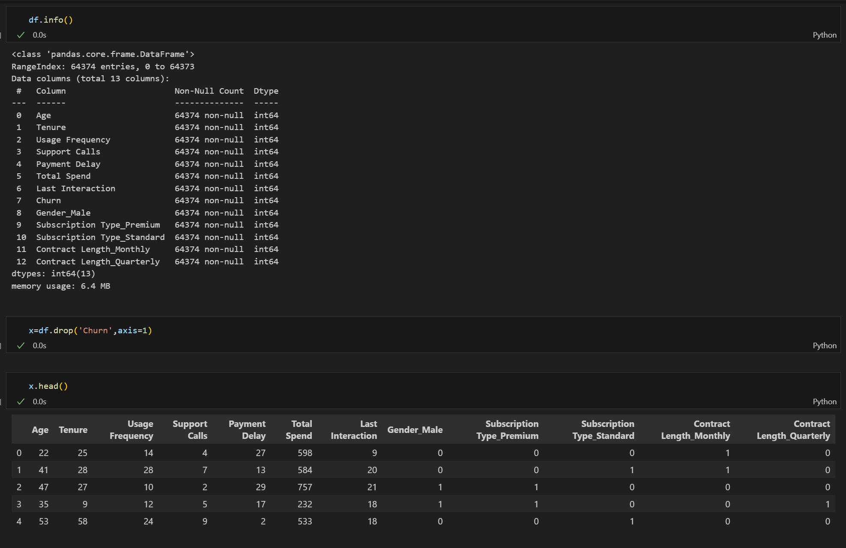

Importing TensorFlow for using keras , Sequential and Dense
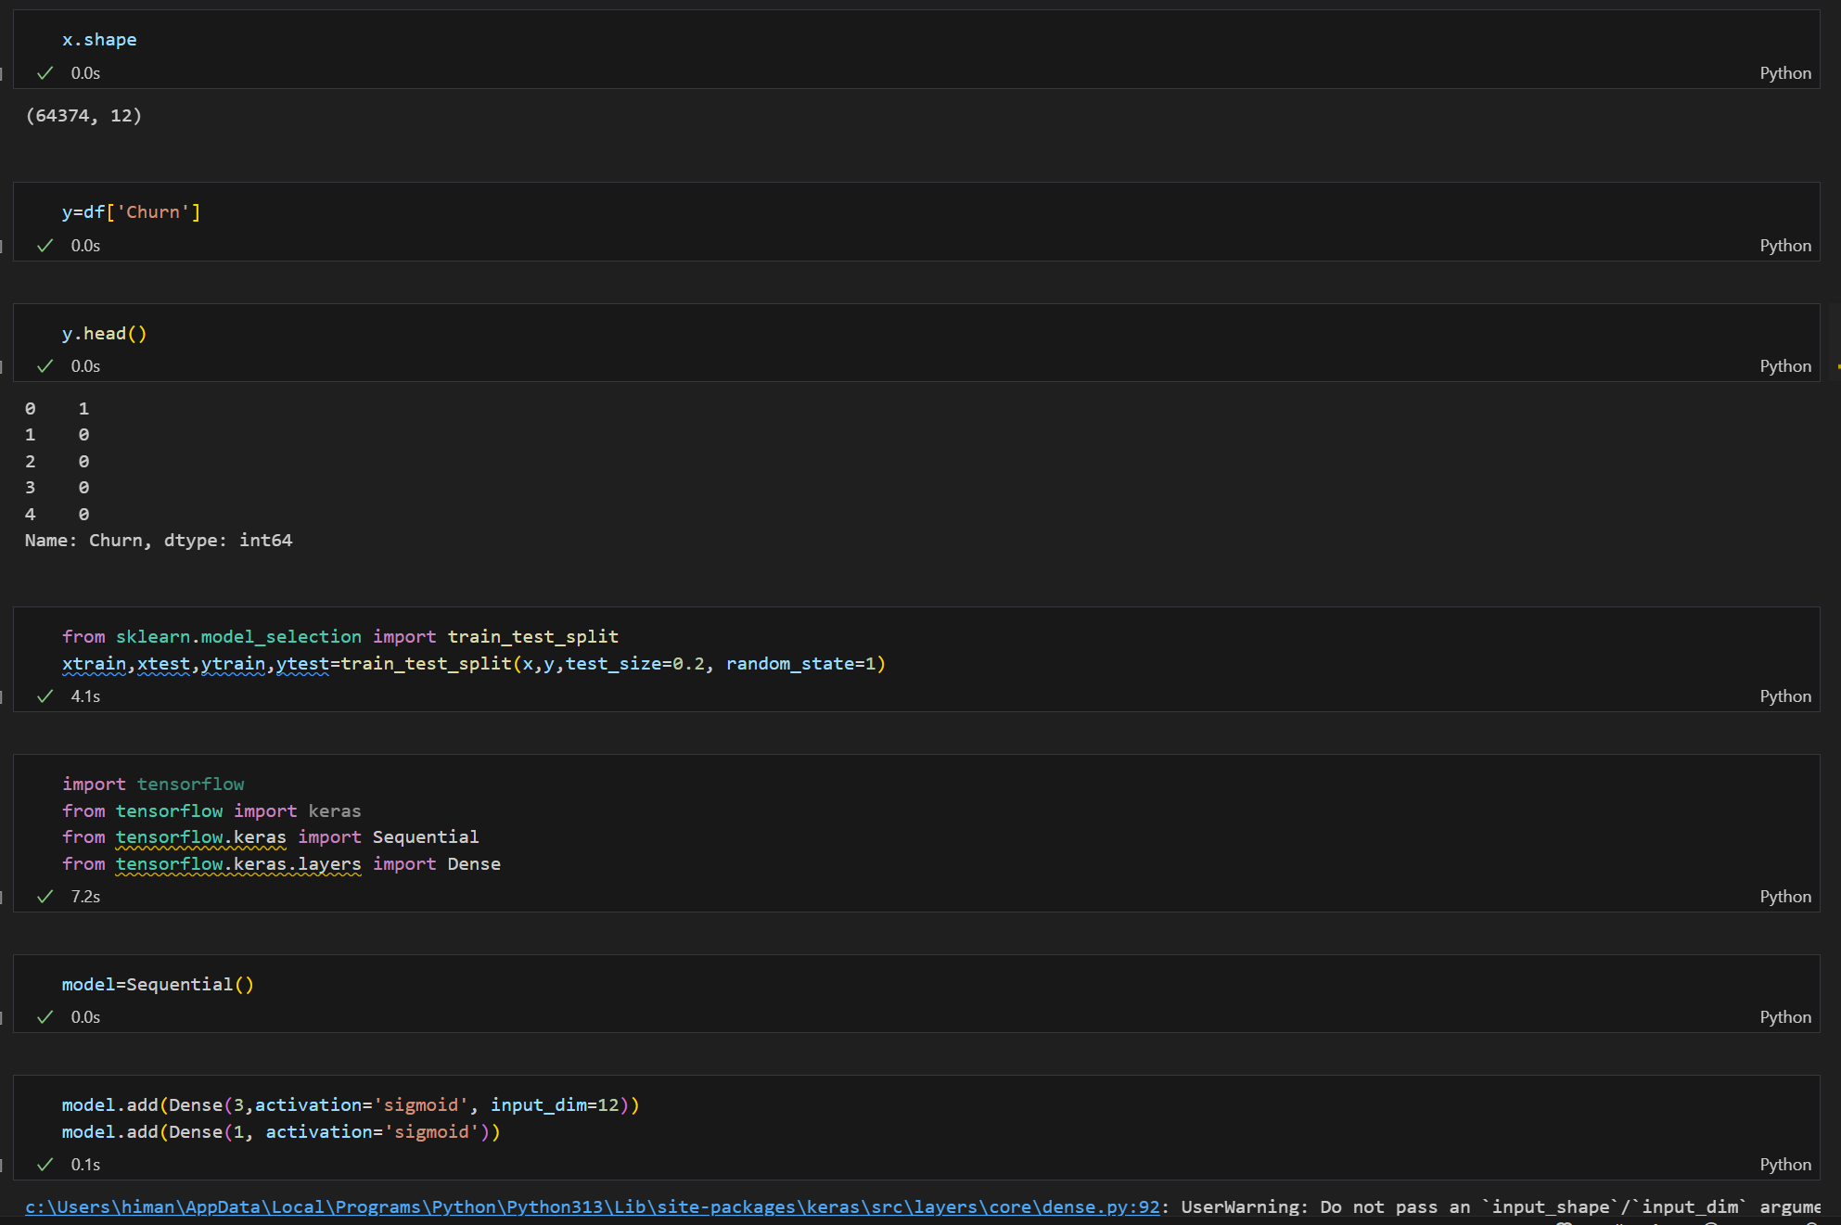

Model Summary & Using Sequential:
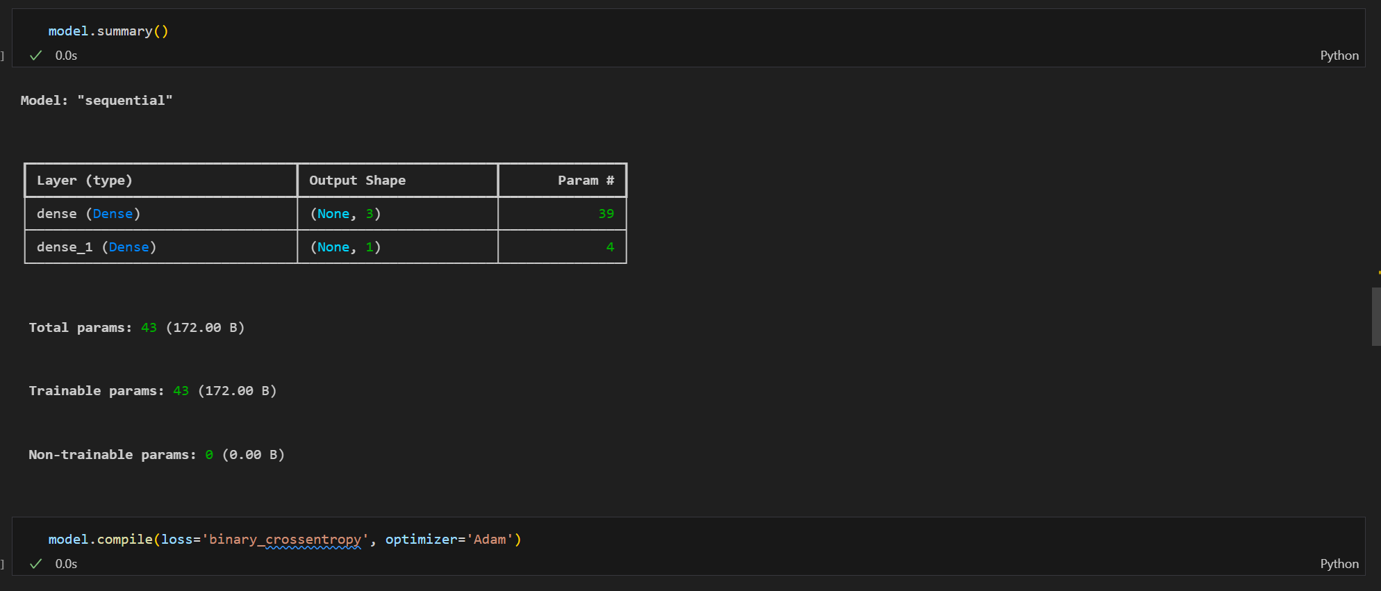

Model with 20 Epoch:

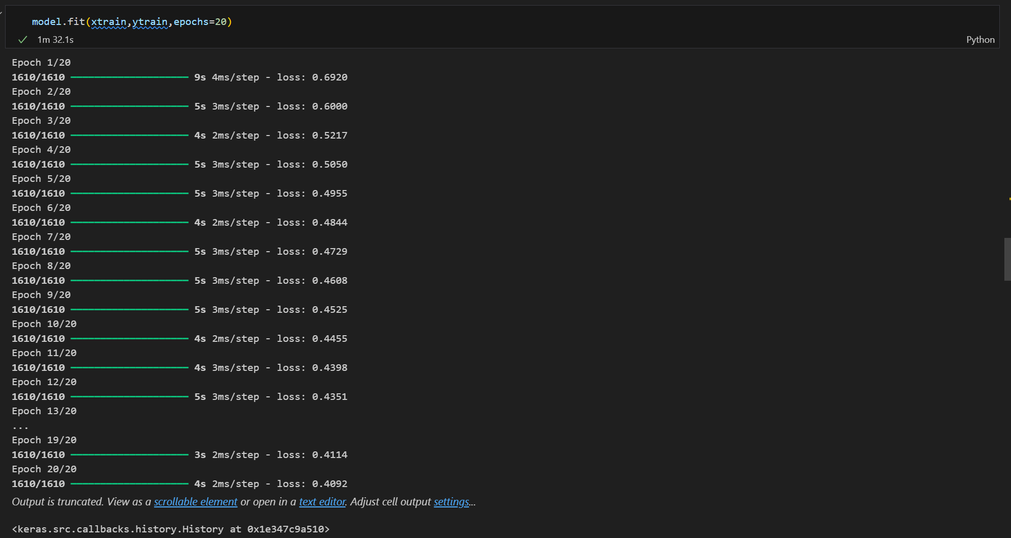

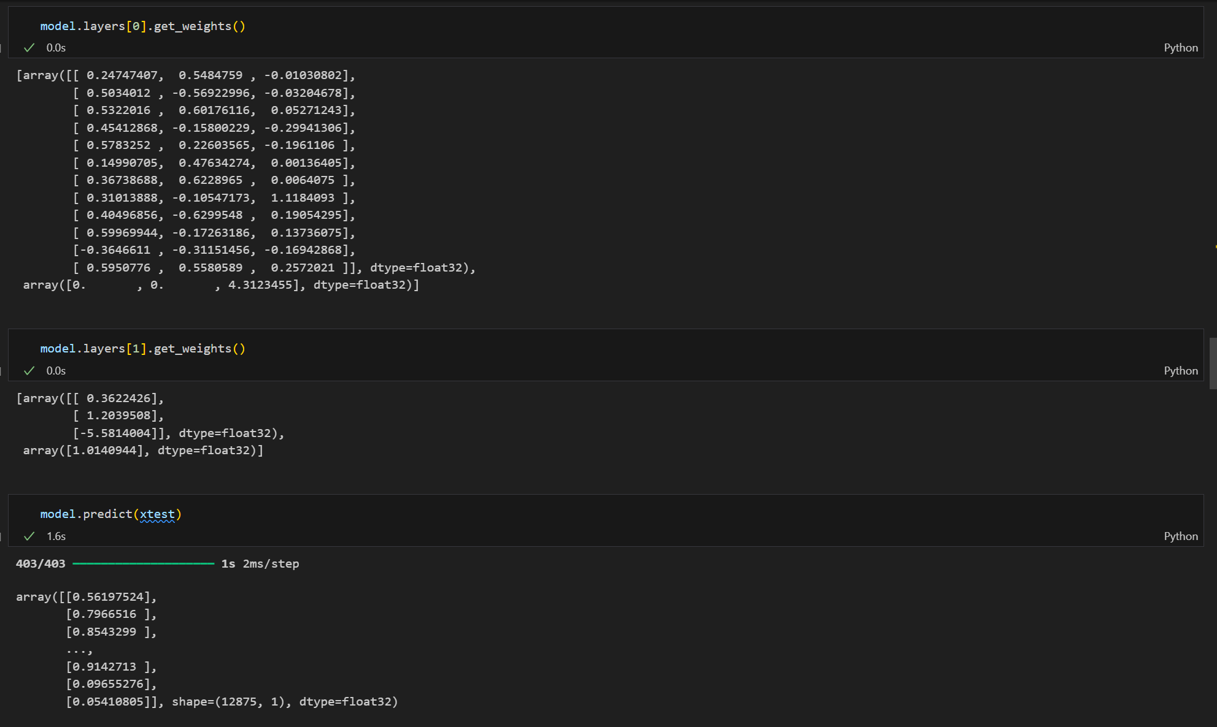

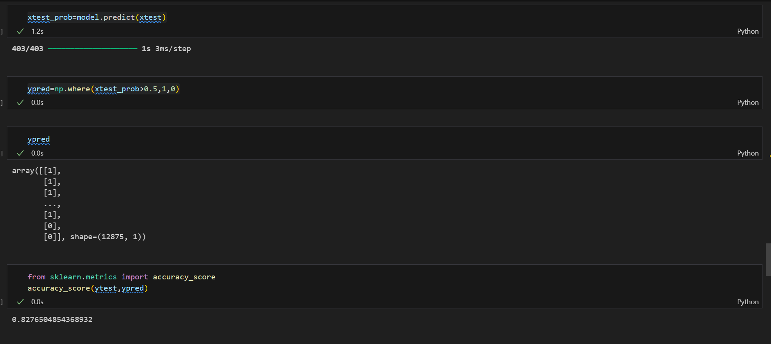

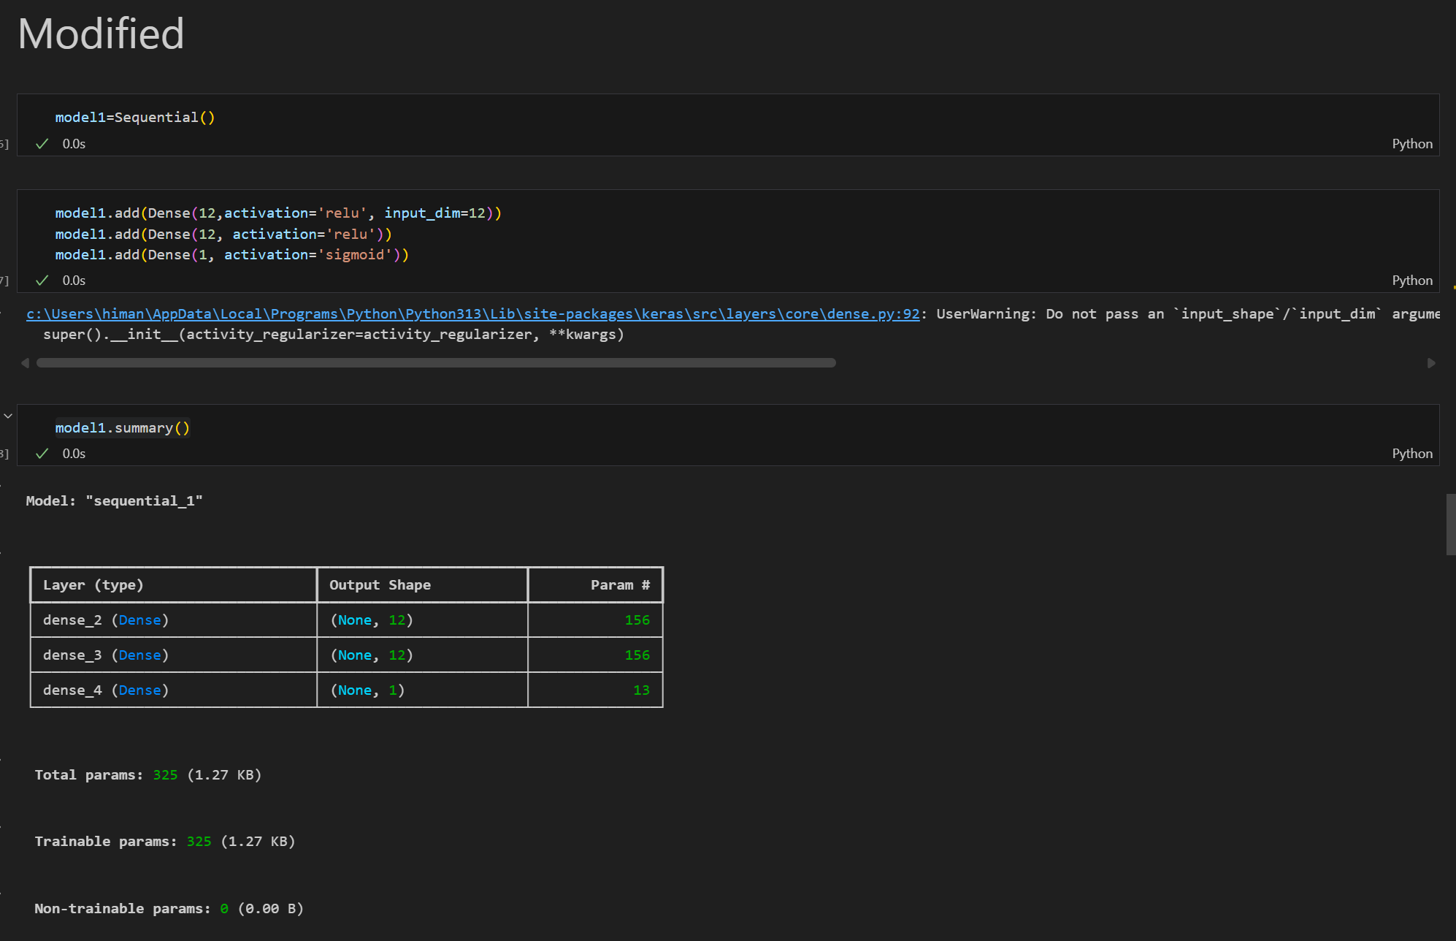

Model Accuracy with 20 Epoch:
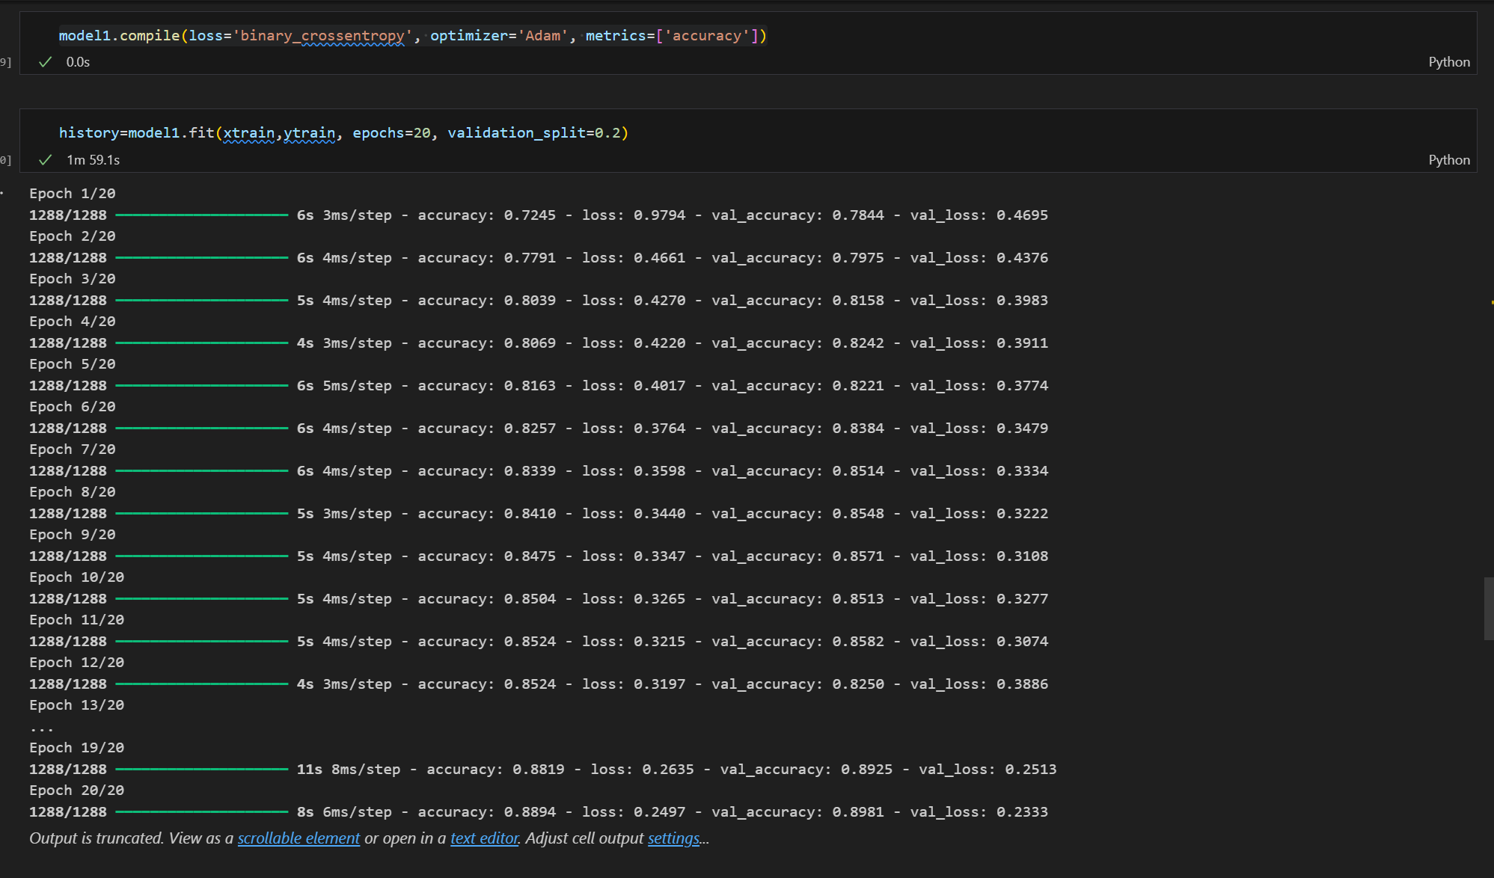

History:
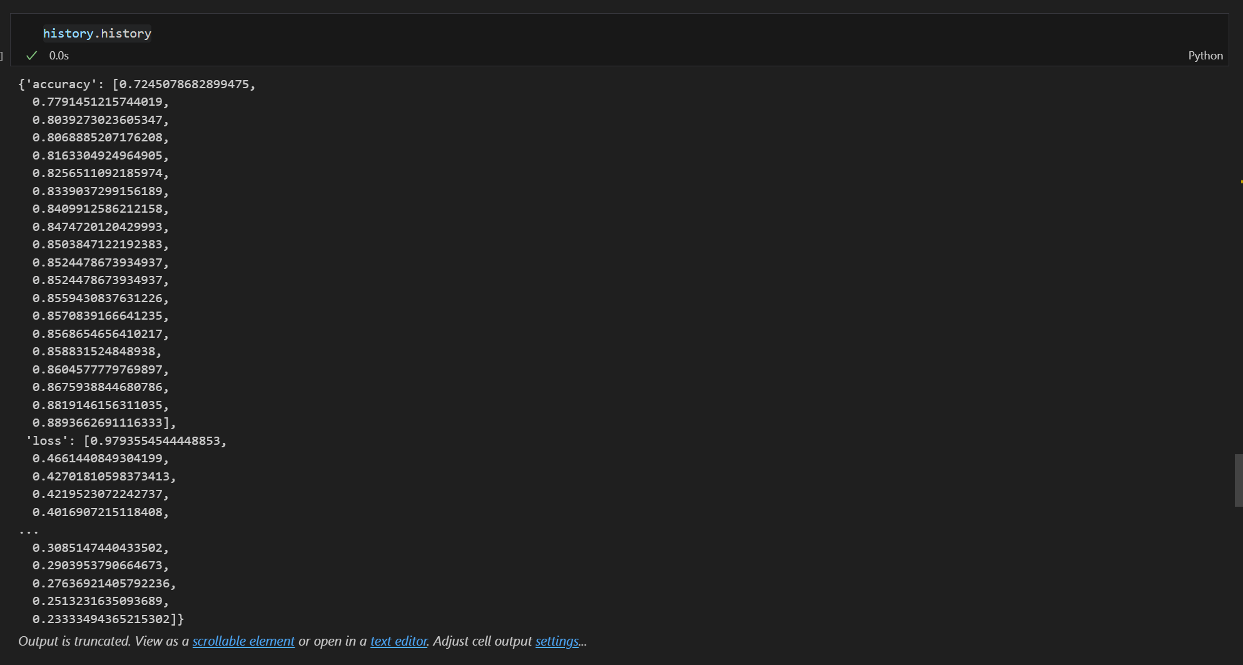

Model Layers:
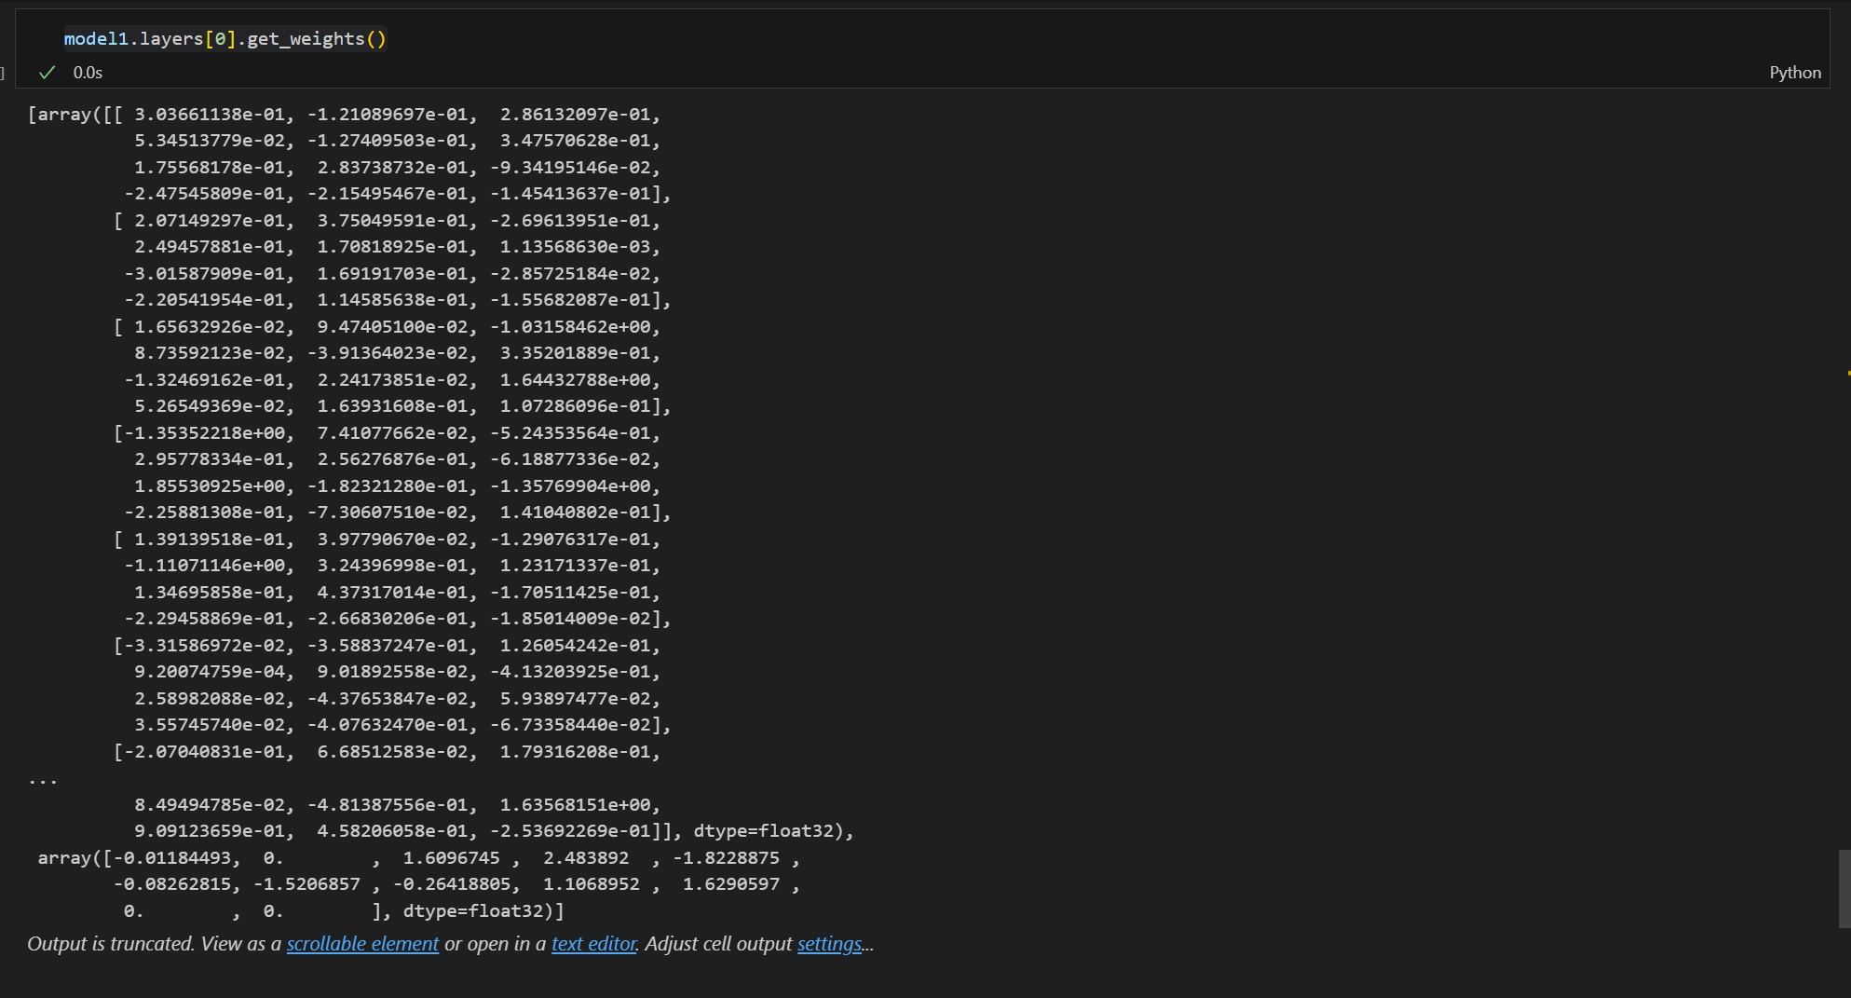

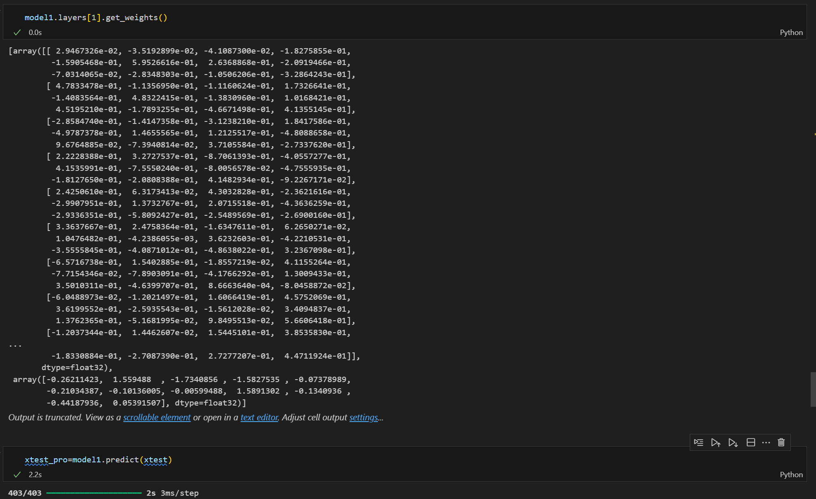

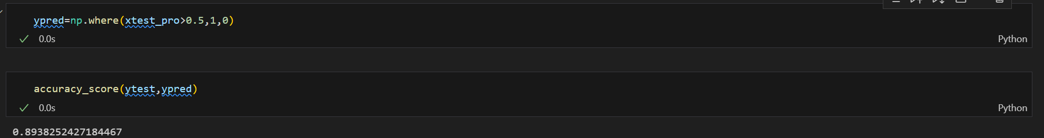

Importing Matplotlib for Graphical Presentation of Accuracies:
import matplotlib.pyplot as plt

plt.plot(history.history['accuracy'])
plt.plot(history.history['val_accuracy'])

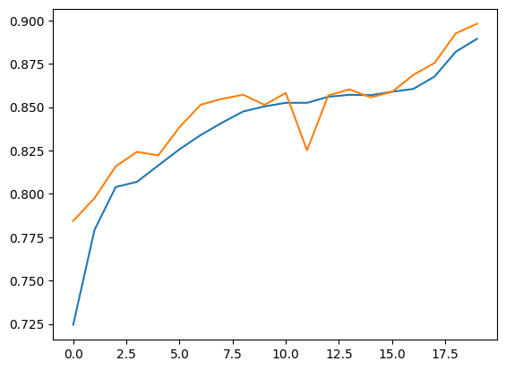

Loss Graph:

plt.plot(history.history['loss'])
plt.plot(history.history['val_loss'])

