
NLDL Programming
MCA-575
Assignment – 03
BY
HIMANSHU HEDA (24225013)
SUBMITTED TO
Dr. Manjula Shannhog
SCHOOL OF SCIENCES
2025-26

1) Applications of Neural Networks
Neural Networks are a powerful tool in artificial intelligence, inspired by the structure and function of the human brain. They excel at recognizing patterns and making predictions, leading to a wide array of applications across various industries. Here are some key areas where neural networks are applied:
- Image Recognition and Computer Vision:
  - Object Detection: Identifying and localizing objects within an image or video (e.g., self-driving cars recognizing pedestrians, traffic signs).
  - Facial Recognition: Identifying individuals from images or videos, used in security, authentication, and social media.
  - Image Classification: Categorizing images into predefined classes (e.g., identifying different animal species, medical image analysis for disease detection).
  - Image Generation and Style Transfer: Creating new images, modifying existing ones, or transferring artistic styles (e.g., DeepFakes, artistic filters).
  - Medical Imaging: Assisting in diagnosing diseases by analyzing X-rays, MRIs, and CT scans.
Here's an example of an image classification network:
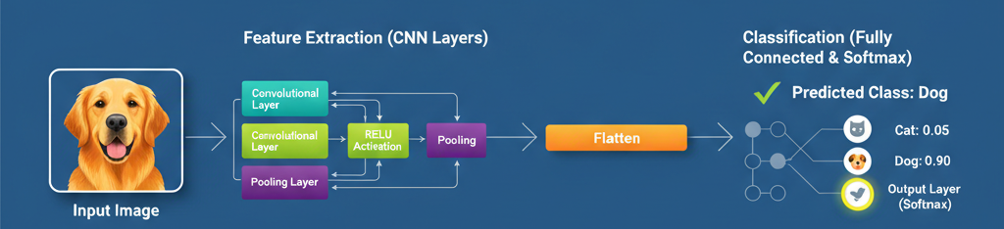

• Natural Language Processing (NLP):
- Machine Translation: Translating text or speech from one language to another (e.g., Google Translate).
- Sentiment Analysis: Determining the emotional tone or sentiment expressed in a piece of text (e.g., customer reviews, social media monitoring).
- Text Summarization: Generating concise summaries of longer documents.
- Chatbots and Virtual Assistants: Powering conversational AI systems that can understand and respond to human language (e.g., Siri, Alexa, customer service bots).
- Speech Recognition: Converting spoken language into text (e.g., voice-to-text features).
• Speech Recognition and Audio Processing:
- Voice Assistants: Enabling devices to understand and respond to voice commands.
- Speaker Identification: Recognizing who is speaking.
- Noise Reduction: Filtering out unwanted noise from audio signals.
• Forecasting and Prediction:
- Financial Market Prediction: Predicting stock prices, market trends, and currency exchange rates.
- Weather Forecasting: Improving the accuracy of weather predictions.
- Demand Forecasting: Predicting future product demand for inventory management and supply chain optimization.
- Medical Prognosis: Predicting disease progression or treatment outcomes.
• Recommendation Systems:
- E-commerce: Suggesting products to customers based on their past behavior and preferences (e.g., Amazon, Netflix).
- Content Platforms: Recommending movies, music, or articles to users.
• Robotics and Control Systems:
- Robot Navigation: Guiding robots through complex environments.
- Industrial Automation: Optimizing manufacturing processes and quality control.
- Self-driving Cars: Enabling autonomous vehicles to perceive their surroundings, make decisions, and navigate.
• Healthcare and Medicine:
- Drug Discovery: Accelerating the process of identifying potential drug candidates.
- Disease Diagnosis: Assisting doctors in diagnosing diseases earlier and more accurately.
- Personalized Medicine: Tailoring treatments to individual patients based on their genetic makeup and medical history.
• Fraud Detection:
- Identifying unusual patterns in financial transactions to detect credit card fraud, insurance fraud, and other illicit activities.
• Gaming:
- Developing more intelligent and adaptive AI opponents in video games.
- Generating game content and assets.

2) Exploring Loss Functions, Activation Functions, and Optimization Functions
These three components are fundamental to the training and performance of neural networks.

A) Loss Functions (Cost Functions / Objective Functions)
A loss function quantifies the difference between the predicted output of a neural network and the actual target value. The goal during training is to minimize this loss.
Features:
- Measures Error: Provides a numerical measure of how well the model is performing.
- Differentiable: Most loss functions need to be differentiable to allow for gradient-based optimization (backpropagation).
- Guides Optimization: The gradient of the loss function with respect to the model's parameters indicates the direction for parameter updates to reduce the error.
Common Loss Functions:
- Mean Squared Error (MSE) / L2 Loss:
  - Formula: MSE=N1​∑i=1N​(yi​−y^​i​)2
    - yi​: actual value
    - y^​i​: predicted value
    - N: number of samples
  - Features:
    - Commonly used in regression problems.
    - Penalizes larger errors more heavily due to the squaring.
    - Produces a convex error surface, which is good for optimization.
    - Sensitive to outliers.
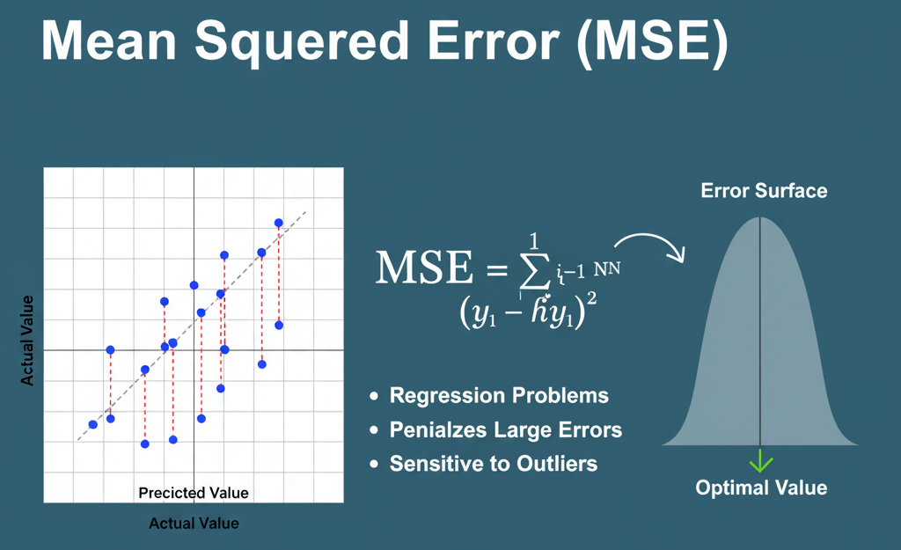

- Mean Absolute Error (MAE) / L1 Loss:
- Formula: MAE=N1​∑i=1N​∣yi​−y^​i​∣
- Features:
  - Also used in regression problems.
  - Less sensitive to outliers than MSE because it does not square the errors.
  - The gradient is constant, which can lead to larger updates even for small errors and might not converge as smoothly as MSE.
  - Can be harder to compute gradients at 0.
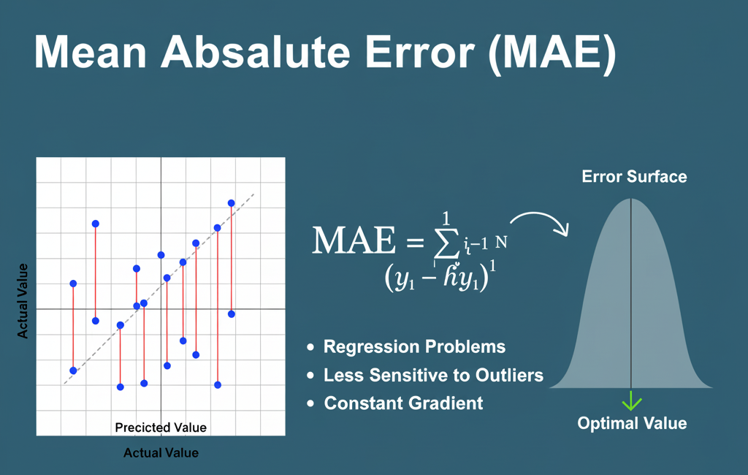

- Rectified Linear Unit (ReLU) Function:
- Formula: ReLU(x)=max(0,x)
- Features:
  - Outputs the input directly if it's positive, otherwise outputs zero.
  - Most widely used activation function for hidden layers in deep learning.
  - Solves Vanishing Gradient Problem: For positive inputs, the gradient is always 1, preventing vanishing gradients.
  - Computational Efficiency: Very fast to compute (simple comparison and assignment).
  - Dying ReLU Problem: If an input to a ReLU neuron is always negative, the neuron will output 0 and its gradient will always be 0, effectively "killing" the neuron as it stops learning.
