
NLDL Programming
MCA-575
Assignment – 04
BY
HIMANSHU HEDA (24225013)
SUBMITTED TO
Dr. Manjula Shannhog
SCHOOL OF SCIENCES
2025-26
Importing Libraries:
import numpy as np
import pandas as pd

Import Dataset:
df = pd.read_csv('./Dataset/customer.csv')

Shape:
df.shape

Head:
df.head()

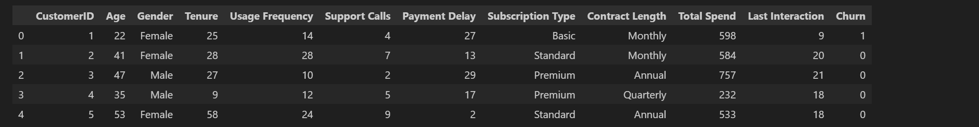

df.info()

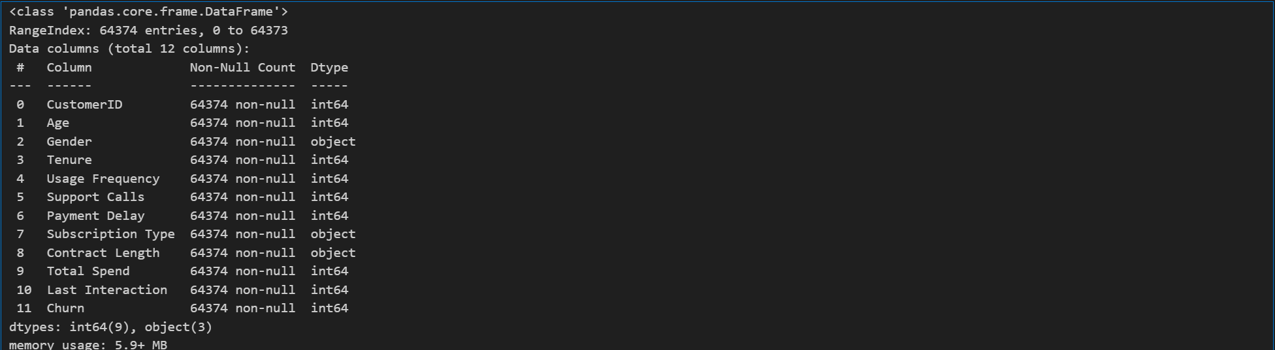

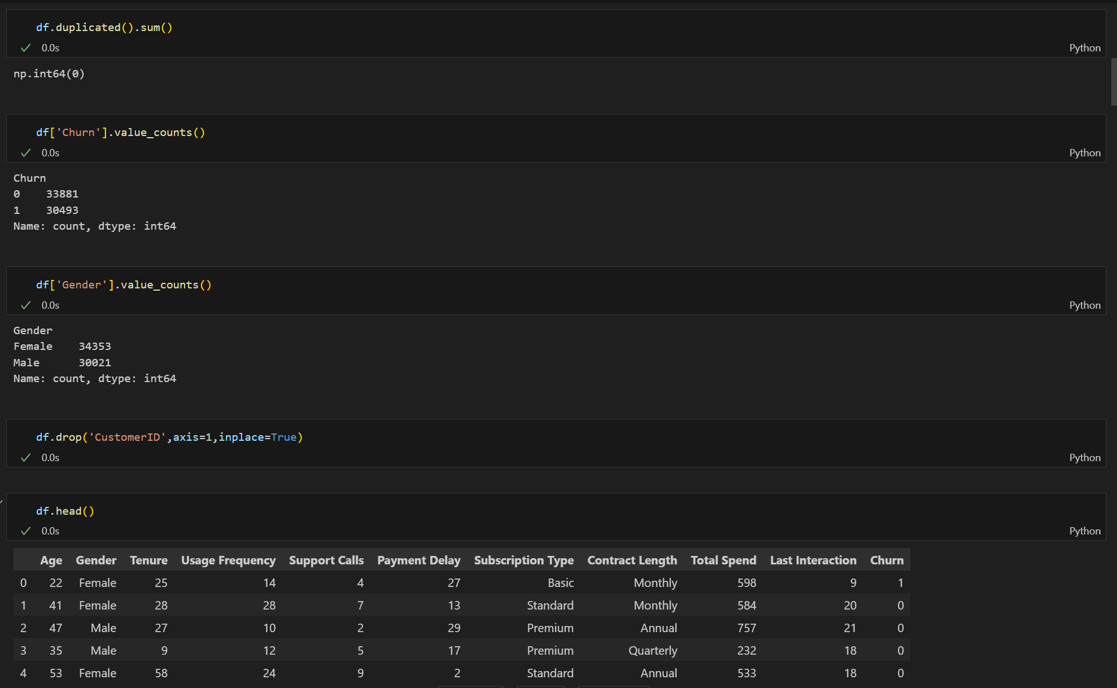

Unique:

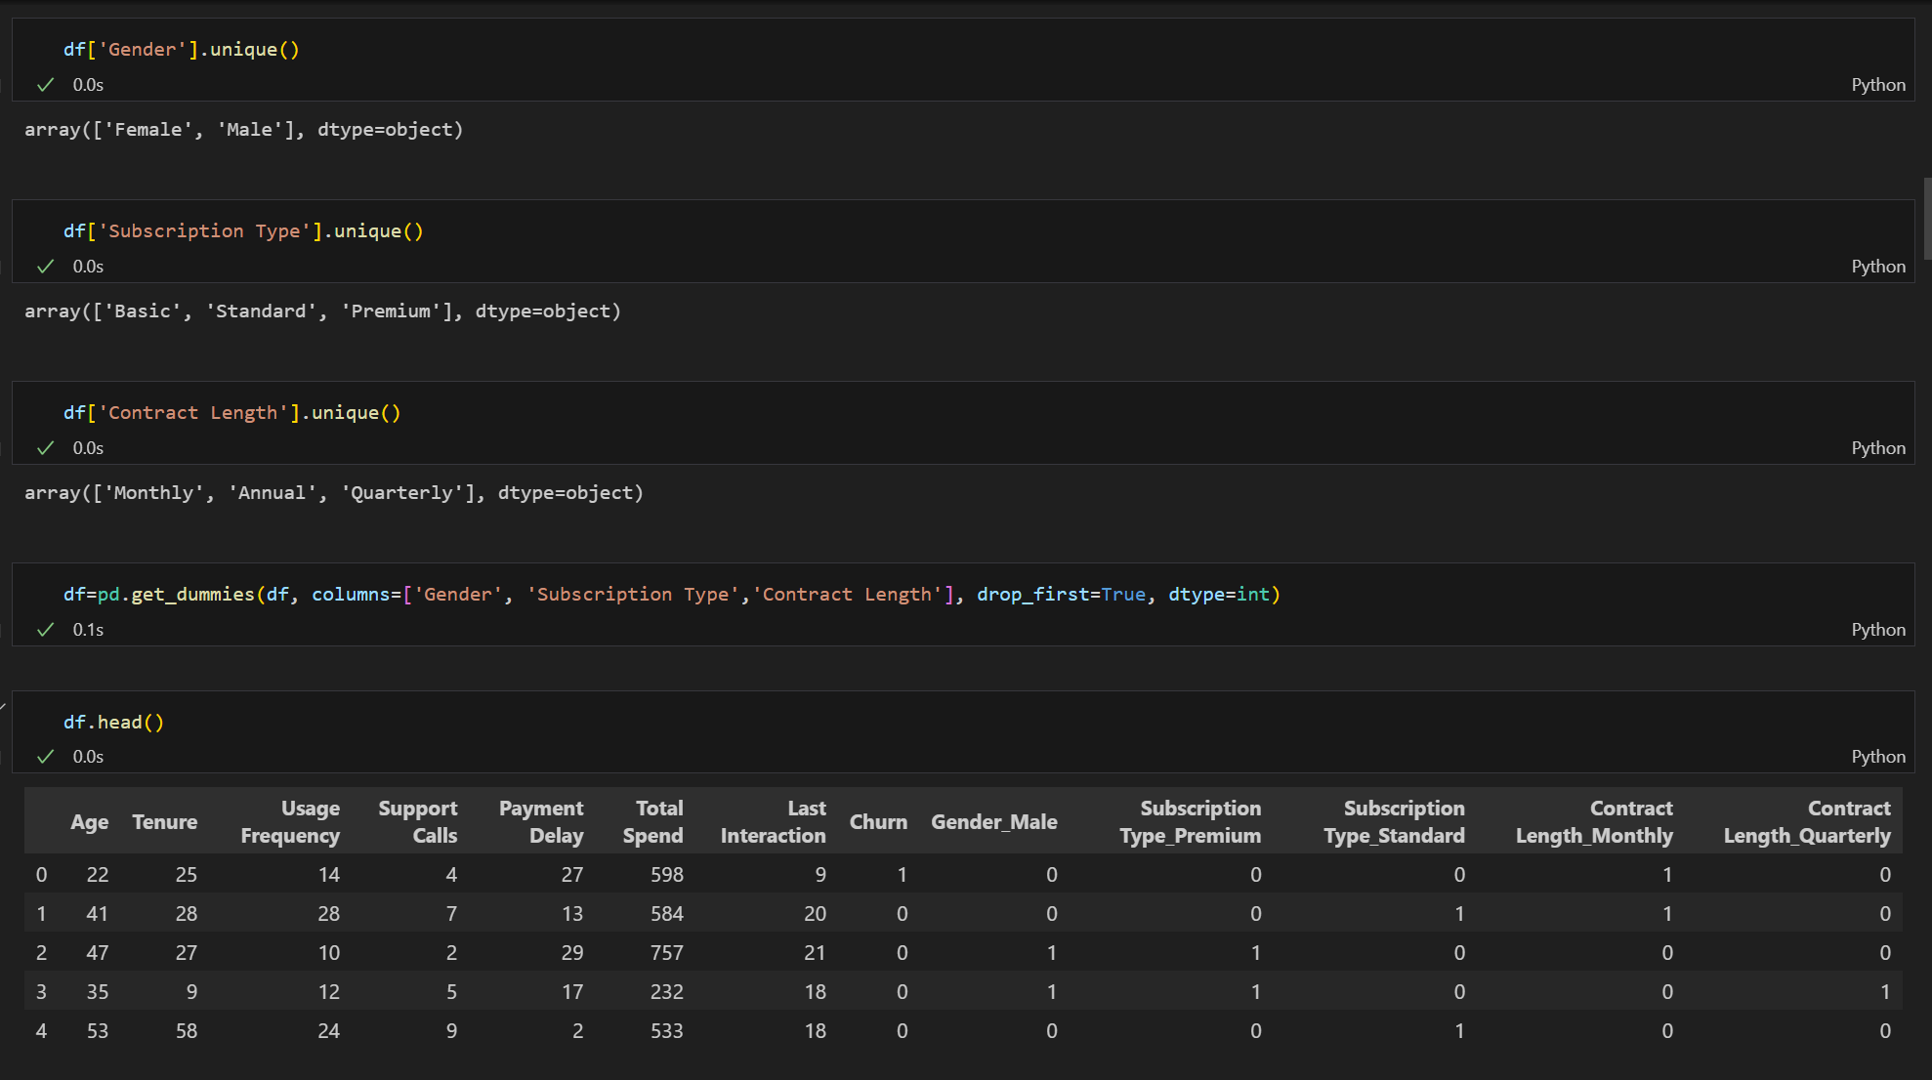

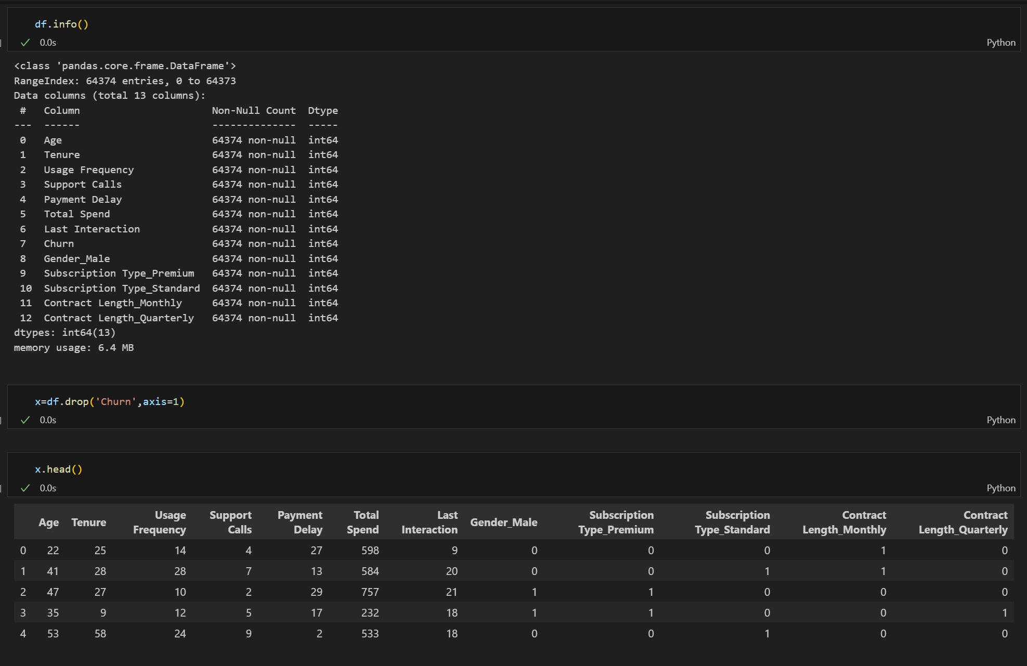

Importing TensorFlow for using keras , Sequential and Dense
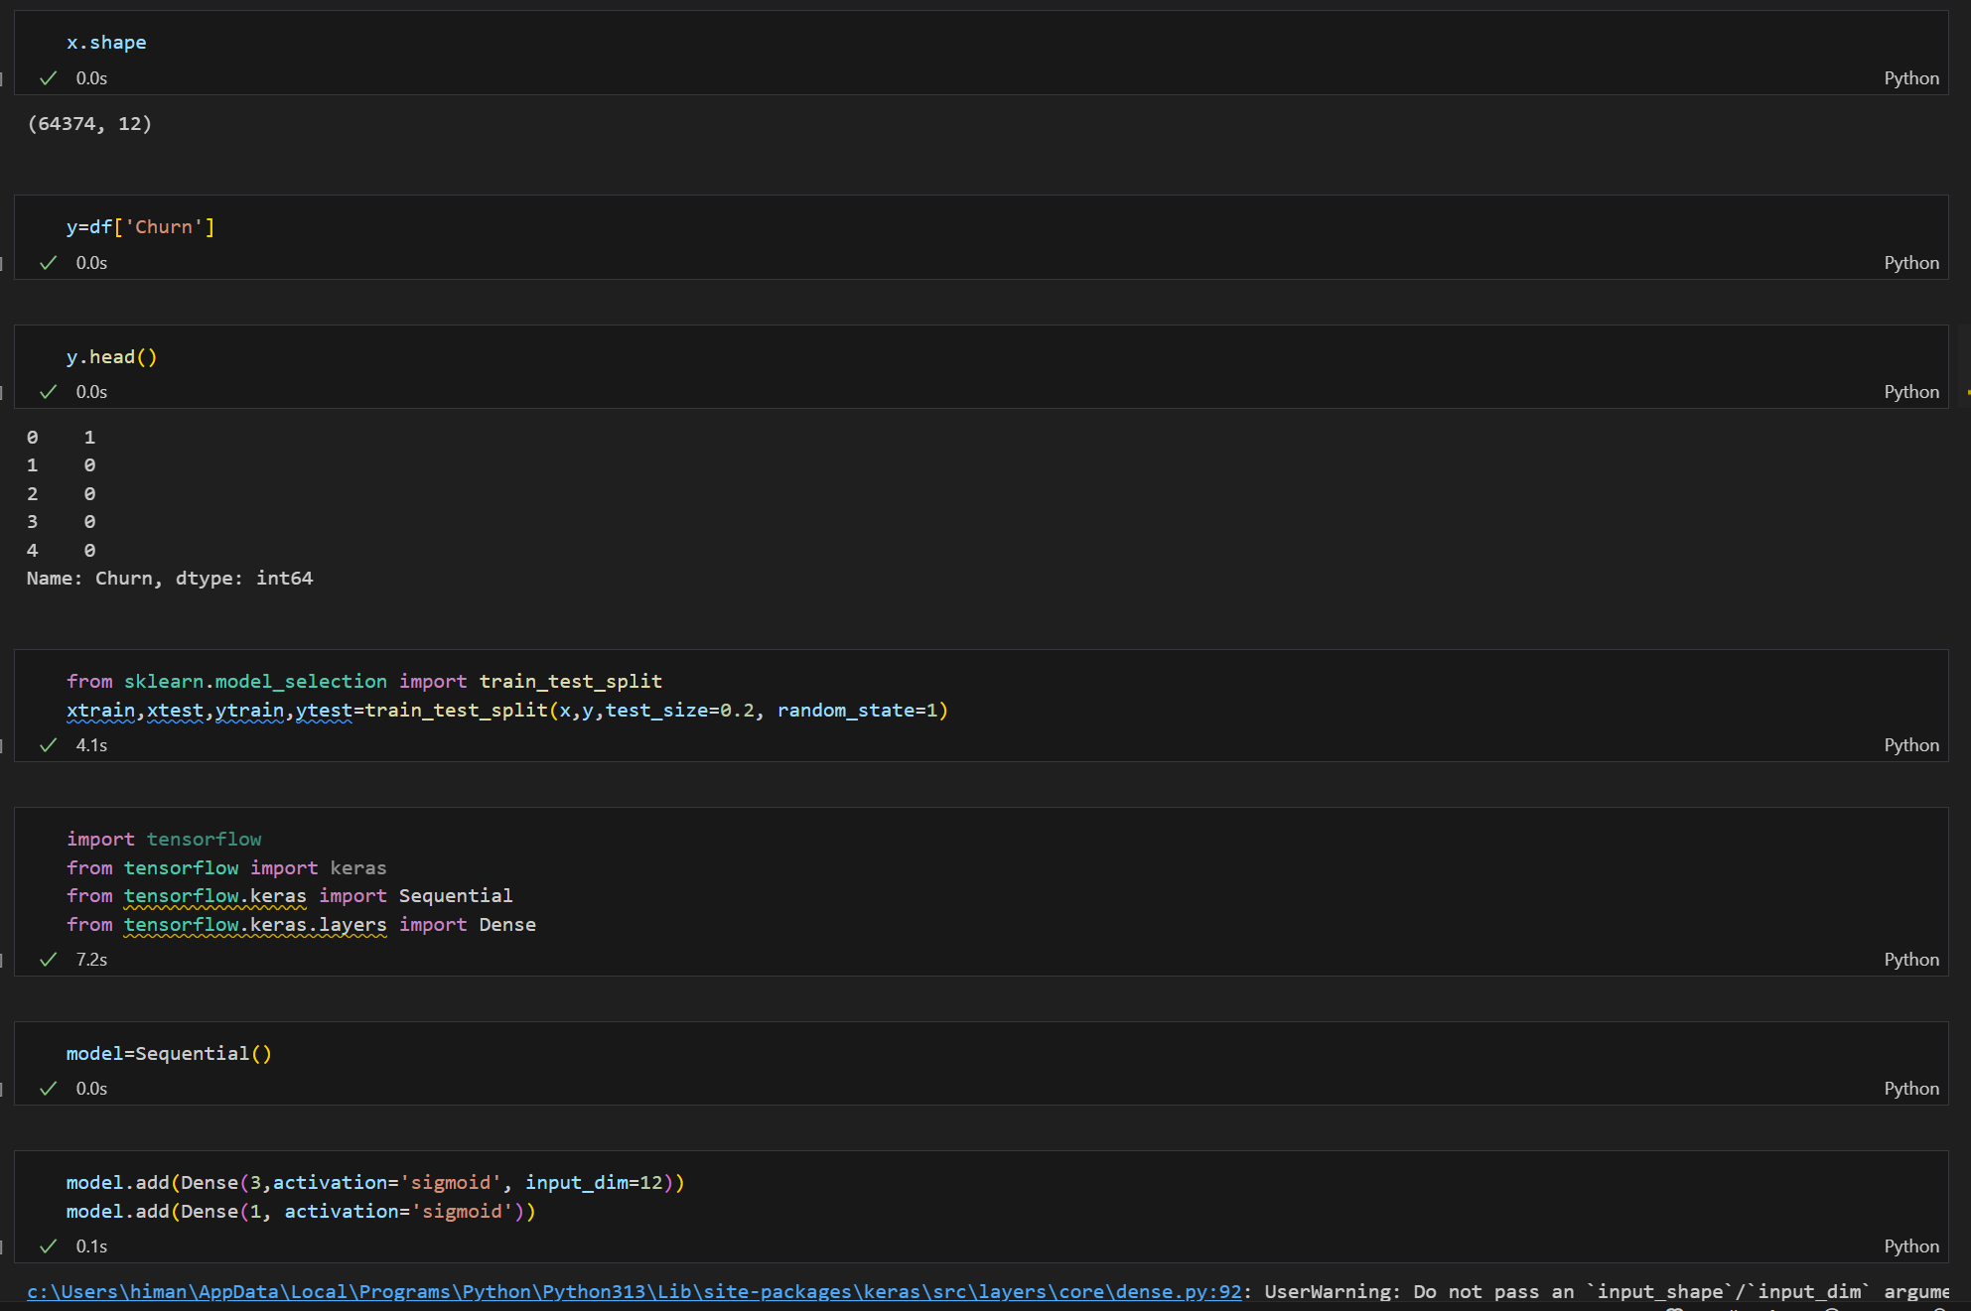

Model Summary & Using Sequential:
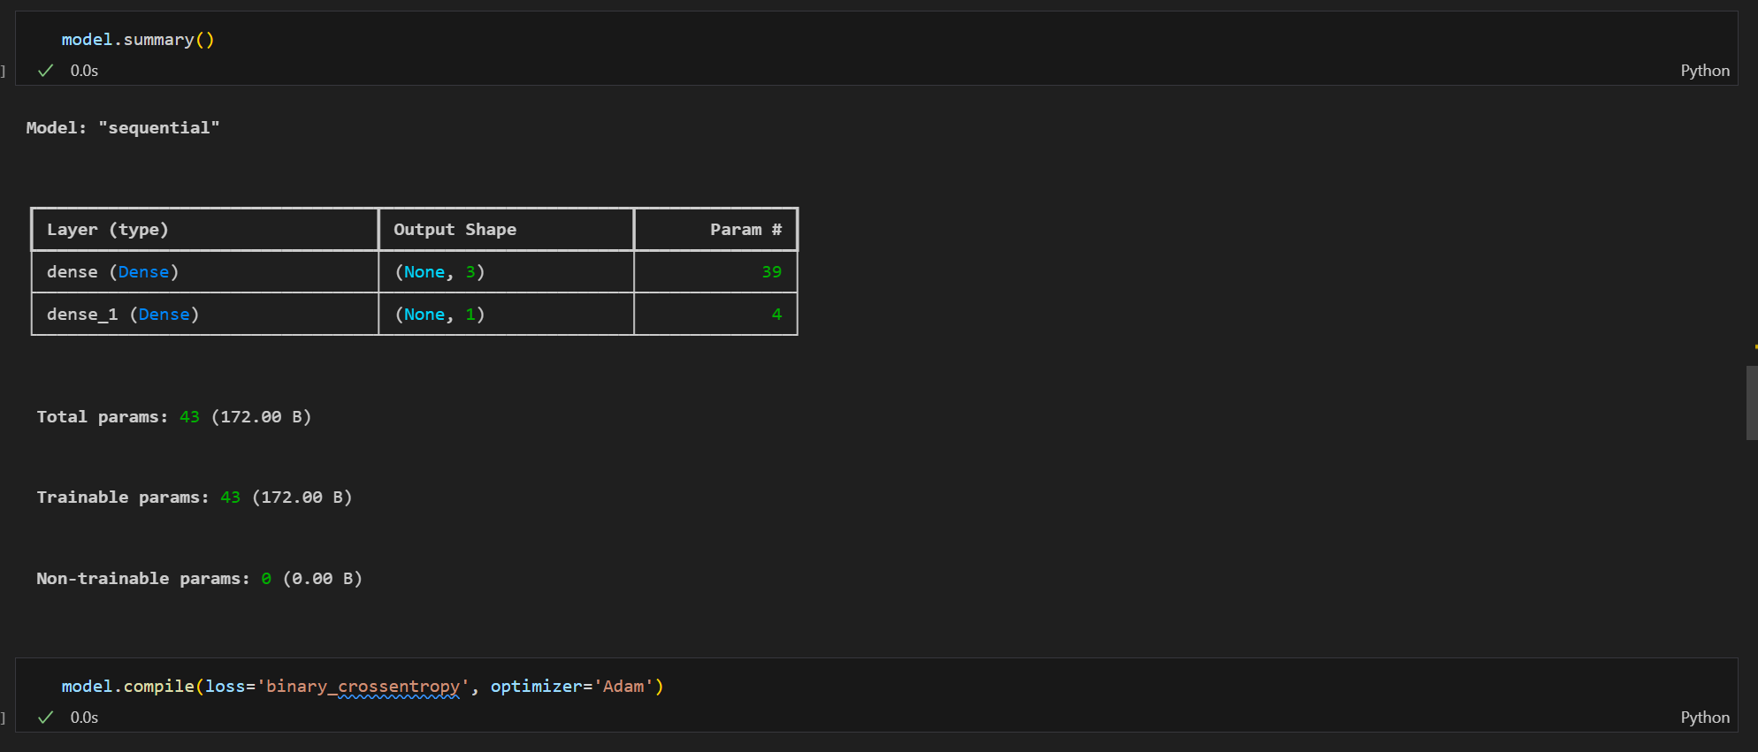

Model with 20 Epoch:

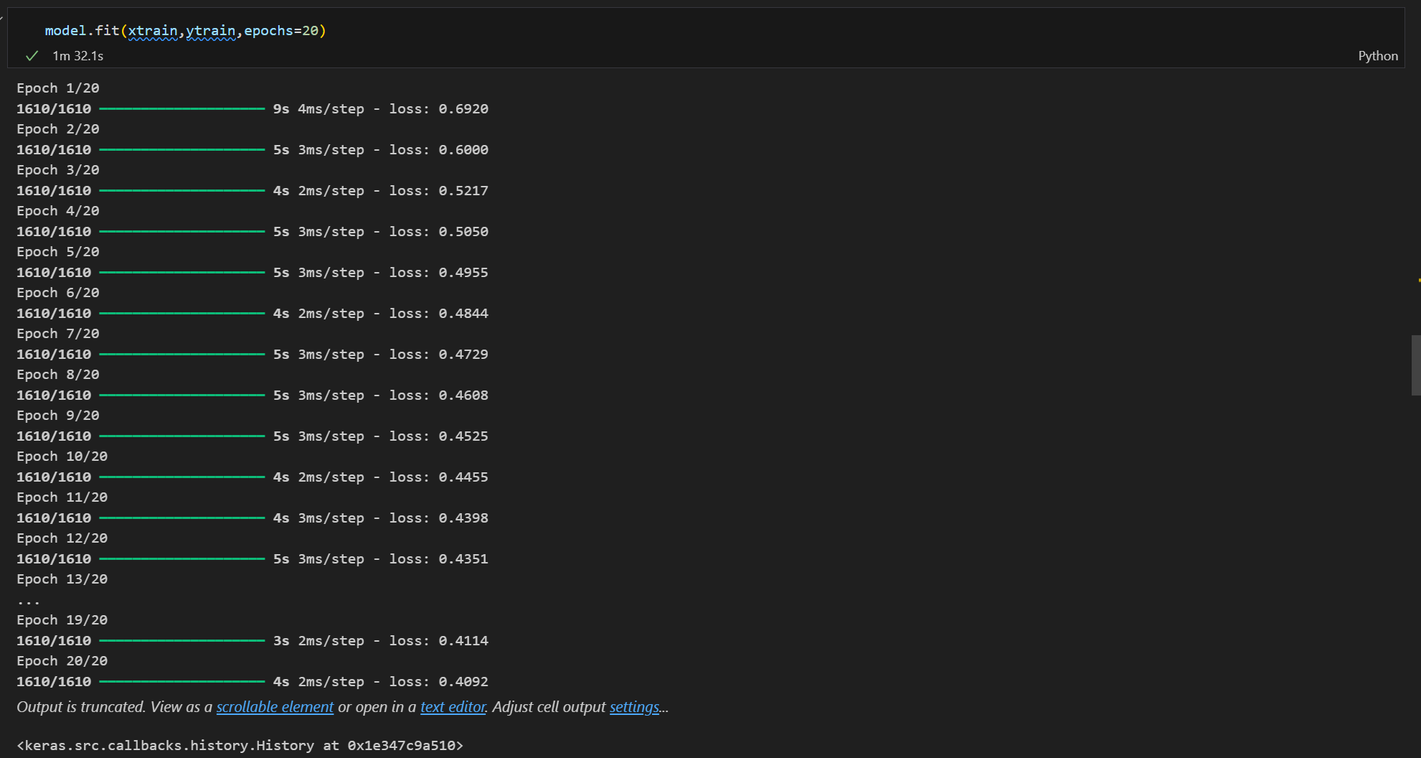

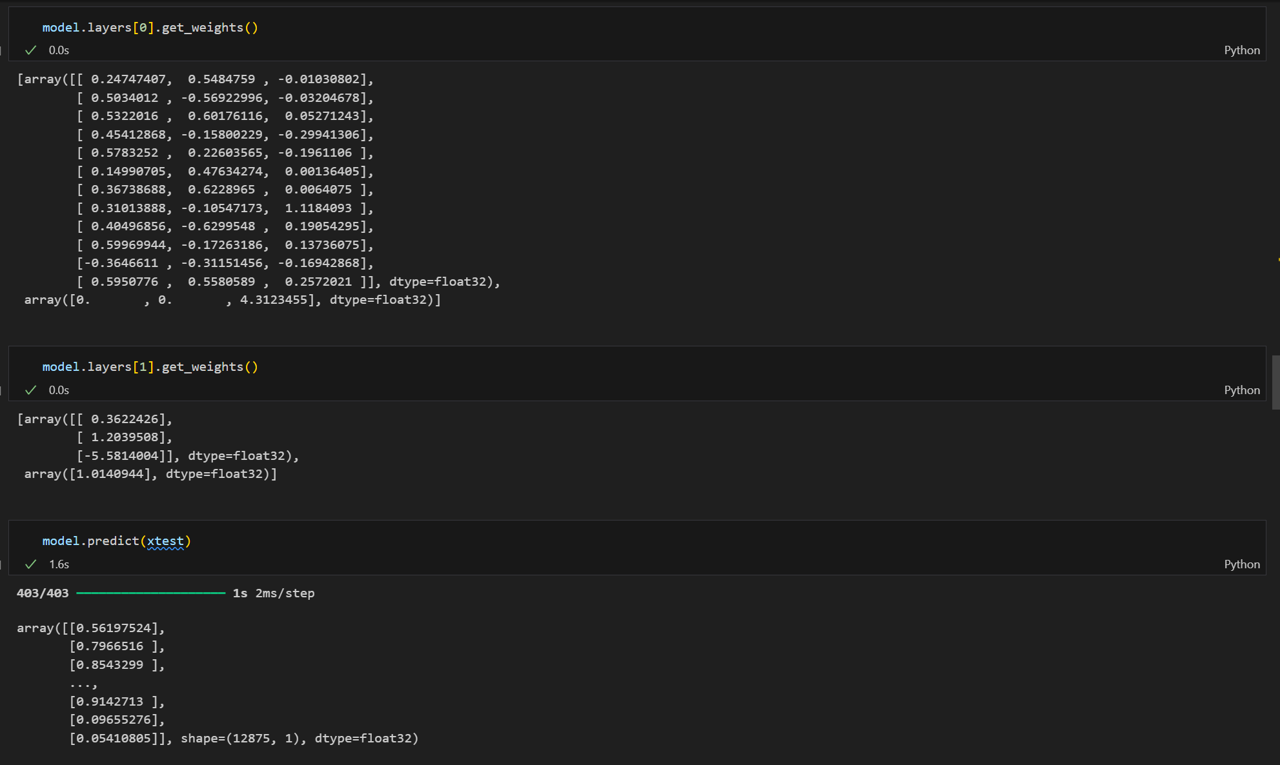

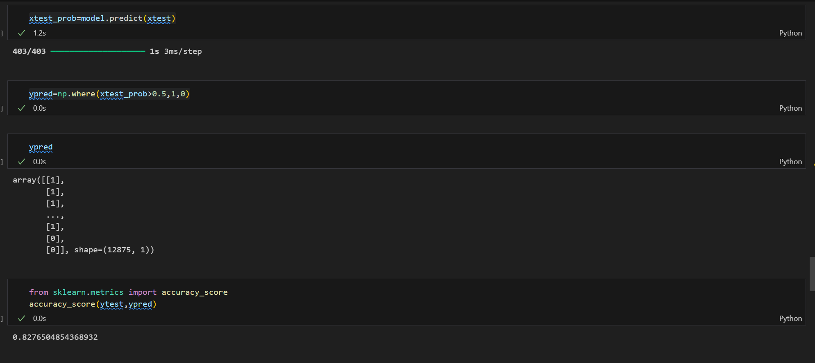

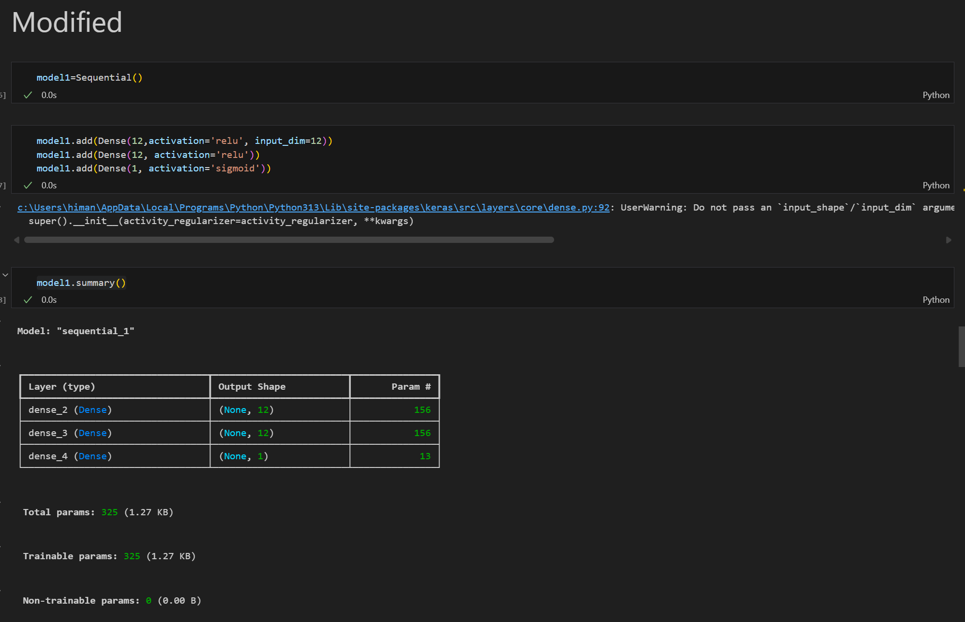

Model Accuracy with 20 Epoch:
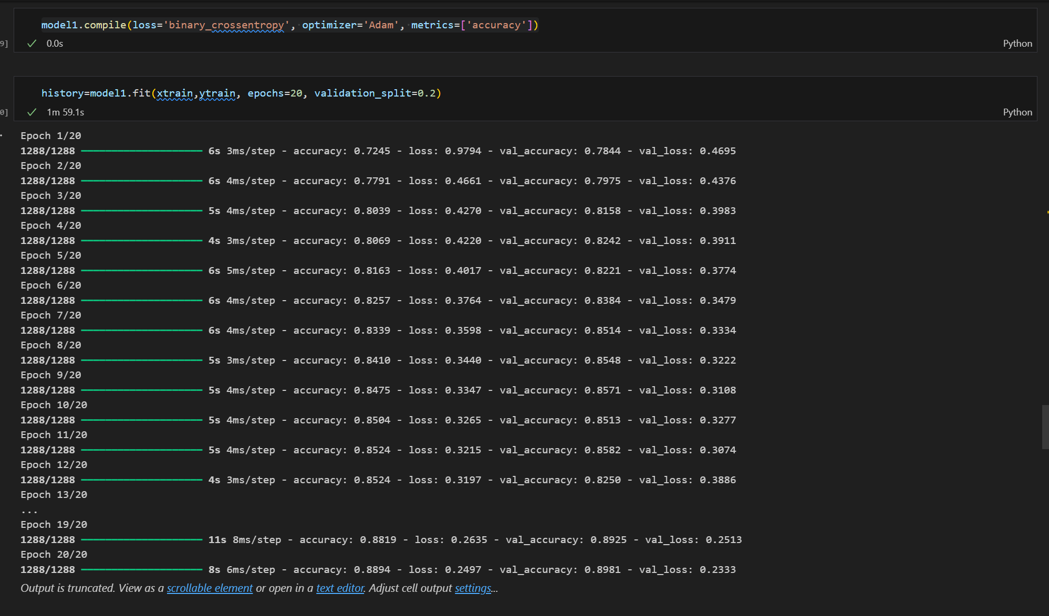

History:
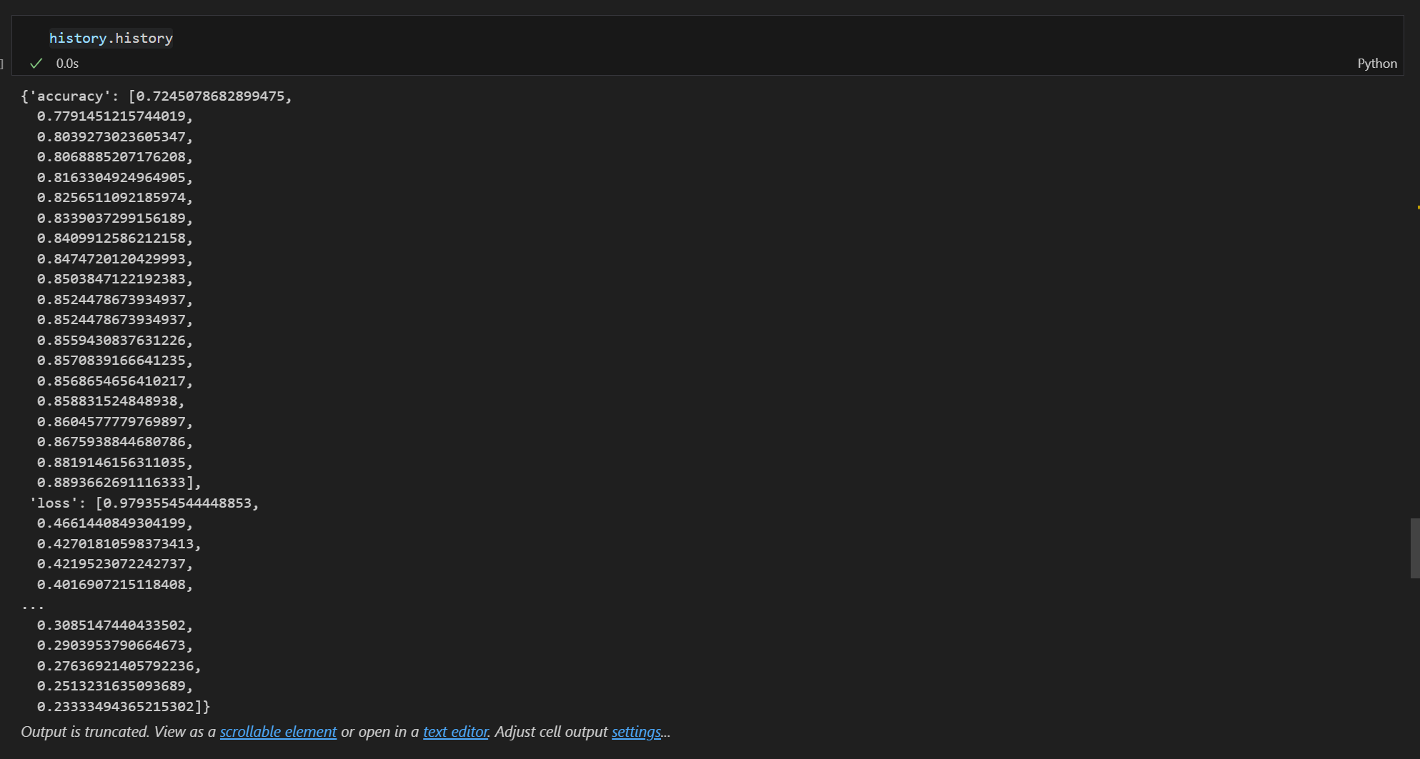

Model Layers:
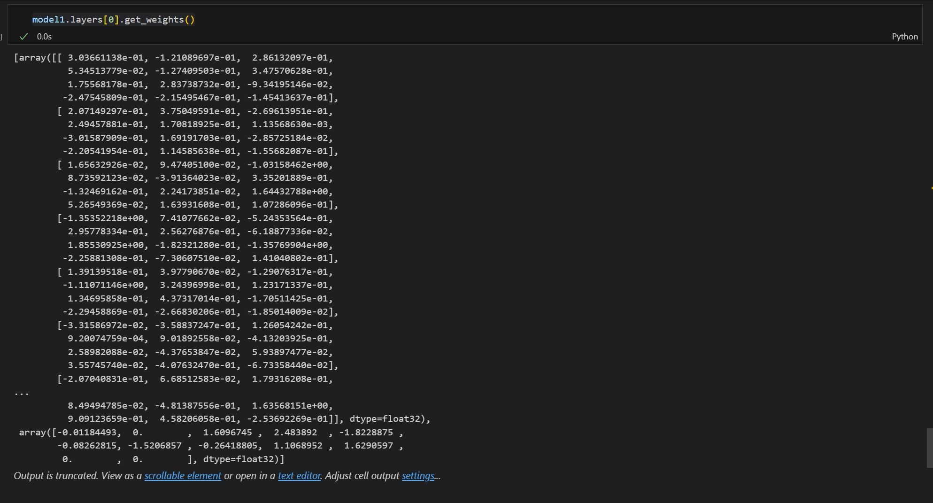

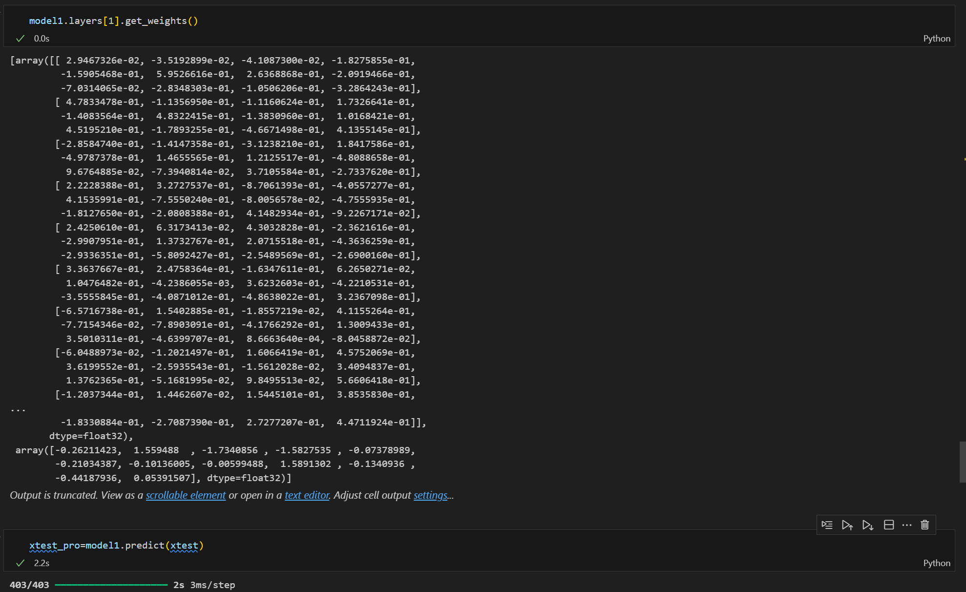

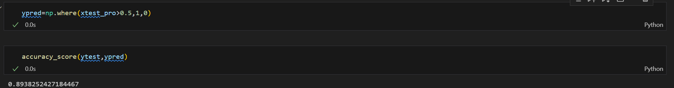

Importing Matplotlib for Graphical Presentation of Accuracies:
import matplotlib.pyplot as plt

plt.plot(history.history['accuracy'])
plt.plot(history.history['val_accuracy'])

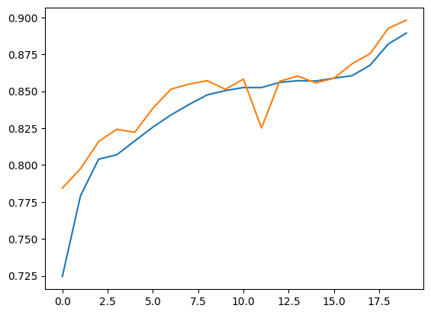

Loss Graph:

plt.plot(history.history['loss'])
plt.plot(history.history['val_loss'])

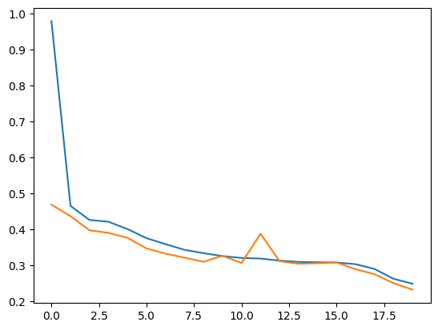

# Model 2: ReLU activation, binary_crossentropy loss
model2 = Sequential()
model2.add(Dense(12, activation='relu', input_dim=12))
model2.add(Dense(12, activation='relu'))
model2.add(Dense(1, activation='sigmoid'))
model2.summary()
model2.compile(loss='binary_crossentropy', optimizer='Adam', metrics=['accuracy'])
history2 = model2.fit(xtrain, ytrain, epochs=20, validation_split=0.2)

# Model 3: Tanh activation, mean_squared_error loss
model3 = Sequential()
model3.add(Dense(12, activation='tanh', input_dim=12))
model3.add(Dense(12, activation='tanh'))
model3.add(Dense(1, activation='sigmoid'))
model3.summary()
model3.compile(loss='mean_squared_error', optimizer='Adam', metrics=['accuracy'])
history3 = model3.fit(xtrain, ytrain, epochs=20, validation_split=0.2)

# Model 4: Softmax activation, categorical_crossentropy loss
from tensorflow.keras.utils import to_categorical
ytrain_cat = to_categorical(ytrain)
ytest_cat = to_categorical(ytest)
model4 = Sequential()
model4.add(Dense(12, activation='relu', input_dim=12))
model4.add(Dense(12, activation='relu'))
model4.add(Dense(2, activation='softmax'))
model4.summary()
model4.compile(loss='categorical_crossentropy', optimizer='Adam', metrics=['accuracy'])
history4 = model4.fit(xtrain, ytrain_cat, epochs=20, validation_split=0.2)

# Model 5: ELU activation, hinge loss
model5 = Sequential()
model5.add(Dense(12, activation='elu', input_dim=12))
model5.add(Dense(12, activation='elu'))
model5.add(Dense(1, activation='sigmoid'))
model5.summary()
model5.compile(loss='hinge', optimizer='Adam', metrics=['accuracy'])
history5 = model5.fit(xtrain, ytrain, epochs=20, validation_split=0.2)

