

Applied Statistics Using R

(MCA232)

# Practical 2

***BY***

**Himanshu Heda (24225013)**

**SUBMITTED TO**

**Dr. Ashish Sharma**



**Data Set : --**

> # Load Dataset

> data <- read.csv("HUBC_stock_data.csv")

> data

X open high low close adjclose volume ticker

1 03-01-2022 98.40 98.40 98.40 98.40 98.40 1000 HUBC

2 04-01-2022 98.40 98.40 98.40 98.40 98.40 0 HUBC

3 05-01-2022 98.80 99.00 98.70 98.90 98.90 90090 HUBC

4 06-01-2022 99.10 99.10 98.90 99.00 99.00 38390 HUBC

5 07-01-2022 99.00 99.30 98.80 99.20 99.20 54640 HUBC

6 10-01-2022 99.10 99.20 99.00 99.00 99.00 11510 HUBC

7 11-01-2022 99.00 99.20 99.00 99.00 99.00 4920 HUBC

8 12-01-2022 99.00 99.20 99.00 99.20 99.20 110 HUBC

9 13-01-2022 99.20 99.20 99.20 99.20 99.20 60 HUBC

10 14-01-2022 99.10 99.30 99.10 99.20 99.20 5700 HUBC

11 18-01-2022 99.20 99.20 99.20 99.20 99.20 0 HUBC

12 19-01-2022 99.20 99.50 99.20 99.50 99.50 48350 HUBC

13 20-01-2022 99.30 99.30 99.30 99.30 99.30 80 HUBC

14 21-01-2022 99.10 99.15 98.90 98.90 98.90 610 HUBC

15 24-01-2022 99.00 99.10 99.00 99.00 99.00 390 HUBC

16 25-01-2022 99.00 99.00 99.00 99.00 99.00 0 HUBC

17 26-01-2022 99.00 99.00 99.00 99.00 99.00 0 HUBC

18 27-01-2022 99.00 99.10 98.60 98.60 98.60 8800 HUBC

19 28-01-2022 99.00 99.20 99.00 99.20 99.20 680 HUBC

20 31-01-2022 99.20 99.20 99.20 99.20 99.20 0 HUBC

21 01-02-2022 99.20 99.20 99.20 99.20 99.20 0 HUBC

22 02-02-2022 99.00 99.00 99.00 99.00 99.00 3200 HUBC

23 03-02-2022 99.00 99.00 99.00 99.00 99.00 0 HUBC

24 04-02-2022 99.10 99.10 99.10 99.10 99.10 4350 HUBC

25 07-02-2022 99.10 99.10 99.10 99.10 99.10 0 HUBC

26 08-02-2022 99.10 99.10 99.10 99.10 99.10 0 HUBC

27 09-02-2022 99.30 99.40 99.30 99.35 99.35 12130 HUBC

28 10-02-2022 99.30 99.50 99.30 99.50 99.50 17560 HUBC

29 11-02-2022 99.50 99.50 99.50 99.50 99.50 0 HUBC

30 14-02-2022 99.50 99.50 99.50 99.50 99.50 0 HUBC

31 15-02-2022 99.50 99.50 99.50 99.50 99.50 0 HUBC

32 16-02-2022 99.40 99.40 99.40 99.40 99.40 24060 HUBC

33 17-02-2022 99.40 99.40 99.30 99.40 99.40 30080 HUBC

34 18-02-2022 99.40 99.40 99.40 99.40 99.40 0 HUBC

35 22-02-2022 99.50 99.50 99.50 99.50 99.50 1050 HUBC

36 23-02-2022 99.50 99.50 99.50 99.50 99.50 0 HUBC

37 24-02-2022 99.50 99.50 99.50 99.50 99.50 0 HUBC

38 25-02-2022 99.50 99.50 99.50 99.50 99.50 0 HUBC

39 28-02-2022 99.60 99.60 99.60 99.60 99.60 90 HUBC

40 01-03-2022 99.60 99.80 99.60 99.80 99.80 23110 HUBC

41 02-03-2022 99.80 99.80 99.80 99.80 99.80 20 HUBC

42 03-03-2022 99.80 99.80 99.80 99.80 99.80 50 HUBC

43 04-03-2022 99.80 99.80 99.80 99.80 99.80 0 HUBC

44 07-03-2022 99.80 99.80 99.80 99.80 99.80 0 HUBC

45 08-03-2022 99.80 99.80 99.80 99.80 99.80 1760 HUBC

46 09-03-2022 99.80 99.80 99.80 99.80 99.80 0 HUBC

47 10-03-2022 99.80 99.80 99.80 99.80 99.80 0 HUBC

48 11-03-2022 99.50 99.80 99.50 99.80 99.80 7670 HUBC

49 14-03-2022 99.90 100.00 99.80 100.00 100.00 9260 HUBC

50 15-03-2022 100.00 100.00 100.00 100.00 100.00 450 HUBC

51 16-03-2022 100.00 100.00 100.00 100.00 100.00 0 HUBC

52 17-03-2022 100.00 100.00 100.00 100.00 100.00 80 HUBC

53 18-03-2022 100.00 100.10 100.00 100.10 100.10 50 HUBC

54 21-03-2022 100.10 100.10 100.10 100.10 100.10 0 HUBC

55 22-03-2022 100.10 100.10 100.10 100.10 100.10 0 HUBC

56 23-03-2022 100.70 100.70 100.00 100.30 100.30 117280 HUBC

57 24-03-2022 100.50 100.50 99.70 100.00 100.00 64730 HUBC

58 25-03-2022 99.89 100.10 99.70 99.80 99.80 2910 HUBC

59 28-03-2022 99.80 100.00 99.70 99.70 99.70 10680 HUBC

60 29-03-2022 99.86 100.40 99.70 99.90 99.90 29020 HUBC

61 30-03-2022 99.70 99.80 99.70 99.70 99.70 660 HUBC

62 31-03-2022 99.80 100.02 99.80 99.80 99.80 470 HUBC

63 01-04-2022 99.80 100.25 99.70 100.25 100.25 3870 HUBC

64 04-04-2022 100.02 100.10 99.95 100.10 100.10 600 HUBC

65 05-04-2022 100.10 100.15 100.05 100.10 100.10 1470 HUBC

66 06-04-2022 100.20 100.20 99.90 99.90 99.90 8130 HUBC

67 07-04-2022 99.91 100.22 99.91 100.18 100.18 60 HUBC

68 08-04-2022 99.90 99.90 99.90 99.90 99.90 180 HUBC

69 11-04-2022 99.90 99.90 99.90 99.90 99.90 0 HUBC

70 12-04-2022 99.90 99.90 99.90 99.90 99.90 130 HUBC

71 13-04-2022 100.00 100.00 100.00 100.00 100.00 130 HUBC

72 14-04-2022 100.00 100.15 100.00 100.15 100.15 20 HUBC

73 18-04-2022 100.15 100.15 100.15 100.15 100.15 0 HUBC

74 19-04-2022 100.30 100.30 100.10 100.30 100.30 2280 HUBC

75 20-04-2022 100.49 100.60 100.10 100.10 100.10 1670 HUBC

76 21-04-2022 100.50 100.50 100.50 100.50 100.50 180 HUBC

77 22-04-2022 100.50 100.50 100.50 100.50 100.50 0 HUBC

78 25-04-2022 100.20 100.20 100.10 100.20 100.20 7410 HUBC

79 26-04-2022 100.20 100.20 100.20 100.20 100.20 20 HUBC

80 27-04-2022 100.20 100.20 100.20 100.20 100.20 0 HUBC

81 28-04-2022 100.30 100.30 100.20 100.20 100.20 650 HUBC

82 29-04-2022 100.20 100.20 100.20 100.20 100.20 0 HUBC

83 02-05-2022 100.20 100.30 100.20 100.20 100.20 340 HUBC

84 03-05-2022 100.20 100.20 100.20 100.20 100.20 1350 HUBC

85 04-05-2022 100.62 100.62 100.62 100.62 100.62 20 HUBC

86 05-05-2022 100.20 100.30 100.20 100.30 100.30 1770 HUBC

87 06-05-2022 100.20 100.20 100.20 100.20 100.20 90 HUBC

88 09-05-2022 100.20 100.20 100.20 100.20 100.20 90 HUBC

89 10-05-2022 100.10 100.10 100.10 100.10 100.10 2980 HUBC

90 11-05-2022 100.35 100.35 100.10 100.10 100.10 200 HUBC

91 12-05-2022 100.00 100.30 100.00 100.30 100.30 1020 HUBC

92 13-05-2022 99.90 99.90 99.90 99.90 99.90 40 HUBC

93 16-05-2022 99.90 99.90 99.90 99.90 99.90 0 HUBC

94 17-05-2022 100.49 100.49 100.49 100.49 100.49 30 HUBC

95 18-05-2022 100.60 100.60 100.00 100.00 100.00 70 HUBC

96 19-05-2022 99.90 99.90 99.90 99.90 99.90 60 HUBC

97 20-05-2022 99.90 99.90 99.90 99.90 99.90 0 HUBC

98 23-05-2022 99.90 99.90 99.90 99.90 99.90 60 HUBC

99 24-05-2022 99.90 99.90 99.90 99.90 99.90 60 HUBC

100 25-05-2022 99.90 99.90 99.90 99.90 99.90 0 HUBC

101 26-05-2022 99.90 99.90 99.90 99.90 99.90 30 HUBC

102 27-05-2022 99.90 99.90 99.90 99.90 99.90 0 HUBC

103 31-05-2022 99.90 99.90 99.90 99.90 99.90 20 HUBC

104 01-06-2022 100.00 100.00 100.00 100.00 100.00 30 HUBC

105 02-06-2022 100.10 100.20 99.90 100.20 100.20 6880 HUBC

106 03-06-2022 100.00 100.20 100.00 100.20 100.20 11170 HUBC

107 06-06-2022 100.25 100.25 100.10 100.10 100.10 320 HUBC

108 07-06-2022 100.10 100.28 100.10 100.28 100.28 5140 HUBC

109 08-06-2022 100.30 100.30 100.20 100.20 100.20 130 HUBC

110 09-06-2022 100.20 100.20 100.20 100.20 100.20 0 HUBC

111 10-06-2022 100.20 100.20 100.20 100.20 100.20 40 HUBC

112 13-06-2022 100.40 100.40 100.15 100.20 100.20 5920 HUBC

113 14-06-2022 100.20 100.20 99.90 99.90 99.90 5500 HUBC

114 15-06-2022 99.90 99.90 99.90 99.90 99.90 0 HUBC

115 16-06-2022 100.00 100.30 99.90 99.90 99.90 21110 HUBC

116 17-06-2022 100.05 100.05 100.05 100.05 100.05 20 HUBC

117 21-06-2022 100.00 100.10 100.00 100.10 100.10 130 HUBC

118 22-06-2022 100.10 100.10 100.10 100.10 100.10 0 HUBC

119 23-06-2022 100.05 100.20 99.95 100.00 100.00 5130 HUBC

120 24-06-2022 100.10 100.15 100.10 100.15 100.15 140 HUBC

121 27-06-2022 100.15 100.15 100.15 100.15 100.15 0 HUBC

122 28-06-2022 100.15 100.15 100.15 100.15 100.15 0 HUBC

123 29-06-2022 100.15 100.15 100.15 100.15 100.15 0 HUBC

124 30-06-2022 100.60 100.60 100.60 100.60 100.60 20 HUBC

125 01-07-2022 100.60 100.60 100.60 100.60 100.60 0 HUBC

[ reached 'max' / getOption("max.print") -- omitted 494 rows ]

> # Assign Variables

> Open <- data$open

> High <- data$high

> Low <- data$low

> Close <- data$close

**# Descriptive Statistics**

**Mean : --**

> # Mean

> print("Mean of Open")

[1] "Mean of Open"

> mean(Open, na.rm = TRUE)

[1] 49.06099

> print("Mean of High")

[1] "Mean of High"

> mean(High, na.rm = TRUE)

[1] 49.7892

> print("Mean of Close")

[1] "Mean of Close"

> mean(Close, na.rm = TRUE)

[1] 48.9487

**Median : --**

> # Median

> print("Median of Open")

[1] "Median of Open"

> median(Open, na.rm = TRUE)

[1] 14.4

> print("Median of High")

[1] "Median of High"

> median(High, na.rm = TRUE)

[1] 15.6

> print("Median of Close")

[1] "Median of Close"

> median(Close, na.rm = TRUE)

[1] 13.9

**Mode : --**

> # Mode Function

> modes <- function(x) {

+ freq_table <- table(x)

+ mode_values <- as.numeric(names(freq_table)[freq_table == max(freq_table)])

+ return(mode_values)

+ }

> print("Mode of Open")

[1] "Mode of Open"

> modes(Open)

[1] 100.8

> print("Mode of High")

[1] "Mode of High"

> modes(High)

[1] 100.8

> print("Mode of Close")

[1] "Mode of Close"

> modes(Close)

[1] 100.8

**Standard Deviation : --**

> # Standard Deviation

> print("Standard Deviation of Open")

[1] "Standard Deviation of Open"

> sd(Open, na.rm = TRUE)

[1] 47.60199

> print("Standard Deviation of High")

[1] "Standard Deviation of High"

> sd(High, na.rm = TRUE)

[1] 48.10159

> print("Standard Deviation of Close")

[1] "Standard Deviation of Close"

> sd(Close, na.rm = TRUE)

[1] 47.59011

**Graphical Representation : --**

**Histogram : --**

> # Histograms

> hist(Open,

+ main = "Histogram of Open Prices",

+ xlab = "Open Prices",

+ breaks = 10,

+ col = rainbow(8))

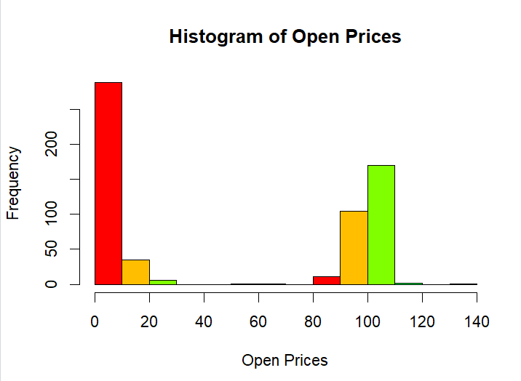

> hist(High,

+ main = "Histogram of High Prices",

+ xlab = "High Prices",

+ breaks = 10,

+ col = rainbow(8))

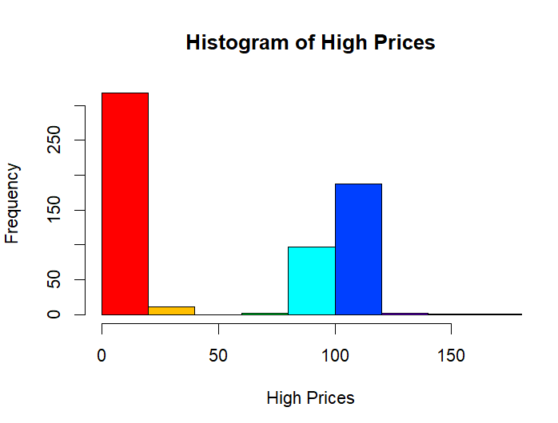

> hist(Close,

+ main = "Histogram of Close Prices",

+ xlab = "Close Prices",

+ breaks = 10,

+ col = rainbow(8))

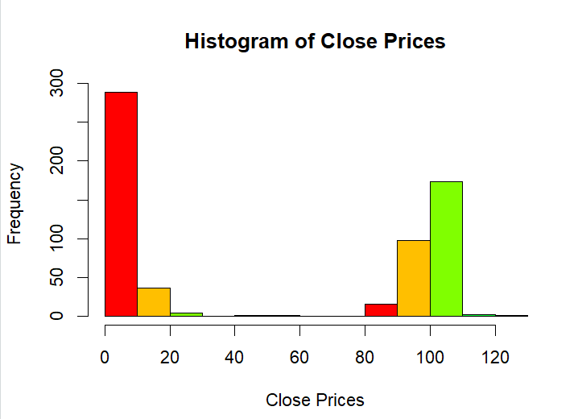

**Min and Max : --**

> max(Open, na.rm = TRUE)

[1] 132.7

> min(Open, na.rm = TRUE)

[1] 0.73

> Open_class <- cut(Open, c(0, 50, 100, 150), right = FALSE)

> Open_class

[1] [50,100) [50,100) [50,100) [50,100) [50,100) [50,100) [50,100) [50,100) [50,100)

[10] [50,100) [50,100) [50,100) [50,100) [50,100) [50,100) [50,100) [50,100) [50,100)

[19] [50,100) [50,100) [50,100) [50,100) [50,100) [50,100) [50,100) [50,100) [50,100)

[28] [50,100) [50,100) [50,100) [50,100) [50,100) [50,100) [50,100) [50,100) [50,100)

[37] [50,100) [50,100) [50,100) [50,100) [50,100) [50,100) [50,100) [50,100) [50,100)

[46] [50,100) [50,100) [50,100) [50,100) [100,150) [100,150) [100,150) [100,150) [100,150)

[55] [100,150) [100,150) [100,150) [50,100) [50,100) [50,100) [50,100) [50,100) [50,100)

[64] [100,150) [100,150) [100,150) [50,100) [50,100) [50,100) [50,100) [100,150) [100,150)

[73] [100,150) [100,150) [100,150) [100,150) [100,150) [100,150) [100,150) [100,150) [100,150)

[82] [100,150) [100,150) [100,150) [100,150) [100,150) [100,150) [100,150) [100,150) [100,150)

[91] [100,150) [50,100) [50,100) [100,150) [100,150) [50,100) [50,100) [50,100) [50,100)

[100] [50,100) [50,100) [50,100) [50,100) [100,150) [100,150) [100,150) [100,150) [100,150)

[109] [100,150) [100,150) [100,150) [100,150) [100,150) [50,100) [100,150) [100,150) [100,150)

[118] [100,150) [100,150) [100,150) [100,150) [100,150) [100,150) [100,150) [100,150) [100,150)

[127] [100,150) [100,150) [100,150) [100,150) [100,150) [100,150) [100,150) [100,150) [100,150)

[136] [100,150) [100,150) [100,150) [100,150) [100,150) [100,150) [100,150) [100,150) [100,150)

[145] [100,150) [100,150) [100,150) [100,150) [100,150) [100,150) [100,150) [100,150) [100,150)

[154] [100,150) [100,150) [100,150) [100,150) [100,150) [100,150) [100,150) [100,150) [100,150)

[163] [100,150) [100,150) [100,150) [100,150) [100,150) [100,150) [100,150) [100,150) [100,150)

[172] [100,150) [100,150) [100,150) [100,150) [100,150) [100,150) [100,150) [100,150) [100,150)

[181] [100,150) [100,150) [100,150) [100,150) [100,150) [100,150) [100,150) [100,150) [100,150)

[190] [100,150) [100,150) [100,150) [100,150) [100,150) [100,150) [100,150) [100,150) [100,150)

[199] [100,150) [100,150) [100,150) [100,150) [100,150) [100,150) [100,150) [100,150) [100,150)

[208] [100,150) [100,150) [100,150) [100,150) [100,150) [100,150) [100,150) [100,150) [100,150)

[217] [100,150) [100,150) [100,150) [100,150) [100,150) [100,150) [100,150) [100,150) [100,150)

[226] [100,150) [100,150) [100,150) [100,150) [100,150) [100,150) [100,150) [100,150) [100,150)

[235] [100,150) [100,150) [100,150) [100,150) [100,150) [100,150) [100,150) [100,150) [100,150)

[244] [100,150) [100,150) [100,150) [100,150) [50,100) [50,100) [100,150) [100,150) [100,150)

[253] [100,150) [100,150) [50,100) [50,100) [50,100) [50,100) [50,100) [50,100) [50,100)

[262] [50,100) [50,100) [50,100) [50,100) [50,100) [50,100) [50,100) [100,150) [50,100)

[271] [50,100) [50,100) [50,100) [50,100) [50,100) [50,100) [50,100) [50,100) [50,100)

[280] [50,100) [50,100) [50,100) [50,100) [50,100) [50,100) [50,100) [50,100) [100,150)

[289] [50,100) [50,100) [0,50) [0,50) [0,50) [0,50) [0,50) [0,50) [0,50)

[298] [0,50) [0,50) [0,50) [0,50) [0,50) [0,50) [0,50) [0,50) [0,50)

[307] [0,50) [0,50) [0,50) [0,50) [0,50) [0,50) [0,50) [0,50) [0,50)

[316] [0,50) [0,50) [0,50) [0,50) [0,50) [0,50) [0,50) [0,50) [0,50)

[325] [0,50) [0,50) [0,50) [0,50) [0,50) [0,50) [0,50) [0,50) [0,50)

[334] [0,50) [0,50) [0,50) [0,50) [0,50) [0,50) [0,50) [0,50) [0,50)

[343] [0,50) [0,50) [0,50) [0,50) [0,50) [0,50) [0,50) [0,50) [0,50)

[352] [0,50) [0,50) [0,50) [0,50) [0,50) [0,50) [0,50) [0,50) [0,50)

[361] [0,50) [0,50) [0,50) [0,50) [0,50) [0,50) [0,50) [0,50) [0,50)

[370] [0,50) [0,50) [0,50) [0,50) [0,50) [0,50) [0,50) [0,50) [0,50)

[379] [0,50) [0,50) [0,50) [0,50) [0,50) [0,50) [0,50) [0,50) [0,50)

[388] [0,50) [0,50) [0,50) [0,50) [0,50) [0,50) [0,50) [0,50) [0,50)

[397] [0,50) [0,50) [0,50) [0,50) [0,50) [0,50) [0,50) [0,50) [0,50)

[406] [0,50) [0,50) [0,50) [0,50) [0,50) [0,50) [0,50) [0,50) [0,50)

[415] [0,50) [0,50) [0,50) [0,50) [0,50) [0,50) [0,50) [0,50) [0,50)

[424] [0,50) [0,50) [0,50) [0,50) [0,50) [0,50) [0,50) [0,50) [0,50)

[433] [0,50) [0,50) [0,50) [0,50) [0,50) [0,50) [0,50) [0,50) [0,50)

[442] [0,50) [0,50) [0,50) [0,50) [0,50) [0,50) [0,50) [0,50) [0,50)

[451] [0,50) [0,50) [0,50) [0,50) [0,50) [0,50) [0,50) [0,50) [0,50)

[460] [0,50) [0,50) [0,50) [0,50) [0,50) [0,50) [0,50) [0,50) [0,50)

[469] [0,50) [0,50) [0,50) [0,50) [0,50) [0,50) [0,50) [0,50) [0,50)

[478] [0,50) [0,50) [0,50) [0,50) [0,50) [0,50) [0,50) [0,50) [0,50)

[487] [0,50) [0,50) [0,50) [0,50) [0,50) [0,50) [0,50) [0,50) [0,50)

[496] [0,50) [0,50) [0,50) [0,50) [0,50) [0,50) [0,50) [0,50) [0,50)

[505] [0,50) [0,50) [0,50) [0,50) [0,50) [0,50) [0,50) [0,50) [0,50)

[514] [0,50) [0,50) [0,50) [0,50) [0,50) [0,50) [0,50) [0,50) [0,50)

[523] [0,50) [0,50) [0,50) [0,50) [0,50) [0,50) [0,50) [0,50) [0,50)

[532] [0,50) [0,50) [0,50) [0,50) [0,50) [0,50) [0,50) [0,50) [0,50)

[541] [0,50) [0,50) [0,50) [0,50) [0,50) [0,50) [0,50) [0,50) [0,50)

[550] [0,50) [0,50) [0,50) [0,50) [0,50) [0,50) [0,50) [0,50) [0,50)

[559] [0,50) [0,50) [0,50) [0,50) [0,50) [0,50) [0,50) [0,50) [0,50)

[568] [0,50) [0,50) [0,50) [0,50) [0,50) [0,50) [0,50) [0,50) [0,50)

[577] [0,50) [0,50) [0,50) [0,50) [0,50) [0,50) [0,50) [0,50) [0,50)

[586] [0,50) [0,50) [0,50) [0,50) [0,50) [0,50) [0,50) [0,50) [0,50)

[595] [0,50) [0,50) [0,50) [0,50) [0,50) [0,50) [0,50) [0,50) [0,50)

[604] [0,50) [0,50) [0,50) [0,50) [0,50) [0,50) [0,50) [0,50) [0,50)

[613] [0,50) [0,50) [0,50) [0,50) [0,50) [0,50) [0,50)

Levels: [0,50) [50,100) [100,150)

> Open_freq <- table(Open_class)

> Open_freq

Open_class

[0,50) [50,100) [100,150)

329 106 184

**Pie Chart : --**

> pie(Open_freq,

+ labels = c("Low [0-50)", "Medium [50-100)", "High [100-150)"),

+ col = rainbow(10))

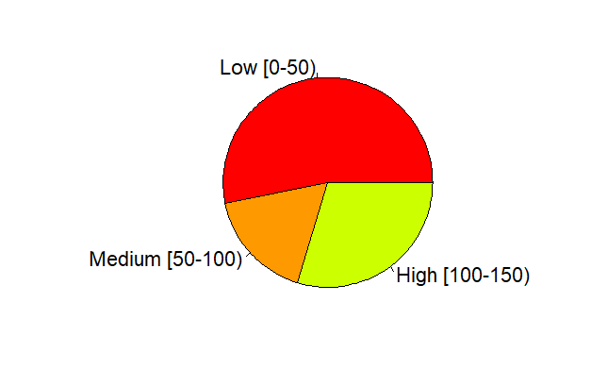

**Box Plot : --**

> # Box Plot

> boxplot(Open,

+ main = "Box Plot of Open Prices",

+ ylab = "Open Prices",

+ col = "lightgreen")

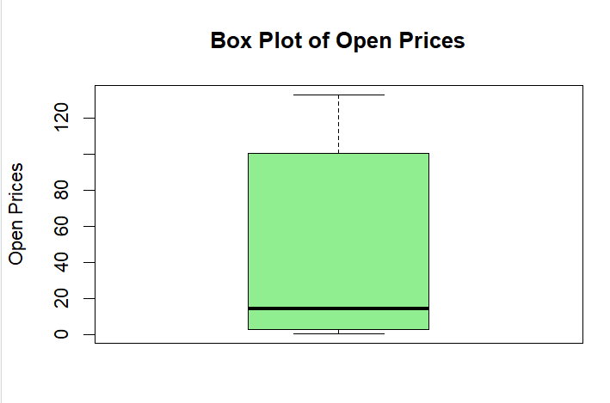

> boxplot(High,

+ main = "Box Plot of High Prices",

+ ylab = "High Prices",

+ col = "lightblue")

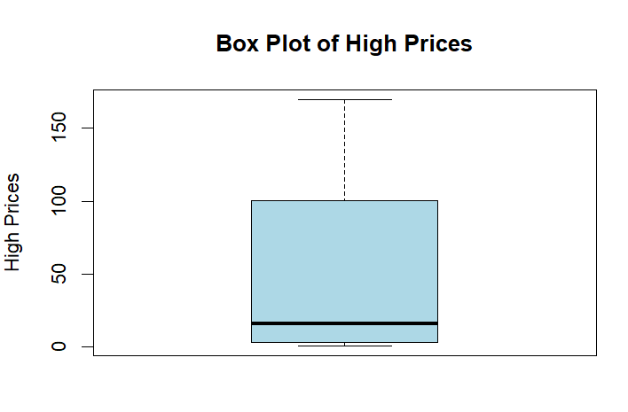

> boxplot(Close,

+ main = "Box Plot of Close Prices",

+ ylab = "Close Prices",

+ col = "pink")

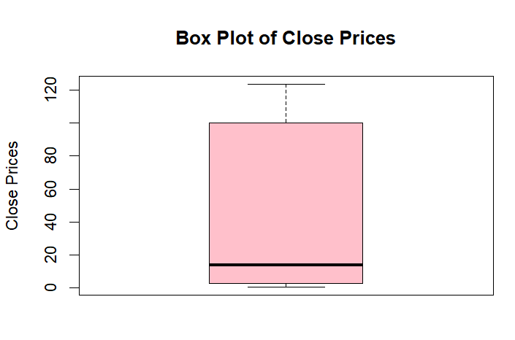

**Line Graph : --**

> # Line Graph

> sorted_Open <- sort(data$open)

> sorted_High <- sort(data$high)

> sorted_Close <- sort(data$close)

> plot(sorted_Open, sorted_High,

+ main = "Open vs High Prices",

+ type = "o",

+ lty = 2,

+ pch = 16,

+ col = "blue",

+ xlab = "Open Prices",

+ ylab = "High Prices")

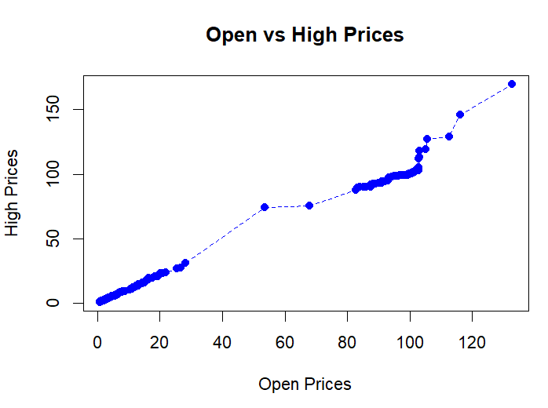

> lines(sorted_Open, sorted_Close,

+ type = "o",

+ lty = 1,

+ pch = 17,

+ col = "red")

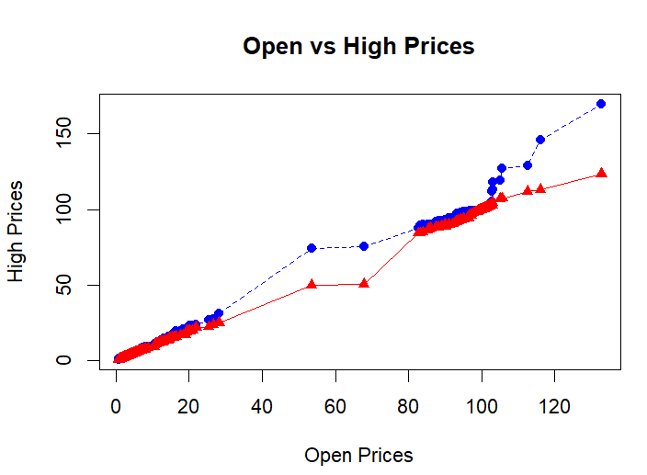

**Legend : --**

> # Add Legend

> legend("topright",

+ legend = c("Open vs High", "Open vs Close"),

+ col = c("blue", "red"),

+ lty = c(2, 1),

+ pch = c(16, 17))

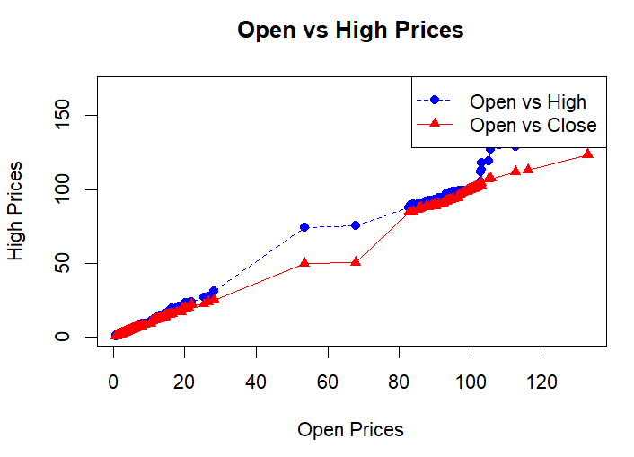

**Analysis of HUBC Stock Prices**

**Description of Dataset**

The dataset used for this analysis was sourced from [Kaggle](https://www.kaggle.com/). It contains daily stock prices for HUBC, including variables such as **Open**, **High**, **Low**, and **Close** prices. These variables represent the stock price metrics at various points during the trading day.

**Aim/Objective**

The primary objective of this analysis is:

1. To compute descriptive statistics (mean, median, mode, standard deviation) for the stock price variables.
2. To visualize the stock price trends and distributions using graphical methods (histograms, pie charts, box plots, and line graphs).
3. To interpret the findings and derive insights from the dataset.

**Results**

**Descriptive Statistics**

1. **Mean**:
   * **Open**: [Mean of Open Prices]
   * **High**: [Mean of High Prices]
   * **Close**: [Mean of Close Prices]
2. **Median**:
   * **Open**: [Median of Open Prices]
   * **High**: [Median of High Prices]
   * **Close**: [Median of Close Prices]
3. **Mode**:
   * **Open**: [Mode of Open Prices]
   * **High**: [Mode of High Prices]
   * **Close**: [Mode of Close Prices]
4. **Standard Deviation**:
   * **Open**: [SD of Open Prices]
   * **High**: [SD of High Prices]
   * **Close**: [SD of Close Prices]

**Visualizations**

1. **Histograms**:
   * The histograms depict the distribution of **Open**, **High**, and **Close** prices. They indicate whether the prices are normally distributed, skewed, or have multimodal tendencies.
2. **Pie Chart**:
   * **Open Price Categories**:
     + Low: [Frequency]
     + Medium: [Frequency]
     + High: [Frequency]
3. **Box Plots**:
   * Box plots highlight the spread, median, and outliers for the **Open**, **High**, and **Close** prices.
4. **Line Graphs**:
   * The line graphs compare trends between **Open vs High** and **Open vs Close** prices, showing how the variables are correlated over sorted price ranges.

**Interpretation**

* **Open Price Analysis**:
  + The average opening price indicates the general market sentiment at the start of the trading day.
  + A high standard deviation in the opening prices would suggest volatility in the initial trading hours.
* **High and Close Price Trends**:
  + The relationship between high and close prices can provide insights into intraday market dynamics.
  + Distributions and outliers in these variables could indicate periods of significant market activity.
* **Visualization Insights**:
  + The histograms and box plots show whether prices are concentrated within specific ranges or exhibit high variability.
  + The pie chart categorization helps segment the stock prices into meaningful groups for quick understanding.

**Conclusion**

The analysis of HUBC stock prices provides a comprehensive overview of the stock's trading dynamics. The mean, median, mode, and standard deviation values give essential statistical insights into the dataset. Visualizations complement these findings by offering a clear picture of trends, distributions, and variations. This analysis can aid in making informed trading or investment decisions.