**PROJECT REPORT ON**

**“WATER FILTER SELLING WEBSITE”**

**SUBMITTED AS A PARTIAL REQUIREMENT FOR THE DEGREE OF**

**BACHELOR OF COMPUTER APPLICATION (B.C.A.)**

**SUBMITED BY: GUIDED BY:**

**PARMAR HIMANSHU BIPINBHAI PROF. PUJA SONI**

**(2020028180)**

**SHREE UTTAR GUJARAT BCA COLLEGE AFFILIATED TO**

**VEER NARMAD SOUTH GUJARAT UNIVERSITY,SURAT YEAR 2023-24**

SHREE UTTAR GUJARAT EDUCATION TRUST SANCHALIT

**Shree Uttar Gujarat B.C.A. College**

(Under Affiliation of - V.N.S.G. University)

Arjun Complex Lane, Bhatar Road,Surat-395017

**Website:**www.sugc.co.in**Ph.:**0261-2236076 [**E-mail**:shreeuttargujaratcollege@gmail.com](mailto:shreeuttargujaratcollege@gmail.com)

Date: 16/09/2023

Certificate

*This is to certify that the Project Report entitled “Water Filter Selling Website” have been submitted by Mr. Parmar Himanshu Bipinbhai (Exam No: 3206)towards partial fulfillment of the requirement for 5th semester of Bachelor Of Computer Application (B.C.A.) for the academic year 2023-24.*

***Signature Signature Signature***

*Internal Examiner External Examiner* ***(Prof. Pradip H. Rajput) (Prof. Puja Soni)***

The project: "**Water Filter Selling Website**" Selling Gharghanti like Water filter, Gas gehser etc. User can access all Pages / fill login, registration and contact us form and try to buy any item. User can view photos of the item as well as ask related queries. There are many Water filter Selling websites available on the internet now. But there are some which provide better understanding between users and website like solving user queries, answering user questions etc. Developing a website that will solve the above problems. Through this website user can get all information about Water filter, Gas gehser, Gharghanti. Also, through this website, the physical strength of the user remains good.

.

|  |  |
| --- | --- |
| Chapter | Page No. |
| 1. Introduction    1. Project description    2. Project Profile 2. Environment Description    1. Hardware and Software Requirements    2. Technologies Used 3. System Analysis    1. Existing System and its Drawbacks    2. Feasibility Study    3. Requirement Gathering and Analysis 4. Proposed System    1. Scope    2. Project modules    3. Modules wise Objectives / Functionalities Constraints    4. Expected Advantage 5. Detail Planning    1. Data Flow Diagram / UML    2. Process Specification / Activity Flow Diagram    3. Data Dictionary    4. Entity-Relationship Diagram / Class Diagram 6. System Design    1. Database Design    2. Directory Design    3. Input Design    4. Output Design 7. Software Testing 8. Limitations and Future Scope of Enhancements 9. References | 1  3  4  11  12  14  15  16  17  20  22  23  27  31  33  34 |

# 1.INTRODUCTION

## Project Description

The project: "Water Filter Selling Website" Selling Gharghanti like Water filter, Gas gehser etc. User can access all Pages / fill login, registration and contact us form and try to buy any item. User can view photos of the item as well as ask related queries. There are many Water filter Selling websites available on the internet now. But there are some which provide better understanding between users and website like solving user queries, answering user questions etc. Developing a website that will solve the above problems. Through this website user can get all information about Water filter, Gas gehser, Gharghanti. Also, through this website, the physical strength of the user remains good.

First, we need to Create an interface for the Home Page, About us Page, Gallery Page, Service Page, Certificate Page, Login Page, Sign up Form and Contact us Form. All these have connectivity to page Server and Database. So that it can work properly. Currently, there are Websites that display a limited number of items related to different Browser consoles. Many Browser consoles don't have a single platform for technical, electrical, etc. related stuff. And there is no Website where users can upload his/her queries and answers for others. We have to develop a Website that can solve all the above problems. By this user can get Good water.

* + - **Login Page**
    - **Sign up Form**
    - **Home Page**
    - **About us Page**
    - **Gallery Page**
    - **Service Page**
    - **Certificate Page**
    - **Contact us Page**
  1. **Project Profile**

|  |  |
| --- | --- |
| Project Title :- | Water Filter Selling Website |
| Project Type :- | Selling Website |
| Organization :- | My Self |
| Technology :- | Html, Css, Bootstrap, Javascript, Angular js, Php, Mysql |
| Front End :- | Html, Css, Bootstrap, Javascript, Angular js |
| Back End :- | Php |
| Framework :- | Bootstrap |
| Server :- | Mysql |
| Internal Guide :- | Asst. Prof. Puja Soni |
| Submitted To :- | Shree Uttar Gujarat BCA College |
| Devloped By :- | Himanshu Parmar |
|  |  |

# Environment Description

## Hardware and Software Requirements

* + - The Efficient Hardware and Software Configuration Requires To Run The System Is As Suggest Below. The Configuration Suggested Is For Better Performance. Same Functionality or Higher Configuration Will Always Better.
    - Same Functionality or Higher Configuration Will Always Better. A Software requirements specification is a document that describes requirements for a software product , program or set of programs.
    - In software development, the software requirements specification represents the results of the requirements analysis and describe the requirements of the software under development.

## Hardware Requirements

|  |  |
| --- | --- |
| Operating system | Windows |
| Database | Real Time Database |
| Microprocessor | Any but Latest Is Good For Performance |
| Memory | 256 MB |
| Hard Disk Space | 8 GB |

**Software Requirements**

|  |  |
| --- | --- |
| Software | Android Studio 2021.2.1 |

|  |  |
| --- | --- |
| Os Version | Android |
| Microprocessor | Any but Latest Is Good For Performance |

# 2.4 Technologies Used :

## Overview Of Android

Android is an open source and Linux-based **Operating System** for mobile devices such as smartphones and tablet computers. Android was developed by the *Open Handset Alliance*, led by Google, and other companies.

Android offers a unified approach to application development for mobile devices which means developers need only develop for Android, and their applications should be able to run on different devices powered by Android.

The first beta version of the Android Software Development Kit (SDK) was released by Google in 2007 where as the first commercial version, Android 1.0, was released in September 2008.

On June 27, 2012, at the Google I/O conference, Google announced the next Android version, 4.1 **Jelly Bean**. Jelly Bean is an incremental update, with the primary aim of improving the user interface, both in terms of functionality and performance.

The source code for Android is available under free and open source software licenses. Google publishes most of the code under the Apache License version 2.0 and the rest, Linux kernel changes, under the GNU General Public License version 2.

## Features of Android :

Android is a powerful operating system competing with Apple 4GS and supports great features. Few of them are listed below –

|  |  |  |  |
| --- | --- | --- | --- |
|  | | | |
|  | **Sr.No.** | **Feature & Description** |  |
|  | 1 | **Beautiful UI**  Android OS basic screen provides a beautiful and intuitive user interface. |
|  | 2 | **Connectivity**  GSM/EDGE, IDEN, CDMA, EV-DO, UMTS, Bluetooth, Wi-Fi, LTE, NFC and WiMAX. |
|  | 3 | **Storage**  SQLite, a lightweight relational database, is used for data storage purposes. |
|  | 4 | **Media support**  H.263, H.264, MPEG-4 SP, AMR, AMR-WB, AAC, HE-AAC, AAC 5.1, MP3, MIDI, Ogg Vorbis, WAV, JPEG, PNG, GIF, and BMP. |
|  | 5 | **Messaging**  SMS and MMS |
|  | 6 | **Web browser**  Based on the open-source WebKit layout engine, coupled with Chrome's V8 JavaScript engine supporting HTML5 and CSS3. |

|  |  |  |  |
| --- | --- | --- | --- |
|  | | | |
|  | 7 | **Multi-touch**  Android has native support for multi-touch which was initially made available in handsets such as the HTC Hero. |  |
|  | 8 | **Multi-tasking**  User can jump from one task to another and same time various application can run simultaneously. |
|  | 9 | **Resizable widgets**  Widgets are resizable, so users can expand them to show more content or shrink them to save space. |
|  | 10 | **Multi-Language**  Supports single direction and bi-directional text. |
|  | 11 | **GCM**  Google Cloud Messaging (GCM) is a service that lets developers send short message data to their users on Android devices, without needing a proprietary sync solution. |
|  | 12 | **Wi-Fi Direct**  A technology that lets apps discover and pair directly, over a high- bandwidth peer-to-peer connection. |
|  | 13 | **Android Beam**  A popular NFC-based technology that lets users instantly share, just by touching two NFC-enabled phones together. |

# Dart :

Dart is a client-optimized language for developing fast apps on any platform. Its goal is to offer the most productive programming language for multi-platform development, paired with a [flexible execution runtime platform](https://dart.dev/overview#platform) for app frameworks.

Languages are defined by their *technical envelope*—the choices made during development that shape the capabilities and strengths of a language. Dart is designed for a technical envelope that is particularly suited to client development, prioritizing both development (sub-second stateful hot reload) and high-quality production experiences across a wide variety of compilation targets (web, mobile, and desktop).

Dart also forms the foundation of [Flutter](https://flutter.dev/). Dart provides the language and runtimes that power Flutter apps, but Dart also supports many core developer tasks like formatting, analyzing, and testing code.

# Features of Dart:

## Object Oriented

Dart supports all primary operating systems such as [Windows](https://www.javatpoint.com/windows), [Linux](https://www.javatpoint.com/linux-tutorial), Macintosh, etc. The Dart has its own Virtual Machine which known as Dart VM, that allows us to run the Dart code in every operating system.

## Platform Independent

Unlike many other programming languages including C and C++, when Java is compiled, it is not compiled into platform specific machine, rather into platformindependent byte code. This byte code is distributed over the web and interpreted by the Virtual Machine (JVM) on whichever platform it is being run on.

## Concurrency

Dart is an asynchronous programming language, which means it supports multithreading using Isolates. The isolates are the independent entities that are related to threads but don't share memory and establish the communication between the processes by the message passing. The message should be serialized to make effective communication. The serialization of the message is done by using a snapshot that is generated by the given object and then transmits to another isolate for desterilizing.

## Extensive Libraries

Dart consists of many useful inbuilt libraries including SDK (Software Development Kit), core, [math](https://www.javatpoint.com/math), async, math, convert, [html](https://www.javatpoint.com/html-tutorial), IO, etc. It also provides the facility to organize the Dart code into libraries with proper namespacing. It can reuse by the import statement.

## Easy to learn

As we discussed in the previous section, learning the Dart is not the Hercules task as we know that Dart's syntax is similar to [Java](https://www.javatpoint.com/java-tutorial), [C#](https://www.javatpoint.com/c-sharp-tutorial), [JavaScript](https://www.javatpoint.com/javascript-tutorial), [kotlin](https://www.javatpoint.com/kotlin-tutorial), etc. if you know any of these languages then you can learn easily the Dart.

## Flexible Compilation

Dart provides the flexibility to compile the code and fast as well. It supports two types of compilation processes, AOT (Ahead of Time) and JIT (Just-in-Time). The Dart code is transmitted in the other language that can run in the modern web- brewers.

## Type Safe

The Dart is the type safe language, which means it uses both static type checking and runtime checks to confirm that a variable's value always matches the variable's static type, sometimes it known as the sound typing.

Although *types* are required, type *annotations* are optional because of type interference. This makes it code more readable. The other advantage to being type-

safe language is, when we change the part of code, the system warns us about that modification that we have modified earlier.

## Objects

The Dart treats everything as an object. The value which assigns to the variable is an object. The functions, numbers, and strings are also an object in Dart. All objects inherit from Object class.

## Browser Support

The Dart supports all modern web-browser. It comes with the dart2js compiler that converts the Dart code into optimized JavaScript code that is suitable for all type of web-browser.

# System Analysis

## Existing Systems

There are various MCQ quiz applications exist in the internet with different criteria. Each of the existing applications has their own goodness and problems. In this MCQ quiz application which is designed and implemented in JSP based we try to overcome the existing problems with following features:

* + - Remove source confuse issue;
    - Better management;
    - Connection to database for better storing of data;
    - Better frontend management;
    - Better backend management;
    - Try to decrease error issuer during

## Drawbacks of Existing System

The main objective of the project MCQ Quiz Application is to manage the details of students, examinations, marks, courses and papers. The project is totally at administrative end and thus only the administrator is granted the access. The purpose of the project is to build an application to reduce the manual work for managing the MCQ quiz and we will follow to achieve these objectives in this project.

* + - To User has to choose any three existing options and then user has to hit the submit button and each right answer will automatically count the score.
* To create an appropriate platform for best managing of MCQ test;
* To overcome the time consuming issues and taking MCQ tests
* To release the marks of the test taker as soon as possible
* To manage the information of different tests.

## Expected Advantages :

**Engage your audience**

Engage your audience in a unique and fun way and connect them to your brand or learning material. By creating a returning event, you will improve your consumer loyalty.

## Large number

Taking online quizzes makes it possible to have a large number of participants. It could be up to a number of 1000 participants (and even more!). It doesn’t matter at what kind of location they take the online quiz as long as they are connected to the Internet.

## Randomizing questions

It is significant more easy to randomize your question with just one click than to do it all manually. Randomizing questions and even answers of those questions is not a lot a of work to do with online quizzes. Besides the advantage of time saving, it also helps preventing students from [cheating.](https://www.onlinequizcreator.com/knowledge-center/online-exam-center/how-to-prevent-cheating-on-an-online-exams-and-tests/item10616)

## Quiz results/ gain insight in audience

Another plus of online quizzes is getting immediate results from your participants. Not only does the creator get the results, the participant itself is also possible to get his or her results. This makes it for the creator easy to identify the gaps in knowledge. The participants are able to view on what kind of section they have to improve themselves.

## More benefits of an online quiz

**No instructor needed**

Quizzes can be given without an instructor, which saves money and time **Set timer**

The creator is able to [set a timer](https://www.onlinequizcreator.com/features/online-test-maker-with-timer/item10236) for the whole quiz or to set a timer per question. This is possible to do with written quizzes, but is very time consuming for the instructor. Plus it’s almost impossible to do with a huge amount of participants. **Better overview**

It’s possible to show one question at the time with online quizzes. People are not able to skip a question, because you will get a reminder that you can’t leave the answer blank.

## Improve your brand

There are several ways to gain more brand awareness: Generate new interactive sales opportunities, build your traffic to your online channels, improve time spent on site and improve the sharing on social media about your campaign and brand.

## Conclusion

A large number of participants, with instant results of your online quiz (for the creator as well as the participants), a better overview, you’re able to randomize

your questions and set a timer. That all without the need of an instructor. What’s holding you back to not use online quizzes?

# Proposed System

## Scope :

The Scope of this project is very broad in terms of gaining knowledge and sharing knowledge among world.

* + - Can be used anywhere any time as it is a Programming based application.
    - This Application will be used in educational institutions as well as in corporate world.

## Main AIM OF THE SYSTEM

The aim of this project is to computerized the existing manual system and help the examiners to save their valuable time and important data. Apart from this, data which are exist in this system, will exist for long period of time and will be easy accessible. This project helps the examiners to manage their services in a good way and provide a better service to their users. The objective of this project is to manage the details of students, examinations, marks, courses and papers in a good manner. The performance of the application will be fully control by administrator and administrator can guaranty any one to access. The project will reduce the manual process in managing examinations and all issues regarding that. Functionalities of the project will be as following:

* + - Able the examiners to punch the MCQ questions online;
    - Able the users to solve the questions online;
    - Examiners can manage the information regarding exam;
    - Correct answers will be evaluated by system (First it should be determ-
    - ining by examiner
    - Users can see their result after submitting the test.

## Project Modules :

* Index: Which allow users to select their type of login to system.
* Student Login: Able the students to login to system with a valid user Email and password.

If student is successfully login to system, he/she will have access to following pages:

* **Student Home Page :-** Which have information about online mcq quiz and issues support by this system for students.
* **Attempt Test :-** which able the student to select a particular test

For attempting from the existing test in system from drop down list and after clicking on go to selected test the questions of selected test will be displayed for the student to attempt. Then student will be able to attempt the questions and after submitting, students will receivea result that another activity will be after submit Exam.

* **Marks :-** Which able the particular students to have access to result of the test which he/she attempt.

## Objective / Functionalities

The main objective of the project MCQ Quiz Application is to manage the details of students, examinations, marks, courses and papers. The project is totally at administrative end and thus only the administrator is granted the access. The purpose of the project is to build an application to reduce the manual work for managing the MCQ quiz and we will follow to achieve these objectives in this project.

* To create an appropriate platform for best managing of MCQ test
* To overcome the time consuming issues and taking MCQtests
* To release the marks of the test taker as soon as possible
* To manage the information of different tests.

# Detail Planning

## Data Flow Diagram

The Data Flow Diagrams Are An Intuitive Way Of Showning How Data Is Processed By a System. The Symbols Used In The DFD For This Project Are Shown Bellow.

## Data Flow :

Followning Sysmbol Is Used To Show Data Flow.The Data Flow Is Packet Of Data.

## Processes :

People, Procedures or Devices That Use or Produce Data.

## Source or Destination Of Data :

The Are Entities, Which Interect With The System From Outside Its Boundaries.

## Data Storage :

Here Data Are Stored Or Referenced Process In The System.

## 0 Level Diagram(Context Level) :

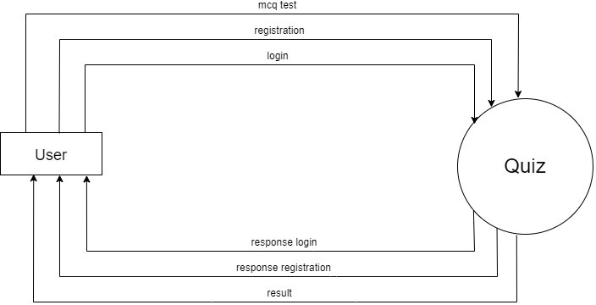

* **1ST Level Diagram :**

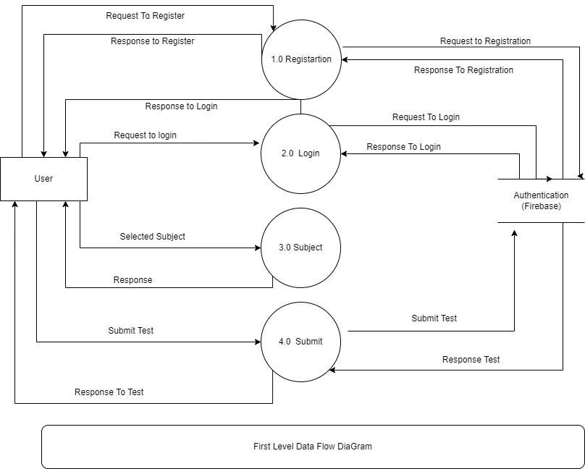

## Process Specification

1. **Registration Process :**

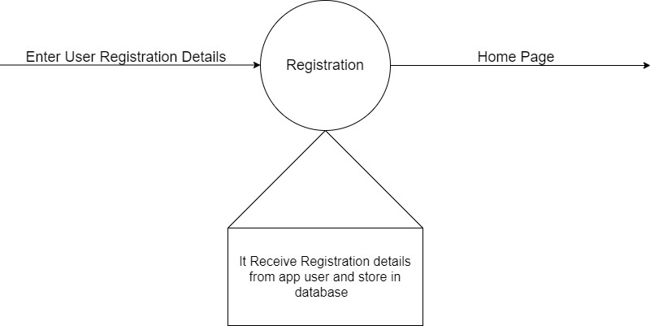

## Login Process :

1. 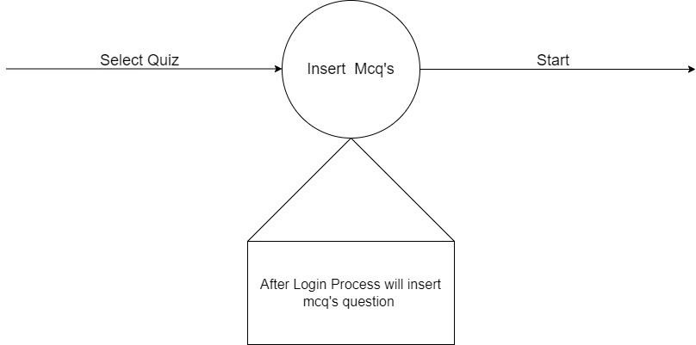**Insert Mcq:**

## View Question Answer :

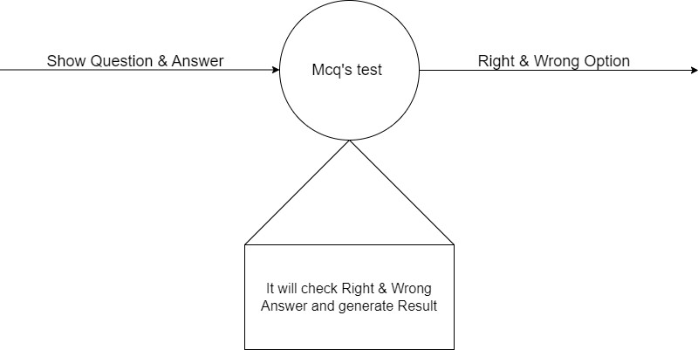

1. 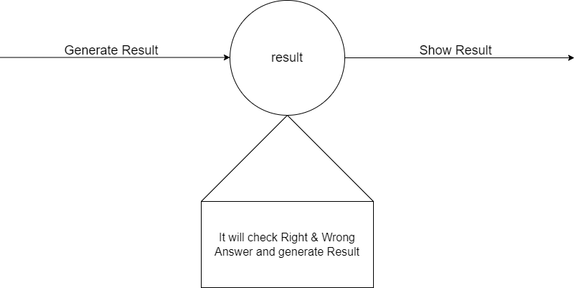**Result :**

## 4.4 Data Dictionary :

1. **User :**

|  |  |
| --- | --- |
| **Name** | **Users** |
| **Alias Name** | None |
| **Source** | Admin |
| **Destination** | User |
| **Description** | Admin Details Stored In Table.(Email & Password) |

# SystemDesign

## Input Device : 1)Programming Quiz App :

1. 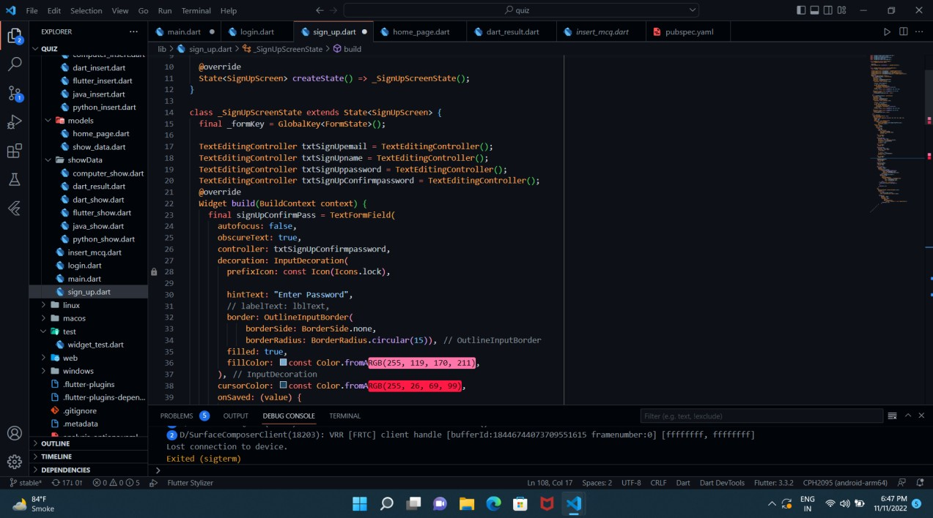**Registration Activity:**

## Login Activity :

1. 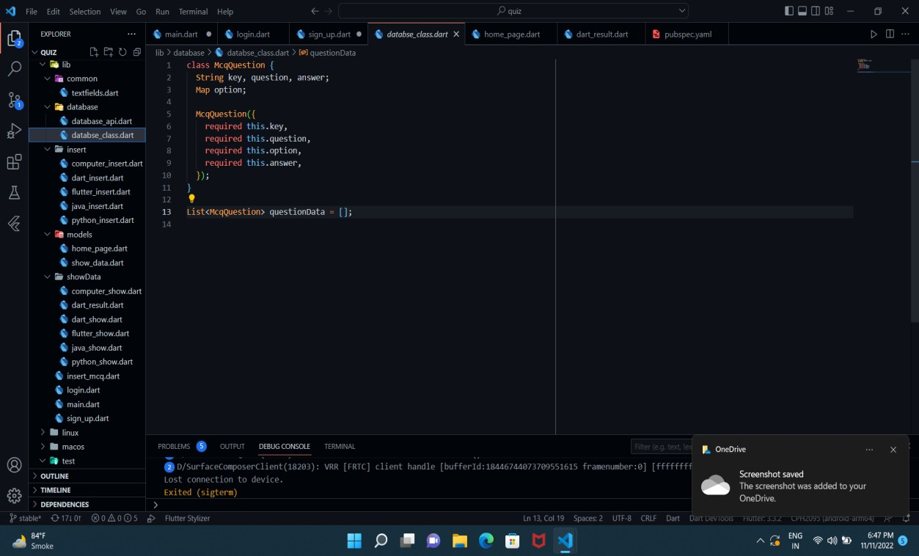**Database**

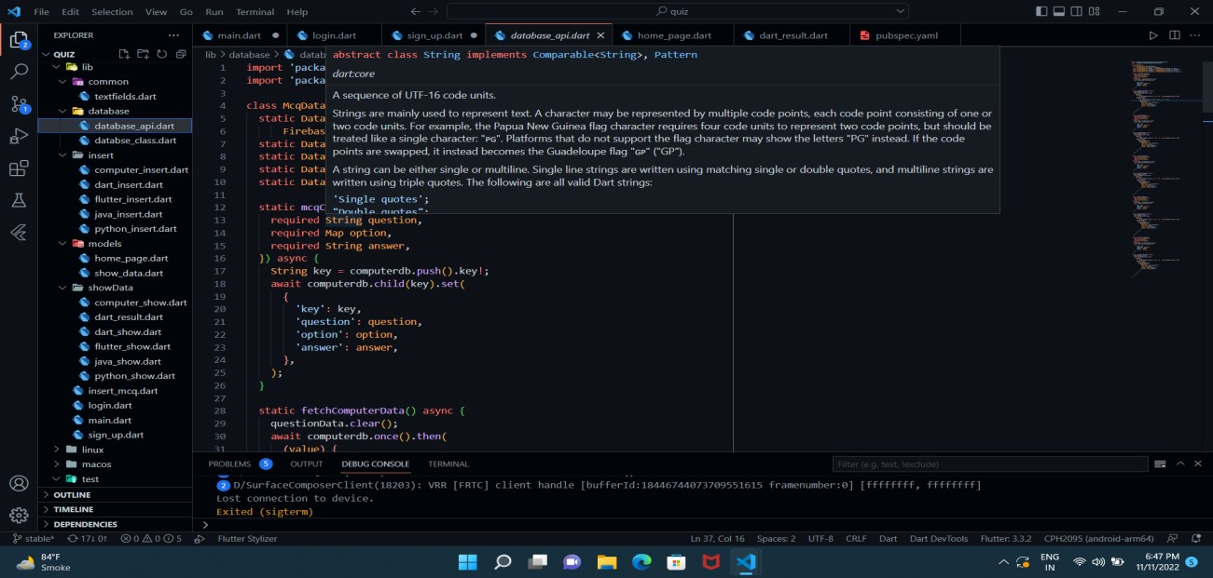

## Result Activity :

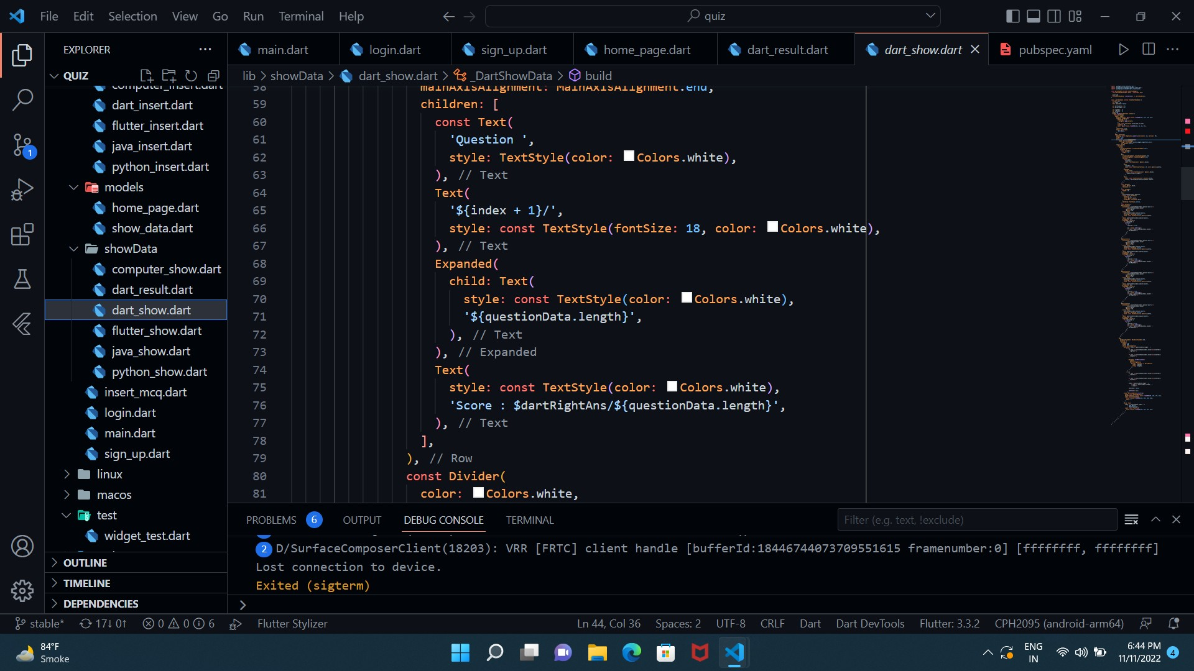

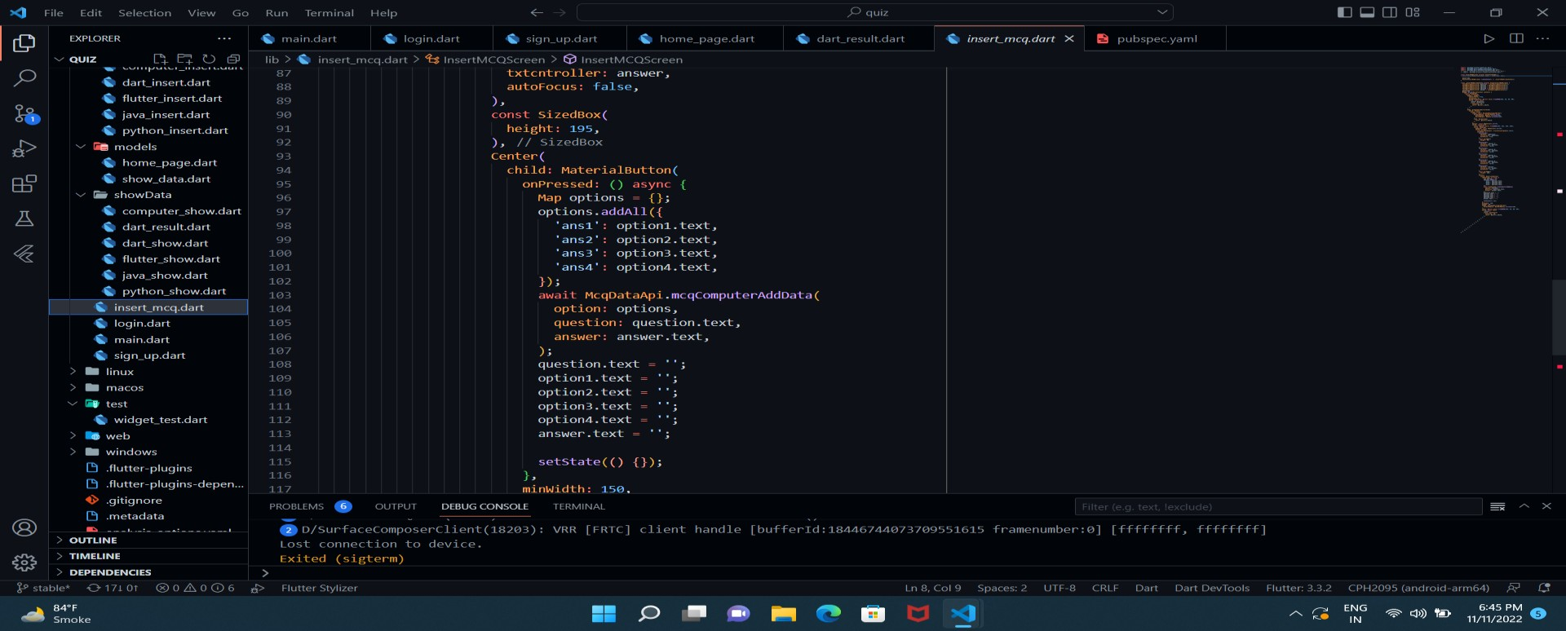

* 1. **Output Design**

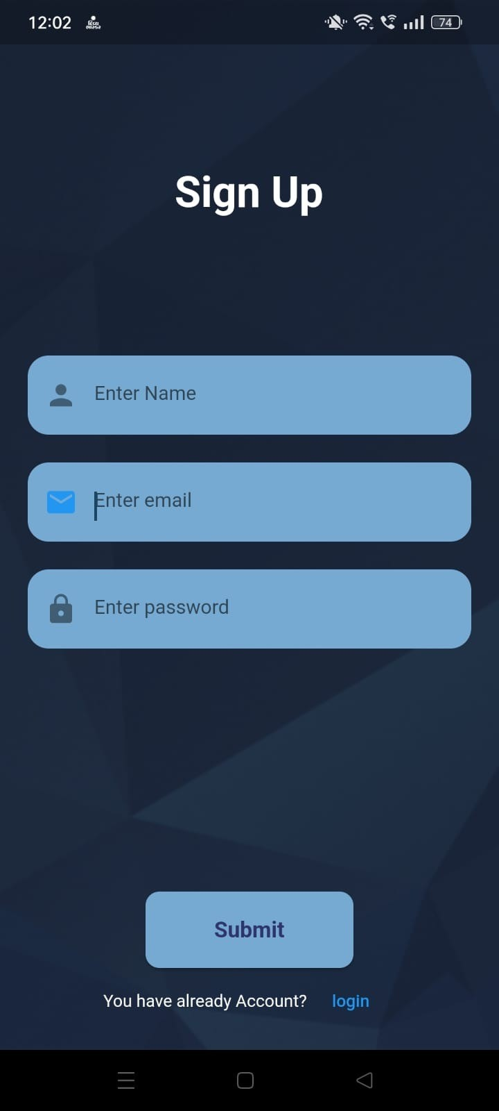

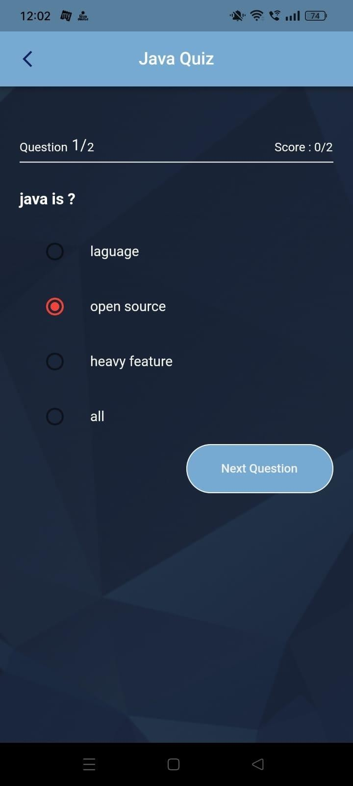

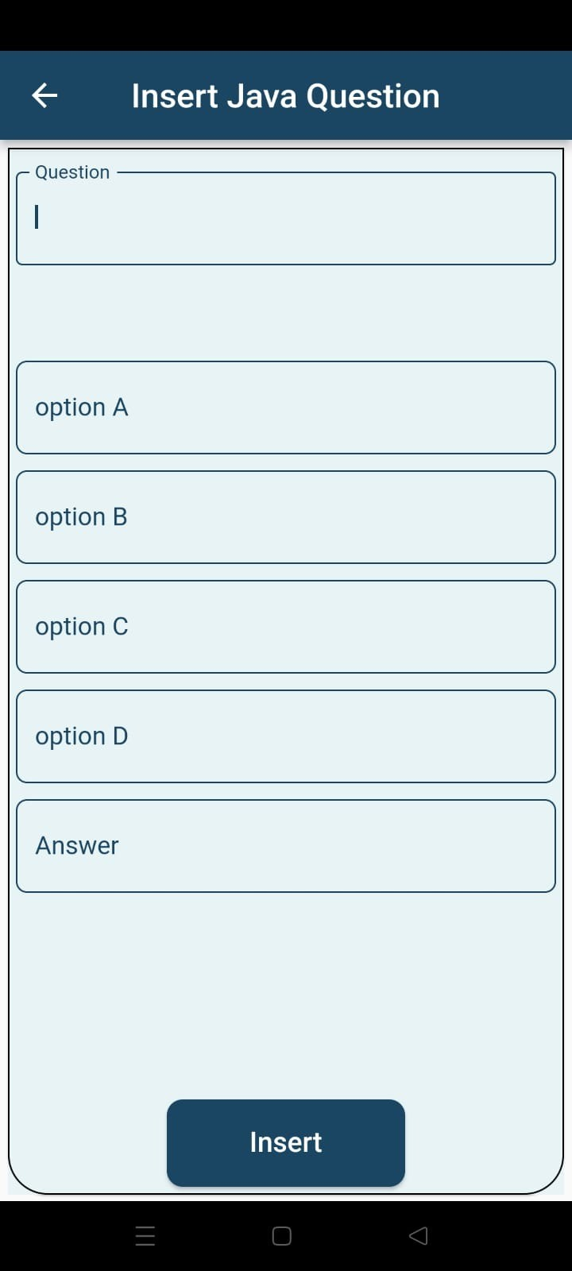

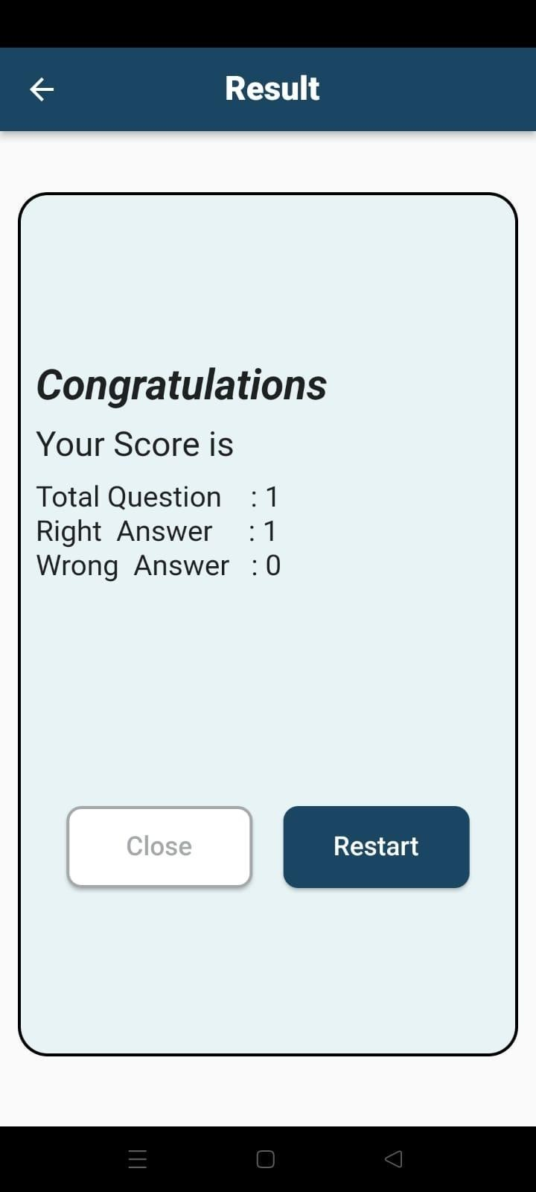

# Software Testing

## Testing Introduction

Software testing tutorial provides basic and advanced concepts of software testing. Our software testing tutorial is designed for beginners and professionals.

Software testing is widely used technology because it is compulsory to test each and every software before deployment.

Our Software testing tutorial includes all topics of Software testing such as Methods such as Black Box Testing, White Box Testing, Visual Box Testing and Gray Box Testing. Levels such as Unit Testing, Integration Testing, Regression Testing, Functional Testing. System Testing, Acceptance Testing, Alpha Testing, Beta Testing, Non-Functional testing, Security Testing, Portability Testing.

## Test Plan :

A test plan is a detailed document which describes software testing areas and activities. It outlines the test strategy, objectives, test schedule, required resources (human resources, software, and hardware), test estimation and test deliverables.

The test plan is a base of every software's testing. It is the most crucial activity which ensures availability of all the lists of planned activities in an appropriate sequence.

The test plan is a template for conducting software testing activities as a defined process that is fully monitored and controlled by the testing manager. The test plan is prepared by the Test Lead (60%), Test Manager(20%), and by the test engineer(20%).

## Unit Testing :

Unit testing involves the testing of each unit or an individual component of the software application. It is the first level of functional testing. The aim behind unit testing is to validate unit components with its performance.

A unit is a single testable part of a software system and tested during the development phase of the application software.

The purpose of unit testing is to test the correctness of isolated code. A unit component is an individual function or code of the application. White box testing approach used for unit testing and usually done by the developers.

Whenever the application is ready and given to the Test engineer, he/she will start checking every component of the module or module of the application independently or one by one, and this process is known as **Unit testing** or **components testing**.

## Integration Testing :

Integration testing is the second level of the software testing process comes after unit testing. In this testing, units or individual components of the software are tested in a group. The focus of the integration testing level is to expose defects at the time of interaction between integrated components or units.

uses modules for testing purpose, and these modules are combined and tested in integration testing. The Software is developed with a number of software modules that are coded by different coders or programmers. The goal of integration testing is to check the correctness of communication among all the modules.

# Limitations and Future Scope of Enhancements

## Limitation :

If user cannot login then user can’t Play Quiz.

## Future Scope of Enhancements:

FUTURE SCOPE In this application, answer will not display only result will be displayed at last. It is our future enhancement to display answer while answering the question. Can be used at fest’s in college for quiz contest.

 **Conclusion**

* This Online Quiz Application Provides facility to play quiz anywhere and anytime. It save time since user does need to wait for result. so student/user cannot wait for the result.all Student/user get extra knowledge any skills.administrator has a privilege to put as much as question in any category given in application. User can register, log-in, and give the test with his/her specific id, and can see the result as well.

# References

1. [**https://www.javatpoint.com/android-tutorial**](https://www.javatpoint.com/android-tutorial)
2. [**https://www.w3schools.in/android/tutorials/**](https://www.w3schools.in/android/tutorials/)
3. [**https://stackoverflow.com/questions/tagged/android**](https://stackoverflow.com/questions/tagged/android)
4. [**https://console.firebase.google.com/**](https://console.firebase.google.com/)