**A PROJECT REPORT**

**ON**

**“WATER FILTER WEBSITE”**

**SUBMITTED AS A PARTIAL REQUIREMENT FOR THE DEGREE OF**

**BACHELOR OF COMPUTER APPLICATION (B.C.A.)**



**SUBMITED BY: GUIDED BY: PARMAR HIMANSHU BIPINBHAI PROF. POOJA SONI**

**(2021026821)**

**SHREE UTTAR GUJARAT BCA COLLEGE AFFILIATED TO**

**VEER NARMAD SOUTH GUJARAT UNIVERSITY, SURAT YEAR 2023-24**

SHREE UTTAR GUJARAT EDUCATION TRUST SANCHALIT

**Shree Uttar Gujarat B.C.A. College**

(Under Affiliation of - V.N.S.G. University)

**Website:** www.sugc.co.in **Ph.:**0261-2236076

**E-mail**: [shreeuttargujaratcollege@gmail.com](mailto:shreeuttargujaratcollege@gmail.com)

_____________________________________________________________

Date: 03/10/2023

**Certificate**

This is to certify that the Mini Project Report entitled **“Water Filter Website”** have been submitted by **Mr. Parmar Himanshu B. (Exam No: 4428)** towards partial fulfillment of the requirement for 5th semester of Bachelor Of Computer Application **(B.C.A.)** for the academic year **2023-24**.

|  |  |  |
| --- | --- | --- |
| ***Signature*** | ***Signature*** | ***Signature*** |
|  |  |  |
| *Project Guide*  ***(Mrs. Pooja Soni)*** | *External Examiner* | ***(Prof. Pradip H. Rajput)*** |
|  |  |  |

**Abstract**

"Water Filter Selling Website" sells Water filter items like Gas gasser, Gharghanti etc. User can Login, Register and fill form in all Pages to Contact us and try to buy any item. User can view photos of the item as well as ask related Questions.

Krishna Sales & Service has brought new models of Spun filter cartridge, Ro membrane, Pressure pump, Uv, Second filter and Water filter so that user can get Clean water and user can Drink clean water.

There are many Water Filter Selling websites available on the internet now. But there are some which provide better understanding between users and website like solving user queries, answering user queries etc.

Developing a website that solves the above problems. Through this website user can get all the information about Water filter, Gas gasser, Gharghanti.

User can visit krishna Sales & Service in Instagram and Social media for more information about product service and to watch videos of service.

**INDEX**

|  |  |
| --- | --- |
| Chapter | Page No. |
| 1. Introduction | **1** |
| 1.1 Project description |  |
| 1.2 Project Profile |  |
| 2. Environment Description | **2** |
| 2.1 Hardware and Software Requirements |  |
| 2.2 Technologies Used |  |
| 3. System Analysis | **4** |
| 3.1 Existing System and its Drawbacks |  |
| 3.2 Expected Advantages |  |
| 1. Proposed System    1. Scope | **6** |
| 4.2 Project modules |  |
| 4.3 Objectives / Functionalities |  |
| 1. Detail Planning    1. Data Flow Diagram / UML | **8** |
| 5.2 Process Specification / Activity Flow Diagram |  |
| 5.3 Data Dictionary  5.4 Entity-Relationship Diagram / Class Diagram |  |
| 1. System Design    1. Input Design | **14** |
| 6.2 Output Design |  |
| 7. Limitations and Future Scope of Enhancements | **24** |
| 8. References | **25** |

**Introduction**

## Project Description

Water Filter Website provides the user with the facility of Water filter, Gas gehser and Gharghanti anywhere and anytime. Here user can see photos of all types of Water filter, Gas gehser and Gharghanti. If the user likes, he can fill the Contact us form or Call the mobile number of krishna Sales & Service. The purpose of developing Water filter website is that the user can get the facility of Water filter, Gas gehser and Gharghanti.

## Project Profile

|  |  |
| --- | --- |
| PROJECT TITLE | Water Filter Website |
| FRONT END | Html, Css, Bootstrap, Javascript, Angular js |
| BACK END | Php |
| DATA BASE | Mysql |
| PROJECT  DURATION | 2/5 Month |
| INTERNAL GUIDE | Mrs. Pooja Soni |

**Environment Description**

* 1. **Hardware and Software Description**
* **Here are the recommended specification of require software to develop the system.**

**Hardware Requirement**

|  |  |
| --- | --- |
| Processor | Intel(R) Core(TM) i5-6300U CPU @ 2.40GHz 2.50 GHz |
| Memory | 8 GB |
| Hard Disk | 240 GB |

**Software Requirement**

|  |  |
| --- | --- |
| Operating  System | Microsoft Windows 10 |
| Frontend | Vscode |
| Backend | Phpmyadmin |
| Scripting Language | JavaScript |
| Date Base | Mysql |

## Technology Used

**Technology Used**

|  |  |
| --- | --- |
| Frontend | Html, Css, Bootstrap, Javascript,  Angular js |
| Backend | Php |
| Scripting Language | JavaScript |
| Data Base | Mysql |

**System Analysis**

## existing system and its drawback

* + **Existing System And its Drawbacks**
* **Existing System**
  + When the admin goes into the system, the admin can only check the contact list and change the contact status of the users, where the admin can't change the category and add new products but the admin can't change the access.
  + Once the user is logged in, the user can fill out the contact us form. User cannot fill contact us form if user is not logged in. Feedback not available.
* **Drawbacks**
  + In the admin panel, whenever the admin login there, the admin can only show the contact list of the users. The only thing an admin can do is that he/she can only change the status of a contact.

* + When user logs in, he/she can not change/modify his/her profile or cannot change/update the login details.

## Feasibility Study

* **The feasibility study is an important phase during the development of anyproject, its goal is to determine whether the project is doable or not.**

#### 1.Technical Feasibility

* Creating a specialized website focusing on water filter technology is technically feasible.
* You'd need to design the site, implement features like product listings, educational content, user interfaces, and possibly e-commerce capabilities for purchasing filters.
* It would also involve server setup, database management, and ensuring security measures for.
* Tailoring the content and design to the water filter niche will be essential for user engagement and success.
* Integrating databases of water filter products, their specifications, and user reviews could enhance the site's value.
* You'd need to focus on informative content, user-friendly interface, and possibly interactive tools to help users choose the right water filter based on their needs.

**Proposed System**

## Scope

#### Aim of The System

* + - A water filter specialization website aims to provide detailed information, resources, and products related to water filtration.
    - It may focus on educating users about various types of water filters, their features, benefits, installation guides, maintenance tips, and help users choose the right filter for their specific needs.

#### Scope of System

* + - The scope of the water filter specialization system involves providing a comprehensive platform that caters to various aspects related to water filtration and purification.

#### Visitor

* **Admin**

## Project Modules

* 1. **Module Vise Objectives**

#### Visitor –

* + - Shows their products after login.

##### Visitor can view category and its products.

#### Admin –

* + Only admin can view in admin portal.
  + Only admin can view and control product categories (coming soon)
* **Easy to browse –**

## Expected Advantages

* + Creating a specialized water filter website with an emphasis on easy browsing offers several advantages.
  + It enhances user experience, increases user engagement, improves accessibility, boosts conversion rates, and establishes credibility by showcasing expertise in water filtration products and information.

**Detail Planning**

## Data Flow Diagram

#### 0 level – Context level

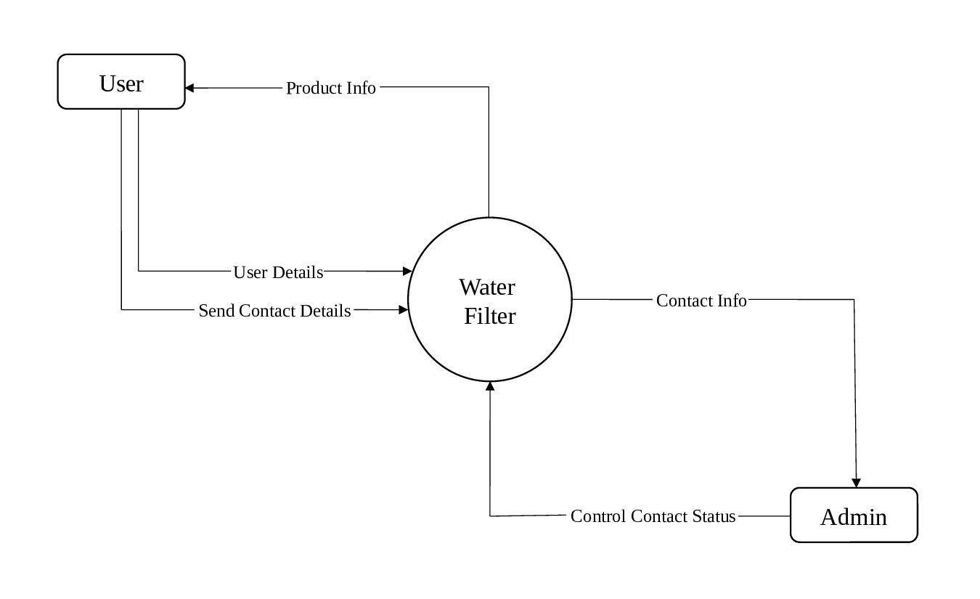

* **1 level – User**

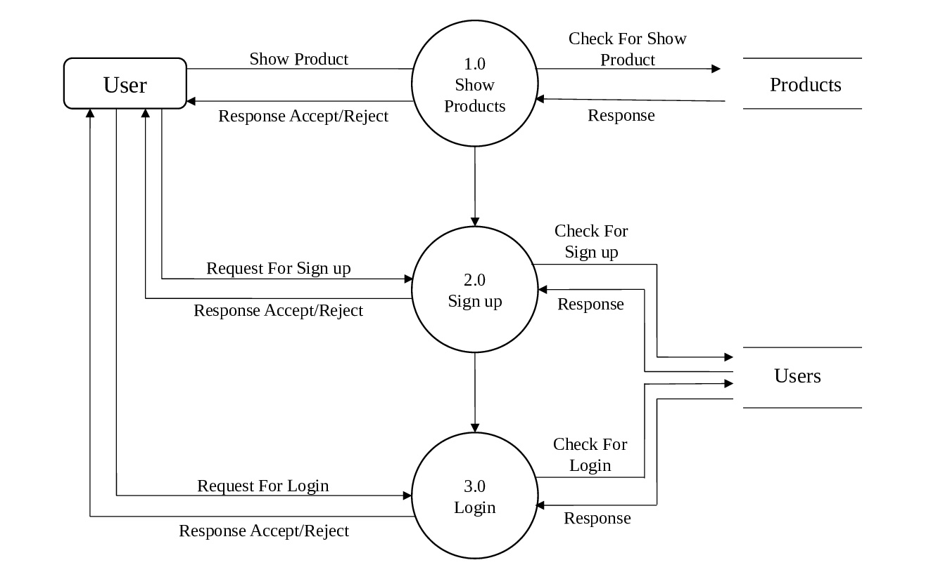

* **2 level – Admin**

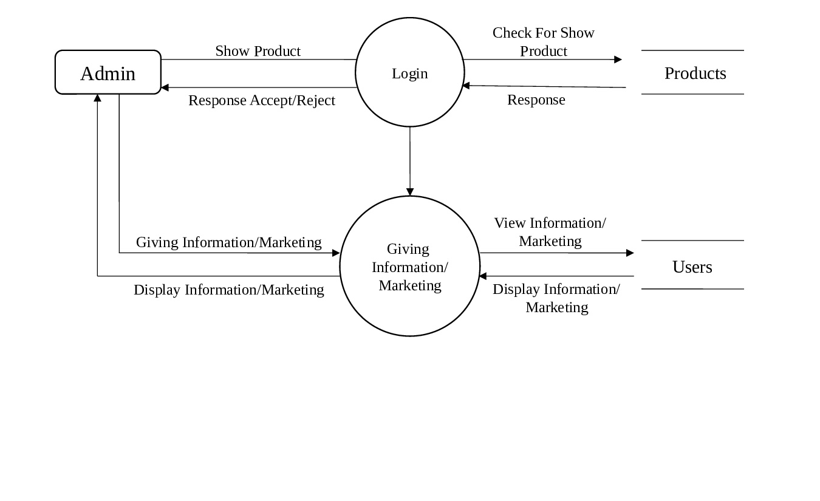

## Process Specification

* **A process specification is a method used to document, analyze and explain the decision-making logic and formulas used to create output making logic and formulas used to create output data from process input data.**

**it’s objective is to flow down and specify regulatory engineering requirements andprocedures.**

* + 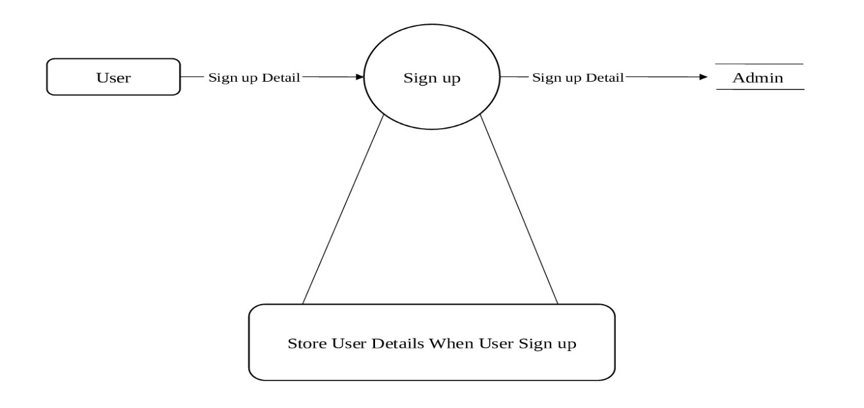**Sign up Process**
  + **Login Process**

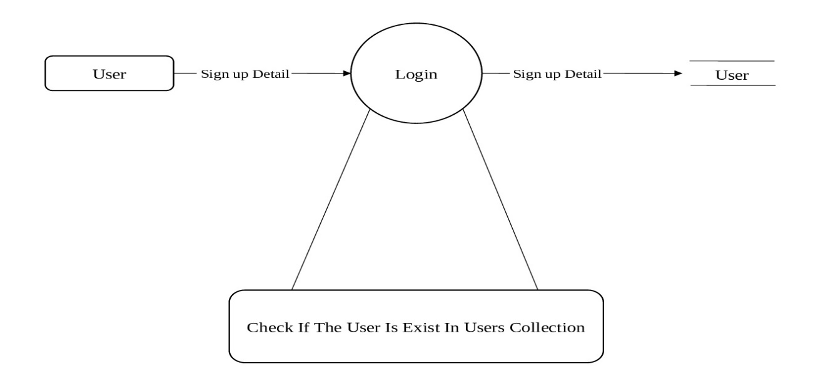

* 1. **Data Dictionary**

# User:

|  |  |
| --- | --- |
| Name | User |
| Alias | Null |
| Where used/ How used | To store user’s information |
| Description | Auto-incr object id |

## Product:

|  |  |
| --- | --- |
| Name | Product |
| Alias | Null |
| Where used/ How used | To water filter & Gharghanti detail |
| Description | Auto-incr object id |

* **Contacts**:

|  |  |
| --- | --- |
| Name | Contacts |
| Alias | Null |
| Where used/ How used | To customer’s contacts list |
| Description | Auto-incr object id |

## Entity-Relationship diagram

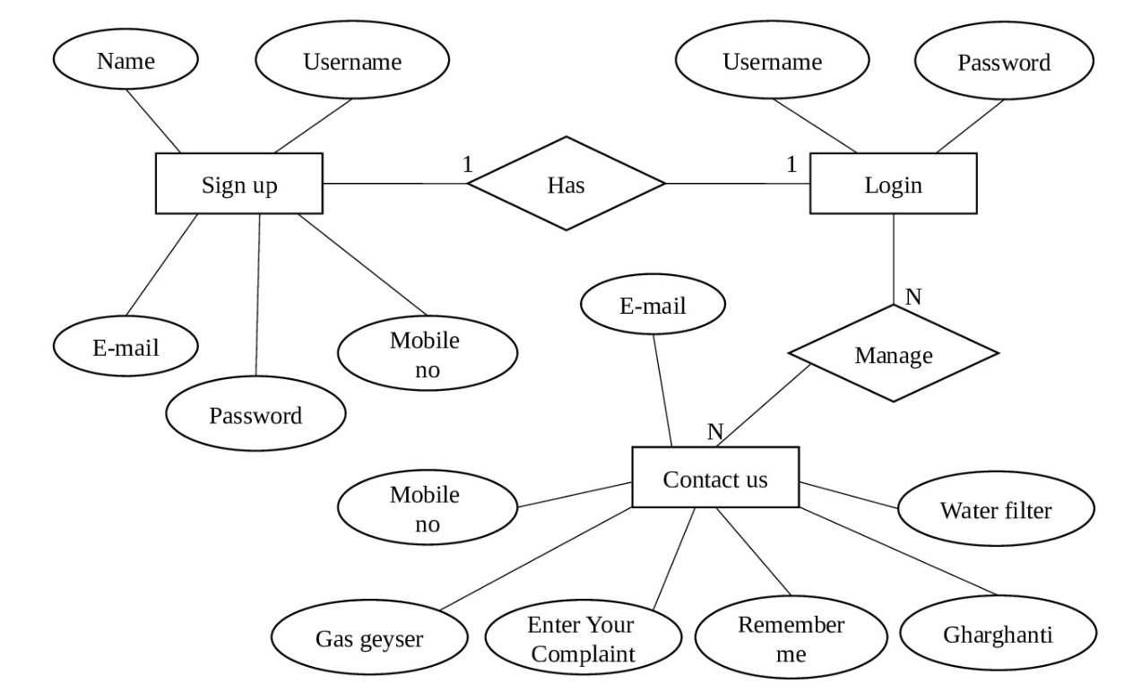

**System Design**

* 1. **Input Design**
  + **Login:**

**  **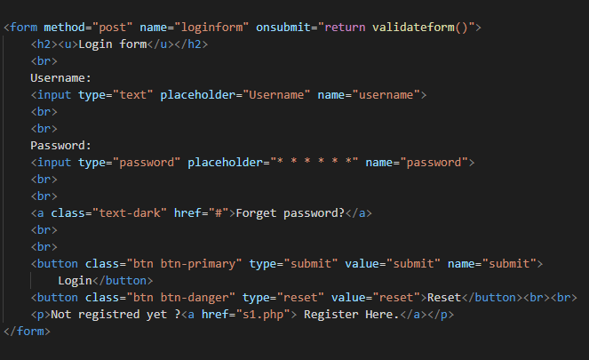

* + **Login Control:**

**  **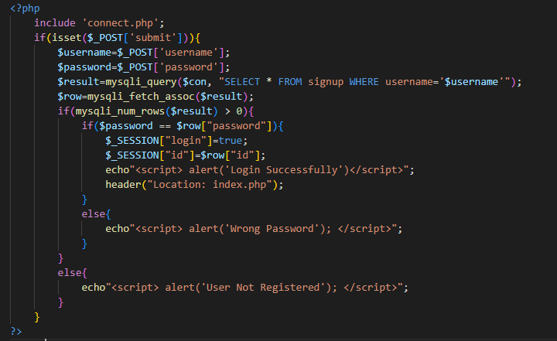

**  **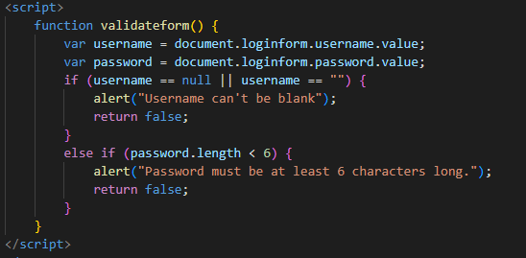

**  **

* **Sign up:**

**  **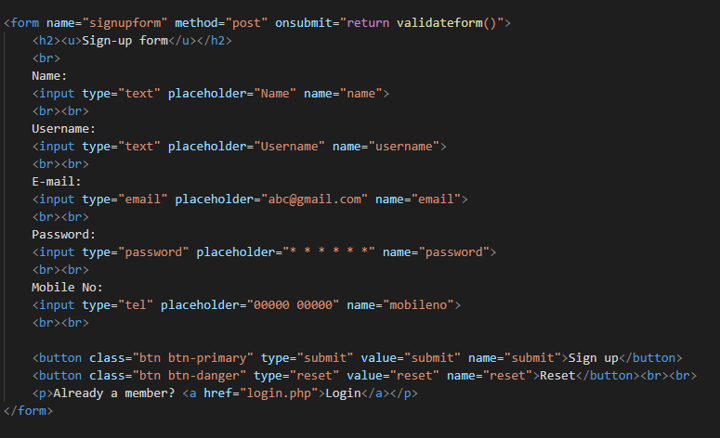

**  **

* + **Sign up control:**

**  **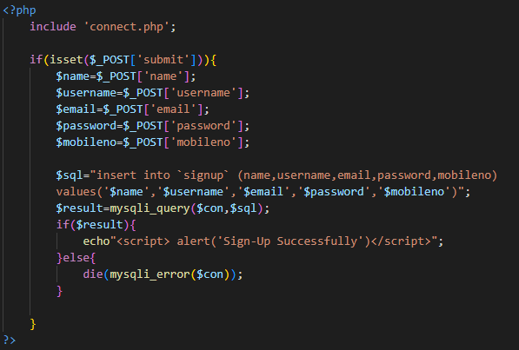

**  **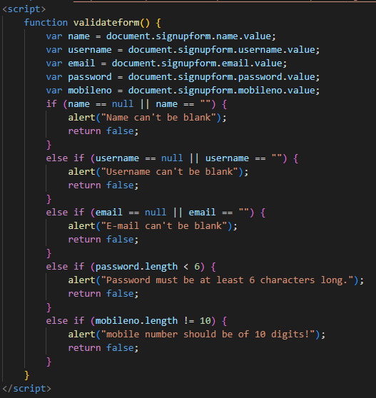

* + **Product:**

**  **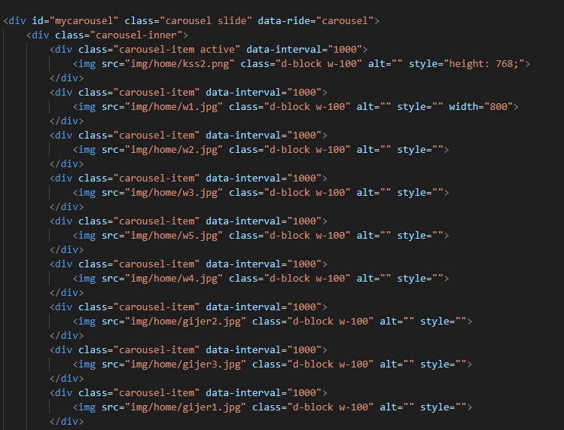

## 

## 

## 6.2 Output Design

### Login:

* **Sign up:**

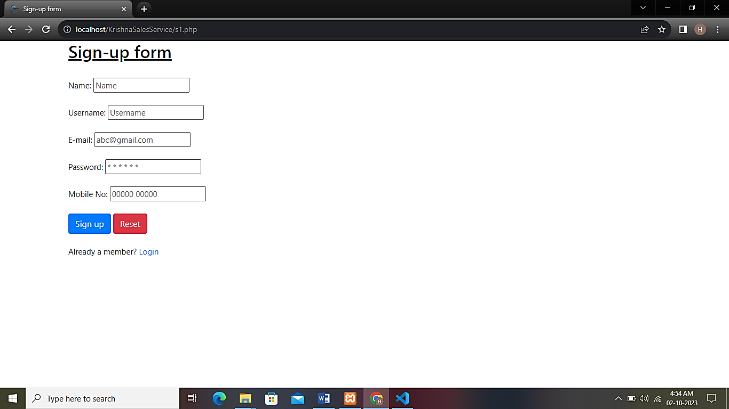

### Product:

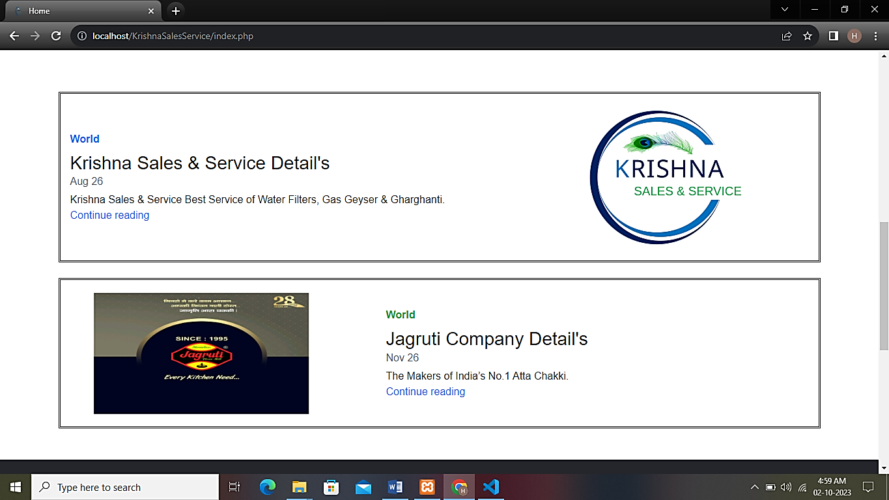

**Limitation and Future Scope of Enhancements**

* Water filter is a service to provide to users which connects to users through web application, here user can browse according to his choice if user like any water filter then user can fill contact us form.
* Currently in this system the user can take advantage of knowing the information about the water filter only.
* In future this system will provide add to cart and payment facilities, and will focus on user security.
* In admin panel, admin can only change or edit user's contact us status, he can't add any new product. These facilities will also be provided in future.

**References**

#### Sites Url:

https://www.php.net

https://www.w3schools.com/php/

