A COVID-19 Detection app has been created to detect the presence of COVID-19 in a user's cough. The application is developed using Streamlit and is user friendly. Streamlit is an easy-to-learn framework that helps create predictive analytics web applications.

In the application, the user is required to input their name and record their cough. This 4-second cough recording will then be classified into a COVID positive or a COVID negative cough.

The model is trained on the COSWARA dataset provided by IISc Bangalore (<https://github.com/iiscleap/Coswara-Data>) and the COUGHVID data provided by EPFL (<https://zenodo.org/record/4498364#.YUbqg7gzaMp>).

\*Screenshots\*

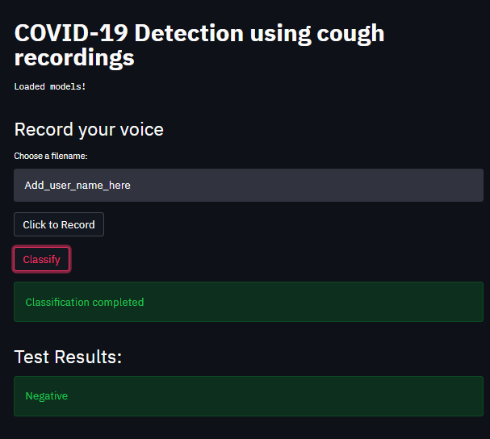

This app is written in python. The cough recording is initially saved in .WAV format, making it easier to process the recording. The model is trained separately, saved in a Pickle file, and loaded onto the Streamlit server, significantly reducing the utilization of computational resources and the waiting time for the users. This model includes a pipeline that pre-processes the recording to numerical features and then uses classification algorithms to classify the recording based on these numerical features derived in the previous stage.