**DTL Assignment : Bash Scripting**

**Name : Himanshu Kamdi**

**MIS No. : 112103067**

**Batch : Div 1 S4**

**Commands**

**1. Making new file and entering text into it**

**2. Making the file executable**

**3. Listing all the files in directory**

**4. Executing the file**

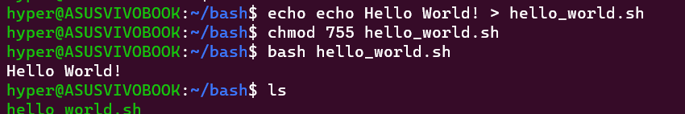

**1. Adding multiple lines to a file**

**2. Changing permission of the file created**

**3. Listing all the files in the directory**

**4. Executing the file**

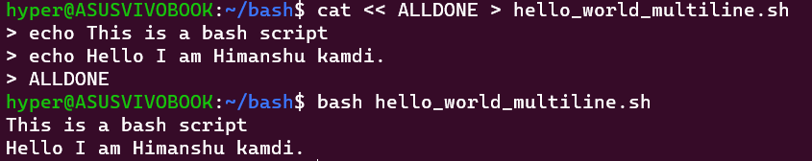

**1. Opening Bash directory**

**2. Creating a new file with current timestamp**

**3. Opening the file**

**4. Changing permissions**

**5. Listing the files in the directory**

**6. Executing the file**

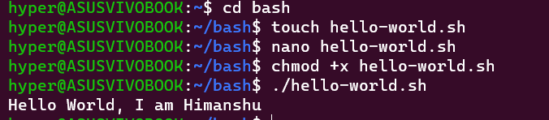

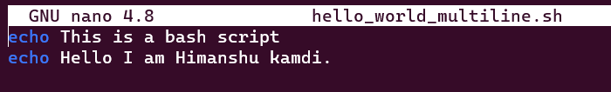

**Special Parameters**

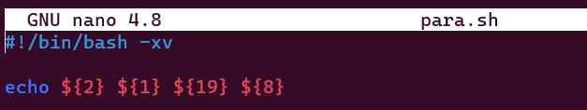

**Exploring all special parameters**

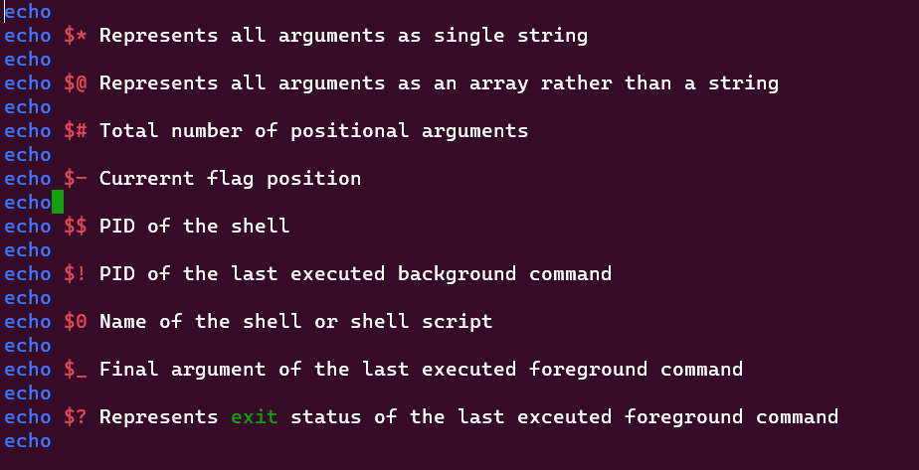

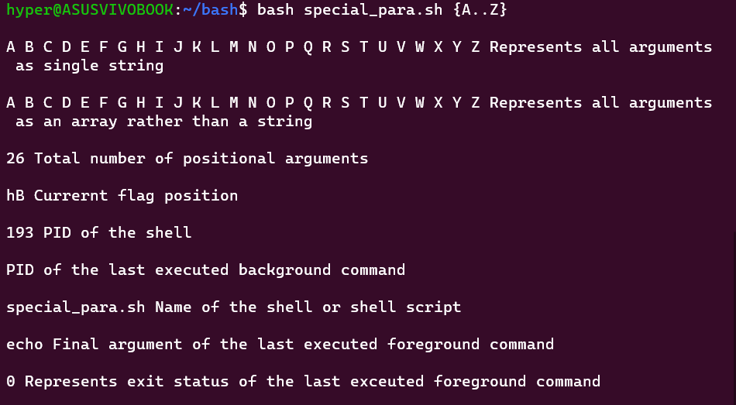

**Bracket Expansion**

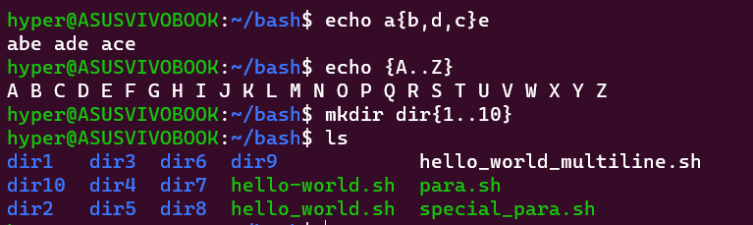

**Using Variables**



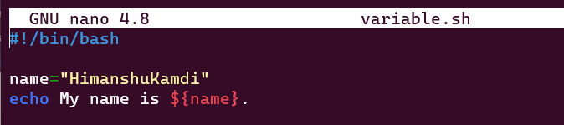

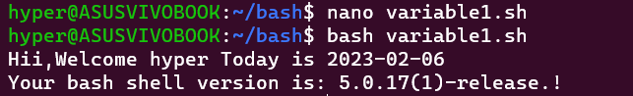

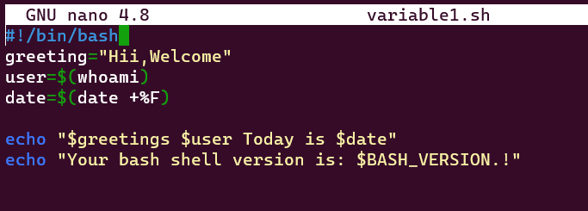

**Arithmetic Expansion:**

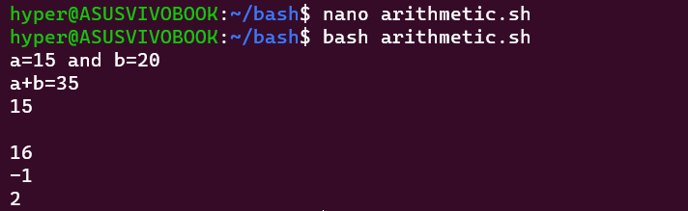

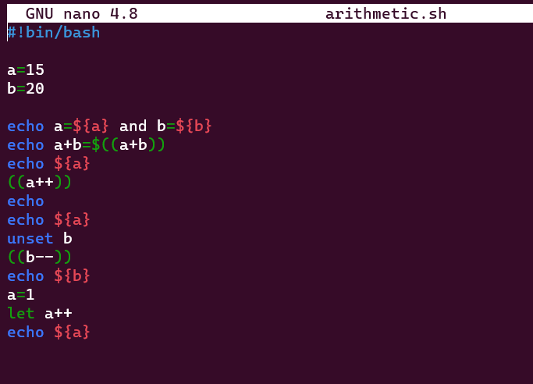

**Creating backup**

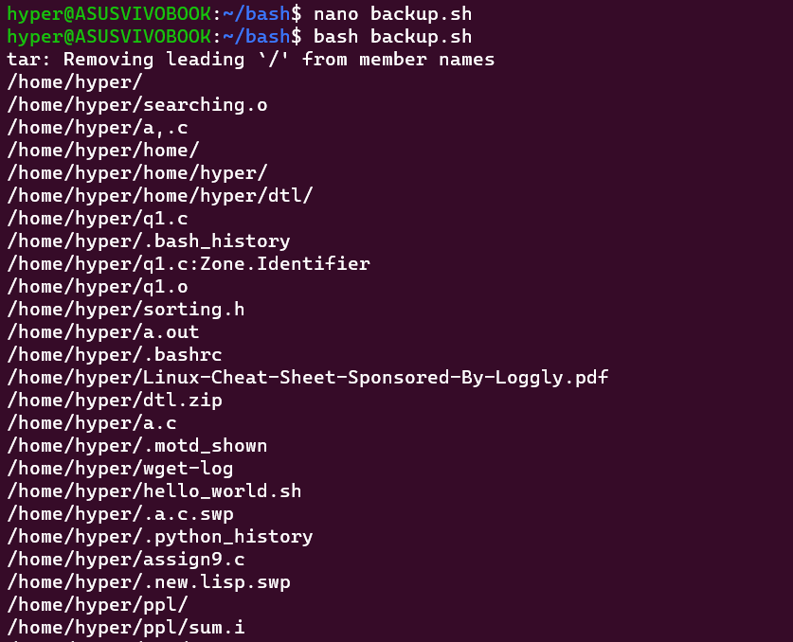

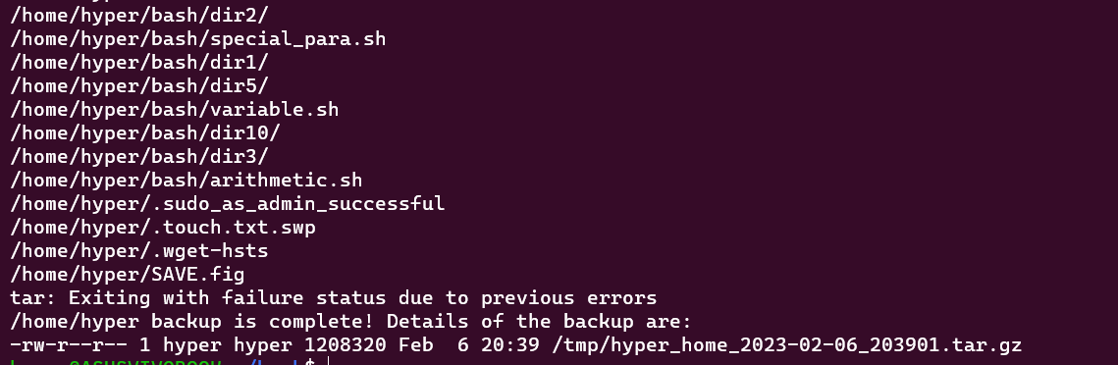

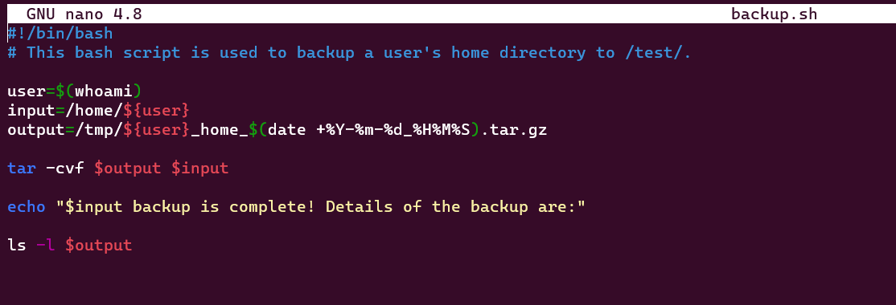

**Environment**

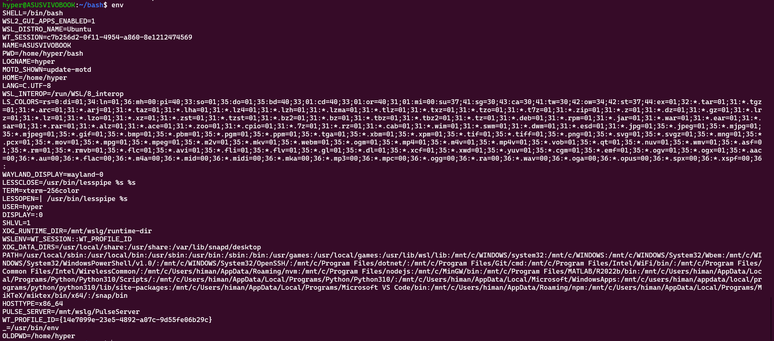

**Array**

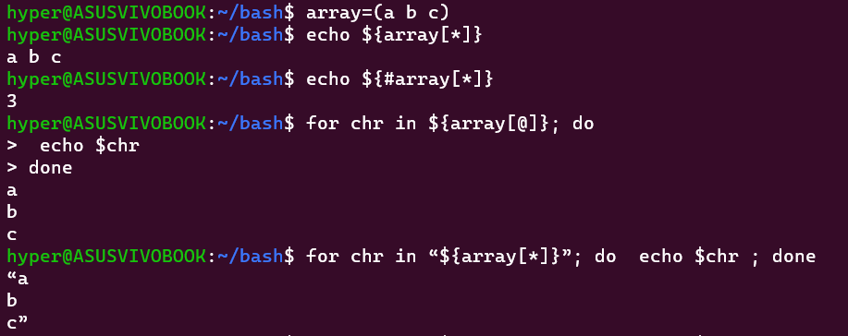

**Input and Output Redirection**

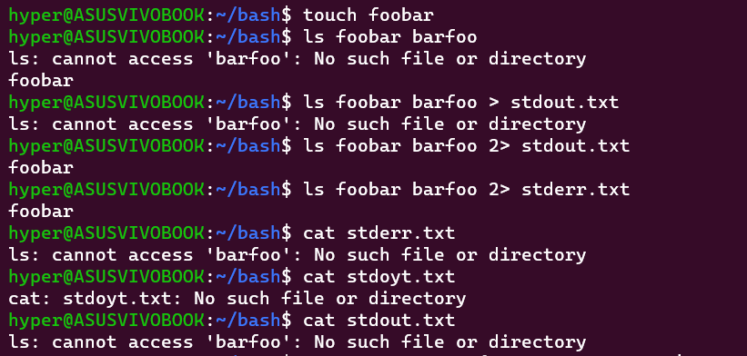

**Functions**

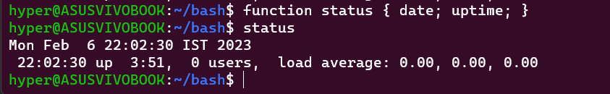



**Numeric and String Comparison**

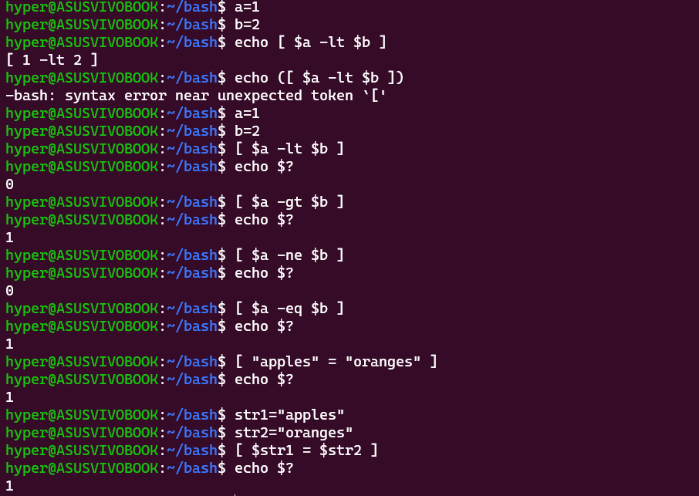

**Conditional statements**

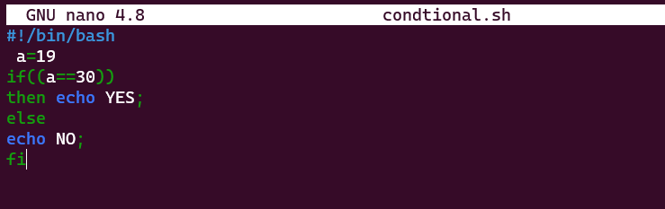



**Arithmetic Expansion**

